EXPERIMENT 1
AIM: simulate discrete time sequences

CODE:

import numpy as np
import matplotlib.pyplot as plt
def unit_impulse(length, position): signal = np.zeros(length) signal[position] = 1
return signal

# Parameters
start = -10 # Start value of the x-axis range stop = 10 # Stop value of the x-axis range step = 1 # Step size

# Generate x-axis values
x = np.arange(start, stop + step, step)

# Generate unit impulse signal
impulse_signal = unit_impulse(len(x), abs(start) // step)

# Plot the signal plt.stem(x, impulse_signal) plt.xlabel("Time") plt.ylabel("Amplitude")
plt.title("Unit Impulse Signal") plt.grid(True)
plt.show()

OUTPUT:

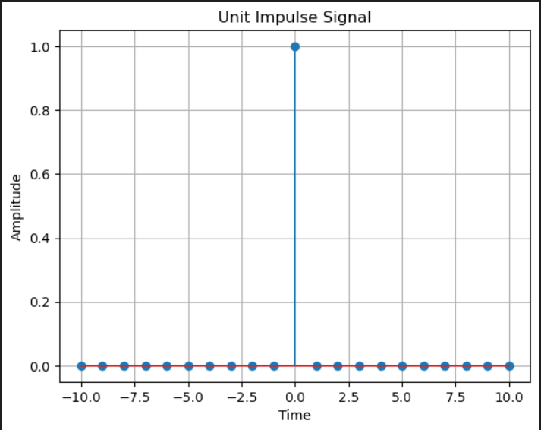

Conclusion:
The unit impulse signal was generated and plotted successfully using Python. From this experiment, I learned how to create and display a discrete-time sequence using Python. The graph showed an amplitude of 1 at (n = 0) and 0 at all other points, which is the characteristic of a unit impulse signal. This experiment helped me understand the basic concept of discrete-time sequences in Digital Signal Processing (DSP).

EXPERIMENT 1

AIM:
Simulate impulse train

CODE:
import numpy as np
import matplotlib.pyplot as plt
def simulate_impulse_train(signal_length, period): impulse_train = np.zeros(signal_length)
for n in range(signal_length): if n % period == 0:
impulse_train[n] = 1 return impulse_train

# Define the parameters for the impulse train signal_length = 100 # Length of the impulse train period = 10 # Period of the impulse train

# Simulate the impulse train
impulse_train = simulate_impulse_train(signal_length, period)

# Plot and display the impulse train plt.stem(impulse_train) plt.title('Impulse Train') plt.xlabel('Sample') plt.ylabel('Amplitude')
plt.show()
# Save the impulse train array (optional)
# np.savetxt('impulse_train.txt', impulse_train, delimiter=',')

OUTPUT:

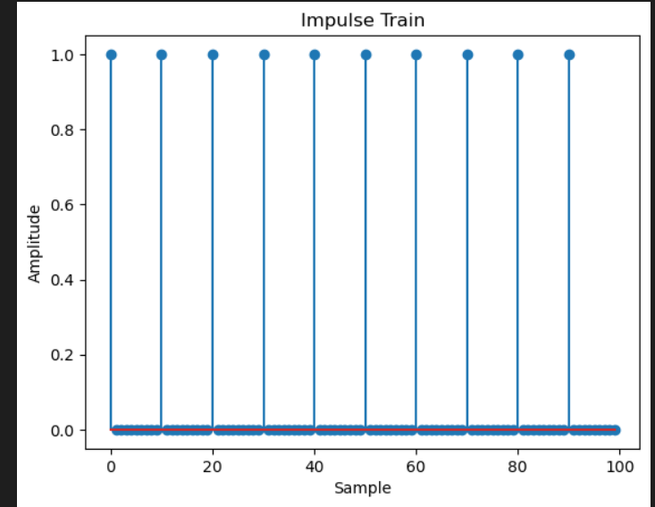

CONCLUSION:
The impulse train signal was successfully generated and plotted using Python. From this experiment, I learned how to create a periodic sequence of impulses using Python. The output graph showed impulses occurring at regular intervals with an amplitude of 1, while all other values were 0. This experiment helped me understand the basic concept of an impulse train signal and its representation in Digital Signal Processing (DSP).

EXPERIMENT 1

AIM: Write a python program to Simulate continuous and discrete unit step signal Code:
import numpy as np
import matplotlib.pyplot as plt
def simulate_continuous_unit_step(time): unit_step = np.zeros_like(time) unit_step[time >= 0] = 1
return unit_step
def simulate_discrete_unit_step(num_samples): unit_step = np.zeros(num_samples) unit_step[num_samples // 2:] = 1
return unit_step

# Define the time range for the continuous unit step signal
time = np.linspace(-5, 5, 1000) # Time range from -5 to 5

# Simulate the continuous unit step signal
continuous_unit_step = simulate_continuous_unit_step(time)

# Define the number of samples for the discrete unit step signal
num_samples = 20 # Number of samples

# Simulate the discrete unit step signal
discrete_unit_step = simulate_discrete_unit_step(num_samples)

# Plot and display the continuous and discrete unit step signals
plt.figure(figsize=(10, 6))
plt.subplot(2, 1, 1)
plt.plot(time, continuous_unit_step) plt.title('Continuous Unit Step Signal') plt.xlabel('Time') plt.ylabel('Amplitude')
plt.subplot(2, 1, 2) plt.stem(discrete_unit_step) plt.title('Discrete Unit Step Signal') plt.xlabel('Sample') plt.ylabel('Amplitude') plt.tight_layout()
plt.show()

# Save the unit step signal arrays (optional)
# np.savetxt('continuous_unit_step.txt', continuous_unit_step, delimiter=',') # np.savetxt('discrete_unit_step.txt', discrete_unit_step, delimiter=',')

OUTPUT:
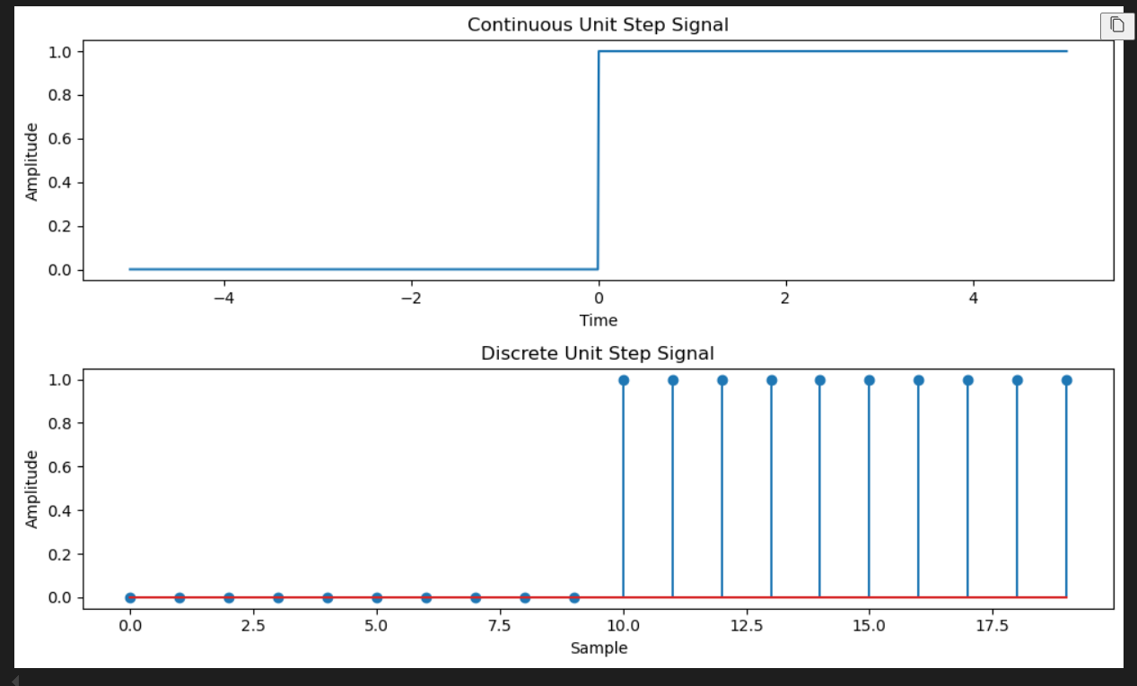

Conclusion:
The continuous and discrete ramp signals were successfully generated and plotted using Python. From this experiment, I learned that the ramp signal increases linearly with time after the starting point. This experiment helped me understand the characteristics and representation of ramp signals in Digital Signal Processing.

EXPERIMENT 1
AIM: Write a python program to Simulate continuous and discrete ramp signal Code:
import numpy as np
import matplotlib.pyplot as plt
def simulate_continuous_ramp(time, slope): ramp = np.zeros_like(time)
ramp[time >= 0] = slope * time[time >= 0] return ramp
def simulate_discrete_ramp(num_samples, slope): ramp = np.zeros(num_samples)
ramp[num_samples // 2:] = slope * np.arange(num_samples // 2, num_samples) return ramp
# Define the time range for the continuous ramp signal
time = np.linspace(-5, 5, 1000) # Time range from -5 to 5
# Define the number of samples and slope for the discrete ramp signal
num_samples = 20 # Number of samples slope = 2 # Slope of the ramp
# Simulate the continuous ramp signal
continuous_ramp = simulate_continuous_ramp(time, slope)
# Simulate the discrete ramp signal
discrete_ramp = simulate_discrete_ramp(num_samples, slope) # Plot and display the continuous and discrete ramp signals plt.figure(figsize=(10, 6))
plt.subplot(2, 1, 1) plt.plot(time, continuous_ramp)
plt.title('Continuous Ramp Signal') plt.xlabel('Time') plt.ylabel('Amplitude') plt.subplot(2, 1, 2) plt.stem(discrete_ramp) plt.title('Discrete Ramp Signal') plt.xlabel('Sample') plt.ylabel('Amplitude') plt.tight_layout()

plt.show()
# Save the ramp signal arrays (optional)
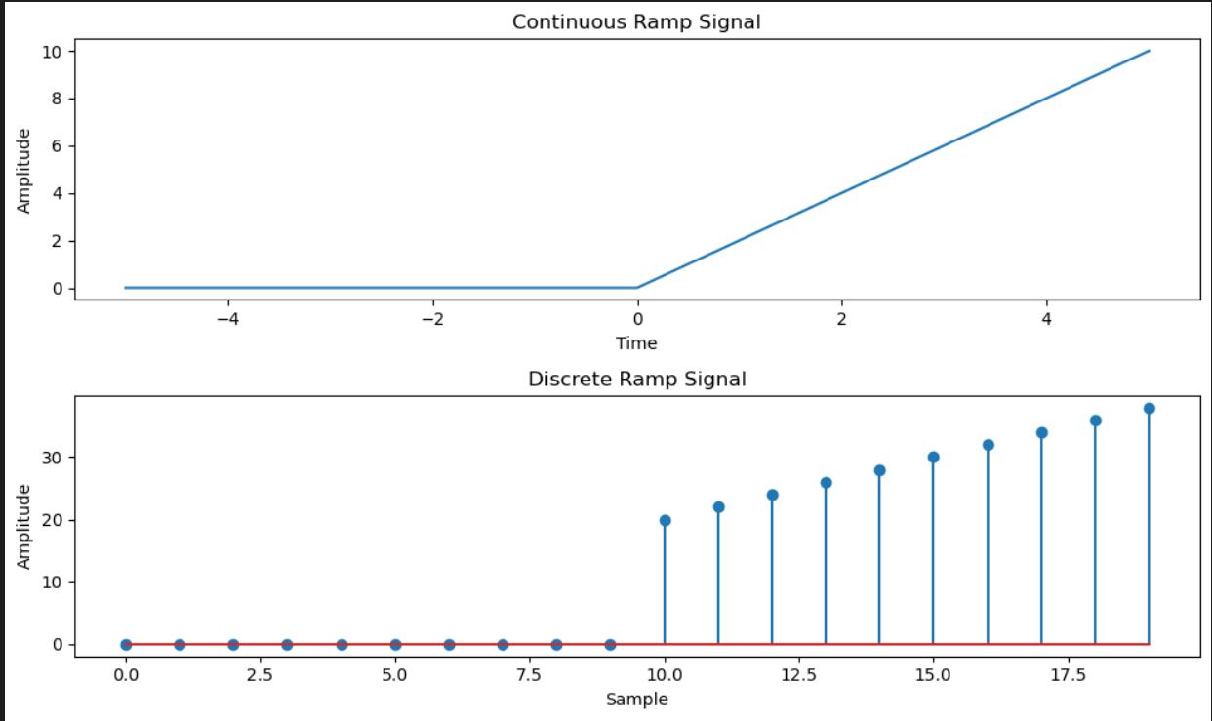
# np.savetxt('continuous_ramp.txt', continuous_ramp, delimiter=',') # np.savetxt('discrete_ramp.txt', discrete_ramp, delimiter=',') Output:

Conclusion:
The continuous and discrete exponential signals were successfully generated and plotted using Python. From this experiment, I learned how exponential signals change with time based on the given coefficient. This experiment helped me understand the behavior of exponential signals in Digital Signal Processing.

EXPERIMENT 1

AIM: Write a python program to Simulate continuous and discrete exponential signal CODE:
import numpy as np
import matplotlib.pyplot as plt
def simulate_continuous_exponential(time, amplitude, coefficient): exponential_signal = amplitude * np.exp(coefficient * time) return exponential_signal
def simulate_discrete_exponential(num_samples, amplitude, coefficient): exponential_signal = amplitude * np.exp(coefficient * np.arange(num_samples)) return exponential_signal

# Define the time range for the continuous exponential signal
time = np.linspace(0, 5, 1000) # Time range from 0 to 5

# Define the number of samples, initial amplitude, and coefficient for the discrete exponential signal
num_samples = 20 # Number of samples amplitude = 2 # Initial amplitude coefficient = -0.5 # Exponential coefficient

# Simulate the continuous exponential signal
continuous_exponential = simulate_continuous_exponential(time, amplitude, coefficient)

# Simulate the discrete exponential signal
discrete_exponential = simulate_discrete_exponential(num_samples, amplitude, coefficient) # Plot and display the continuous and discrete exponential signals plt.figure(figsize=(10, 6))
plt.subplot(2, 1, 1)
plt.plot(time, continuous_exponential) plt.title('Continuous Exponential Signal') plt.xlabel('Time')
plt.ylabel('Amplitude') plt.subplot(2, 1, 2) plt.stem(discrete_exponential)
plt.title('Discrete Exponential Signal') plt.xlabel('Sample') plt.ylabel('Amplitude') plt.tight_layout()
plt.show()
# Save the exponential signal arrays (optional)

# np.savetxt('continuous_exponential.txt', continuous_exponential, delimiter=',') # np.savetxt('discrete_exponential.txt', discrete_exponential, delimiter=',') OUTPUT:
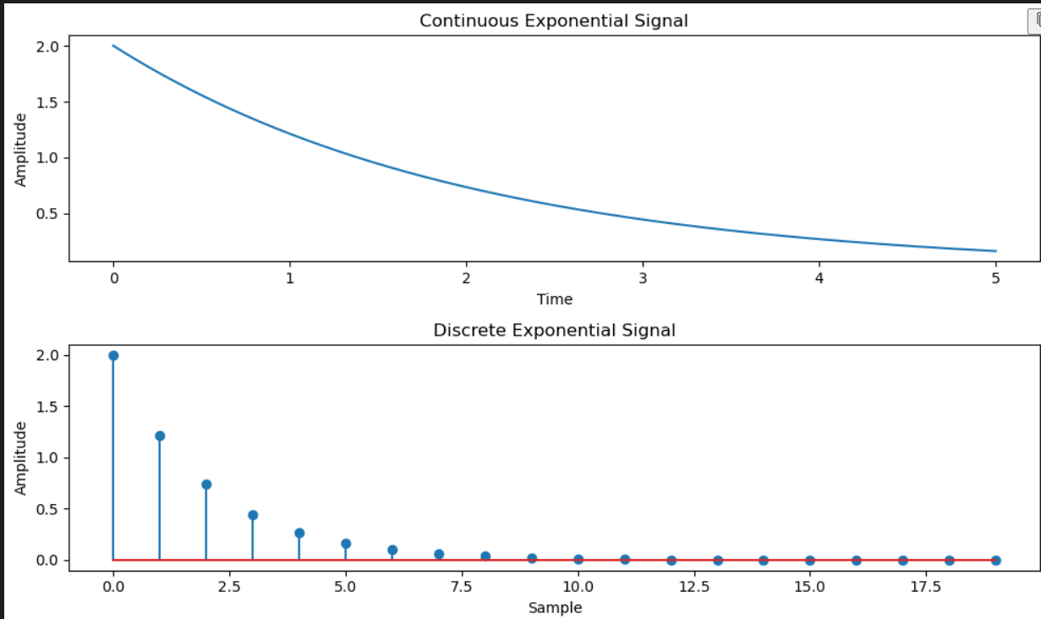

Conclusion:
The continuous and discrete parabolic signals were successfully generated and plotted using Python. From this experiment, I learned how a parabolic signal is created using polynomial coefficients and how it can be represented graphically. This experiment improved my understanding of parabolic signals in Digital Signal Processing.

EXPERIMENT 1

AIM: Write a python program to Simulate continuous and discrete parabolic signal Code:
import numpy as np
import matplotlib.pyplot as plt
def simulate_continuous_parabolic(time, coefficients): parabolic_signal = np.polyval(coefficients, time) return parabolic_signal
def simulate_discrete_parabolic(num_samples, coefficients): parabolic_signal = np.polyval(coefficients, np.arange(num_samples)) return parabolic_signal

# Define the time range for the continuous parabolic signal
time = np.linspace(-5, 5, 1000) # Time range from -5 to 5

# Define the number of samples and coefficients for the discrete parabolic signal
num_samples = 20 # Number of samples
coefficients = [1, 2, 1] # Coefficients of the parabolic signal

# Simulate the continuous parabolic signal
continuous_parabolic = simulate_continuous_parabolic(time, coefficients)

# Simulate the discrete parabolic signal
discrete_parabolic = simulate_discrete_parabolic(num_samples, coefficients) # Plot and display the continuous and discrete parabolic signals plt.figure(figsize=(10, 6))
plt.subplot(2, 1, 1)
plt.plot(time, continuous_parabolic) plt.title('Continuous Parabolic Signal') plt.xlabel('Time') plt.ylabel('Amplitude')
plt.subplot(2, 1, 2) plt.stem(discrete_parabolic) plt.title('Discrete Parabolic Signal') plt.xlabel('Sample') plt.ylabel('Amplitude') plt.tight_layout()
plt.show()
# Save the parabolic signal arrays (optional)

# np.savetxt('continuous_parabolic.txt', continuous_parabolic, delimiter=',') # np.savetxt('discrete_parabolic.txt', discrete_parabolic, delimiter=',')

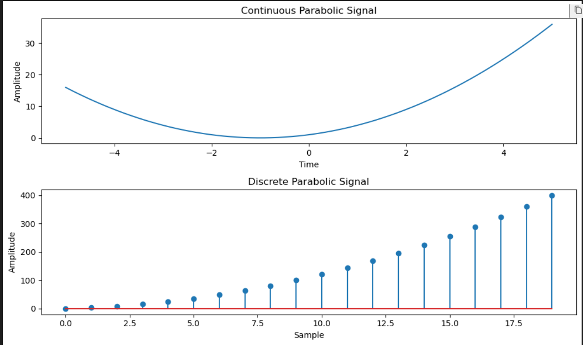
OUTPUT:

Conclusion:
The continuous and discrete sine wave signals were successfully generated and plotted using Python. From this experiment, I learned how the amplitude, frequency, and phase affect the sine wave. This experiment helped me understand the generation and visualization of sine wave signals in Digital Signal Processing.

EXPERIMENT 1

AIM: Write a python program to Simulate continuous and discrete sine wave signal Code:
import numpy as np
import matplotlib.pyplot as plt
def simulate_continuous_sine_wave(time, amplitude, frequency, phase): sine_wave = amplitude * np.sin(2 * np.pi * frequency * time + phase) return sine_wave
def simulate_discrete_sine_wave(num_samples, sampling_frequency, amplitude, frequency, phase): time = np.arange(num_samples) / sampling_frequency
sine_wave = amplitude * np.sin(2 * np.pi * frequency * time + phase) return sine_wave

# Define the time range for the continuous sine wave signal
time = np.linspace(0, 1, 1000) # Time range from 0 to 1 second

# Define the number of samples, sampling frequency, and parameters for the discrete sine wave signal
num_samples = 100 # Number of samples sampling_frequency = 10 # Sampling frequency in Hz amplitude = 1 # Amplitude of the sine wave frequency = 2 # Frequency of the sine wave in Hz phase = 0 # Phase angle of the sine wave in radians # Simulate the continuous sine wave signal
continuous_sine_wave = simulate_continuous_sine_wave(time, amplitude, frequency, phase)

# Simulate the discrete sine wave signal
discrete_sine_wave = simulate_discrete_sine_wave( num_samples,
sampling_frequency, amplitude, frequency,
phase
)

# Plot and display the continuous and discrete sine wave signals
plt.figure(figsize=(10, 6))
plt.subplot(2, 1, 1)
plt.plot(time, continuous_sine_wave) plt.title('Continuous Sine Wave Signal') plt.xlabel('Time (s)')

plt.ylabel('Amplitude') plt.subplot(2, 1, 2) plt.stem(discrete_sine_wave) plt.title('Discrete Sine Wave Signal') plt.xlabel('Sample') plt.ylabel('Amplitude') plt.tight_layout()
plt.show()
# Save the sine wave signal arrays (optional)
# np.savetxt('continuous_sine_wave.txt', continuous_sine_wave, delimiter=',') # np.savetxt('discrete_sine_wave.txt', discrete_sine_wave, delimiter=',') OUTPUT:
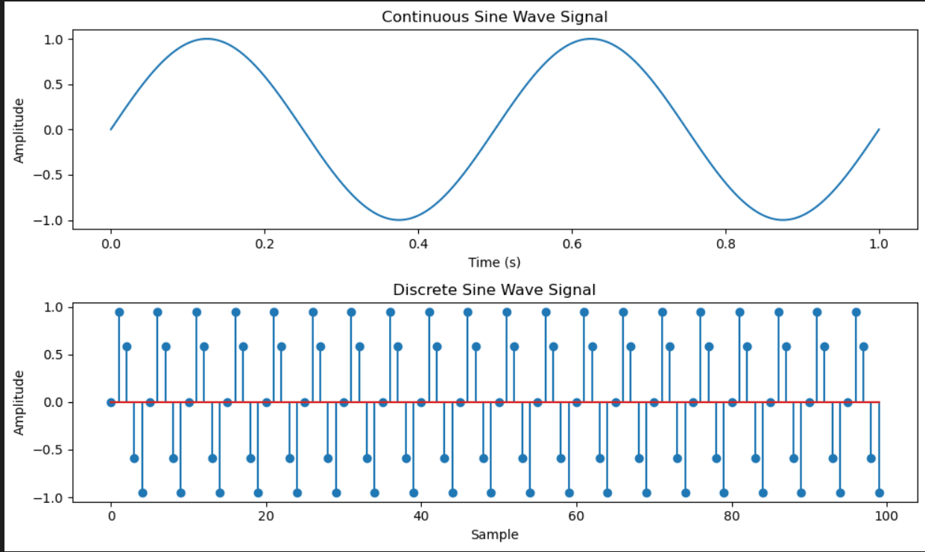

Conclusion:
The given signal was successfully generated and plotted using Python. From this experiment, I learned how different unit step signals can be combined to form a single signal. The output graph clearly showed the changes in amplitude at different time values. This experiment helped me understand the representation of combined signals in Digital Signal Processing.

EXPERIMENT 1

AIM: Write a python program to simulate y(t)=u(t)+u(t-1)+3u(t+5). Code:

import numpy as np
import matplotlib.pyplot as plt def simulate_function(time):
y = np.zeros_like(time) y[time >= 0] = 1
y[time >= 1] += 1
y[time >= -5] += 3 return y

# Define the time range
time = np.linspace(-10, 10, 1000)

# Simulate the function
function_values = simulate_function(time)

# Plot and display the function
plt.plot(time, function_values)
plt.title('Function y(t) = u(t) + u(t-1) + 3*u(t+5)') plt.xlabel('Time')
plt.ylabel('Amplitude') plt.ylim([-0.5, 5.5]) plt.grid(True) plt.show()

OUTPUT:

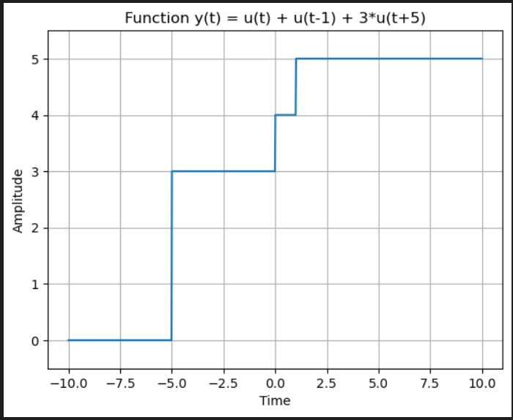

Conclusion:
The given function was generated and plotted successfully using Python. From this experiment, I understood how different unit step signals can be combined to form a single signal. The output graph clearly shows the changes in amplitude at different time values. This experiment helped me improve my understanding of unit step functions and their applications in Digital Signal Processing (DSP).

EXPERIMENT 1

AIM:
To write a Python program to simulate and plot the signal (y(t) = \delta(t) + \delta(t-1) + 3\delta(t+5))

CODE:
import numpy as np
import matplotlib.pyplot as plt def simulate_function(time):
y = np.zeros_like(time) y[time == 0] = 1
y[time == 1] += 1
y[time == -5] += 3 return y

# Define the time range
time = np.arange(-10, 11)

# Simulate the function
function_values = simulate_function(time)

# Plot and display the function
plt.stem(time, function_values)
plt.title('Function y(t) = Delta(t) + delta(t-1) + 3*delta(t+5)') plt.xlabel('Time')
plt.ylabel('Amplitude') plt.ylim([-0.5, 4.5]) plt.grid(True) plt.show()

OUTPUT:

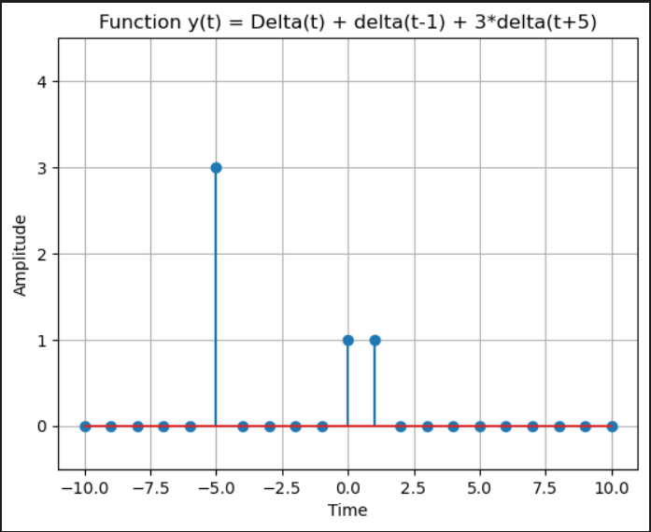

Conclusion:
The given signal was successfully simulated and plotted using Python. From this experiment, I understood how delta (impulse) signals can be generated and combined to form a single signal. The output graph showed the impulses at the correct positions with the correct amplitudes. This experiment helped me understand the basic concept of impulse signals and their representation in Digital Signal Processing (DSP).

