DATE – 16 JUNE 2026
NAME – Bhavya dalal 24bce10229

Post_payment_records 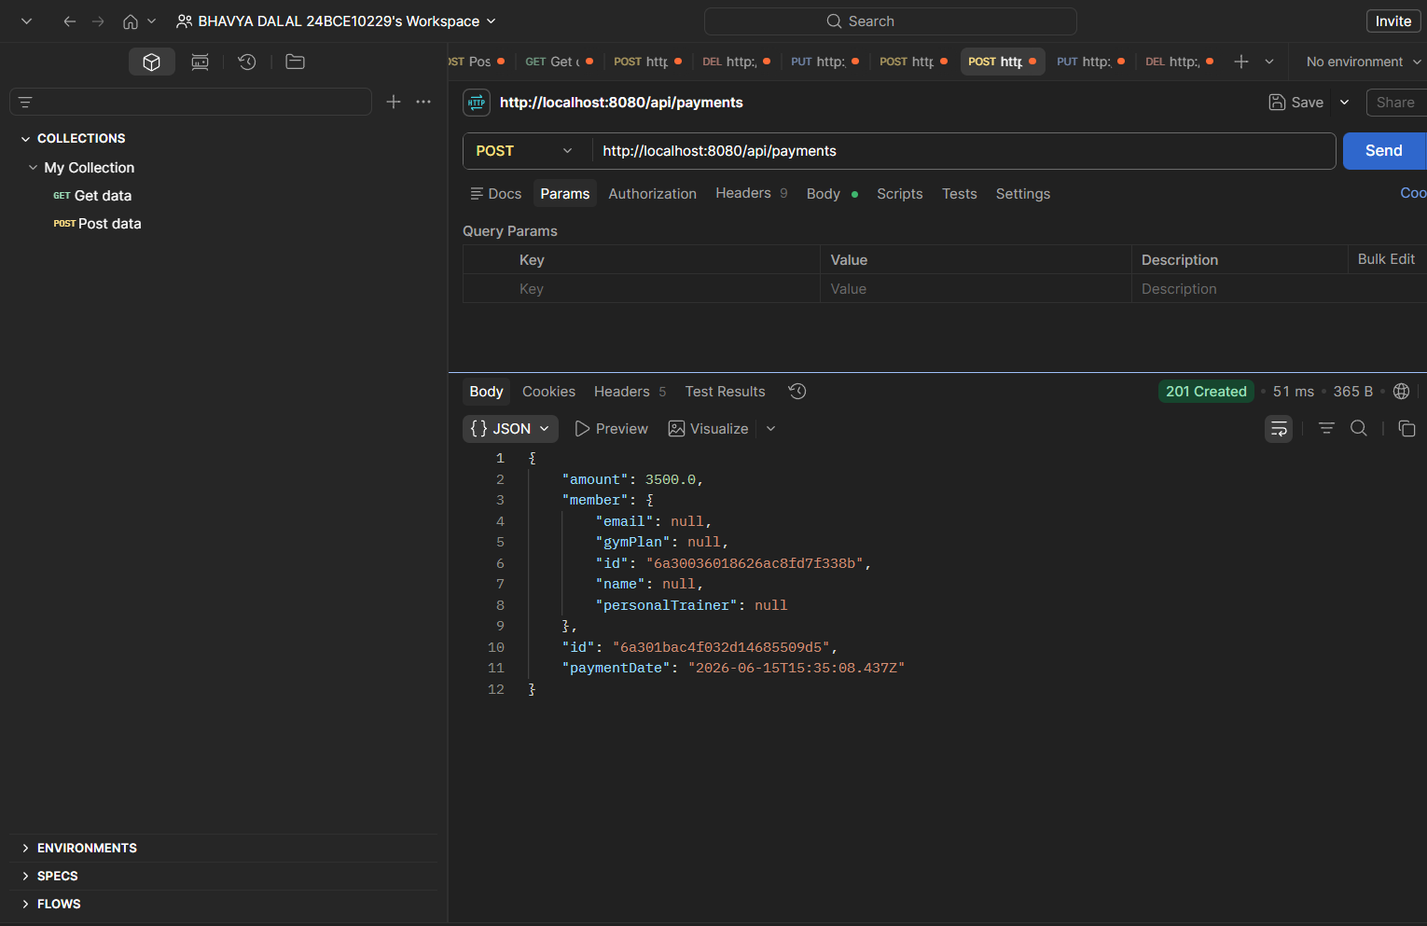

DEL_delete_member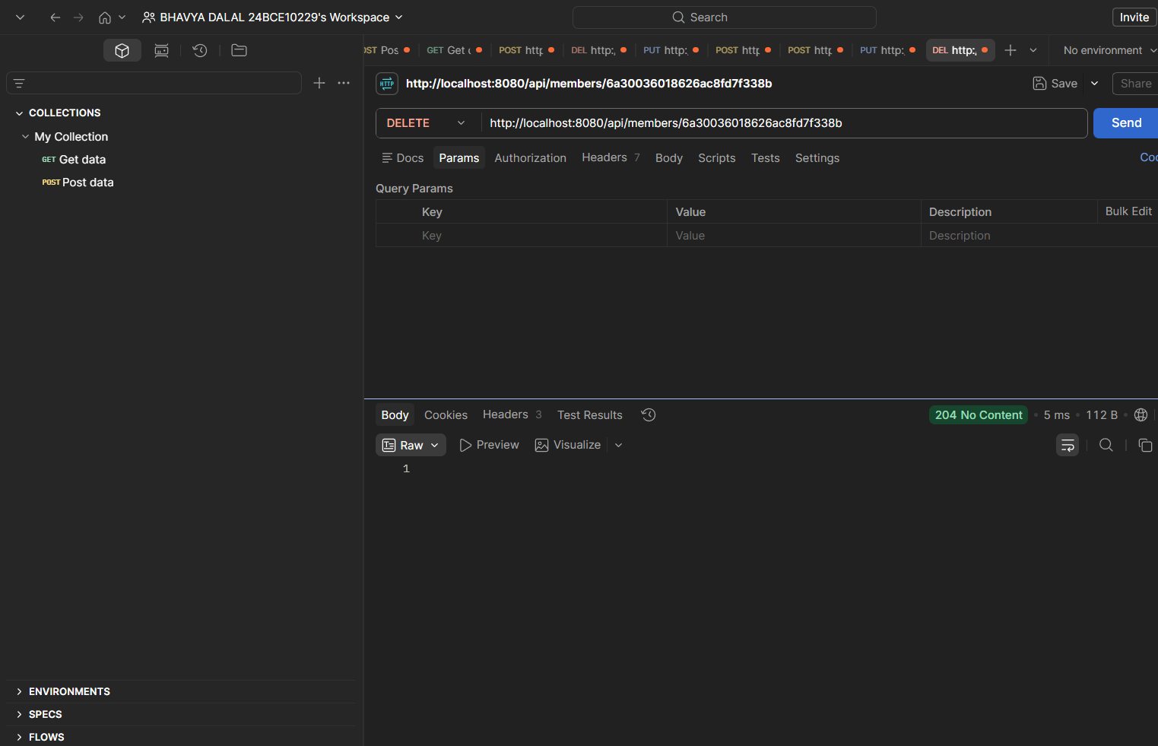

PUT_update_members
