**Objective:**

1. Explore the structure of the dataset by understanding the relationships between tables.
2. Formulate SQL queries to extract meaningful insights from the data.

select * from list_of_orders

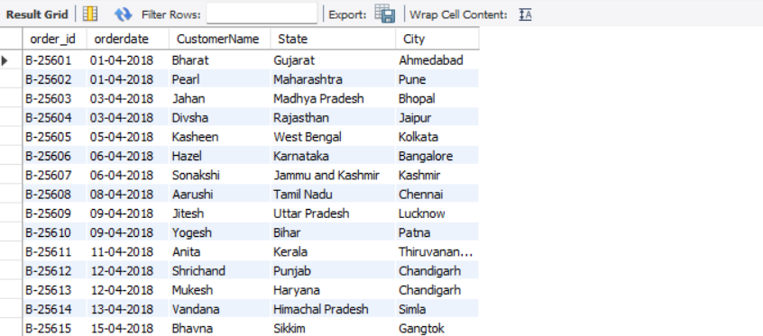

select * from order_details

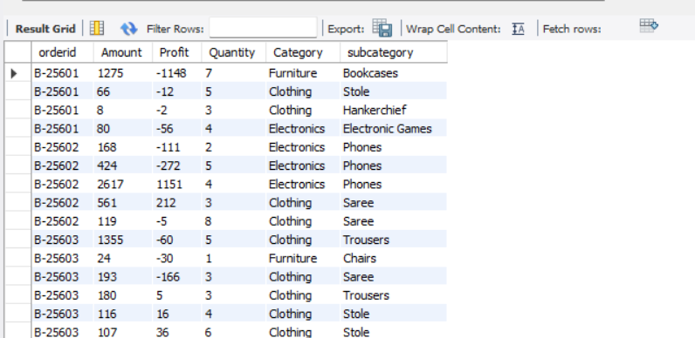

select * from sales_target

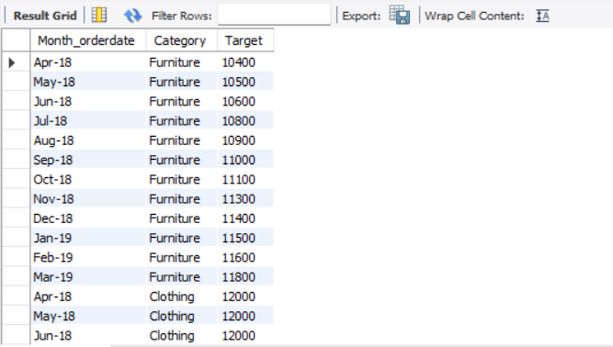

SELECT 'list_of_orders' AS Table_Name, COUNT(*) AS RowCount FROM list_of_orders

UNION

SELECT 'order_details' AS order_details, COUNT(*) AS RowCount FROM order_details

UNION

SELECT 'sales_target' AS sales_target, COUNT(*) AS RowCount FROM sales_target;