EXP NO 2: CREATE A SIMPLE CLOUD SOFTWARE APPLICATION FOR FLIGHT RESERVATION SYSTEM USING ANY CLOUD SERVICE PROVIDER TO DEMONSTRATE SAAS.

DATE:
AIM:
To create a simple cloud software application for flight reservation system using
any cloud service provider to demonstrate saas.
PROCEDURE:
step1: Go to zoho.com.
step 2: Log into the zoho.com.
step 3: Select one application step.
step4: Enter application name as flight reservation system.
step 5: Created new application flight reservation system.
step 6: Select one form
step 7: The software has been created.

IMPLEMENTATION:

- All Payments
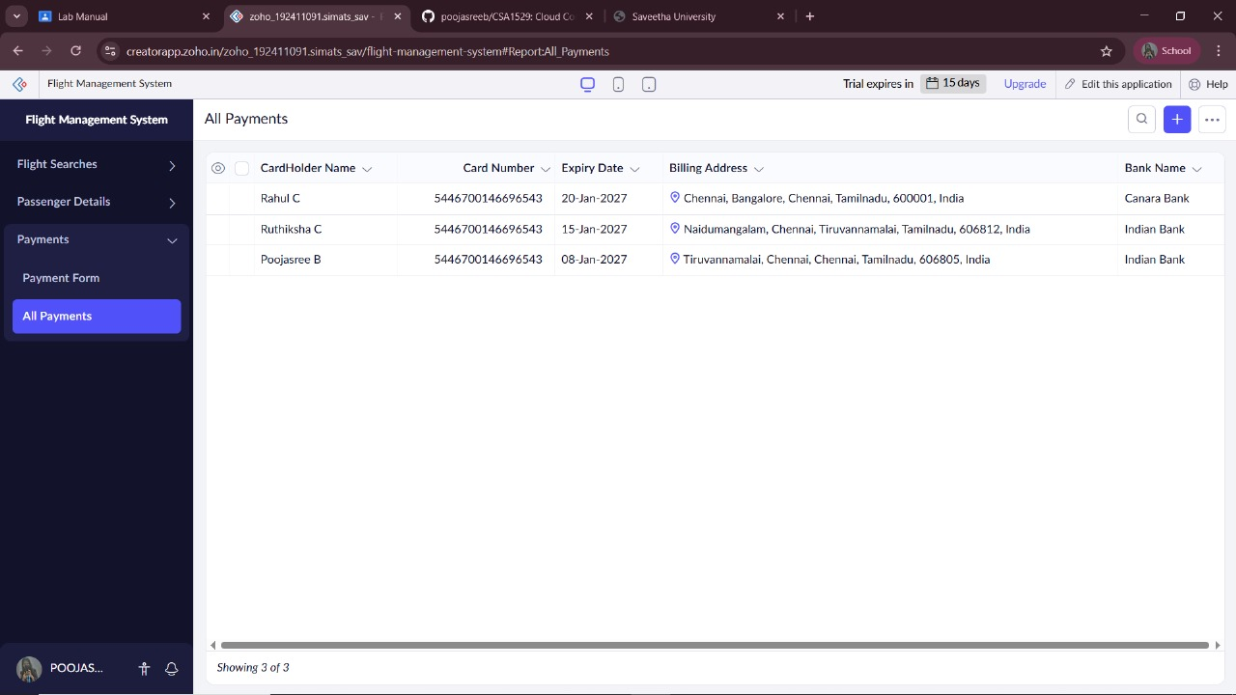
- All Flight searches
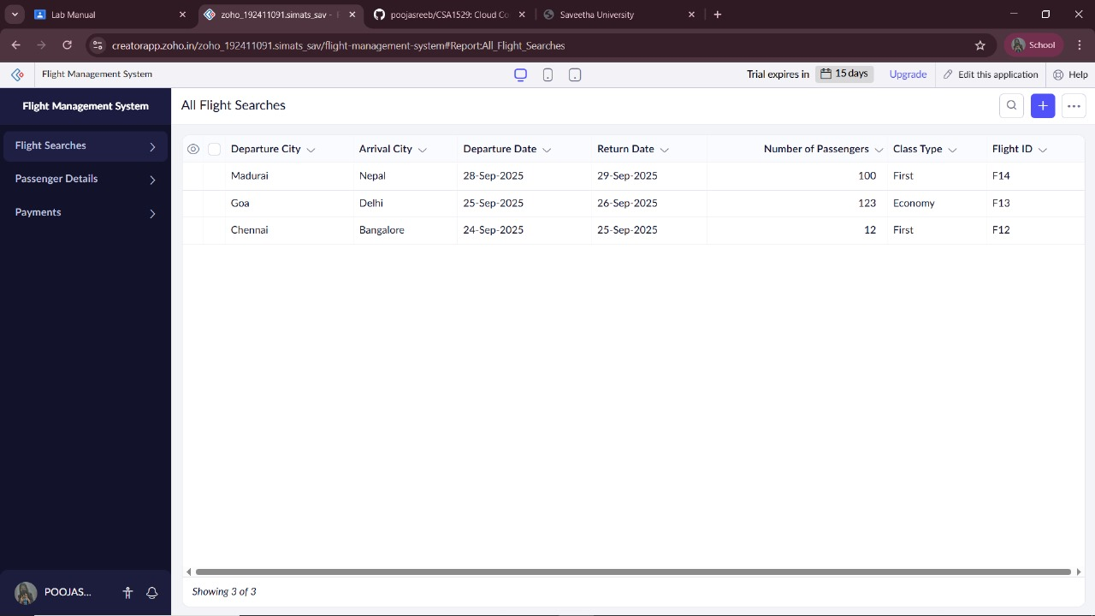

- All Passengers Details
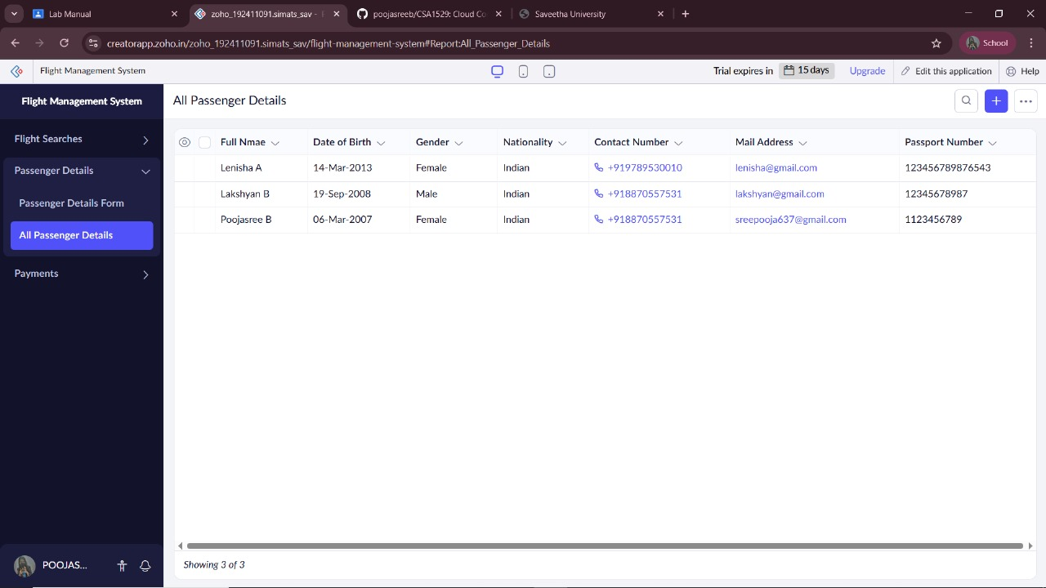

RESULT:
Thus, a F light Reservation System application was successfully created using Zoho Creator (Cloud SaaS platform) with the forms:
- All Flight Searches
- All Passengers Details
- All Payments
This demonstrates Software as a Service (SaaS), where the Flight Reservation System can access the system anytime through the cloud without installing any software.

