1. INTRODUCTION

  - OVERVIEW
Automatic number plate recognition system is used for providing security and protection. This system can be used for access control. This system grants access to only authorized people. It is used in traffic and security applications, such as parking, access and border control, or tracking of stolen cars. Number plates are used to identify the vehicles. If the number plate is an invalid one then the vehicle is prevented from entering. Even many companies use this system in access control. It is a reliable system. Logs are maintained which help in order to have knowledge about the details of stolen vehicles and also about intruders.

  - EXISTING SYSTEM
When the number plate recognition system was not developed, many security problems arose since there was no restriction in order to prevent the access of invalid vehicles (intruders).Hence this system was developed which provides access control. This system has problems with the lightening condition and also the placement of license plate in the picture.

  - AIM OF THE PROJECT
The aim of this project is to overcome the lightening problem and also to identify number
plate irrespective of its position and template used in the picture captured. So, that it would be easy and efficient system for access control. The aim of this system is also reduce the cost of installation and maintenance of the system.

1.4 PROPOSED SOLUTION
This is done by using a template file which matches the characters of the number plate
and identifies them uniquely, however their texture might be in the input image. We use MATLAB functions for this purpose. Using MATLAB software and All-in-one equipment the cost of installation and maintenance can be reduced.

1.5 ORGANIZATION OF REPORT
The organization of the report is as follows:
Chapter 1 deals with the Introduction of the project and gives the details about the project in an abstract view.
Chapter 2 deals with the Software Requirements Specifications which is a specification of the project software and hardware requirements.
Chapter 3 deals with the System Requirements Specifications which comprises of UML diagrams and their explanation.
Chapter 4 deals with the Implementation part which includes the technologies that are used.
Chapter 5 deals with the Testing of the project and Test cases has been explained
Chapter 6 explains the Conclusion and further scope of the project.

2. SOFTWARE REQUIREMENT SPECIFICATION
2.1 INTRODUCTION
The requirements specification is a technical specification of requirements for the software products. It is the first step in the requirements analysis process it lists the requirements of a particular software system including functional, performance and security requirements. The requirements also provide usage scenarios from a user, an operational and an administrative perspective. The purpose of software requirements specification is to provide a detailed overview of the software project, its parameters and goals. This describes the project target audience and its user interface, hardware and software requirements. It defines how the client, team and audience see the project and its functionality.
2.1.1 Purpose of the document
This SRS describes all the requirements elicited for “License Plate Recognition System” and is intended to be used by the members examining the project and implementing and verifying the application. Unless otherwise noted all requirements are of high priority and are committed.

    - Scope of the document
This Document plays a vital role in the development life cycle (SDLC) and it describes the complete requirement of the system. It is meant for use by the developers and will be the basic during testing phase. Any changes made to the requirements in the future will have to go through formal change approval process.

  - Users and their Characteristics
These system users are of different types:
One can use this system for the identification of the intruder at the border security check post.
One can use this system to have a count of number of vehicles which have entered and exited the gate.
One can use this system to have details about which vehicle has checked in and checked out at what time.

  - Functional Requirements
The image of a car with its number plate is given as an input to the system. MATLAB
must contain the image processing toolbox which processes the image. Image acquisition toolbox, database toolbox must also be present.

  - Non-Functional Requirements
Performance requirements: The system should be fast and must produce accurate results.
Reliability: The system should be reliable enough such that different interfaces are provided for different users based on their responsibilities.
Maintainability: The system will be designed as a closed system. New methods can be added easily with little or no changes in the existing architecture.
Security: The system should be securing that can be accomplished by providing login option for the different types of users.
System Integrity: The power functioning of hardware and programs, appropriate physical security and safety against external threats such as eavesdropping and wiretapping.
Privacy: Defines the rights of the user or organizations to determine what information they are willing to share with or accept from others and how the organization can be protected against unwelcome, unfair or excessive dissemination of information about it.
Confidentiality: It is a special status given to sensitive information in a database to minimize the possible invasion of privacy. It is an attribute of information that characterizes its need for protection.

2.5 SOFTWARE AND HARDWARE REQUIREMENT
Windows operating system.
MATLAB R2008a.
Pentium 4 computer with at least 512MB RAM and 40GB hard disk.
1GB RAM is recommended.

3. SYSTEM DESIGN SPECIFICATIONS

3.1 INTRODUCTION
Design is the first step in the development phase for any engineered product or system. The designer’s goal is to produce a model or representation of an entity that will later be built. Beginning, once system requirement have been specified and analyzed, system design is the first of the three technical activities -design, code and test that is required to build and verify software.

The importance can be stated with a single word “Quality”. Design is the place where quality is fostered in software development. Design provides us with representations of software that can assess for quality. Design is the only way that we can accurately translate a customer’s view into a finished software product or system. Software design serves as a foundation for all the software engineering steps that follow. Without a strong design we risk building an unstable system – one that will be difficult to test, one whose quality cannot be assessed until the last stage.

During design, progressive refinement of data structure, program structure, and procedural details are developed reviewed and documented. System design can be viewed from either technical or project management perspective. From the technical point of view, design is comprised of activities – procedural design, interface design and data structure design

The System Design Specifications provides a listing of the specifications of the system and its subsystems. It also defines, in detail, the interfaces with other systems and subsystems and the facilities to be used for accomplishing the interfaces. For each subsystem, include such information as timing requirements, equipment needs, communications environment, support software, security, and input and output records.

3.2 PROCEDURAL DESIGN
The procedural design of License Plate Recognition System is as shown below.

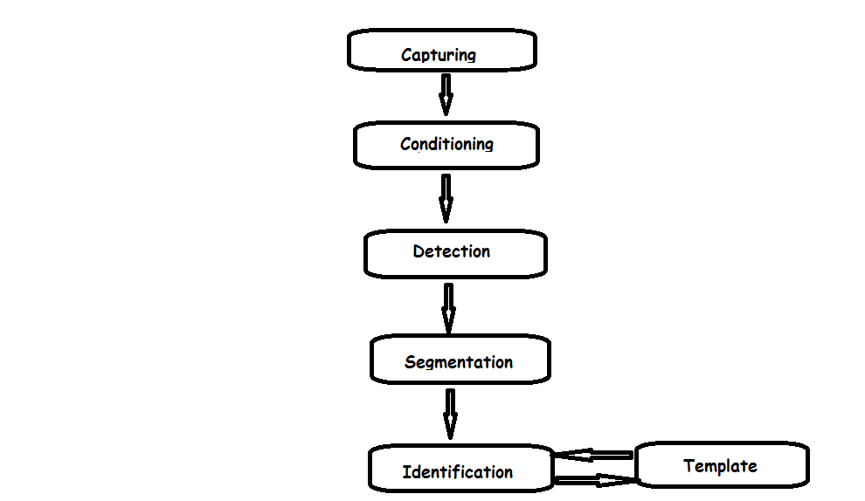
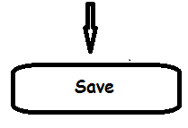

Fig.3.0 Procedural Design of License Plate Recognition System

3.2.1 DESCRIPTION
The system loaded with MATLAB software processes the input image in steps as shown in the above figure and finally saves and stores the result in a text file along with date and time. The result will be the number plate of that vehicle.

3.3 IMAGE PROCESSING AND MATLAB

3.3.1 MATLAB
MATLAB is an abbreviation of Matrix Laboratory. It is a popular Mathematical Programming Environment used extensively in Education as well as in Industry. In MATLAB everything is represented in the form of an array or matrices. Mathematical operations starting from simple algebra to complex calculus are done conveniently using this software. The main use of MATLAB in software development is ALGORITHM DESIGN and DEVELOPMENT.

3.3.2 IMAGE PROCESSING
An image is used to convey useful information in a visible format. An image
is nothing but an arrangement of tiny elements in a two-dimensional plane. These tiny elements are called Pixels. A large number of pixels combine together to form an image, whether small or large. Each pixel represents certain information about the image, like color, light intensity and luminance. A large number of such pixels combine together to form an image. Pixel is the basic element used to describe an image. Mostly, each pixel in an image is represented in either RGB (Red Green Blue) format or YCbCr format. In case of an RGB image, all the three components, namely R, G and B combine together to convey information about the color and brightness of a single pixel.

Image processing involves the extraction of useful information from an image. This useful information may be the dimensions of an engineering component, size of the diagnosed tumor, or even a 3D view of an unborn baby. The main applications of image processing are bio-telemetry receiver, face detection, quality control, traffic control etc.

The figure below shows the steps involved in image processing
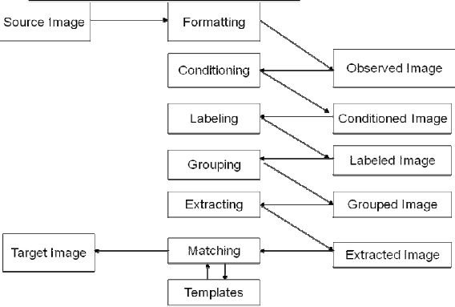
Fig.3.1 Steps involved in image processing

3.4 STEPS INVOLVED IN LPR SYSTEM

3.4.1 PLATE AREA EXTRACTION
Plate region extraction is the first stage in this algorithm. Image captured from the camera is first converted to the binary image consisting of only 1’s and 0’s (only black and white). By thresh holding the pixel values of 0 (black) for all pixels in the input image with luminance less than threshold value and 1 (white) for all other pixels.

3.4.2 SMEARING
The binarized image is then processed using some methods. To find the plate region, firstly smearing algorithm is used. Smearing is a method for the extraction of text areas on a mixed image. With the smearing algorithm, the image is processed along vertical and horizontal runs(scan-lines). If the number of white pixels is less than a desired threshold or greater than any other desired threshold, white pixels are converted to black. In this system, threshold values are selected as 10 and 100 for both horizontal and vertical smearing.

If number of ‘white’ pixels < 10; pixels become ‘black’; Else; no change
If number of ‘white’ pixels > 100; pixels become ‘black’; Else; no change

3.4.3 DILATION
After smearing, a morphological operation, dilation, is applied to the image for specifying the plate location. However, there may be more than one candidate region for plate location. To find the exact region and eliminate the other regions, some criteria tests are applied to the image by smearing and filtering operation. After obtaining plate location, region involving only plate is cut.

3.4.4 SEGMENTATION
In the segmentation of plate characters, license plate is segmented into its constituent parts obtaining the characters individually. Firstly, image is filtered for enhancing the image and removing the noises and unwanted spots. Then dilation operation is applied to the image for separating the characters from each other if the characters are close to each other. After this operation, horizontal and vertical smearing is applied for finding the character regions.

The next step is to cut the plate characters. It is done by finding starting and end points of characters in horizontal direction.

3.4.5 NORMALIZATION
Before recognition algorithm, the characters are normalized. Normalization is to refine the characters into a block containing no extra white spaces (pixels) in all the four sides of the characters. Then each character is fit to equal size.

3.4.6 FITTING APPROACH
Fitting approach is necessary for template matching. For matching the characters
with the database, input images must be equal-sized with the database characters. Here the
characters are fit to 36. The extracted characters cut from plate and the characters on database
are now equal-sized.

3.4.7 TEMPLATE MATCING AND CHARACTER RECOGNITION
The next step is template matching. Template matching is an effective algorithm
for recognition of characters. The character image is compared with the ones in the database
and the best similarity is measured.

3.5 ALGORITHM FOR LPR SYSTEM

3.5.1 CAPTURING THE IMAGE
Capture the input image and store in a file for further processing.

3.5.2 CONVERT THE IMAGE INTO BINARY
Identify the intensity of the image and convert into grayscale. Calculate the appropriate threshold value for the image and convert it into binary format using the calculated threshold value.

3.5.3 DETECTION OF NUMBER PLATE AREA
Fill small holes including numbers of number plate so that number plate area will be large to be isolated. Determine the width and height of the image. Scan each pixel of line counting number of white pixels in the following system. If the number of white pixels less than x; pixels become black; Else no change. If number of white pixels greater than y; pixels become black. Else no change. The value of x and y may be changed according the image intensity and plate area. Check the number of possible areas. Convert image into binary.
Crop the required area.

3.5.4 SEGMENTATION
Filter the noise level present in the image. Clip the plate area in such a way that only numbers of plate area extracted. Separate each character from the plate.

3.5.5 NUMBER PLATE IDENTIFICATION
Create the template file from the stored images. Resize image obtained from segmentation to the size of template. Compare each character with the templates. Store the best matched characters.

3.5.6 SAVE TO FILE IN GIVEN FORMAT
Open a text file in write mode. Store the character obtained from the number identification process to text file in given format. Close the file.

4. IMPLEMENTATION

4.1 INTRODUCTION
The success of the software product is determined only when it is successfully implemented according to the requirements. The analysis and the design of the proposed system provide a perfect platform to implement the idea using the specified technology in the desired environment. The implementation of our system is made user friendly.

Any software project is designed in modules and the project is said to be successfully implemented when each of the module is executed individually to obtain the expected result and also, when all the modules are integrated and run together without any errors

4.2 CAR PARKS
In some countries like Spain or Greece, the law binds the recording of the number plate on the ticket. In this way, the number plate and the ticket number are linked. Thus, car parks improve their management.

These are some direct benefits:
Number plate register: The ticket number, day and the time, and the number plate are linked and registered in the management application

Finding a lost ticket: Thanks to the registry of the number plates it is possible to find a lost ticket and to receive the correct amount

Ticket interchange is avoided: It is possible to block the exit of a vehicle, if the number plate of the vehicle does not match with the number plate in the entrance ticket

4.3 ACCESS CONTROL
ANPR equipment has been used for the access control of vehicles, it was thought as one more tool that allows increasing the security. The client application could control users through personal cards, and the ANPR allows vehicles control.

Nowadays, the ANPR equipment is used for automatizing the accesses of vehicles.
These are the main advantages to incorporate ANPR equipment in access control:

Security increased: Integrating the ANPR technology in access control applications together with the traditional control devices, allows vehicle and people control. Thanks to this convention the security is increased

Dynamic access of vehicles: Automatizing vehicle access is possible through ANPR equipment. If the data base knows the vehicle, the client application will open the barrier automatically. By contrast, if the data base does not know the vehicle, it will not open the barrier

Vehicle images: It is possible to store the image used for the ANPR equipment during the recognition process. It allows having more information about the vehicle in the client application.

4.4 TRAFFIC CONTROL
Some ANPR equipments are able to recognize the number plate of vehicles that circulate up to 200 km/h with a reliability of 95%. Thanks to this, the use of ANPR equipment for traffic control has increased significantly in the last years.
These are some examples of ANPR application on traffic control:

Detecting vehicles in a black list: It is possible to control vehicles that are in search and capture, through the installation of the ANPR equipment in the main accesses to cities, such as highways and roads.

Average speed control: The majority of speed control devices, such as radars or speed traps, control the vehicle instantaneous speed. With the ANPR equipment it is possible to control the average speed during an itinerary. By means of the installation of two ANPR equipment in different points in the same lane, it is possible to make two consecutive recognitions of the number plate and to calculate the average speed of the vehicle.

Traffic optimization: It is important to improve the vehicles mobility during rush hours and traffic jam. The installation of ANPR equipment allows knowing how many times a vehicle spends to cause an itinerary. This way, the average time can be informed.

Urban toll payment: This application solution has been successfully experienced. This proves that the mobility in the central zones of the city improves considerably. Another possibility of urban tolls is to maintain a register of foreign vehicles using the public ways, without contributing in the road tax.

Toll enforcement: Although the use of ANPR equipment in tolls is a logical application, today, the ANPR equipment are only used to control the vehicles that circulate in the toll, as a data base that increases the security

4.5 RED LIGHT CONTROL
To jump a red light is a really dangerous infraction with consequences for others drivers and pedestrians.

Nowadays, it is possible to control when a vehicle jumps a red light. This system combines sensors and image capture equipment, such as cameras or video recorders.

The ANPR systems reinforce the red light control systems. Thanks to ANPR technology the fine process can be done automatically.

5. TESTING AND RESULTS

5.1 Introduction
Software testing is a critical element of software quality assurance and represents the ultimate review of specification, design and coding. In fact, testing is the one step in the software engineering process that could be viewed as destructive rather than constructive.

A strategy for software testing integrates software test case design methods into a well-planned series of steps that result in the successful construction of software. Testing is the set of activities that can be planned in advance and conducted systematically. The underlying motivation of program testing is to affirm software quality with methods that can economically and effectively apply to both strategic to both large and small-scale systems.

5.2 TESTING OBJECTIVES
The main objective of testing is to uncover a host of errors, systematically and with minimum effort and time. Stating formally, we can say,Testing is a process of executing a program with the intent of finding an error. A successful test is one that uncovers an as yet undiscovered error. A good test case is one that has a high probability of finding error, if it exists. But there is one thing that testing cannot do (just to quote a very famous sentence) “Testing cannot show the absence of defects, it can only show that software defects are presents.”

As the test results are gathered and evaluated they begin to give a qualitative indication of the reliability of the software. If severe errors are detected, the overall quality of the software is a natural suspect. If, on the other hand, all the errors, which are encountered, are easily modifiable, then one of the two conclusions can be made: The tests are inadequate to detect possibly present errors. The software more or less confirms to the quality and reliable standards.

5.3 TEST PLAN
This document describes the plan for testing the course scheduling software. All major testing activities are specified here. The basic units to be tested are:
Input module
Conversion module
Checking module
Features to be tested: - All the functional features specified in the requirements document will be tested. No testing is done for the performance requirements like response time.
Approach for Testing: - For unit testing structural testing based on the branch coverage criteria will be used. The goal is to achieve branch coverage of more than 95%.System testing will be largely functional in nature.
Test Deliverables: - The following documents are required.
Unit Test Report for each Unit
Test case specification for system testing
Test report for system testing
The test case specification for system testing has to be submitted for review before system testing commences.

5.3.1 Test Case Report
Here we specify all the test cases that are used for system testing. The different conditions that need to be tested along with the test cases used for testing those conditions and the expected outputs are given. The goal is to test the different functional requirements, as specified in the requirements document. Test cases have been selected for both valid and invalid inputs.

SAMPLE TEST CASE REPORTS

The following are the Test cases that we performed on our Project:

Test Case No. | TC1
Test Case description | Test case for taking the image from user
Test Input | User presses the button to enter the image
Test Expected output | User should enter the name of the image
Actual output | User should enter the name of the image

Test Case No. | TC2
Test Case description | Test case for identifying the number plate
Test Input | Automatically generates when user gives the input
Test Expected output | Modified image with noise
Actual output | Image with noise

Test Case No. | TC3
Test Case description | Test case fordisplaying the number in log file
Test Input | User presses Displaying Number button
Test Expected output | Number is displayed in log.txt file
Actual output | Number is displayed in log.txt file

Test Case No. | TC4
Test Case description | Test case for exiting
Test Input | User presses exit button
Test Expected output | The process ends
Actual output | The process ends
5.4 OUTPUT SCREENS:

The below figure provides information regarding the output obtained during extraction of number plate from each of the input images.
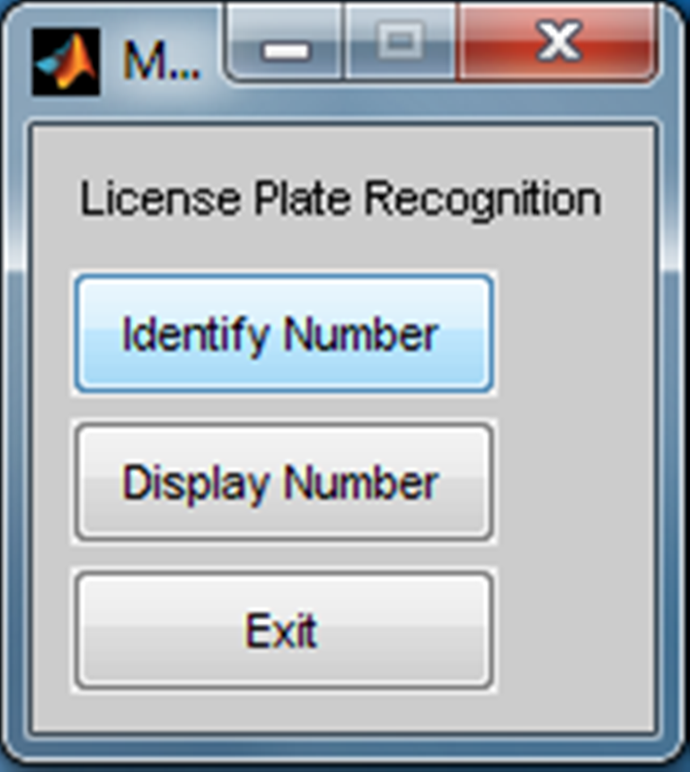
Fig.5.1 Output Screen to identify the image

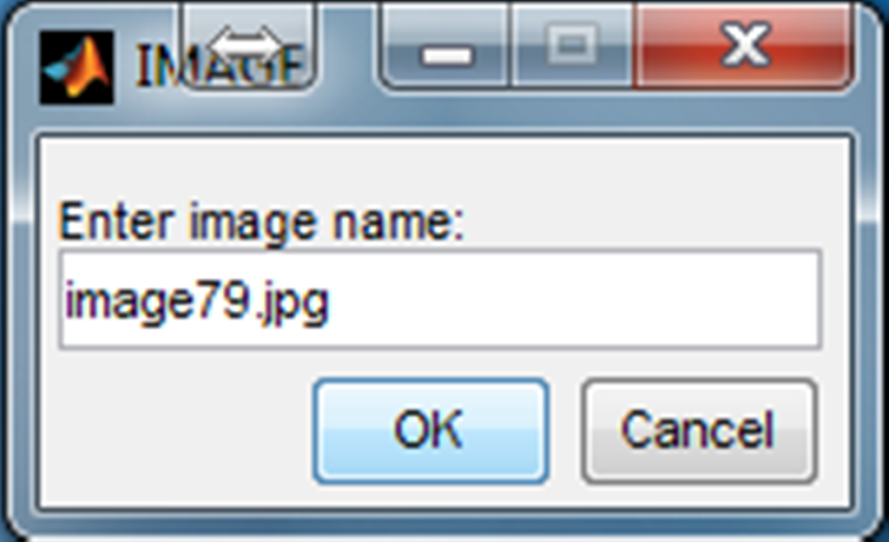
Fig.5.2 Output Screen for entering the name of the image
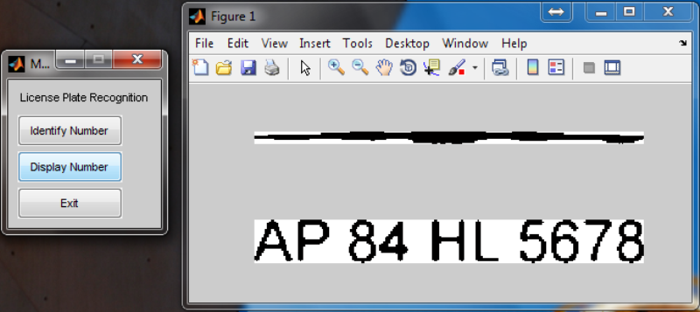
Fig.5.3 Output Screen which displays the number plate of the vehicle identified in the input image

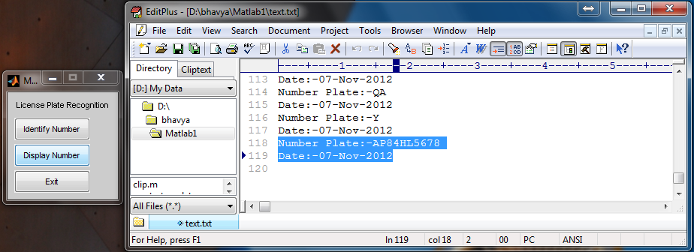
Fig.5.4 Output Screen displaying the number plate extracted along with the date and time.
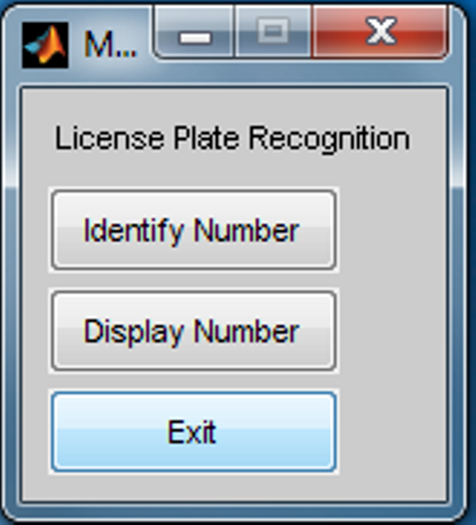
Fig.5.5 Output Screen for identifying one more image with a different background

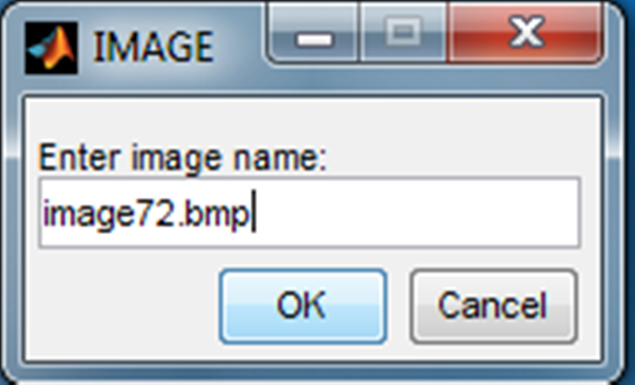
Fig.5.6 Output Screen for entering the name of the 2nd image
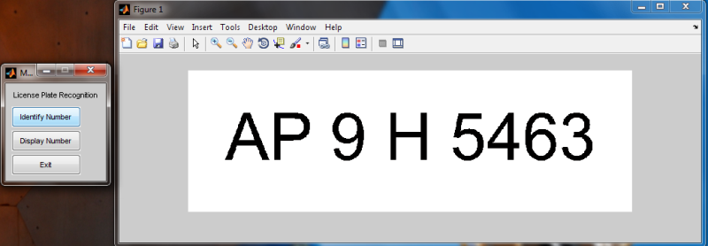
Fig.5.7 Output Screen which displays the number plate of the vehicle identified in the input image

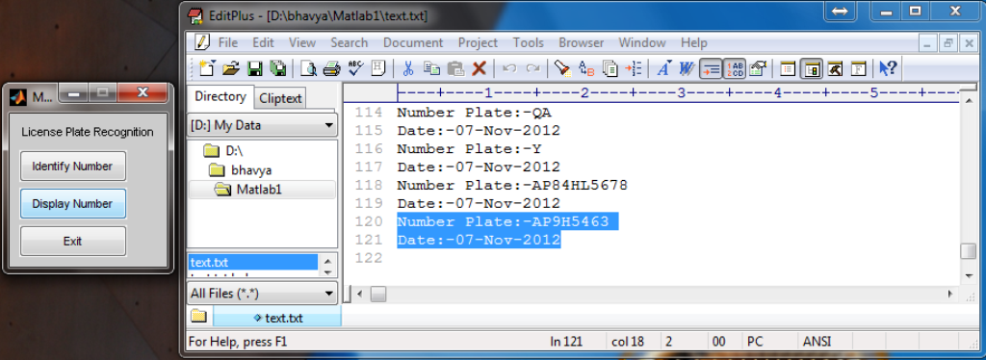
Fig.5.8 Output Screen displaying the number plate extracted along with the date and time.
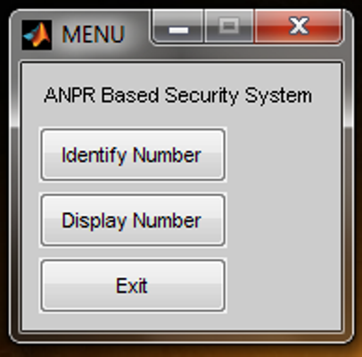
Fig.5.9 Output Screen for identifying one more image with a different background

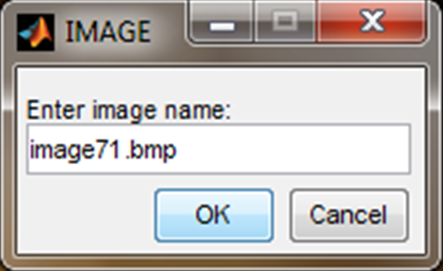
Fig.5.11 Output Screen for entering the name of the 3rd image
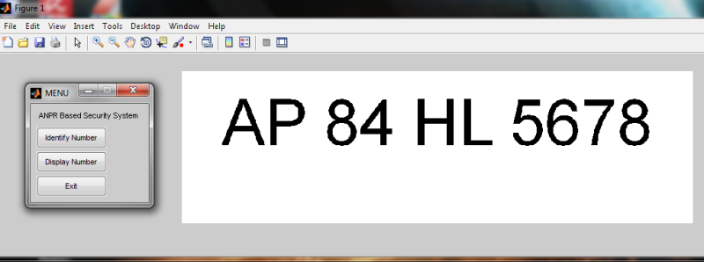
Fig.5.12 Output Screen which displays the number plate of the vehicle identified in the input image

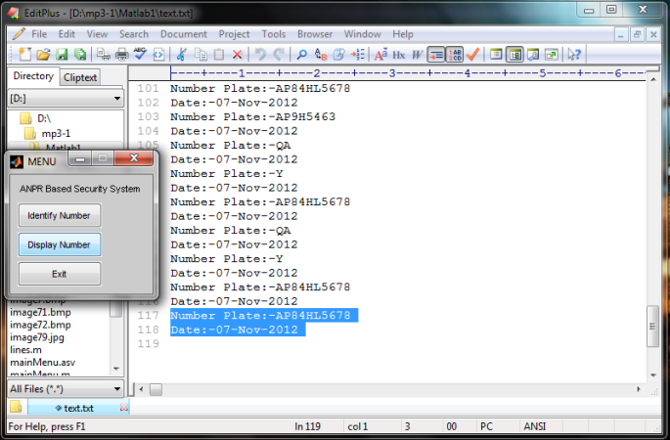
Fig.5.13 Output Screen displaying the number plate extracted along with the date and time.

6. CONCLUSION AND FUTURE SCOPE

The project was designed keeping in mind the automation of the number plate detection system of security reason that could replace the current system of manual entry. This project is successful in recording the number plate of a vehicle although it has got its own limitation of image processing and other hardware requirements. Through this project we learn about image processing and OCR (optical character reader) hardware interface. The basic focus of the project was in image processing using MATLAB. MATLAB is used as a programming tool which provides many features related to image processing. Practical implementation of this project range from small use such as keeping record of incoming and outgoing vehicles from the parking area to a vast implementation such as border security system.

BIBLIOGRAPHY

- http://www.mathworks.in/help/toolbox/images/ref/imadjust.html

- http://amath.colorado.edu/computing/Matlab/Tutorial/ImageProcess.html

- http://www.mathworks.in/help/toolbox/images/ref/rgb2gray.html

- http://www.mathworks.in/help/toolbox/images/ref/graythresh.html

- http://www.mathworks.in/help/toolbox/images/ref/bwareaopen.html

- http://www.licenseplaterecognition.com/

