Eventbridge Scheduler

. console for aws scheduler  
  
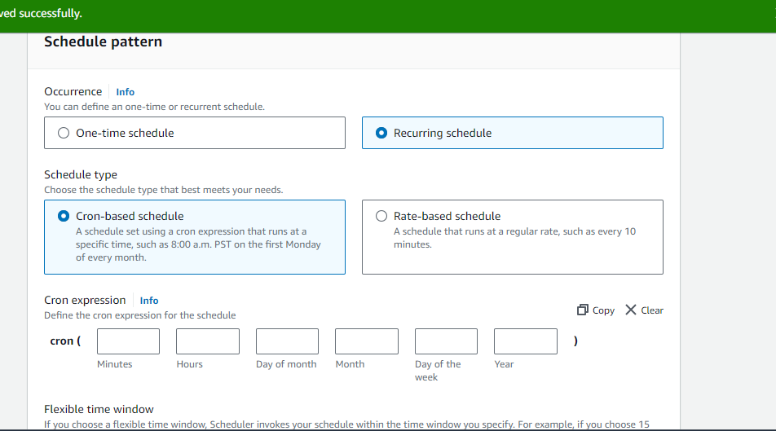

Cron tab configuration  
(everyday at 6 pm)

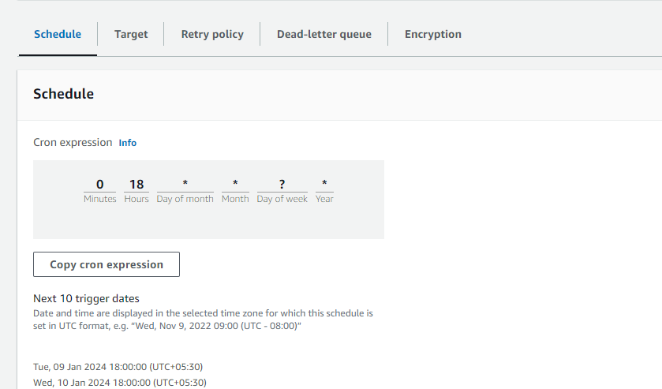

Target for eventbridge: INVOKE Lambda

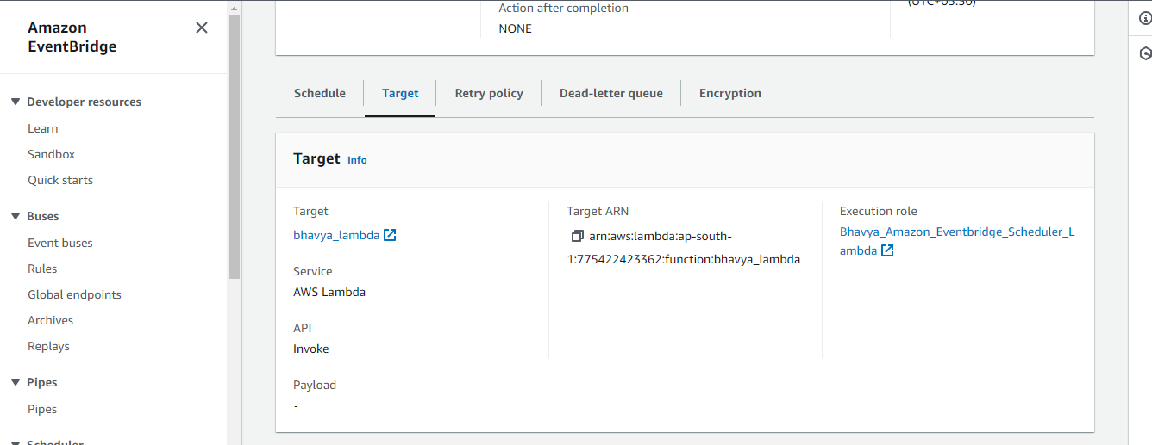

Code for lambda

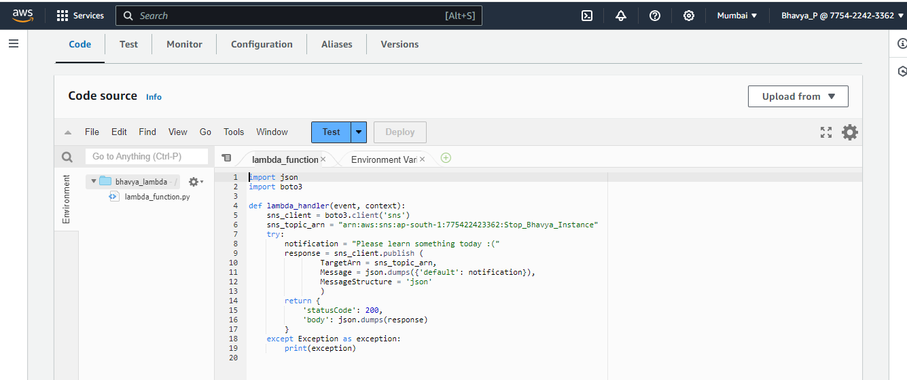

Lambda properties and role:

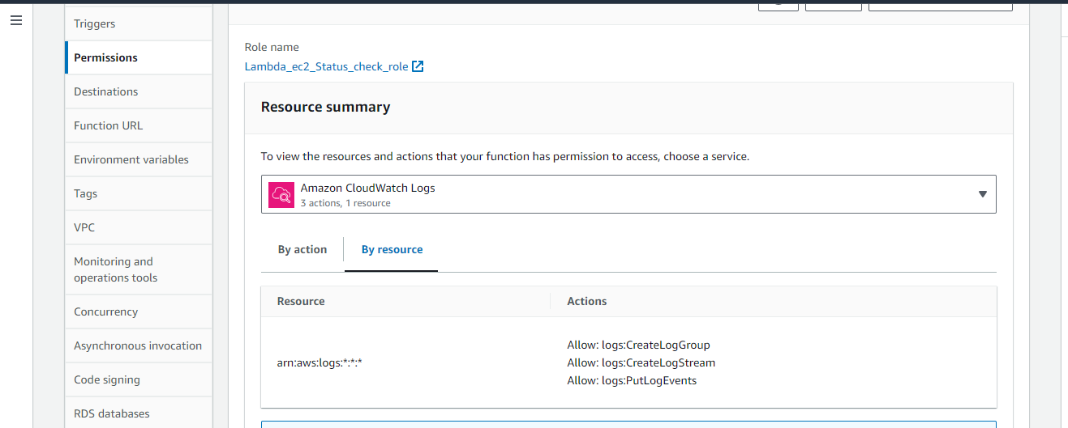

Create role for eventbridge :  
for that role create plict to attach: Policy for evenbridge

