Student Name: Bhavya UID: 24BAI70791
Branch: CSE(AI & ML) Section/Group: 24AIT_KRG-1/G2
Semester:4
Subject Name: Database Management System Subject Code: 24CSH-298

Experiment – 7

1. Aim of the Session
To design and implement a stored procedure that accepts gender as an input parameter and returns the total number of employees based on the given gender, demonstrating procedural programming and parameterized logic in PL/SQL.

2. Software Requirements
Database Management System:
- Oracle Database Express Edition (Oracle XE)
- PostgreSQL Database
Database Administration Tool / Client Tool:
- Oracle SQL Developer (for Oracle XE)
- pgAdmin (for PostgreSQL)

3. Objectives
- To understand and implement stored procedures in PL/SQL
- To use IN and OUT parameters effectively
- To perform dynamic querying based on user input
- To apply aggregate functions (COUNT) inside procedures

4. Procedure of the Experiment
- Open database tool and connect to the database.
- Create the employees table.
- Insert sample employee records.
- Verify data using SELECT query.
- Create a stored procedure with input and output parameters.
- Use COUNT(*) to count employees based on gender.
- Compile and save the procedure.
- Call the procedure by passing gender value.
- Display the result using output statement.
- Verify the correctness of the output.

5. Practical / Experiment Steps

PROGRAM CODE:
-- 1. Create Table
CREATE TABLE employees (
emp_id SERIAL PRIMARY KEY,
emp_name VARCHAR(50),
gender VARCHAR(10),
salary NUMERIC(10,2)
);

-- 2. Insert Data
INSERT INTO employees (emp_name, gender, salary) VALUES
('Amit', 'Male', 30000),
('Riya', 'Female', 35000),
('John', 'Male', 28000),
('Sneha', 'Female', 40000);

-- 3. Procedure
CREATE OR REPLACE PROCEDURE get_employee_count_by_gender(
IN p_gen VARCHAR(20),
OUT count_emp INT,
INOUT status VARCHAR
)
AS $$
BEGIN
SELECT COUNT(*) INTO count_emp
FROM employees
WHERE gender = p_gen;

status := 'SUCCESS';
END;
$$ LANGUAGE plpgsql;

-- 4. Calling Procedure
DO $$
DECLARE
gen VARCHAR(20) := 'Male';
count_by_gen INT;
status VARCHAR(20) := 'Fail';
BEGIN
CALL get_employee_count_by_gender(gen, count_by_gen, status);

RAISE NOTICE 'GENDER IS % YOUR COUNT IS % AND STATUS IS %',
gen, count_by_gen, status;
END;
$$;

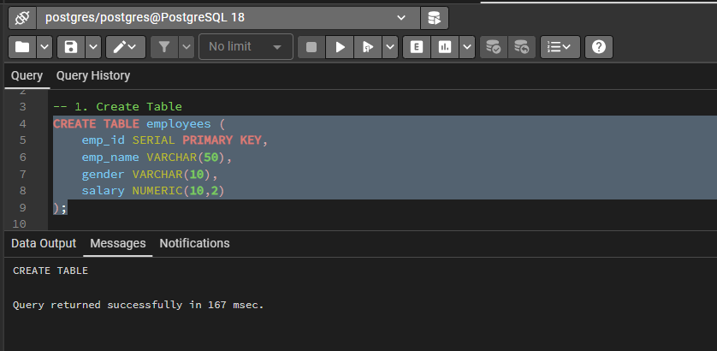
6. Input / Output Details and Screenshot

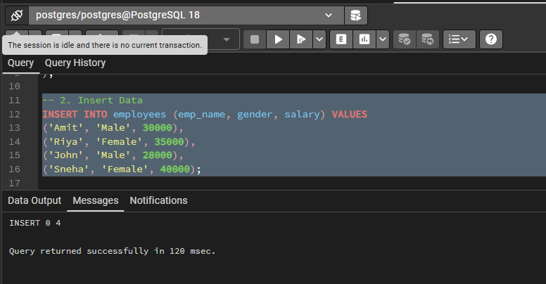

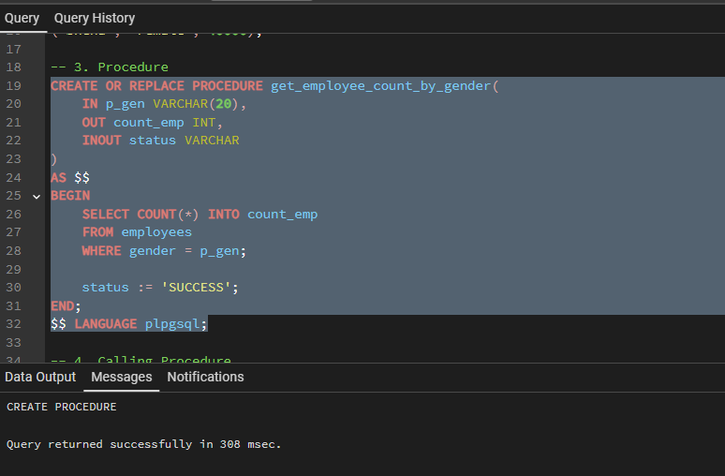

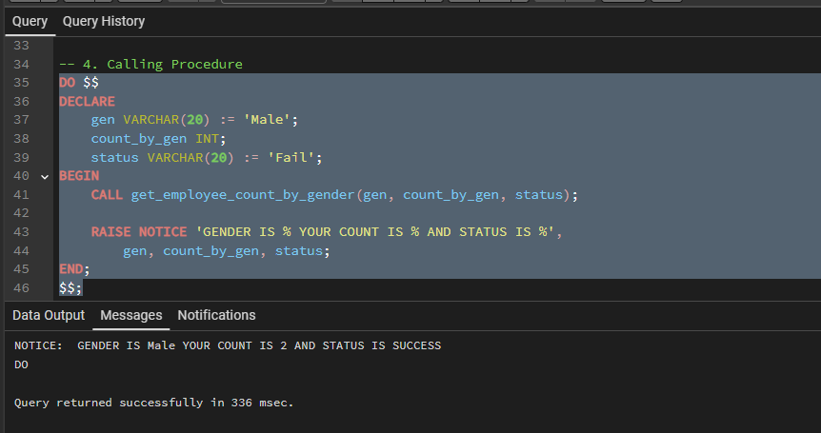

7. Learning Outcome
- Understand the concept of stored procedures.
- Learn to use IN, OUT, and INOUT parameters.
- Gain knowledge of passing dynamic input values.
- Apply COUNT() function for data analysis.
- Develop reusable database logic.
- Understand real-world data handling scenarios.

