Student Name: Bhavya UID: 24BAI70791
Branch: CSE(AI & ML) Section/Group: 24AIT_KRG-1/G2
Semester: 4 Date of Performance: 30/01/2026
Subject Name: Database Management System Subject Code: 24CSH-298

Experiment – 4

1. Aim of the Session
To design and implement PL/SQL programs utilizing conditional control statements such as IF–ELSE, ELSIF, ELSIF ladder, and CASE constructs in order to control the flow of execution based on logical conditions and to analyze decision-making capabilities in PL/SQL blocks.

2. Software Requirements
Database Management System: Oracle Database
Database Administration Tool: Oracle SQL Developer

3. Objectives
- To understand conditional control statements in PL/SQL.
- To implement IF–ELSE statements in PL/SQL blocks.
- To implement IF–ELSIF–ELSE ladder.
- To use CASE statements for decision making.
- To analyze program execution based on conditions.

4. Procedure of the Experiment
- Open Oracle SQL Developer / Oracle Live SQL.
- Enable output using the command: SET SERVEROUTPUT ON;
- Write the required PL/SQL block using conditional statements.
- Compile and execute the program.
- Observe the output displayed using DBMS_OUTPUT.PUT_LINE.
- Modify input values to verify different conditions.

5. Practical / Experiment Steps

Program 1: IF–ELSE Statement
DECLARE
num NUMBER := -5;
BEGIN
IF num > 0 THEN
DBMS_OUTPUT.PUT_LINE('The number is Positive');
ELSE
DBMS_OUTPUT.PUT_LINE('The number is Non-Positive');
END IF;
END;
/

Program 2: IF–ELSIF–ELSE Statement

DECLARE
marks NUMBER := 78;
BEGIN
IF marks >= 90 THEN
DBMS_OUTPUT.PUT_LINE('Grade: A');
ELSIF marks >= 75 THEN
DBMS_OUTPUT.PUT_LINE('Grade: B');
ELSIF marks >= 60 THEN
DBMS_OUTPUT.PUT_LINE('Grade: C');
ELSE
DBMS_OUTPUT.PUT_LINE('Grade: Fail');
END IF;
END;
/

Program 3: ELSIF Ladder (Performance Status)
DECLARE
marks NUMBER := 65;
BEGIN
IF marks >= 85 THEN
DBMS_OUTPUT.PUT_LINE('Performance: Excellent');
ELSIF marks >= 70 THEN
DBMS_OUTPUT.PUT_LINE('Performance: Very Good');
ELSIF marks >= 50 THEN
DBMS_OUTPUT.PUT_LINE('Performance: Good');
ELSE
DBMS_OUTPUT.PUT_LINE('Performance: Poor');
END IF;
END;
/

Program 4: CASE Statement (Day Name)
DECLARE
day_no NUMBER := 3;
BEGIN
CASE day_no
WHEN 1 THEN DBMS_OUTPUT.PUT_LINE('Monday');
WHEN 2 THEN DBMS_OUTPUT.PUT_LINE('Tuesday');
WHEN 3 THEN DBMS_OUTPUT.PUT_LINE('Wednesday');
WHEN 4 THEN DBMS_OUTPUT.PUT_LINE('Thursday');
WHEN 5 THEN DBMS_OUTPUT.PUT_LINE('Friday');
WHEN 6 THEN DBMS_OUTPUT.PUT_LINE('Saturday');
WHEN 7 THEN DBMS_OUTPUT.PUT_LINE('Sunday');
ELSE
DBMS_OUTPUT.PUT_LINE('Invalid Day Number');
END CASE;
END;
/
6. Input / Output Details and Screenshot

Program (Input):

Program 1: IF–ELSE Statement
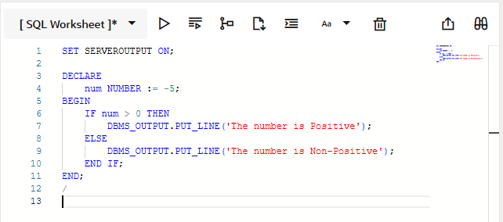

Program 2: IF–ELSIF–ELSE Statement

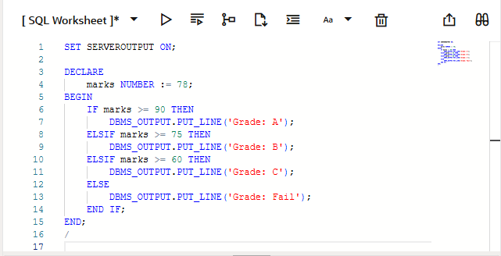

Program 3: ELSIF Ladder
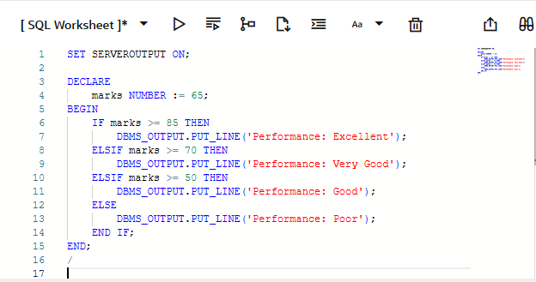

Program 4: CASE Statement

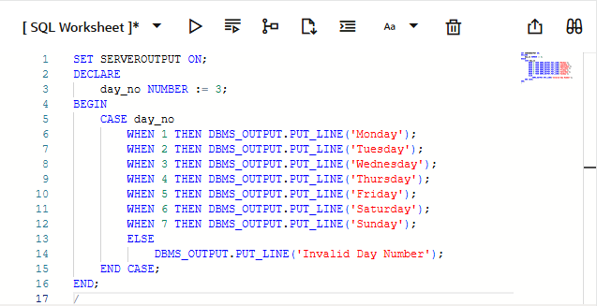

Output:

Program 1: IF–ELSE Statement
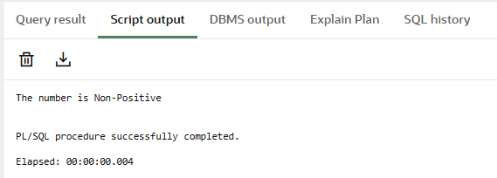

Program 2: IF–ELSIF–ELSE Statement
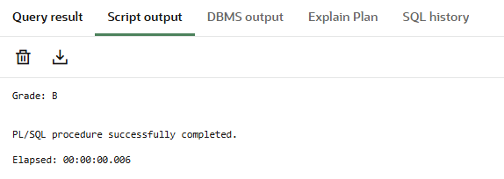

Program 3: ELSIF Ladder

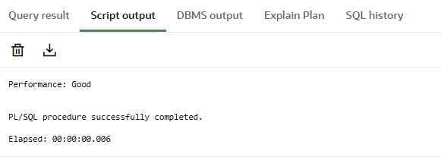

Program 4: CASE Statement
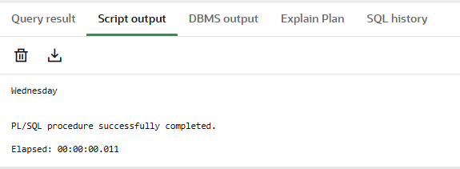

7. Learning Outcome
- Learned how to use IF–ELSE, ELSIF ladder, and CASE statements in PL/SQL.
- Understood decision-making using conditional control structures.
- Gained practical knowledge of writing PL/SQL blocks.
- Improved understanding of logical flow control in database programming.

