Student Name: Bhavya UID: 24BAI70791
Branch: CSE(AI & ML) Section/Group: 24AIT_KRG-1/G2
Semester:4
Subject Name: Database Management System Subject Code: 24CSH-298

Experiment – 10

1. Aim of the Session
To design a trigger that automatically implements the functionality of a primary key, ensuring unique identification of records without manual intervention.

2. Software Requirements
Database Management System:
- Oracle Database Express Edition (Oracle XE)
- PostgreSQL Database
Database Administration Tool / Client Tool:
- Oracle SQL Developer (for Oracle XE)
- pgAdmin (for PostgreSQL)

3. Objectives
To create a database trigger that automatically enforces primary key constraints or generates unique key values, replicating the functionality of a stored procedure.

4. Procedure of the Experiment
- Create the table in the database with required fields and define a primary key column (or leave it for trigger-based assignment).
- Create a sequence (or auto-increment logic) to generate unique values for the primary key.
- Design a trigger function that runs before an INSERT operation.
- Inside the trigger, check if the primary key value is NULL or not provided.
- If NULL, assign a unique value using the sequence or counter logic.
- Create and attach the trigger to the table for INSERT events.
- Insert sample records without specifying the primary key value.
- Verify the output by checking the table to ensure each record has a unique automatically generated primary key.

5. Practical / Experiment Steps

PROGRAM CODE:

CREATE TABLE employee (
emp_id INTEGER PRIMARY KEY,
name VARCHAR(100),
department VARCHAR(50)
);

CREATE SEQUENCE emp_seq START 1;

CREATE OR REPLACE FUNCTION emp_trigger_function()
RETURNS TRIGGER AS $$
BEGIN
IF NEW.emp_id IS NULL THEN
NEW.emp_id := nextval('emp_seq');
END IF;
RETURN NEW;
END;
$$ LANGUAGE plpgsql;

CREATE TRIGGER emp_trigger
BEFORE INSERT ON employee
FOR EACH ROW
EXECUTE FUNCTION emp_trigger_function();

INSERT INTO employee (name, department) VALUES ('John', 'HR');
INSERT INTO employee (name, department) VALUES ('Alice', 'IT');

SELECT * FROM employee;

6. Input / Output Details and Screenshot
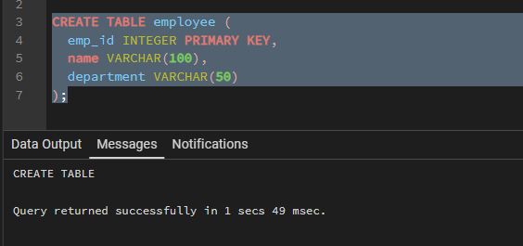

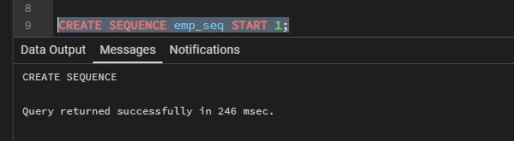
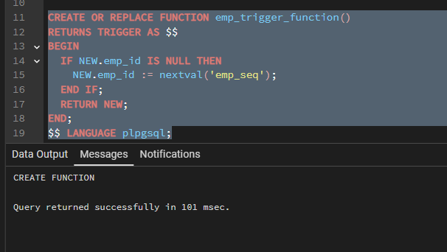
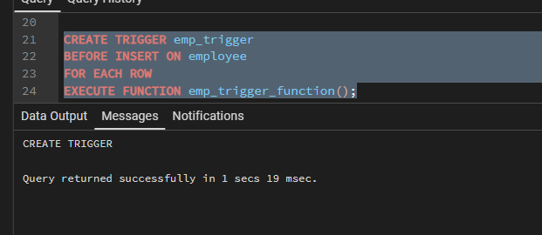

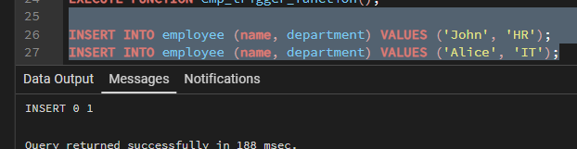
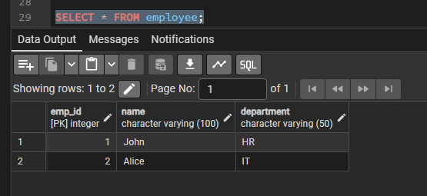

7. Learning Outcome
After completing this experiment, the learner will be able to:
- Understand the purpose and working of database triggers.
- Implement automated primary key functionality using triggers.
- Ensure data integrity without manual key assignment.
- Apply trigger-based automation in real-world enterprise applications such as Amazon, Flipkart, and Oracle.

