Student Name: Bhavya UID: 24BAI70791
Branch: CSE(AI & ML) Section/Group: 24AIT_KRG-1/G2
Semester: 4 Date of Performance: 27/02/2026
Subject Name: Database Management System Subject Code: 24CSH-298

Experiment – 6

1. Aim of the Session
To understand the concept and working of cursors in PL/SQL for row-by-row data processing, and to analyze how implicit cursors, explicit cursors, and cursor attributes are used to implement business logic on multiple rows in a database table.

2. Software Requirements
Database Management System:
- Oracle Database Express Edition (Oracle XE)
- PostgreSQL Database
Database Administration Tool / Client Tool:
- Oracle SQL Developer (for Oracle XE)
- pgAdmin (for PostgreSQL)

3. Objectives
To implement and analyze the use of implicit cursors, explicit cursors, and cursor attributes for processing multiple rows from a database table and applying business logic effectively.

4. Procedure of the Experiment
- Create an employee table with fields EmpID, EmpName, and Salary.
- Insert sample employee records into the table using the INSERT command.
- Display all employee records from the table using the SELECT statement.
- Write a PL/SQL block using an implicit cursor to perform operations such as UPDATE or DELETE on the employee table.
- Use the SQL%ROWCOUNT cursor attribute to check how many rows were affected by the operation.
- Declare an explicit cursor to retrieve employee records from the table.
- Open the cursor using the OPEN statement to begin processing the records.
- Fetch records one by one from the cursor using the FETCH statement.
- Use a LOOP structure to process each employee record individually.
- Apply cursor attributes such as %FOUND, %NOTFOUND, %ROWCOUNT, and %ISOPEN to control the program flow.
- Display the processed employee details using DBMS_OUTPUT.PUT_LINE.
- Close the cursor using the CLOSE statement after all records are processed.
- Execute the program and observe the output.

5. Practical / Experiment Steps

PROGRAM CODE:
CREATE TABLE employee (
emp_id NUMBER PRIMARY KEY,
emp_name VARCHAR2(50),
salary NUMBER
);
INSERT INTO employee VALUES (101,'Rahul',3000);
INSERT INTO employee VALUES (102,'Sneha',4000);
INSERT INTO employee VALUES (103,'Amit',3500);
INSERT INTO employee VALUES (104,'Priya',4500);
COMMIT;
SET SERVEROUTPUT ON;
-------------------------------------------------
-- Problem 1: Implicit Cursor
-------------------------------------------------
BEGIN
UPDATE employee
SET salary = salary + 500
WHERE emp_id = 101;
IF SQL%FOUND THEN
DBMS_OUTPUT.PUT_LINE('Rows Updated: ' || SQL%ROWCOUNT);
ELSE
DBMS_OUTPUT.PUT_LINE('No rows were updated');
END IF;
END;
/
-------------------------------------------------
-- Problem 2: Explicit Cursor
-------------------------------------------------
DECLARE
CURSOR emp_cursor IS
SELECT emp_id, emp_name, salary FROM employee;
v_id employee.emp_id%TYPE;
v_name employee.emp_name%TYPE;
v_salary employee.salary%TYPE;
BEGIN
OPEN emp_cursor;
LOOP
FETCH emp_cursor INTO v_id, v_name, v_salary;
EXIT WHEN emp_cursor%NOTFOUND;
DBMS_OUTPUT.PUT_LINE(v_id || ' ' || v_name || ' ' || v_salary);
END LOOP;
CLOSE emp_cursor;
END;
/
-------------------------------------------------
-- Problem 3: Cursor Attributes
-------------------------------------------------
DECLARE
CURSOR emp_cursor IS
SELECT emp_id FROM employee;
v_id employee.emp_id%TYPE;
BEGIN
OPEN emp_cursor;
LOOP
FETCH emp_cursor INTO v_id;
IF emp_cursor%FOUND THEN
DBMS_OUTPUT.PUT_LINE('Employee ID: ' || v_id);
END IF;
EXIT WHEN emp_cursor%NOTFOUND;
END LOOP;
DBMS_OUTPUT.PUT_LINE('Total Rows Fetched: ' || emp_cursor%ROWCOUNT);
CLOSE emp_cursor;
END;
/
6. Input / Output Details and Screenshot

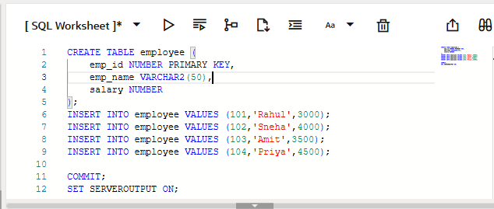

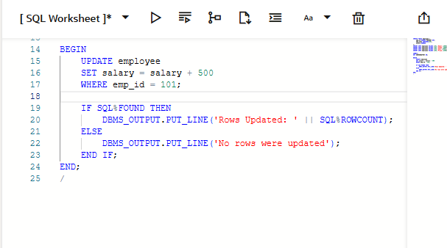

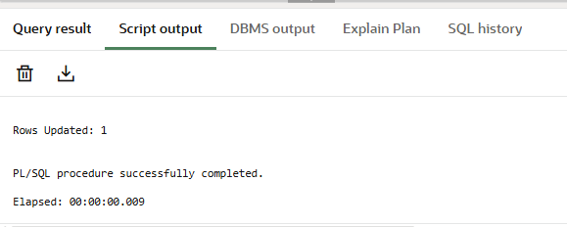

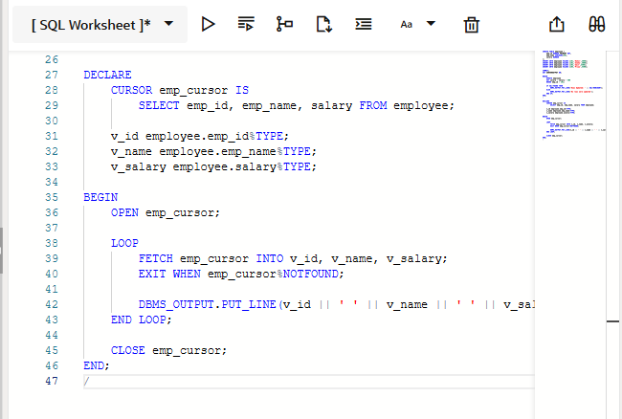
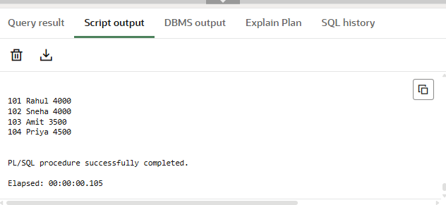
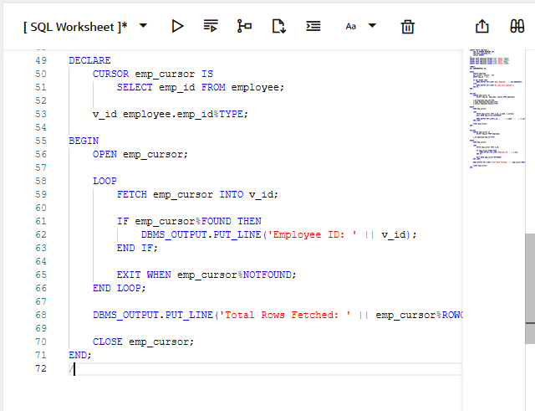
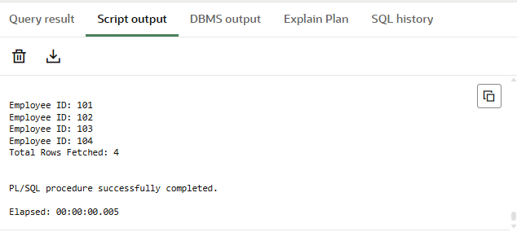

7. Learning Outcome
After completing this experiment, we learned:
- The concept and importance of cursors in PL/SQL
- The difference between implicit and explicit cursors
- How to use cursor attributes such as %FOUND, %NOTFOUND, %ROWCOUNT, and %ISOPEN
- How to process database records row by row
- Practical implementation of cursors in database programs

