Student Name: Bhavya UID: 24BAI70791
Branch: CSE(AI & ML) Section/Group: 24AIT_KRG-1/G2
Semester: 4 Date of Performance: 13/01/2026
Subject Name: Database Management System Subject Code: 24CSH-298

Experiment 2

1. Aim of the Session
To understand and implement SQL SELECT queries using clauses such as WHERE, GROUP BY, HAVING, and ORDER BY for retrieving and analyzing employee data from a relational database table.

2. Software Requirements
- PostgreSQL Database (pgAdmin)
- MS Word / PDF editor

3. Objectives
- To practice writing SQL SELECT queries.
- To apply filtering conditions using the WHERE clause.
- To group records using the GROUP BY clause.
- To filter grouped data using the HAVING clause.
- To sort query results using the ORDER BY clause.
- To use aggregate functions such as AVG() for data analysis.

4. Procedure of the Experiment
- Start the system and log in to the database.
- Create the EMPLOYEE table using SQL commands.
- Insert employee records into the table.
- Execute SELECT queries using GROUP BY, WHERE, HAVING, and ORDER BY clauses.
- Verify the output after execution.
- Save the work and take screenshots for record.

5. Practical / Experiment Steps

(A) Table Creation

CREATE TABLE EMPLOYEE (
emp_id NUMERIC PRIMARY KEY,
emp_name VARCHAR(50),
department VARCHAR(30),
salary NUMERIC,
joining_date DATE
);

(B) Insert Records
INSERT INTO EMPLOYEE VALUES (1, 'Bhavya', 'IT', 48000, DATE '2022-02-10');
INSERT INTO EMPLOYEE VALUES (2, 'Myra', 'IT', 42000, DATE '2021-07-15');
INSERT INTO EMPLOYEE VALUES (3, 'Saksham', 'HR', 35000, DATE '2020-04-20');
INSERT INTO EMPLOYEE VALUES (4, 'Anant', 'HR', 30000, DATE '2019-09-12');
INSERT INTO EMPLOYEE VALUES (5, 'Srijan', 'Sales', 26000, DATE '2021-11-05');
INSERT INTO EMPLOYEE VALUES (6, 'Yash', 'Sales', 38000, DATE '2020-03-18');

(C) Queries Using GROUP BY, WHERE, HAVING and ORDER BY
1. Display department-wise average salary
SELECT department, AVG(salary) AS avg_salary
FROM EMPLOYEE
GROUP BY department;

2. Display average salary considering only employees with salary > 20000
SELECT department, AVG(salary) AS avg_salary
FROM EMPLOYEE
WHERE salary > 20000
GROUP BY department;

3. Display only departments with average salary > 30000
SELECT department, AVG(salary) AS avg_salary
FROM EMPLOYEE
WHERE salary > 20000
GROUP BY department
HAVING AVG(salary) > 30000;

4. Arrange result in descending order of average salary
SELECT department, AVG(salary) AS avg_salary
FROM EMPLOYEE
WHERE salary > 20000
GROUP BY department
HAVING AVG(salary) > 30000
ORDER BY avg_salary DESC;

6. Input / Output Details and Screenshots

Input:
- Employee ID
- Employee Name
- Department
- Salary
- Joining Date

Output:
- Displays department-wise average salary
- Filters employees with salary greater than 20000
- Displays only those departments whose average salary is greater than 30000
- Output is sorted in descending order of average salary
Screenshots:
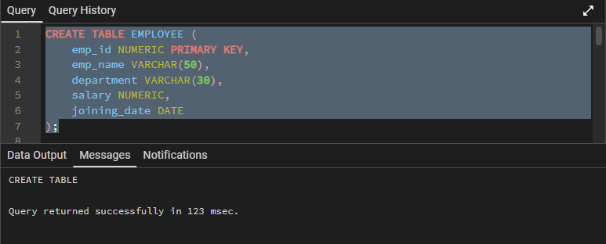

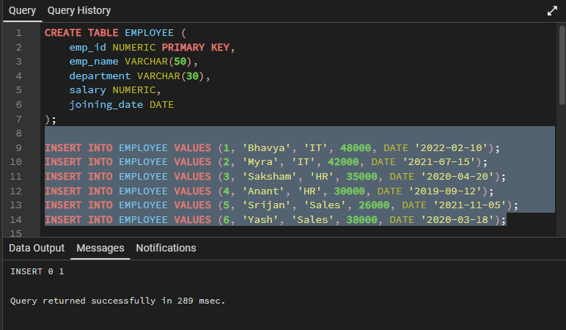

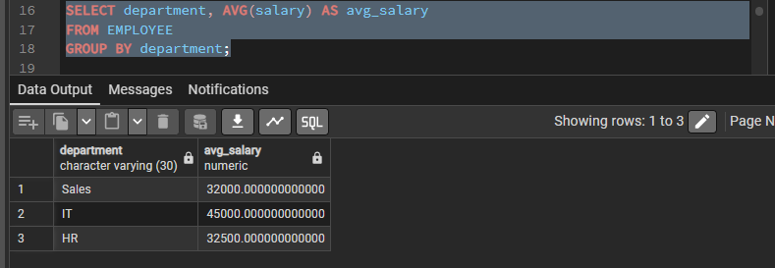
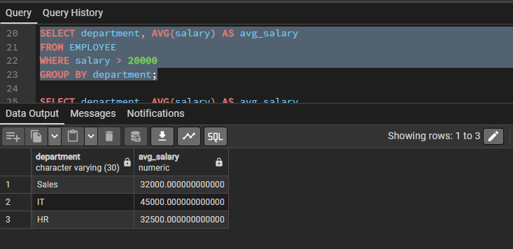
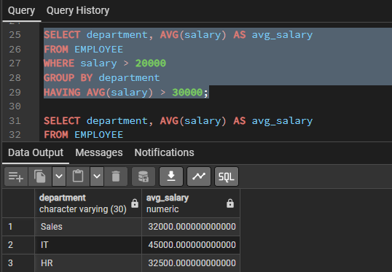

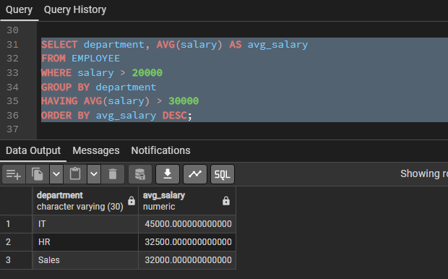

7. Learning Outcome
After completing this experiment, students will be able to:
- Filter records using the WHERE clause.
- Group records using the GROUP BY clause.
- Apply conditions on grouped data using the HAVING clause.
- Sort query results using the ORDER BY clause.
- Use aggregate functions like AVG() for data analysis.

