Student Name: Bhavya UID: 24BAI70791
Branch: CSE(AI & ML) Section/Group: 24AIT_KRG-1/G2
Semester: 4 Date of Performance: 27/02/2026
Subject Name: Database Management System Subject Code: 24CSH-298

Experiment – 5

1. Aim of the Session
To understand and apply conditional logic in SQL by using the modulus operator (MOD / %) to analyze numerical data and classify employee salaries as odd or even, thereby improving data analysis and decision-making skills in SQL.

2. Software Requirements
Database Management System:
- Oracle Database Express Edition (Oracle XE)
- PostgreSQL Database
Database Administration Tool / Client Tool:
- Oracle SQL Developer (for Oracle XE)
- pgAdmin (for PostgreSQL)

3. Objectives

To write and execute SQL queries that use the MOD (%) operator to check employee
salaries and display odd and even salary values separately from an employee table.

4. Procedure of the Experiment
- Create an employee table with fields emp_id, emp_name, and salary.
- Insert sample employee data into the table using the INSERT command.
- Display all records from the employee table using the SELECT statement.
- Use the MOD (%) operator to check and separate even and odd salary values.
- Use the CASE statement to label each salary as “Even” or “Odd” and observe the output.

5. Practical / Experiment Steps

PROGRAM CODE:
CREATE TABLE employee (
emp_id INT PRIMARY KEY,
emp_name VARCHAR(50),
salary INT
);

INSERT INTO employee VALUES (101, 'Rahul', 25000);
INSERT INTO employee VALUES (102, 'Neha', 30001);
INSERT INTO employee VALUES (103, 'Amit', 18000);
INSERT INTO employee VALUES (104, 'Priya', 27555);
INSERT INTO employee VALUES (105, 'Karan', 40000);

SELECT * FROM employee;

SELECT emp_id, emp_name, salary
FROM employee
WHERE MOD(salary, 2) = 0;

SELECT emp_id, emp_name, salary
FROM employee
WHERE MOD(salary, 2) = 1;

SELECT emp_id, emp_name, salary,
CASE
WHEN MOD(salary, 2) = 0 THEN 'Even Salary'
ELSE 'Odd Salary'
END AS salary_type
FROM employee;

6. Input / Output Details and Screenshot

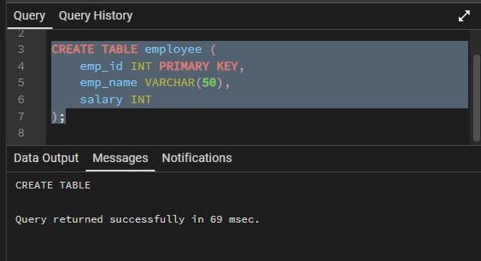

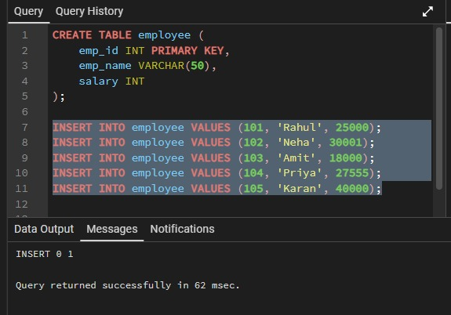
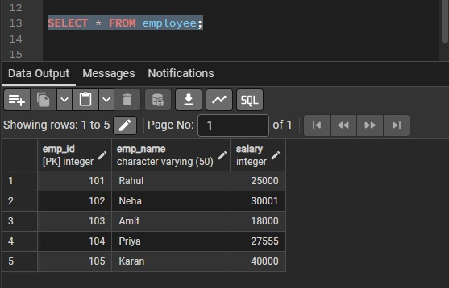
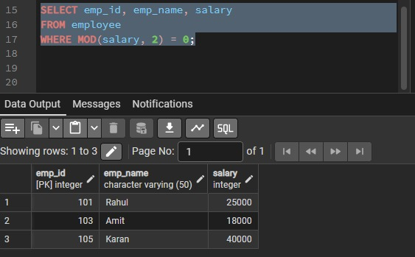

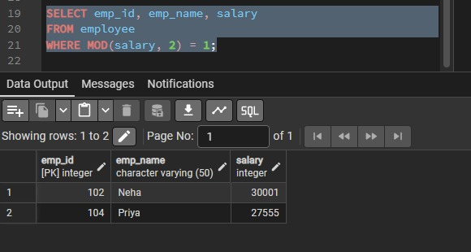

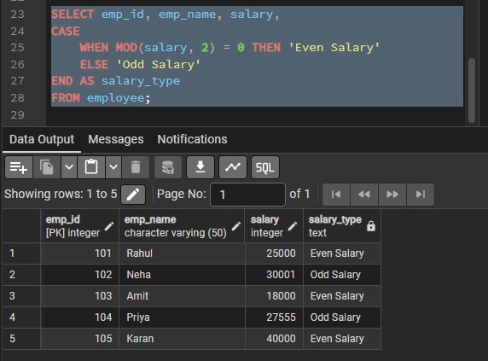

7. Learning Outcome
- Understand the use of the MOD (%) operator in SQL.
- Apply conditional logic to classify numerical data as odd or even.
- Write and execute SELECT queries with conditions using the WHERE clause.
- Use the CASE statement to generate meaningful labels in query results.
- Improve skills in data analysis and decision-making using SQL queries.

