Student Name: Bhavya UID: 24BAI70791
Branch: CSE(AI & ML) Section/Group: 24AIT_KRG-1/G2
Semester:4
Subject Name: Database Management System Subject Code: 24CSH-298

Experiment – 9

1. Aim of the Session
To create and implement PL/SQL packages by developing a package specification and package body containing procedures and shared cursors, in order to achieve modular, reusable, and efficient database programming.

2. Software Requirements
Database Management System:
- Oracle Database Express Edition (Oracle XE)
- PostgreSQL Database
Database Administration Tool / Client Tool:
- Oracle SQL Developer (for Oracle XE)
- pgAdmin (for PostgreSQL)

3. Objectives
To design and implement a PL/SQL package that includes procedures and shared cursors for structured and modular program development.

4. Procedure of the Experiment
- Create an Employee table to store employee details like ID, name, salary, and department.
- Insert sample records into the table to test the package functionality.
- Create the package specification to declare procedures that will be used externally.
- Create the package body to define the actual implementation of the declared procedures.
- Declare a shared cursor inside the package to retrieve employee records efficiently.
- Implement the procedure to open the cursor, fetch records, and display them.
- Compile the package to check and remove any syntax errors.
- Execute the package procedure using a PL/SQL block.
- Verify the output by displaying employee details using DBMS_OUTPUT.

5. Practical / Experiment Steps

PROGRAM CODE:
-- Create Employee Table
CREATE TABLE Employee (
emp_id NUMBER,
emp_name VARCHAR2(50),
salary NUMBER,
dept VARCHAR2(50)
);

-- Insert Sample Data
INSERT INTO Employee VALUES (101, 'Rahul', 50000, 'IT');
INSERT INTO Employee VALUES (102, 'Sneha', 60000, 'HR');
INSERT INTO Employee VALUES (103, 'Amit', 55000, 'Finance');

-- Package Specification
CREATE OR REPLACE PACKAGE emp_pkg AS
PROCEDURE display_employees;
END emp_pkg;
/

-- Package Body
CREATE OR REPLACE PACKAGE BODY emp_pkg AS

CURSOR emp_cursor IS
SELECT * FROM Employee;

PROCEDURE display_employees IS
emp_record emp_cursor%ROWTYPE;
BEGIN
OPEN emp_cursor;
LOOP
FETCH emp_cursor INTO emp_record;
EXIT WHEN emp_cursor%NOTFOUND;

DBMS_OUTPUT.PUT_LINE(
'ID: ' || emp_record.emp_id ||
' Name: ' || emp_record.emp_name ||
' Salary: ' || emp_record.salary ||
' Dept: ' || emp_record.dept
);
END LOOP;
CLOSE emp_cursor;
END;

END emp_pkg;
/

-- Execute Package
BEGIN
emp_pkg.display_employees;
END;
/
6. Input / Output Details and Screenshot

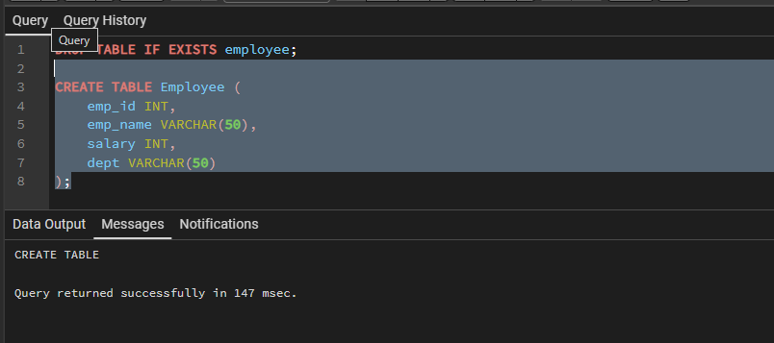

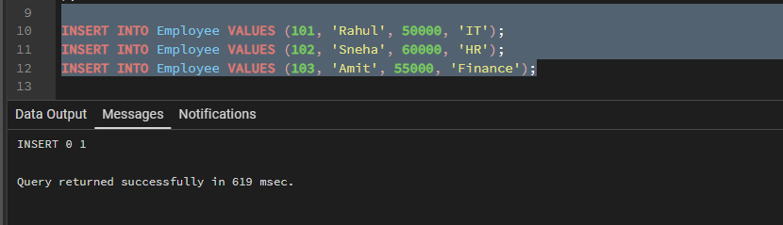

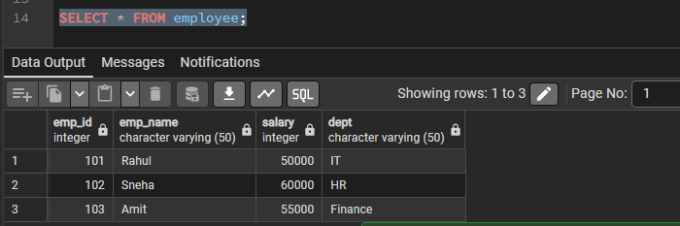
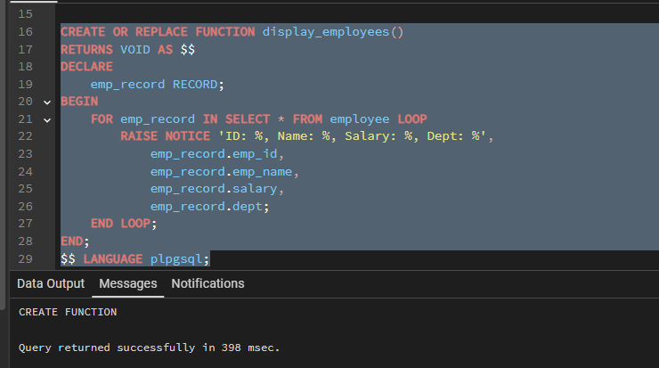
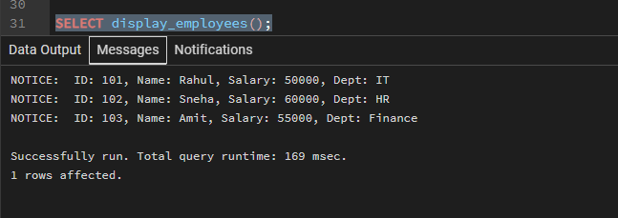

7. Learning Outcome
- Understand the concept and structure of PL/SQL packages.
- Differentiate between package specification and package body.
- Develop procedures to perform database operations.
- Use cursors to retrieve and process records efficiently.
- Write modular and reusable PL/SQL code.

