Student Name: Bhavya UID: 24BAI70791
Branch: CSE(AI & ML) Section/Group: 24AIT_KRG-1/G2
Semester: 4 Date of Performance: 13/01/2026
Subject Name: Database Management System Subject Code: 24CSH-298

Experiment – 3

1. Aim of the Session
To understand the basic structure of a PL/SQL program by creating and executing a simple PL/SQL block that includes Declaration and Execution sections and to display output using built-in procedures.

2. Software Requirements
Database Management System: Oracle Database
Database Administration Tool: Oracle SQL Developer

3. Objectives
- To learn the structure of a PL/SQL block.
- To use the DECLARE section for variable declaration.
- To use the BEGIN…END block for execution.
- To display output using DBMS_OUTPUT.PUT_LINE.

4. Procedure of the Experiment
- Open Oracle SQL Developer and connect to the Oracle database.

- Open a new SQL Worksheet.
- Enable server output using SET SERVEROUTPUT ON;.
- Write a PL/SQL program with:
  - Declaration section for variables
  - Execution section for calculations and output
- Execute the program and observe the results in the output window.

5. Practical / Experiment Steps
- Enable server output: SET SERVEROUTPUT ON;

- Declare variables: emp_id, emp_name, birth_year, current_year, and age.
- Assign values to the variables.
- Calculate age as age := current_year - birth_year;.
- Display all values using DBMS_OUTPUT.PUT_LINE.
- End the PL/SQL block using END; and execute with /.

6. Input / Output Details and Screenshot

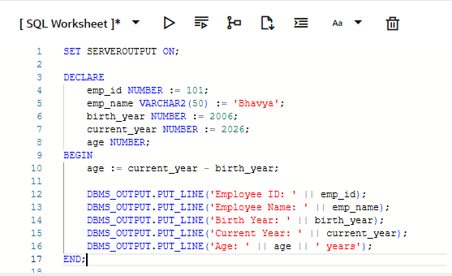
Program (Input):

Output:
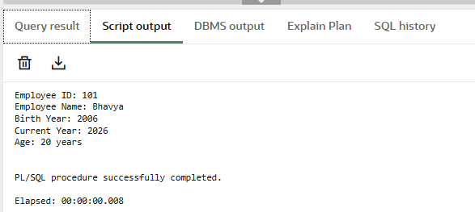

7. Learning Outcome
- Understood the basic structure of a PL/SQL block.
- Learned how to declare and initialize variables.
- Learned how to execute statements inside BEGIN…END block.
- Learned how to display output using DBMS_OUTPUT.PUT_LINE.

