Student Name: Bhavya UID: 24BAI70791
Branch: CSE(AI & ML) Section/Group: 24AIT_KRG-1/G2
Semester: 4 Date of Performance: 13/01/2026
Subject Name: Database Management System Subject Code: 24CSH-298

Experiment – 3

1. Aim of the Session
To understand the basic structure of a PL/SQL program by creating and executing a simple PL/SQL block that includes Declaration and Execution sections and to display output using built-in procedures.

2. Software Requirements
Database Management System: PostgreSQL
Database Administration Tool: pgAdmin

3. Objectives
- To learn the structure of a PL/SQL block.
- To use the DECLARE section for variable declaration.
- To use the BEGIN…END block for execution.
- To display output using DBMS_OUTPUT.PUT_LINE.

4. Procedure of the Experiment
- Open pgAdmin and connect to the PostgreSQL database.
- Open the Query Tool.
- Write a PL/SQL program with:
  - Declaration section
  - Execution section
- Declare variables for employee details.
- Display the variable values using output statements.
- Execute the program and observe the result.

5. Practical / Experiment Steps
- Enable server output.
- Declare variables emp_id, emp_name, and emp_salary.
- Assign values to these variables.
- Print the values using DBMS_OUTPUT.PUT_LINE.
- End the PL/SQL block.

6. Input / Output Details and Screenshot

Program (Input):
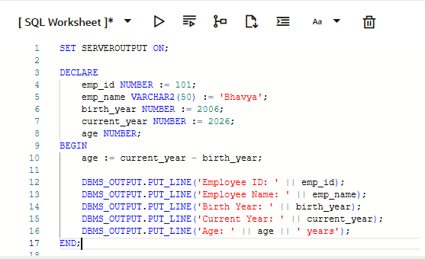

Output:
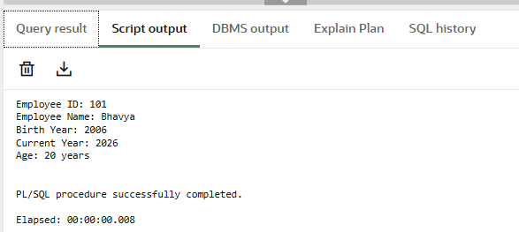

7. Learning Outcome
- Understood the basic structure of a PL/SQL block.
- Learned how to declare and initialize variables.
- Learned how to execute statements inside BEGIN…END block.
- Learned how to display output using DBMS_OUTPUT.PUT_LINE.

