Deploy WAR on different ec2

By -BHAVNA JUNGAHRI

- create two instance one is jenkins-master and other instance where we deploy war

- 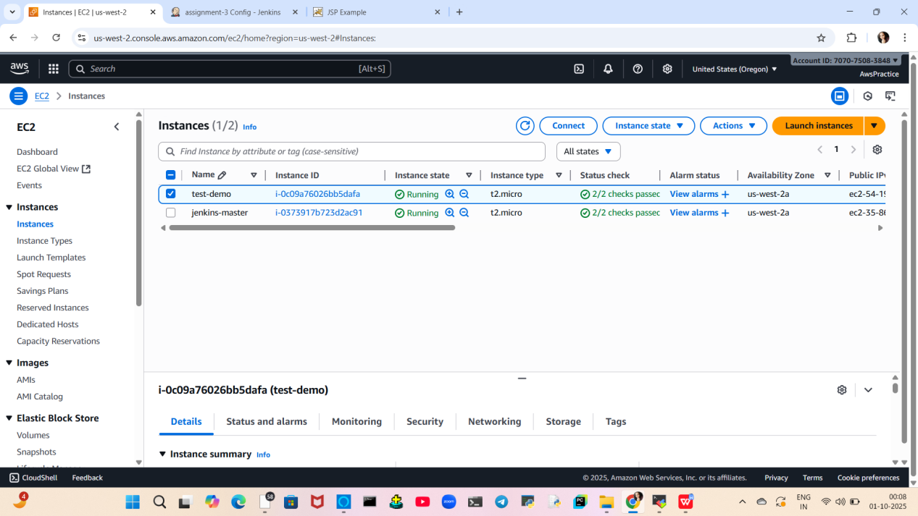

- Install Java-17 on it
Configure a tomcat by using zip from apache
Start the tomcat server using
apache-tomcat-home/bin/startup.sh
- install ssh plugin
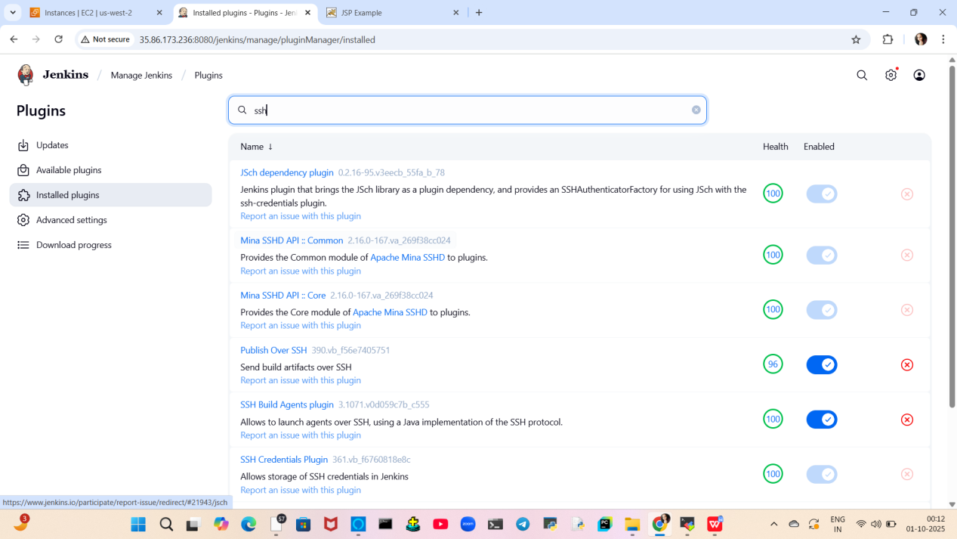

- configure ssh > systems > manage Jenkins
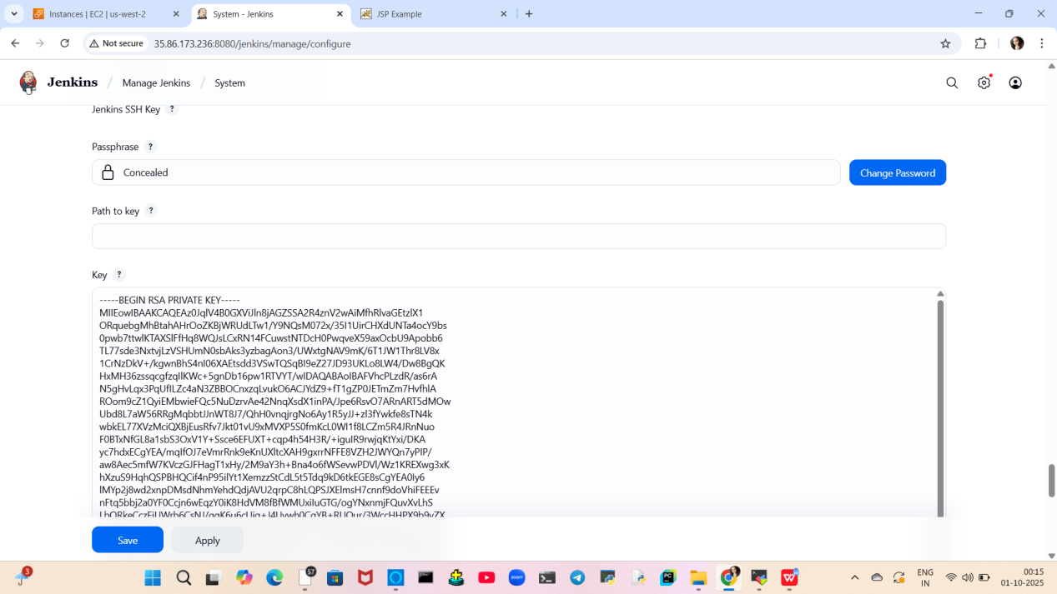

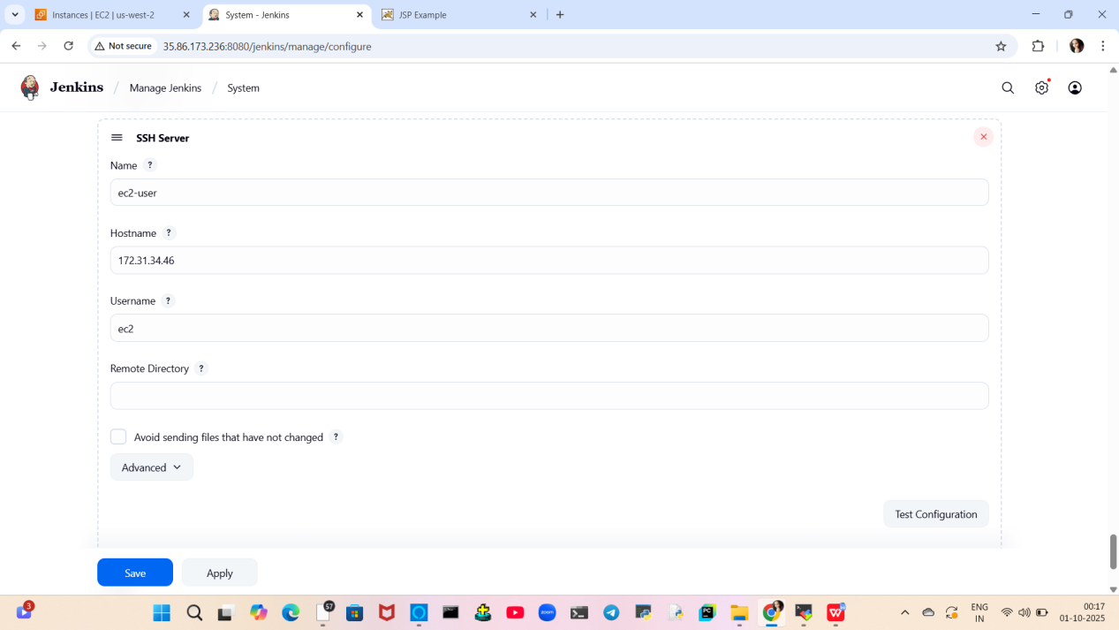
6)create job
Install maven and git in backend on Jenkins master

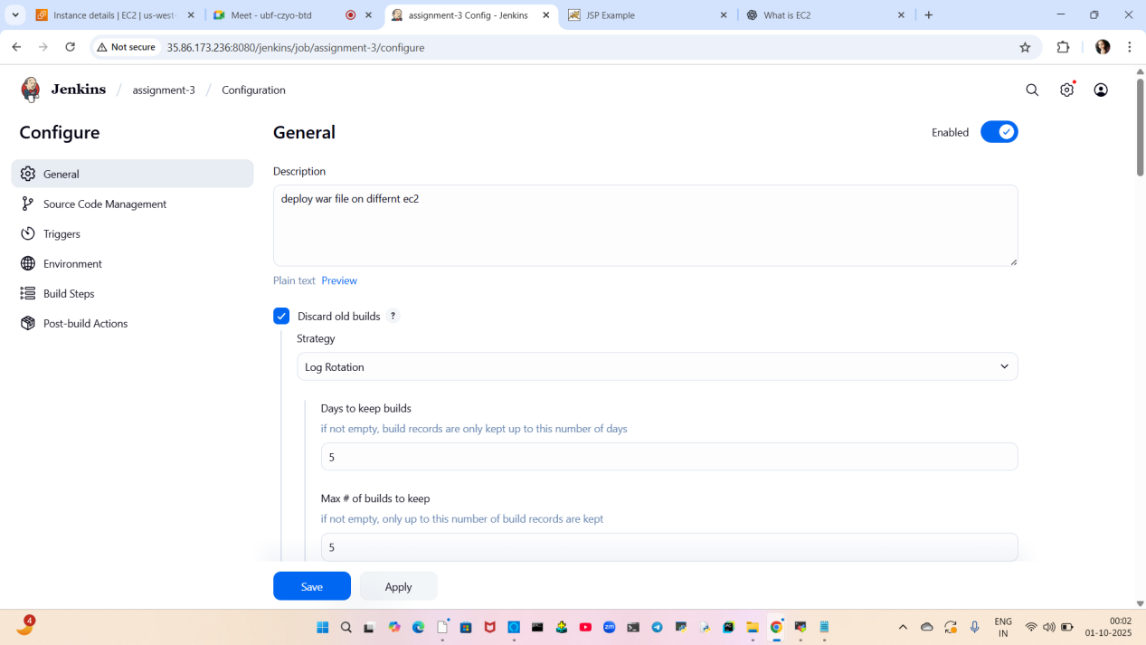
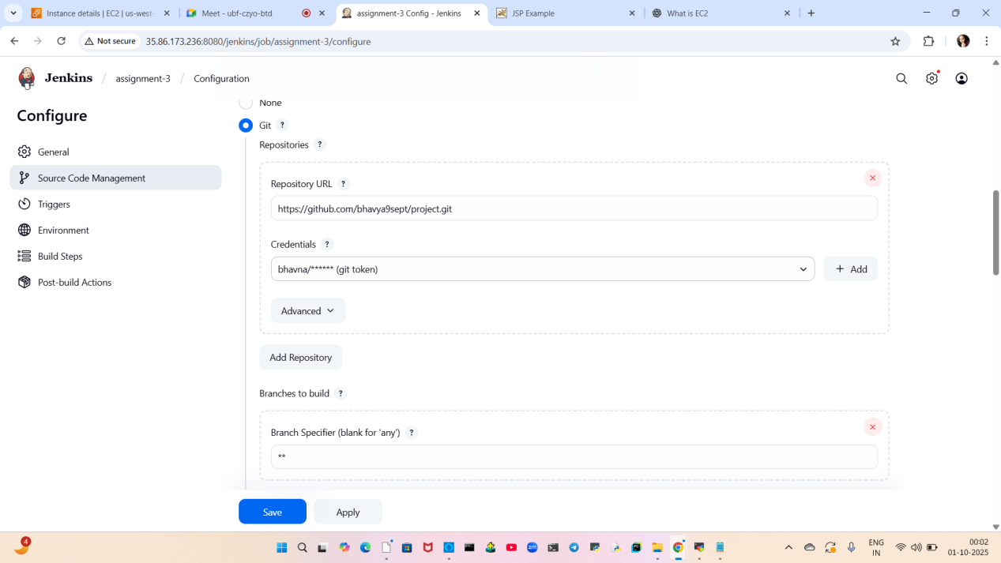
add git repo
So the code is pulled from it
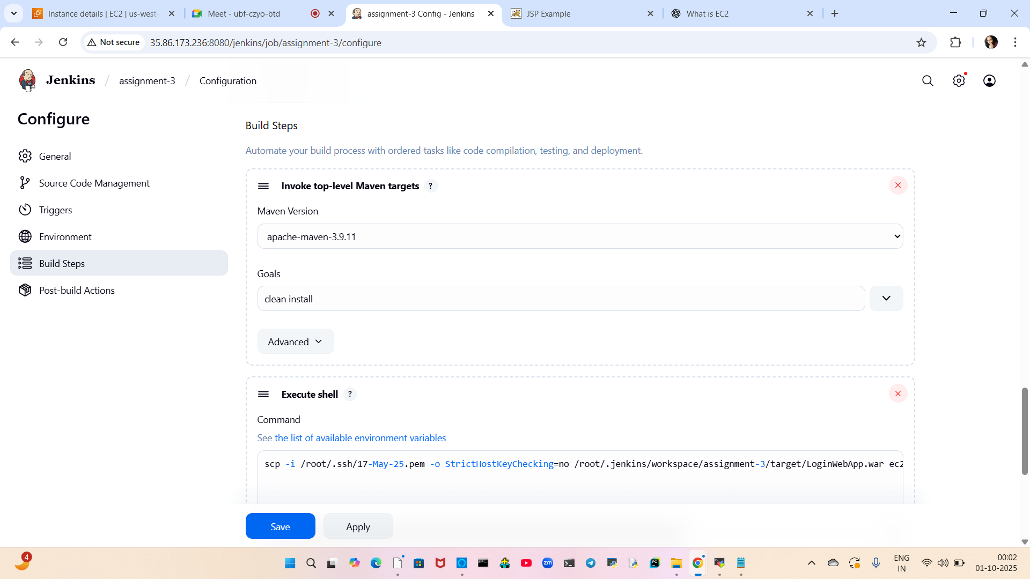
integrate maven , install application
In that our source code is compiled, packaged and create WAR
This war we have to deploy on tomcat server of another ec2

Use scp to transfer the war from Jenkins master to ec2-2
scp -i /root/.ssh/17-May-25.pem -o StrictHostKeyChecking=no /root/.jenkins/workspace/assignment-3/target/LoginWebApp.war ec2-user@172.31.34.46:/mnt/server/apache-tomcat-10.1.46/webapps/



build the job

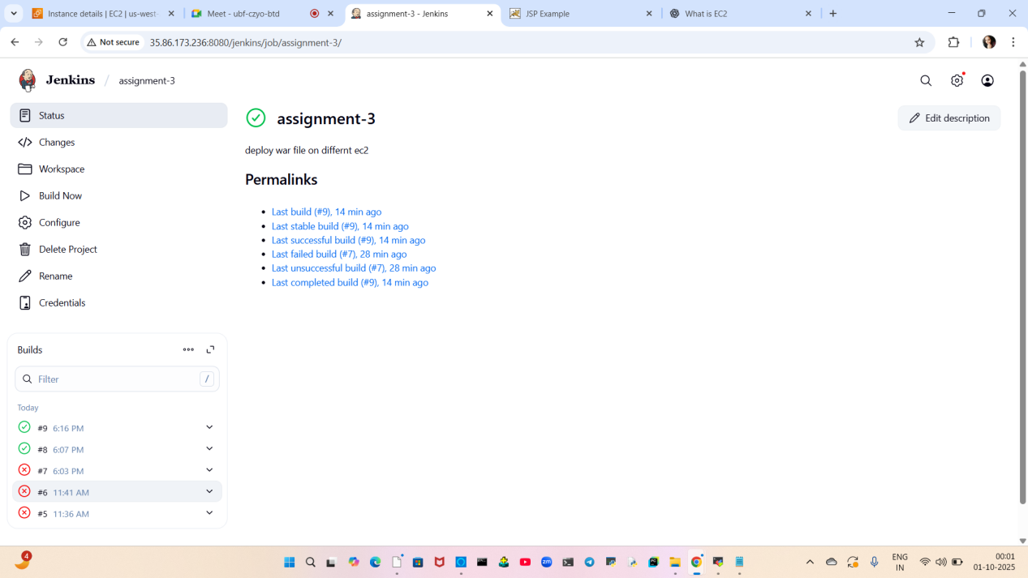
Console output be like
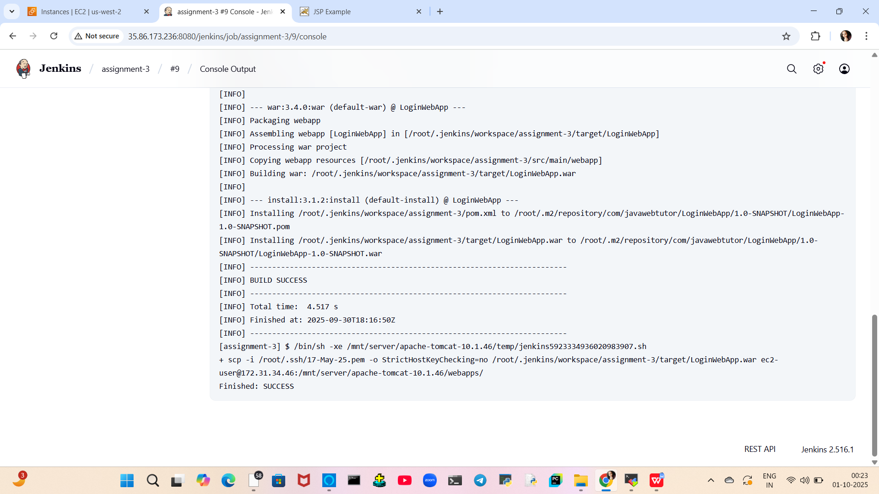
access the webapp using public-IP of end ec2-instance

http://54.190.173.17:8080/LoginWebApp/
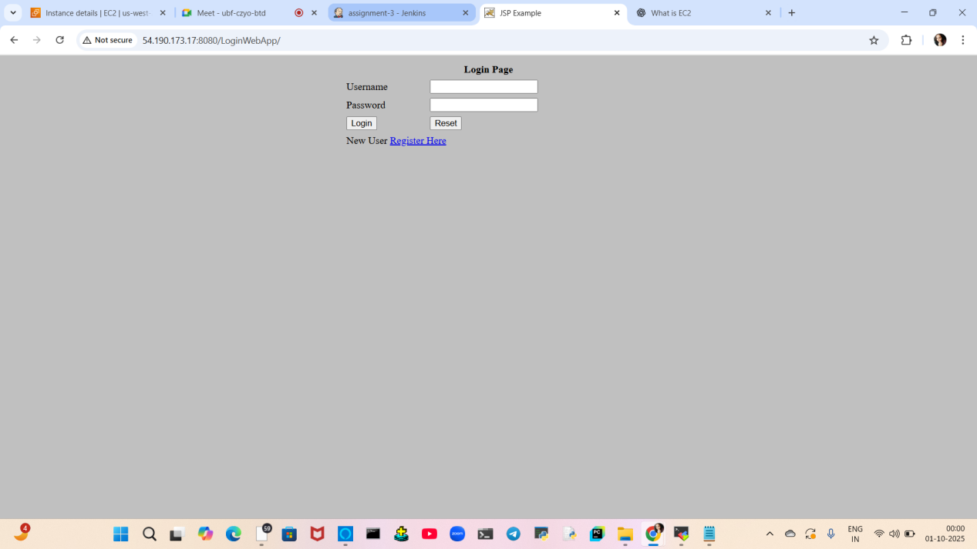
Done
Thankyou!!

