**Output: calculating PI value**

|  |  |  |  |  |
| --- | --- | --- | --- | --- |
| **Input size** | **Execution Time- Number of Threads** | | | |
| **1** | **2** | **4** | **8** |
| 400 | 0.000039 | 0.003567 | 0.000646 | 0.000726 |
| **PI value** | 3.07 | 3.09 | 3.04 | 3.11 |
| 600 | 0.000057 | 0.000374 | 0.000473 | 0.001325 |
| **PI value** | 3.11333 | 3.06667 | 3.07333 | 3.11333 |
| 800 | 0.000059 | 0.001926 | 0.000742 | 0.000696 |
| **PI value** | 3.165 | 3.165 | 3.22 | 3.18 |
| 1000 | 0.000064 | 0.003046 | 0.000876 | 0.002598 |
| **PI value** | 3.168 | 3.168 | 3.156 | 3.168 |

Graphs:

1. Number of threads vs execution time

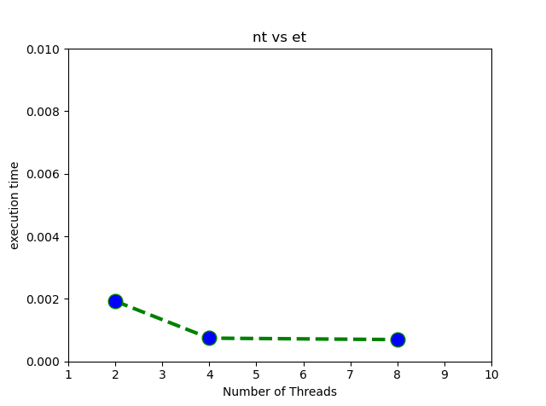

1. Input size vs execution time

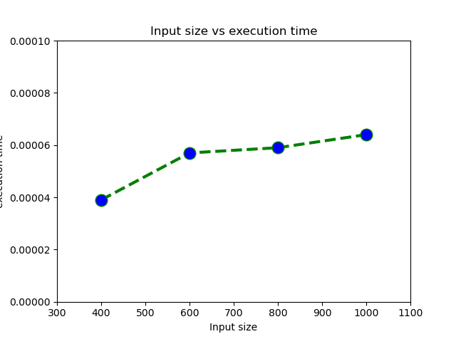

Screenshots:

