**Output: matrix multiplication**

|  |  |  |  |  |
| --- | --- | --- | --- | --- |
| **Input size** | **Execution Time- Number of Threads** | | | |
| **1** | **2** | **4** | **8** |
| 200 | 0.038320 | 0.020697 | 0.020348 | 0.019798 |
| 400 | 0.313005 | 0.167652 | 0.156913 | 0.184893 |
| 800 | 2.693079 | 1.320927 | 1.314265 | 1.322592 |
| 1000 | 6.121444 | 2.934827 | 2.738849 | 2.770755 |

Graphs:

1. Number of threads vs execution time (in seconds)

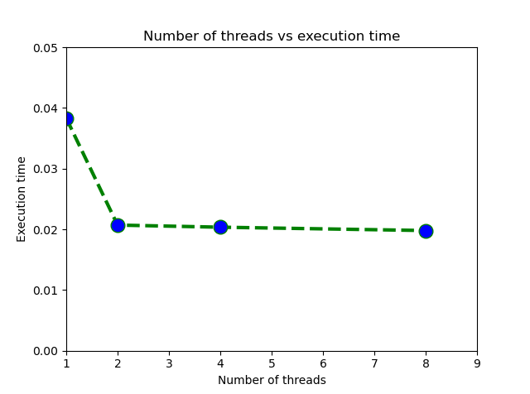

1. Input size vs execution time (in seconds)

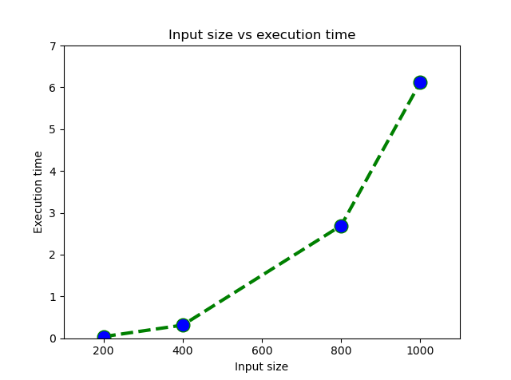

**Screenshots:**

