Trading Project

By Bhavya I007,Karan I008,Yash I024 Ananya I025

from tkinter import *

import yfinance as yf

import matplotlib.pyplot as plt

import pandas as pd

from matplotlib.backends.backend_tkagg import (FigureCanvasTkAgg, NavigationToolbar2Tk)

root = Tk()

root.geometry("600x400")

def stockgraph():

    start_date = '1990-01-01'

    end_date = '2021-07-12'

    # Ticker Name (Stock name )

    ticker = stockn.get()

    data = yf.download(ticker, start_date, end_date)

    data['Adj Close'].plot()

    # label

    plt.title("Adjusted Close Price of %s" % ticker, fontsize=16)

    # labels for  x-axis and y-axis

    plt.ylabel('Price', fontsize=14)

    plt.xlabel('Year', fontsize=14)

    # Grid lines

    plt.grid(which="major", color='k', linestyle='-.', linewidth=0.5)

    plt.show()

def compgraph():

    start_date = '1990-01-01'

    end_date = '2021-07-12'

    tickers_list = stockn.get().split(",")

    data = pd.DataFrame(columns=tickers_list)

    a = 0

    for ticker in tickers_list:

        data[ticker] = yf.download(ticker, start_date,end_date)['Adj Close']

    data.plot()

     # label

    plt.title("Comparing performance of stocks")

    # labels for  x-axis and y-axis

    plt.ylabel('Price', fontsize=14)

    plt.xlabel('Year', fontsize=14)

    # Grid lines

    plt.grid(which="major", color='k', linestyle='-.', linewidth=0.5)

    plt.show()

#Driver Code

def rec():

    start_date = '1990-01-01'

    end_date = '2021-07-12'

    tickers_list = stockn.get().split(",")

    data = pd.DataFrame(columns=tickers_list)

    a = 0

    for ticker in tickers_list:

       data[ticker] = yf.download(ticker, start_date,end_date)['Adj Close']

    fin = data.max().sort_values(ascending=FALSE)

    #fin = recom.max()

    recLabel = Label(root,text=f"Based on the annulised returns we recommend the stock {fin[:2]}")

    recLabel.grid(row=4,column=2)

title = Label(root,text="Welcome to Kenobi's Analytics",font="1")

title.grid(row=0,column=2)

stockn = Entry(root)

stockn.insert(0,"Enter Stock code")

stockn.grid(row=1,column=2)

empty = Label(root,text="")

empty.grid(row=2,column=0)

sLabel1=Label(root,text="Analyse a single stock",font="20")

sLabel1.grid(row=2,column=1)

sButton1=Button(master=root,text="Analyse",command = stockgraph,font="20")

sButton1.grid(row=2,column=2)

sLabel2=Label(root,text="Compare multiple stocks")

sLabel2.grid(row=2,column=3)

sButton2=Button(master=root,text="Analyse",command = compgraph,font="20")

sButton2.grid(row=2,column=4)

recbutton = Button(master=root,text="Our experct recommendations",command=rec)

recbutton.grid(row=3,column=2)

#Crewating an infinite loop which runs till we hit the 'X' button

root.mainloop()

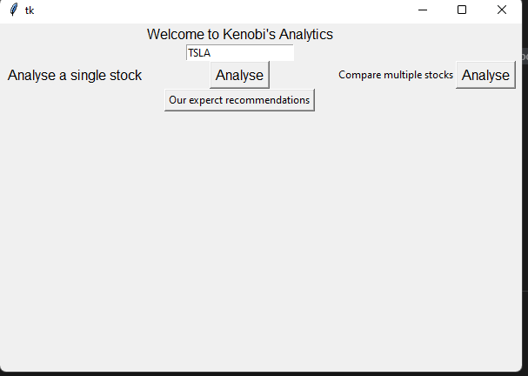

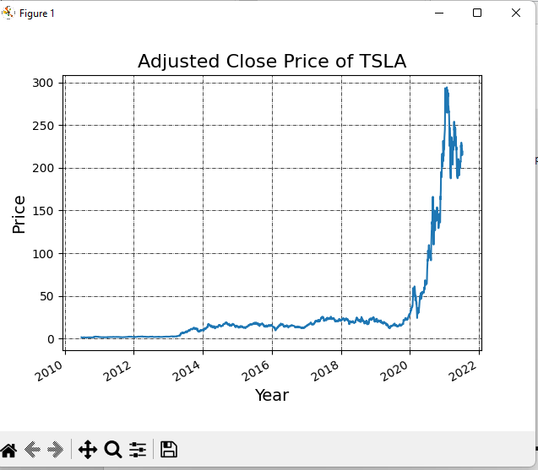

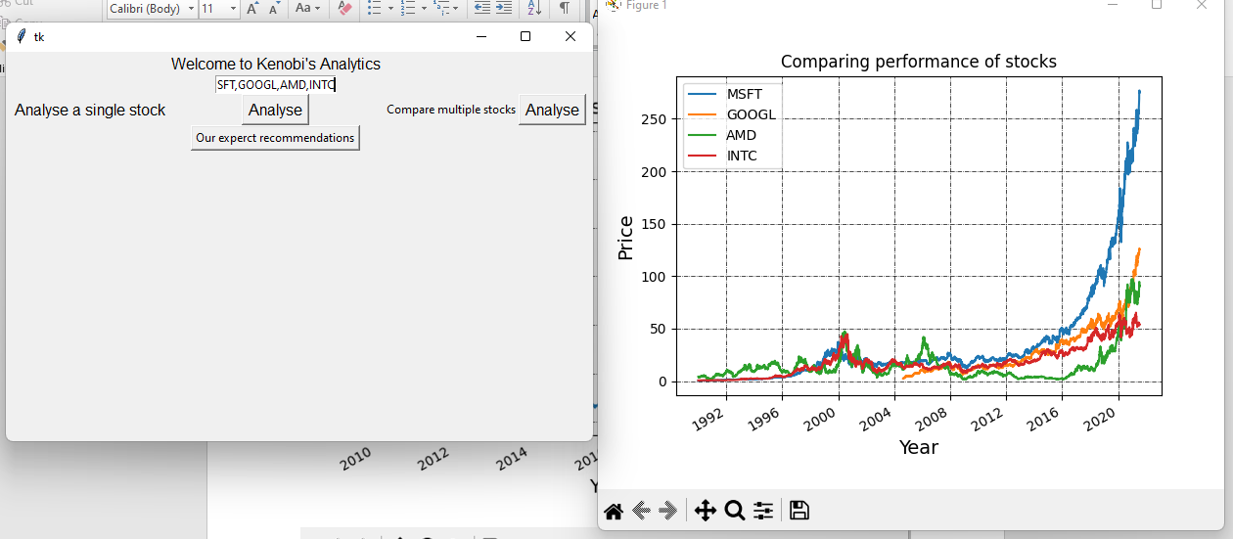

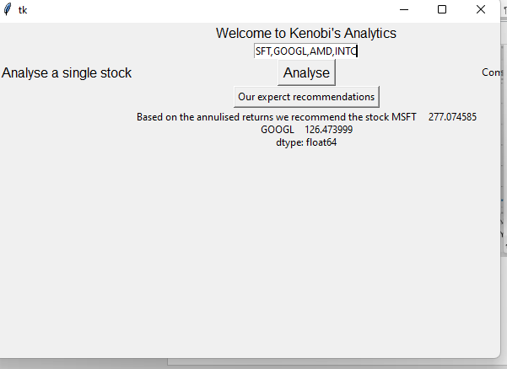

About the project: - it is about the stock market analysis and recommendations ,we have used the real time data from yahoo finance and performed analysis ,plotted graphs, recommended stocks based on their annual returns . we have also implemented GUI using tkinter .