# Please strictly follow the your own directories.

# Step 1: Place provided java.policy file at c:\

# Step 2: Compile Server Code as shown in below image.

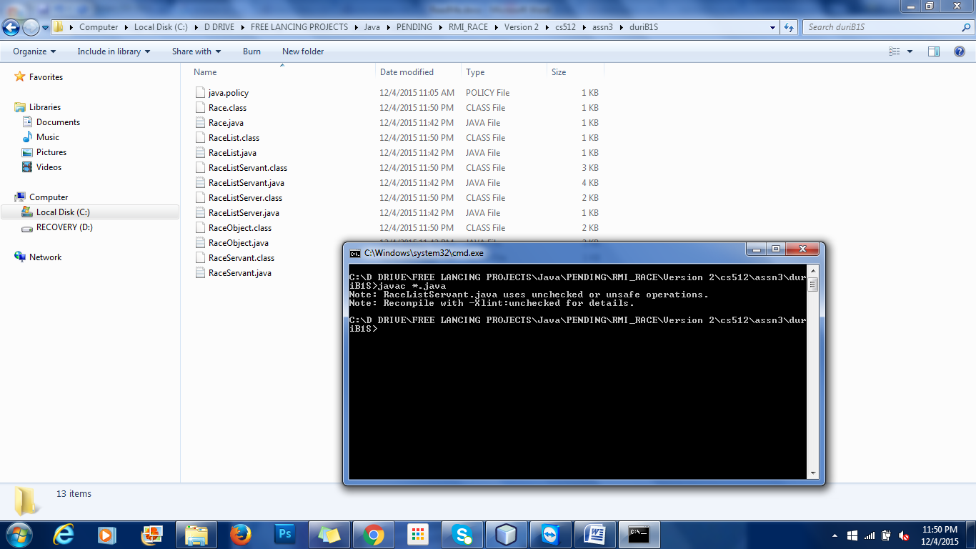

# Step 3: Compile Client code as shown in below image.

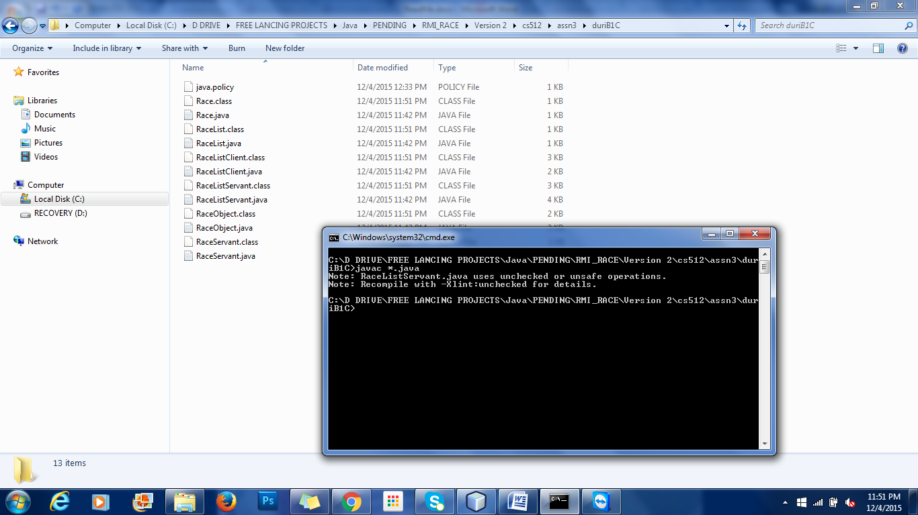

# Step 4: Start rmiregistry from the server class folder. As shown in image.

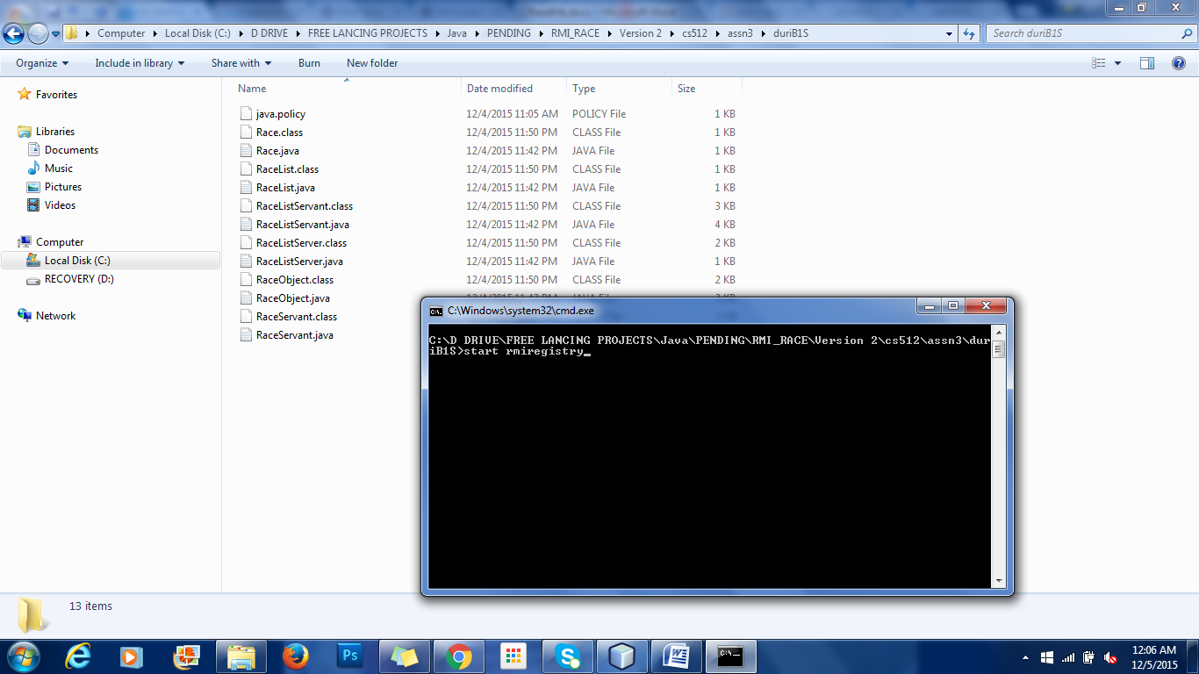

# Step 5: Open a new Command prompt and Start the RaceListServer as shown below

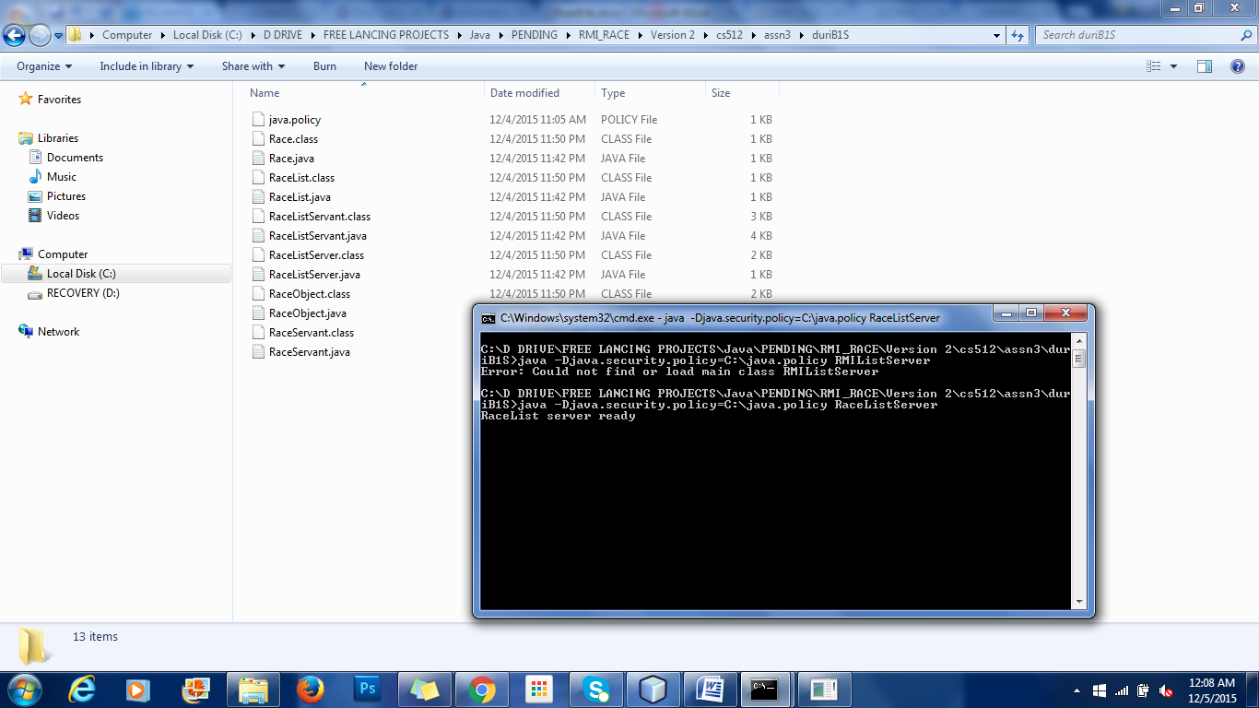

# Step 6: Open a new Command prompt and Start the RaceListClient as shown below

