1. Create a single folder using your name and SBU ID: FirstName_LastName_SBUID

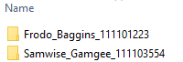

Put your source files, results and other files under this folder, zip and submit it through blackboard.

2. Under this folder, there should be at least two sub-folders named Results and Source. Put source files into Source folder and results into Results folder. **Only put results images** into the Results folder (excluding the input images) and name it like this:

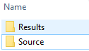 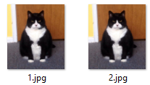

Index.jpg or index.png. The indices are in accordance with the question order.

3. Failing to comply to these instructions may severely delay the grading process of your homework.