Lab 2: Agile Backlog Creation & Sprint Simulation in Jira
Patient Health Record Consent Management System
Name: BHAVYA K
SRN: PES1UG24AM066

1. Jira Backlog
The Agile backlog was created from the functional and non-functional requirements of the Patient Health Record Consent Management System. Three Epics were created to organize the requirements, and seven User Stories were created and assigned priorities and Fibonacci story-point estimates.

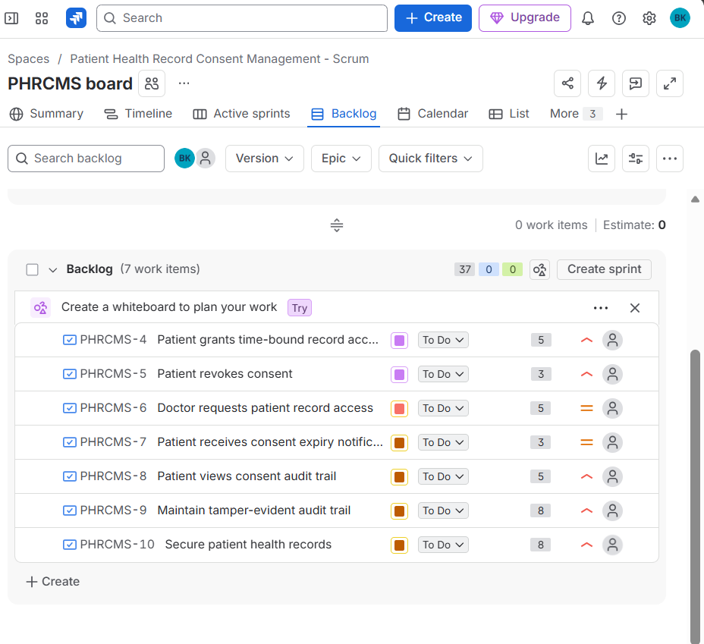

2. Sprint 1 – Sprint Board
Sprint 1 contained five User Stories with a total estimate of 21 story points. The stories were moved through the workflow from To Do to In Progress and then to Done. All five planned stories were completed during the sprint.
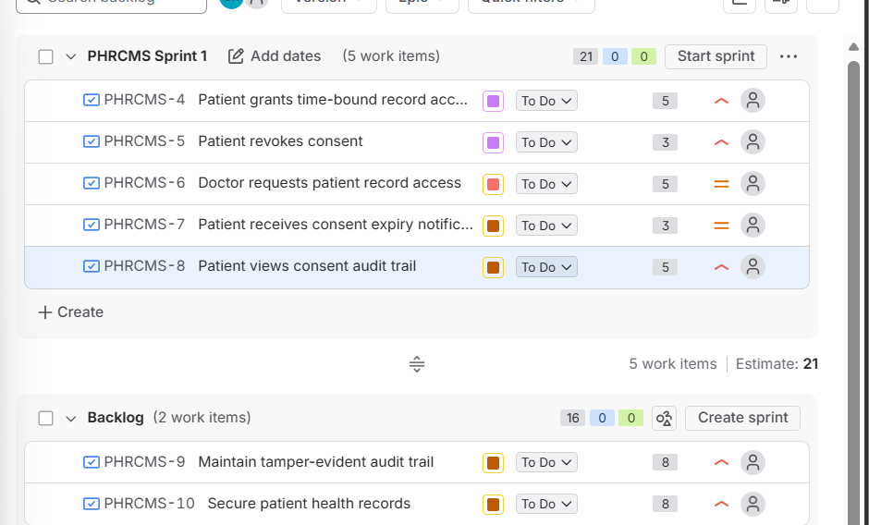

3. Sprint 1 – Burndown Chart
The Sprint 1 Burndown Chart was generated in Jira to visualize the remaining work against the guideline. The sprint started with 21 story points and the planned work was completed by the end of the sprint.
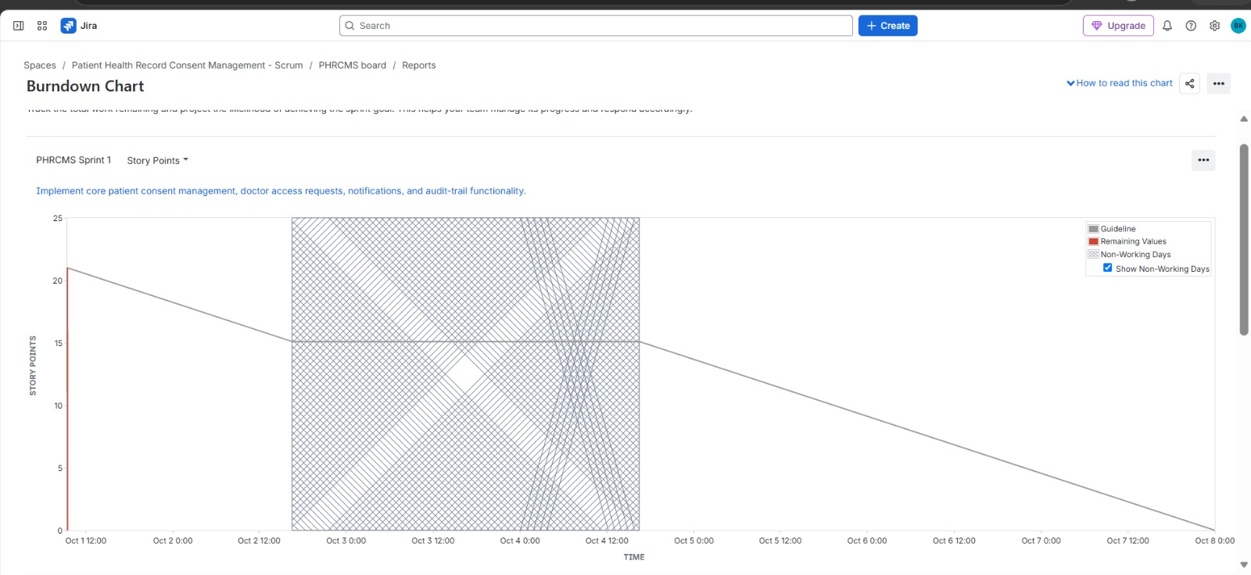

4. Sprint 2 – Sprint Report / Completion
Sprint 2 contained the two remaining User Stories: Maintain tamper-evident audit trail and Secure patient health records. Together they represented 16 story points. Both stories were completed and the sprint was closed successfully.

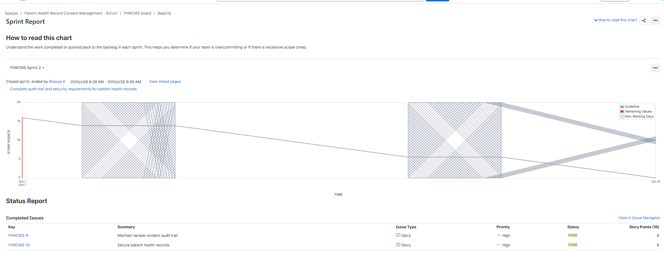

5. Sprint 2 – Burndown Chart
The Sprint 2 Burndown Chart shows the planned reduction of the 16 story points during the sprint. The chart provides a visual representation of sprint progress towards completion.
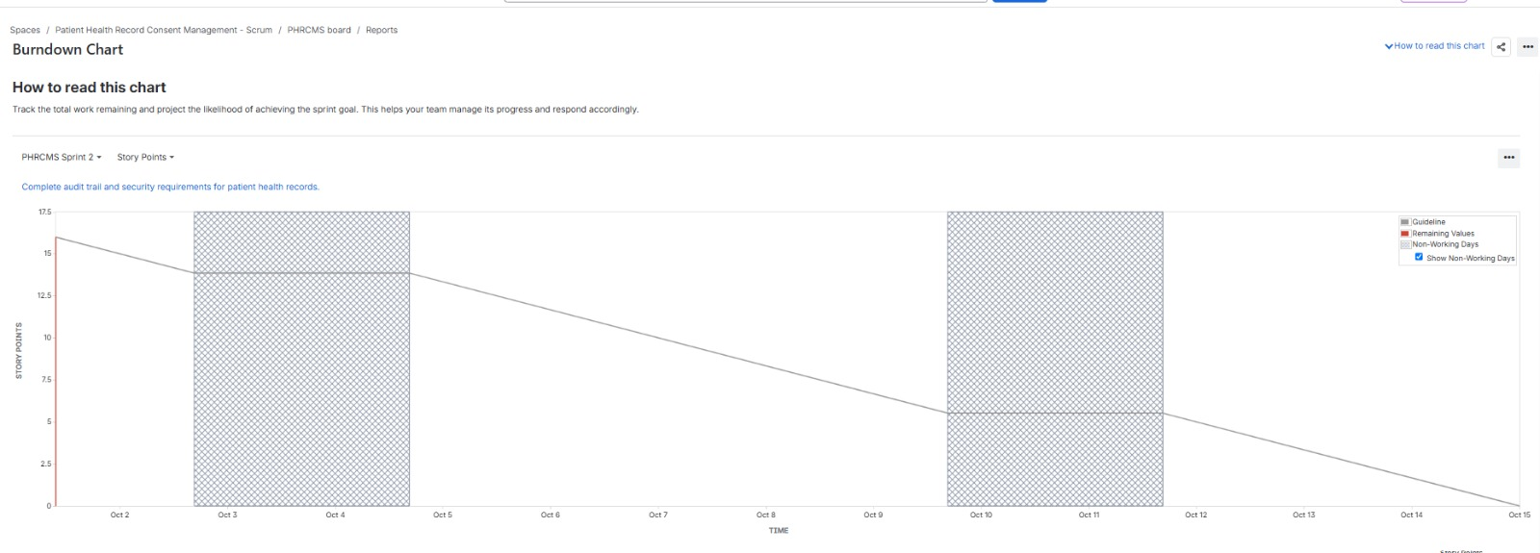

6. Reflection

6.1 Were the estimates accurate?
The story points were estimated using relative effort and complexity. The first sprint was planned with 21 points and all five selected stories were completed. The second sprint contained 16 points and both remaining stories were completed. Since the planned work was completed in both sprints, the estimates were reasonable for this simulation.

6.2 How did prioritization affect the sprint?
Prioritization helped organize the backlog according to importance. High-priority stories related to patient consent, revocation, auditability and security were identified, while medium-priority stories included doctor access requests and expiry notifications. This made it easier to select and organize the work for the sprint.

6.3 Did the sprint align with the sprint goal?
Yes. Sprint 1 focused on core patient consent management, doctor access requests, notifications and audit-trail functionality, and all five planned stories were completed. Sprint 2 focused on audit-trail and security requirements, and both planned stories were completed.

6.4 What did the burndown/capacity show?
The burndown charts provided a visual representation of the remaining story points during each sprint. Sprint 1 started with 21 points and Sprint 2 started with 16 points. The completed work reached zero remaining planned work by the end of each sprint, indicating that the planned sprint capacity was sufficient for the selected work in this simulation.

7. Conclusion
The Jira exercise demonstrated the Agile workflow from requirements to backlog creation, estimation, prioritization, sprint planning, execution and progress tracking. Two sprints were successfully simulated and completed. The backlog, sprint boards, sprint reports and burndown charts provide evidence of the Agile development process.

