2Wheeler Digital Instrument Cluster

Objective
The objective of this project is to design and demonstrate a real-time digital instrument cluster using an embedded Linux display unit.
The system simulates vehicle telemetry data such as speed, temperature, and tilt alerts, transmits it wirelessly using cloud infrastructure, and visualizes it on an automotive-style HMI.
This setup is intended to:
- Demonstrate cloud-connected vehicle telemetry
- Validate real-time data flow from sensors to display
- Showcase Qt/QML-based HMI development on embedded Linux

System Architecture Overview
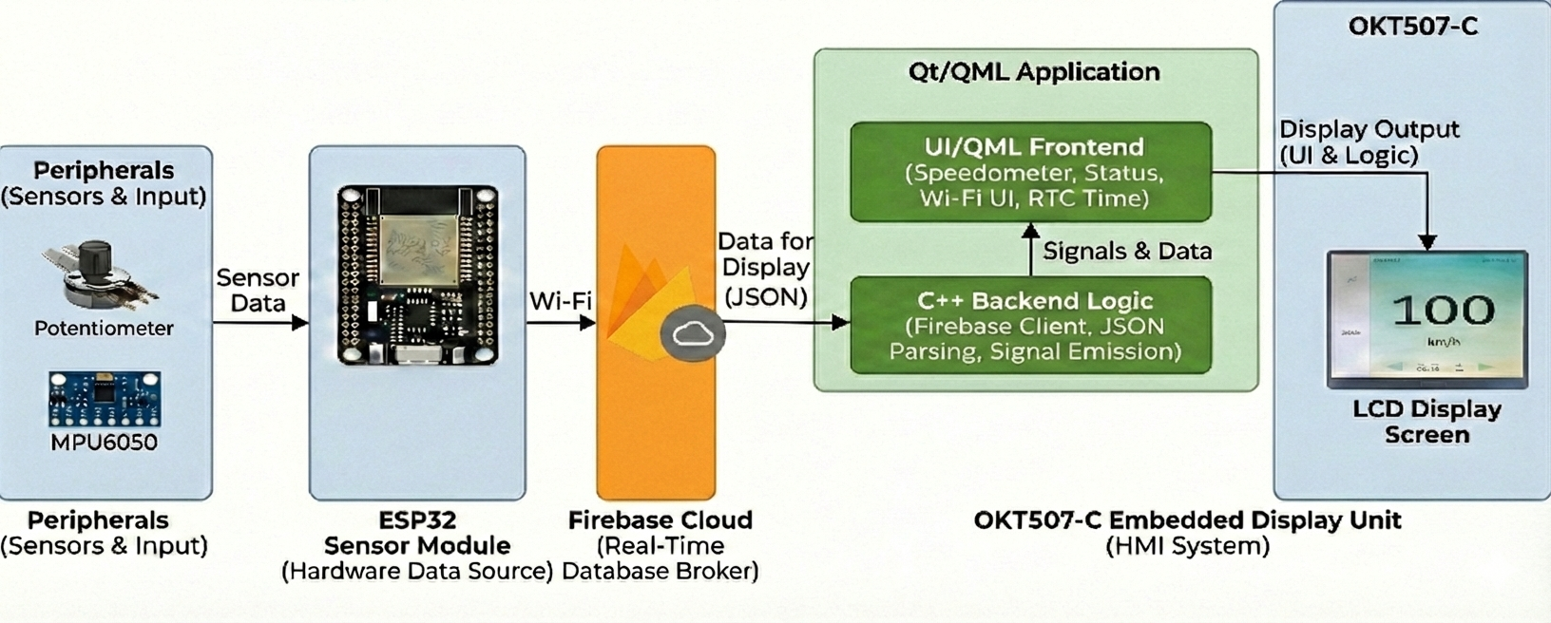

The system consists of three main layers:
- Sensor & Telemetry Layer
  - Sensors (Potentiometer, MPU6050) generate speed, tilt, and temperature data.
  - ESP32 acts as the telemetry gateway, collecting sensor data and pushing it to the cloud.
- Cloud Layer
  - Firebase Realtime Database is used as a cloud broker for real-time data exchange.
  - Enables decoupling between sensor hardware and display system.
- Display & HMI Layer
  - OKT507-C embedded display board fetches real-time data from Firebase.
  - Data is rendered on the LCD using a Qt/QML application.

My Contribution to the Project

Scope of Work
My contribution to the project was limited to the display and application layer.
I was responsible for retrieving real-time telemetry data from Firebase over Wi-Fi and displaying it on the OKT507-C embedded Linux board using a Qt/QML application.

Functional Responsibility
The work involved the following functional flow:
Firebase → Wi-Fi → Qt/C++ Backend → QML UI → OKT507-C Display

Detailed Work Description
- Implemented Firebase data retrieval logic on the OKT507-C board using Wi-Fi connectivity.
- Developed Qt/QML application logic to consume cloud data and update UI elements in real time.
- Implemented C++ backend logic to:
  - Fetch and parse JSON data received from Firebase
  - Expose processed data to QML using signals and properties
- Designed QML UI components to display:
  - Speed
  - Temperature
  - Tilt / alert status
- Ensured real-time synchronization between Firebase data updates and HMI display.
- Built and flashed the Qt/QML application onto the OKT507-C embedded Linux board running Linux.
- Verified correct rendering and live updates during system demos.

Technologies Used
- Embedded Board: OKT507-C
- Operating System: Embedded Linux
- Application Framework: Qt 5 / QML
- Programming Language: C++
- Cloud Backend: Firebase Realtime Database
- Connectivity: Wi-Fi
- Data Format: JSON

