A project report on

ADVANCED PREDICTIVE DIGITAL TWIN FOR INDUSTRIAL IOT MONITORING USING ONNX RUNTIME

Submitted in partial fulfillment for the award of the degree of

Bachelor of Technology in Computer Science and Engineering

by
BHAVYA KEERTHI K (22BCE8819)


SCHOOL OF COMPUTER SCIENCE ENGINEERING
July 2026
DECLARATION
I hereby declare that the project report entitled "Advanced Predictive Digital Twin for Industrial IoT Monitoring Using ONNX Runtime" submitted by me for the award of the degree of Bachelor of Technology in Computer Science Engineering is a record of bonafide work carried out by me under the supervision of the project guide.
I further declare that the work reported in this project has not been submitted, either in part or in full, for the award of any other degree or diploma in this institute or any other institute or university.

Place: Amaravati
Date: 03-07-2026

Signature of the Candidate



ABSTRACT
Industrial IoT (IIoT) systems require reliable, continuous monitoring of distributed devices, communication links, and environmental conditions. This report presents the design, implementation, and evaluation of an advanced predictive digital twin for a Modbus-over-GSM industrial network. The system simulates programmable logic controller (PLC) nodes, streams telemetry through a FastAPI backend over a WebSocket channel, performs machine-learning inference using a multi-task learning (MTL) model exported to the Open Neural Network Exchange (ONNX) format, and presents real-time operational status through a React dashboard.
The project demonstrates how temperature, latency, jitter, packet-loss probability, packet error rate, signal quality, and an inferred health score can be combined into a single practical monitoring interface. The twin supports configurable noise injection, multi-node comparison, automated alerting, and a closed-loop polling-rate optimization mechanism that reduces telemetry load under high-risk conditions. Exporting the trained model to the ONNX runtime yields an approximately 11.4x reduction in inference latency relative to the native PyTorch model (from 11.00 ms to 0.96 ms per inference) while numerical outputs remain within a 1x10-4 tolerance of the original model, confirming that runtime portability was achieved without sacrificing accuracy.
Beyond the working prototype, this report situates the project within the broader context of Industrial Internet of Things architectures and edge-inference practice: it reviews layered IIoT reference models, common field- and application-layer communication protocols, and the mechanics of the ONNX format and its runtime optimizations. The result is a proactive monitoring system that moves beyond reactive threshold alarms and provides early, interpretable insight into communication and device health, together with a discussion of how the same software pipeline could be extended toward a physical industrial deployment.

Keywords: Digital Twin, Industrial IoT, Predictive Maintenance, Multi-Task Learning, ONNX Runtime, Edge Inference, FastAPI, React, Modbus, GSM Communication, WebSocket, SCADA.
ACKNOWLEDGEMENT
It is my pleasure to express with deep sense of gratitude to Mr. Prakash Palanivel, Technical Head of Wiman Communication Technologies for his constant guidance, continual encouragement, understanding; more than all, he taught me patience in my endeavor. My association with him is not confined to the internship only, but it is a great opportunity on my part to work with an intellectual and expert in the field of Industrial Internet of Things (IIoT), Digital Twin Technology, and Artificial Intelligence. I also express my sincere gratitude to Dr. Manomita Chakraborty, Assistant Professor, School of Computer Science and Engineering (SCOPE), VIT-AP University, for her constant guidance, encouragement, and valuable suggestions throughout the course of this project.
I would like to express my gratitude to Dr. G. Viswanathan, Founder & Chancellor, Dr. Sekar Viswanathan and Dr. Sankar Viswanathan, Vice Presidents, Dr. P. Arulmozhivarman, Vice Chancellor (In-Charge), and Dr. S. Sudhakar Ilango, Dean, School of Computer Science and Engineering (SCOPE), VIT-AP University, for their inspiration and continuous support during the tenure of my course.
In jubilant mood I express ingeniously my whole-hearted thanks to Dr. G. Muneeswari , HOD for CSE Core and Data Science and Engineering, all teaching staff and members working as limbs of our university for their not-self-centered enthusiasm coupled with timely encouragements showered on me with zeal, which prompted the acquirement of the requisite knowledge to finalize my course study successfully. I would like to thank my parents for their support.
It is indeed a pleasure to thank my friends who persuaded and encouraged me to take up and complete this task. At last but not least, I express my gratitude and appreciation to all those who have helped me directly or indirectly toward the successful completion of this project.
Place: Amaravati
Date: 03-07-2026
Bhavya Keerthi K (22BCE8819)
CONTENTS
Section | Page
Declaration | 2
Certificate | 3
Abstract | 4
Acknowledgement | 5
List of Tables | 8
List of Figures | 10
List of Symbols, Abbreviations and Acronyms | 11
CHAPTER 1 INTRODUCTION | 13
CHAPTER 2 BACKGROUND AND LITERATURE SURVEY | 19
CHAPTER 3 SYSTEM ANALYSIS AND REQUIREMENTS | 28
CHAPTER 4 SYSTEM DESIGN AND ARCHITECTURE | 35
CHAPTER 5 IMPLEMENTATION | 41
CHAPTER 6 TESTING, RESULTS AND DISCUSSION | 49
CONCLUSION AND FUTURE WORK | 55
REFERENCES | 56
APPENDIX A INSTALLATION AND EXECUTION | 57
APPENDIX B CONFIGURATION PARAMETERS | 58
APPENDIX C GLOSSARY OF ADDITIONAL TERMS | 59
APPENDIX D ILLUSTRATIVE CODE LISTINGS | 60
LIST OF TABLES
Table No. / Title | Page
Table 1.1 System architecture of predictive digital twin | 14
Table 1.2 Common challenges when retrofitting legacy PLCs | 14
Table 2.1a Comparison of maintenance strategies | 20
Table 2.1b Comparison of common IIoT communication protocols | 23
Table 2.2 ONNX compared with alternative deployment formats | 26
Table 2.3 Related work compared with the present system | 27
Table 3.1 Functional and non-functional requirements | 30
Table 3.2 Requirement traceability matrix | 31
Table 3.3 Primary system actors | 29
Table 3.4 Use case: operator responds to a critical alert | 32
Table 4.1 Backend API and WebSocket responsibilities | 36
Table 5.1 Telemetry feature vector | 42
Table 5.2 Selected backend configuration parameters | 47
Table 5.3 Technology stack summary | 48
Table 6.1 Testing scenarios and expected observations | 50
Table 6.2 Summary of measured ONNX vs PyTorch latency | 52
Table 6.3 Objectives-to-outcomes comparison | 54
LIST OF FIGURES
Figure No. / Title | Page
Figure 1.1 System architecture of the predictive digital twin | 13
Figure 2.1 Industrial IoT (IIoT) reference architecture | 21
Figure 2.2 ONNX model export and optimization pipeline | 25
Figure 3.1 Telemetry simulation output under changing noise conditions | 28
Figure 4.1 Multi-task learning model architecture | 37
Figure 5.1 Multi-node telemetry comparison under normal conditions | 40
Figure 5.2 ONNX runtime inference latency benchmark | 43
Figure 5.3 Health score distribution and node classification | 44
Figure 5.4 Model suite performance comparison (feature contribution) | 45
Figure 5.5 Closed-loop polling-rate optimization | 46
Figure 6.1 Effect of GSM noise on system metrics | 50
Figure 6.2 PyTorch vs ONNX output validation | 51
Figure 6.3 Multi-task learning training convergence | 54
LIST OF SYMBOLS, ABBREVIATIONS AND ACRONYMS
Acronym | Expansion
API | Application Programming Interface
CoAP | Constrained Application Protocol
CPS | Cyber-Physical System
GPRS | General Packet Radio Service
GSM | Global System for Mobile Communication
HTTP | Hypertext Transfer Protocol
IIoT | Industrial Internet of Things
IoT | Internet of Things
JSON | JavaScript Object Notation
LSTM | Long Short-Term Memory
LoRaWAN | Long Range Wide Area Network
MQTT | Message Queuing Telemetry Transport
MTL | Multi-Task Learning
NB-IoT | Narrowband Internet of Things
ONNX | Open Neural Network Exchange
OPC-UA | Open Platform Communications Unified Architecture
PER | Packet Error Rate
PLC | Programmable Logic Controller
REST | Representational State Transfer
RTU | Remote Terminal Unit
RUL | Remaining Useful Life
SCADA | Supervisory Control and Data Acquisition
TCP/IP | Transmission Control Protocol / Internet Protocol
TLS | Transport Layer Security
WS | WebSocket

CHAPTER 1
INTRODUCTION
1.1 OVERVIEW
Industrial systems increasingly depend on remote controllers, distributed sensors, and wireless communication links. A digital twin provides a software representation of such a system and continuously updates its state using live telemetry. The project presented in this report implements a predictive digital twin for a Modbus-over-GSM industrial network.
The system focuses on monitoring programmable logic controller (PLC) nodes, observing temperature, latency, jitter, packet loss, and inferred health score. Instead of waiting for an operator to react after a fault, the application estimates packet error rate and failure probability so that maintenance actions can begin earlier.
A React dashboard, FastAPI backend, WebSocket telemetry stream, and multi-task learning (MTL) model together form the implementation. This combination creates an interactive monitoring environment where simulated physical behaviour, network conditions, and machine-learning output are presented in real time.
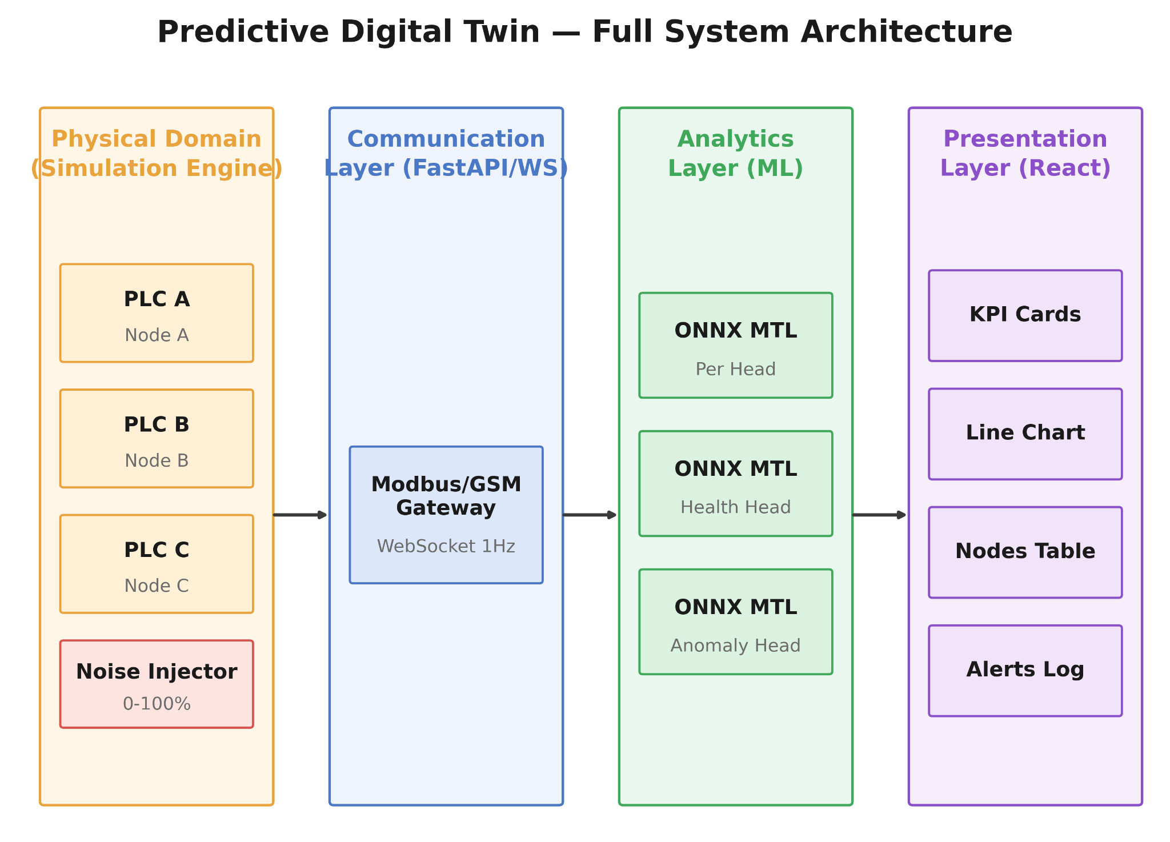
Figure 1.1 System architecture of the predictive digital twin
The practical value of the work is that it links software architecture with industrial maintenance needs. A user can change network noise, observe node response, review charts, and understand how control decisions affect monitoring quality. The project therefore serves both as a working prototype and as a learning model for predictive-maintenance systems.
Table 1.1 Project objectives and deliverables
# | Objective | Deliverable
1 | Real-time multi-node telemetry simulation | Modbus/GSM PLC simulator with configurable noise
2 | Live streaming to a web client | FastAPI backend with WebSocket telemetry stream
3 | Predictive health / risk estimation | ONNX multi-task learning inference module
4 | Operator-friendly visualization | React dashboard with KPI cards, charts, alerts
5 | Adaptive monitoring behaviour | Closed-loop polling-rate optimization
6 | Runtime portability | ONNX export pipeline validated against the source PyTorch model

1.2 INDUSTRIAL IoT: CONTEXT AND MOTIVATION
The Industrial Internet of Things (IIoT) extends conventional IoT concepts — networked sensing, low-cost connectivity, and cloud- or edge-based analytics — into factory floors, process plants, and remote field installations. Where consumer IoT typically optimizes for convenience, IIoT deployments are held to stricter requirements around determinism, uptime, and safety, because the devices being monitored are frequently tied to physical processes with real financial or safety consequences if they fail silently.
A significant fraction of legacy industrial assets were never designed with networked monitoring in mind. Programmable logic controllers deployed decades ago typically expose simple serial protocols such as Modbus RTU, intended for local supervisory control rather than remote analytics. Retrofitting such assets for IIoT visibility commonly means bridging a Modbus interface across a cellular (GSM/GPRS) link to a central or cloud-hosted monitoring service — exactly the scenario this project simulates. This bridging introduces new sources of impairment (latency, jitter, dropped packets) that are largely absent when a PLC is polled over a local, wired fieldbus, which is precisely why network-condition-aware monitoring, rather than simple threshold alarms, becomes valuable.
1.2.1 COMMON RETROFIT CHALLENGES
Table 1.2 summarizes recurring challenges reported when legacy PLC assets are retrofitted for remote IIoT visibility, and notes how the present project's design engages with each — either directly, or as an identified area for future physical-hardware work outside the current simulation-based scope.
Table 1.2 Common challenges when retrofitting legacy PLCs for IIoT visibility
Challenge | Typical Impact | How This Project Engages With It
Serial-only Modbus interfaces | No native path to remote monitoring | Simulated by the Modbus/GSM gateway component
Unstable cellular links | Missed or delayed telemetry | Modeled by the noise-injection parameter (Section 4.2)
Limited on-device compute | Cannot run heavy models at the edge | Addressed via a compact ONNX model (Section 2.4)
Sparse historical data | Hard to train accurate predictive models | Noted as a limitation in Section 6.8
Heterogeneous device fleets | Difficult to generalize a single model | Left as future work (Conclusion)

This project is therefore motivated by two converging trends: first, the continued extension of monitoring and analytics to remote, cellular-connected industrial assets; and second, the increasing practicality of running machine-learning inference close to the data path rather than purely offline, made possible by optimized, portable runtimes such as ONNX Runtime. Section 1.3 and Chapter 2 examine both threads — the digital twin paradigm and IIoT architecture respectively — in more detail before the system requirements are derived in Chapter 3.
1.3 THE DIGITAL TWIN PARADIGM
A digital twin is a virtual representation of a physical asset, process, or system that is kept synchronized with its physical counterpart through a continuous flow of data, and that can be used to monitor, simulate, or predict the behaviour of that counterpart. The concept is generally attributed to Grieves, who described a three-part model consisting of a physical product, a virtual product, and the connections between them that tie the two together throughout the product's lifecycle.
Digital twins are commonly grouped into three levels of sophistication. A descriptive twin mirrors the current state of the physical asset without further analysis — essentially a live dashboard. A predictive twin, the category this project belongs to, additionally uses historical and current data to estimate future states, risks, or failure probabilities. A prescriptive twin goes further still, recommending or automatically triggering corrective actions. The system described in this report sits at the predictive level, with a simple, deliberately transparent step toward prescriptive behaviour in the form of its closed-loop polling-rate optimization, described in Chapter 4.
What distinguishes a digital twin from an ordinary monitoring dashboard is the fidelity and update frequency of the synchronization between virtual and physical states, and the presence of a model — statistical, physics-based, or learned — capable of representing how the asset degrades or responds to changing conditions. In this project, the PLC/GSM simulator plays the role of the physical asset (deliberately, since connecting to real hardware was outside the project's scope), the FastAPI/WebSocket layer provides the synchronization channel, and the multi-task learning model provides the predictive behaviour.
1.4 PROBLEM STATEMENT
Traditional industrial monitoring dashboards are often reactive. They show an alarm only after a temperature threshold or network error has already crossed a critical level. In a remote, GSM-connected environment, delayed reaction can cause loss of telemetry, incorrect control actions, or avoidable downtime.
The problem addressed in this work is the absence of a unified, predictive view of machine and network health. Operators need a tool that converts raw telemetry into health indicators and also explains whether network impairment, thermal stress, or polling behaviour is contributing to risk. The project therefore models a distributed industrial network and uses predictive analytics to transform measurements into a proactive decision-support interface.
1.5 OBJECTIVES AND SCOPE
The primary objective is to build a real-time digital twin that mirrors multiple PLC nodes and streams telemetry to a web dashboard. The secondary objective is to include predictive intelligence so that the twin does not merely display values but estimates risk from the temporal pattern of values.
The implementation also aims to demonstrate the benefit of ONNX runtime deployment: model inference must be lightweight enough to execute during a one-hertz telemetry loop without disturbing the responsiveness of the application. A further objective is to provide clear visualization — health cards, node tables, charts, attention profiles, and alert logs — so that a user can understand the operational state without reading raw logs.

The scope of the project is limited to a simulated Modbus-over-GSM environment; it does not connect to physical PLC hardware. The scope does, however, cover the full software pipeline — from telemetry generation to predictive inference to dashboard presentation — so that the same pipeline can later be pointed at a real industrial network with minimal change. Physical-layer concerns such as antenna placement, SIM provisioning, and PLC firmware configuration are explicitly out of scope.
1.6 CONTRIBUTIONS OF THE PROJECT
In summary, this project makes the following practical contributions:
- A configurable multi-node PLC/GSM telemetry simulator that separately models thermal and network fault behaviour, enabling repeatable scenario testing.
- An end-to-end streaming pipeline (FastAPI + WebSocket) that delivers telemetry and inference results to a browser client once per telemetry tick.
- A compact multi-task learning model that jointly predicts packet error rate, health score, an anomaly-related reconstruction signal, and temporal attention from a single shared backbone, rather than training four separate models.
- An ONNX export and validation pipeline that measures and confirms both the latency benefit and the numerical accuracy preserved after conversion.
- A closed-loop polling-rate control mechanism that demonstrates how analytics output can be fed back into data-acquisition behaviour.
- A React operator dashboard that presents all of the above without requiring the user to read raw logs or JSON payloads.
1.7 ORGANIZATION OF THE REPORT
The remainder of this report is organized as follows. Chapter 2 reviews background literature on digital twins, predictive maintenance, Industrial IoT architecture and communication protocols, and the ONNX ecosystem for portable model inference. Chapter 3 analyses the system requirements, actors, use cases, and constraints. Chapter 4 describes the layered system architecture, including the analytics layer's model design and the ONNX optimization pipeline. Chapter 5 discusses the implementation of the simulator, backend, analytics, and dashboard in more detail. Chapter 6 presents testing methodology, validation results, and a discussion of findings and limitations. The report concludes with a summary of findings, a comparison against the original objectives, and directions for future work.
1.8 SUMMARY
This chapter introduced the motivation, problem statement, objectives, and scope of the project, and situated it within the broader IIoT and digital-twin context. The next chapter reviews the background literature and technology choices — digital twins, predictive maintenance, IIoT protocols, and ONNX — that inform the system design presented in Chapter 4.
CHAPTER 2
BACKGROUND AND LITERATURE SURVEY
2.1 DIGITAL TWINS IN INDUSTRIAL SYSTEMS
Digital twins have become important in industrial cyber-physical systems because they allow experimentation, condition monitoring, and predictive maintenance without interrupting the physical process. Lee describes cyber-physical systems broadly as integrations of computation, networking, and physical processes, in which embedded computers and networks monitor and control physical processes with feedback loops in which physical processes affect computations and vice versa. A digital twin can be viewed as a specialization of this idea, focused on maintaining a live, model-backed replica of one specific physical asset or process.
A twin is most useful when it is synchronized with live data and when its model is detailed enough to represent expected degradation. Tao et al. survey the use of digital twins across the product lifecycle, from design through manufacturing to in-service operation, and note that the value of a twin grows substantially when it is combined with large volumes of operational data and analytics capable of turning that data into actionable predictions rather than passive display — precisely the gap this project's predictive layer is intended to fill for a small-scale IIoT network.
2.2 PREDICTIVE MAINTENANCE APPROACHES
Maintenance strategies are commonly grouped into three categories. Reactive (run-to-failure) maintenance repairs equipment only after it fails, which is simple but risks unplanned downtime. Preventive maintenance performs repairs on a fixed schedule regardless of actual condition, which reduces unplanned failures but can waste maintenance effort on healthy equipment. Predictive maintenance, also called condition-based maintenance, instead uses sensor data to estimate the current health or remaining useful life (RUL) of equipment and schedules interventions only when warranted. The system in this report follows the predictive approach, using live telemetry rather than a fixed calendar to decide when a node's condition warrants attention.
Predictive maintenance research commonly applies time-series models, anomaly detection, and regression-based health estimation. Long Short-Term Memory (LSTM) networks, introduced by Hochreiter and Schmidhuber, are frequently used for temporal dependencies because their gated memory cells mitigate the vanishing-gradient problem that limits simple recurrent networks on long sequences. Tree-based and kernel-based models are useful for nonlinear classification and regression tasks, particularly when interpretability of individual feature contributions matters more than sequential memory. This project draws on the same general principle — using recent temporal history to estimate current risk — but implements it through a compact multi-task learning network with a temporal-attention mechanism rather than a single-purpose LSTM or tree-based model, so that packet error rate, health score, and an anomaly signal can all be produced from one shared representation.
Table 2.1a Comparison of maintenance strategies
Strategy | Trigger | Main Advantage | Main Drawback
Reactive | Failure occurs | Simple, no monitoring needed | Unplanned downtime, higher damage risk
Preventive | Fixed schedule | Predictable maintenance windows | May service healthy equipment unnecessarily
Predictive (used here) | Estimated condition/risk | Interventions timed to actual need | Requires reliable sensing and a trained model

2.3 INDUSTRIAL IoT ARCHITECTURE AND COMMUNICATION PROTOCOLS
IIoT deployments are typically described using a layered reference architecture that separates concerns from the physical sensor up to the end-user application. Figure 2.1 shows the five-layer view used to position this project's components: a perception/device layer of PLCs and sensors, a network/connectivity layer that carries telemetry off-site, an edge/fog layer that performs local pre-processing and protocol translation, a platform/cloud layer that aggregates data and serves model inference, and an application layer that presents information to operators.
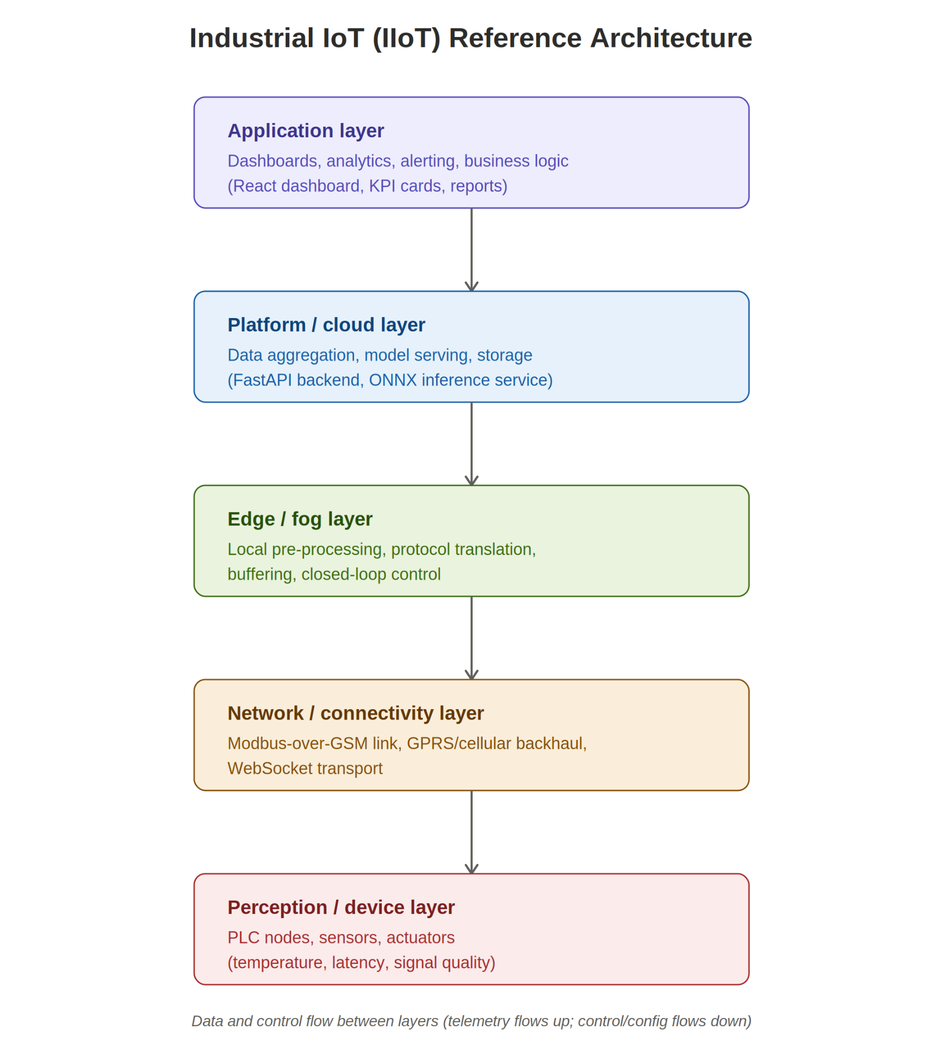
Figure 2.1 Industrial IoT (IIoT) reference architecture

Mapping this project onto the reference architecture: the simulator plays the perception/device layer; the Modbus-over-GSM link represents the network/connectivity layer; the FastAPI backend spans the edge/fog and platform/cloud layers, since it performs both local buffering and model inference; and the React dashboard is the application layer.

2.3.1 FIELD-LEVEL PROTOCOL: MODBUS
Modbus is a request-response protocol originally developed for programmable logic controllers and still widely deployed across process and discrete manufacturing industries because of its simplicity and broad device support. In its serial (RTU) form it addresses a small number of function codes for reading and writing coils, discrete inputs, holding registers, and input registers; a TCP variant carries the same data model over standard networking. Because Modbus itself is a polling protocol with no native support for cellular transport, real-world remote deployments typically pair it with a gateway that bridges Modbus frames over a GSM/GPRS modem — the exact pairing this project's simulator represents through its 'Modbus/GSM Gateway' component shown in Figure 1.1.
2.3.2 CELLULAR CONNECTIVITY FOR REMOTE ASSETS
Where a wired fieldbus is impractical — remote pumping stations, pipeline monitoring, agricultural or utility assets — cellular connectivity is a common bridge back to a central system. Classic GSM/GPRS modems offer wide coverage and low hardware cost but comparatively high and variable latency, modest throughput, and connection instability under poor signal conditions, which is exactly the behaviour this project's noise-injection model is designed to approximate. Newer low-power wide-area options such as NB-IoT and LoRaWAN trade throughput for much lower power consumption and longer range, and are worth noting as an alternative connectivity choice for battery-powered IIoT endpoints, even though they are outside this project's simulated GSM scenario.
2.3.3 APPLICATION-LAYER IoT PROTOCOLS
Above the field and network layers, a range of application-layer protocols carry telemetry to dashboards, brokers, and analytics services. MQTT is a lightweight publish/subscribe protocol favoured for constrained devices and unreliable links because of its small header overhead and configurable quality-of-service levels. CoAP offers a similarly lightweight, RESTful-over-UDP alternative suited to very constrained devices. OPC-UA is a richer, platform-independent standard common in factory automation, offering built-in security and a standardized information model at the cost of greater implementation complexity. This project instead uses a WebSocket connection carrying JSON payloads between the FastAPI backend and the React frontend — a pragmatic choice for a browser-facing dashboard, since WebSocket is natively supported by web clients without an additional broker, while still providing the persistent, low-latency, server-push behaviour that a polling REST API would lack. Table 2.1 compares these options along dimensions relevant to this project's design choice.
Table 2.1b Comparison of common IIoT communication protocols
Protocol | Transport | Pattern | Typical Use | Relative Overhead
Modbus RTU/TCP | Serial / TCP | Request-response (poll) | Field-level PLC access | Low
MQTT | TCP | Publish/subscribe | Constrained-device telemetry | Very low
CoAP | UDP | Request-response / observe | Very constrained devices | Very low
OPC-UA | TCP | Client-server, pub/sub | Factory automation, rich data models | High
WebSocket (used here) | TCP | Persistent, server push | Browser-facing live dashboards | Low
HTTP REST | TCP | Request-response (poll) | Occasional status queries | Medium (per poll)

2.4 ONNX AND CROSS-FRAMEWORK MODEL INTEROPERABILITY
Edge deployment is another important concern for predictive-maintenance systems. A model that performs well during training may still be unsuitable for live monitoring if inference is slow, memory-hungry, or tied to a training-time framework that is inconvenient to run inside a production backend. The Open Neural Network Exchange (ONNX) format addresses this by defining a framework-independent representation of a trained model's computation graph, together with a runtime (ONNX Runtime) capable of executing that graph efficiently across CPUs, GPUs, and specialized accelerators.
2.4.1 THE ONNX FORMAT AND COMPUTATION GRAPH
An ONNX model is stored as a protocol-buffer serialization of a directed acyclic graph: nodes represent standardized mathematical operators (matrix multiplication, convolution, activation functions, and so on) drawn from a versioned operator set (opset), and edges represent tensors flowing between them. Because the operator definitions are versioned and framework-agnostic, a graph exported from PyTorch can, subject to operator coverage, be executed by any ONNX-compliant runtime without requiring PyTorch itself to be installed at inference time — the property this project relies on to keep the FastAPI backend free of a full deep-learning training stack.
2.4.2 ONNX RUNTIME EXECUTION PROVIDERS AND GRAPH OPTIMIZATION
ONNX Runtime executes a loaded graph through a pluggable execution provider, which maps operators onto available hardware — for example a CPU execution provider using optimized kernels, or a GPU/accelerator-specific provider where available. Before execution, the runtime applies graph-level optimizations such as constant folding (pre-computing sub-graphs whose inputs are already known), operator fusion (combining sequences of operators, such as a linear layer followed by an activation, into a single kernel call), and redundant-node elimination. These optimizations reduce the number of kernel launches and memory round-trips required per inference, which is a primary reason the exported model in this project runs substantially faster than the equivalent PyTorch graph evaluated eagerly, as quantified in Chapter 6.
2.4.3 MODEL COMPRESSION FOR EDGE INFERENCE
Beyond graph-level optimization, ONNX models can be further compressed through quantization — representing weights and activations using lower-precision numeric types such as INT8 or FP16 instead of FP32 — and through pruning of redundant weights. Quantization in particular can reduce both memory footprint and inference latency substantially, at the cost of a small, usually acceptable, accuracy loss that must be validated against the original model, in the same spirit as the PyTorch-versus-ONNX parity check performed in Section 6.4 of this report. The multi-task model in this project is exported at full FP32 precision, since the measured latency already comfortably fits the one-hertz telemetry budget; quantization is noted here as a natural next step should the model be deployed on more constrained edge hardware, and is revisited in the Future Work section of the conclusion.
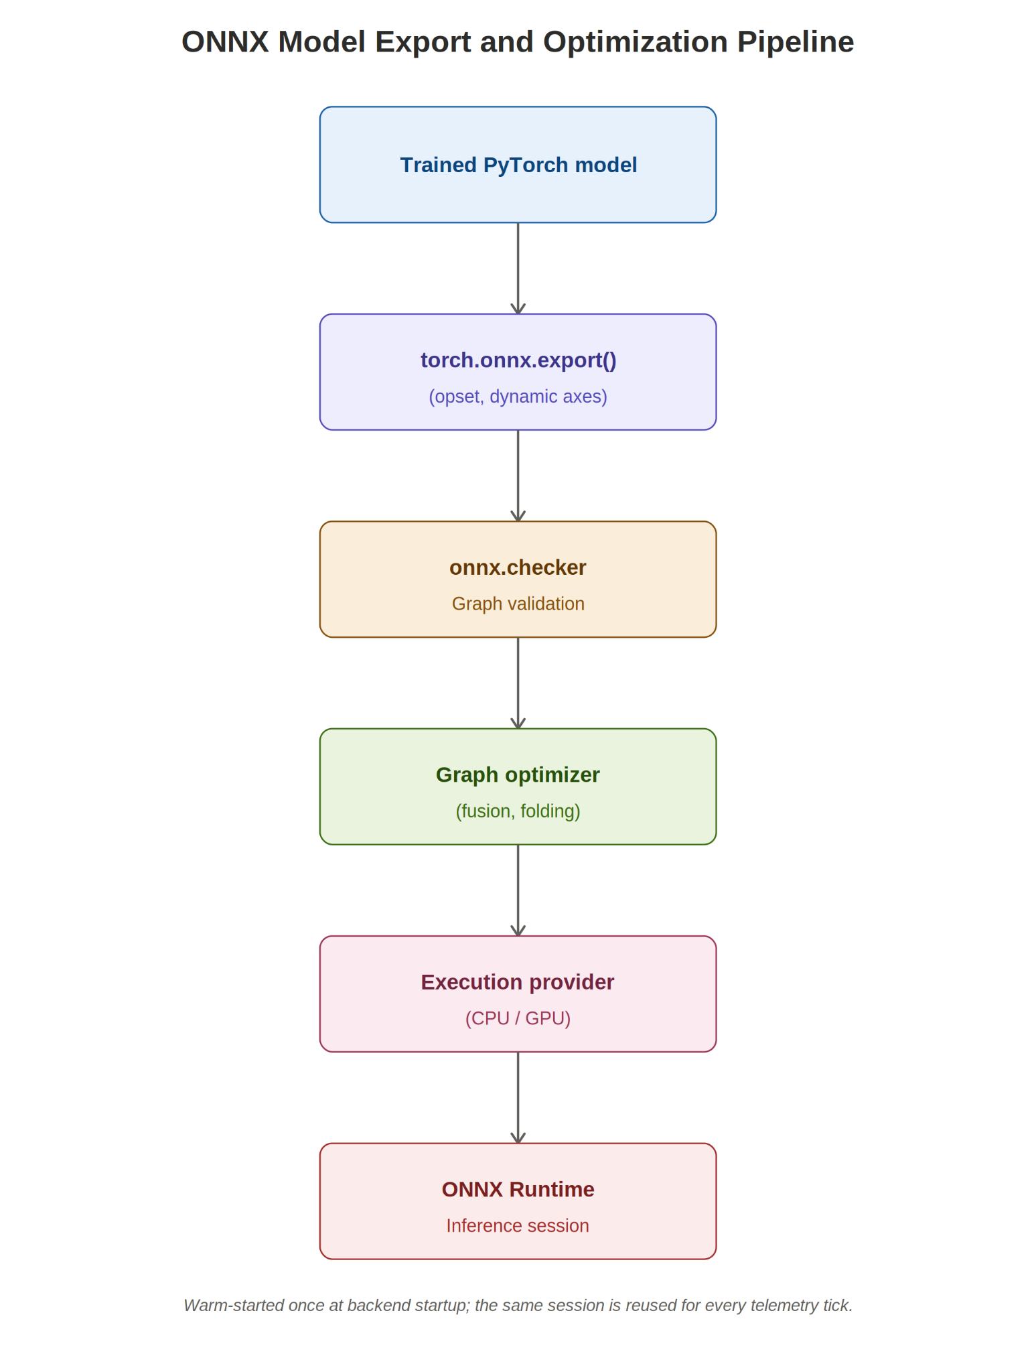

Figure 2.2 ONNX model export and optimization pipeline

2.4.4 COMPARISON WITH ALTERNATIVE DEPLOYMENT FORMATS
ONNX is one of several options for deploying a trained model outside its original training framework. TorchScript serializes a PyTorch model's graph directly and is convenient when the serving environment is guaranteed to be PyTorch, but is less portable across frameworks. TensorFlow Lite targets mobile and embedded devices with aggressive size and latency optimization but is tied to the TensorFlow ecosystem. ONNX was selected for this project because it decouples the training framework (PyTorch, used to develop the multi-task model) from the serving framework (a plain Python/FastAPI backend), and because ONNX Runtime's CPU execution provider gives strong latency without requiring GPU hardware in the deployment environment. Table 2.2 summarizes the comparison.
Table 2.2 ONNX compared with alternative deployment formats
Format | Framework Coupling | Typical Target | Notable Strength
ONNX (used here) | Framework-independent | CPU/GPU servers, edge | Portability + broad runtime support
TorchScript | PyTorch only | PyTorch-native serving | Minimal export friction
TensorFlow Lite | TensorFlow only | Mobile / microcontrollers | Aggressive size reduction
Native framework (eager) | Framework only | Research / training | Simplicity, debuggability

2.5 RELATED WORK COMPARISON
Existing predictive-maintenance literature and open tooling largely treat simulation, model inference, and visualization as separate concerns, each evaluated independently. Table 2.3 positions the present system against three representative categories of related work along dimensions relevant to this project's goals.

Table 2.3 Related work compared with the present system
Category | Simulated Fault Injection | Live Streaming Dashboard | Portable (ONNX) Inference | Closed-loop Control
Classical SCADA/HMI dashboards | No | Yes | No | No
Offline predictive-maintenance research models | N/A (uses recorded data) | No | Rarely | No
Generic IoT dashboard templates | No | Yes | No | No
This project | Yes | Yes | Yes | Yes (simple)

2.6 RESEARCH GAP
Few openly documented systems combine a controllable network/fault simulator, a multi-task inference model exported to an optimized runtime, and a live operator dashboard into a single closed loop. This project addresses that gap by unifying telemetry simulation, ONNX-based multi-task inference, and real-time visualization into one end-to-end system, and by using the resulting prototype to study how monitoring quality changes as network conditions degrade — a question that is difficult to study with either a purely offline dataset or a purely descriptive (non-predictive) dashboard.
CHAPTER 3
SYSTEM ANALYSIS AND REQUIREMENTS
3.1 SYSTEM ANALYSIS
The problem addressed in this work is the absence of a unified, predictive view of machine and network health. Operators need a tool that converts raw telemetry into health indicators and also explains whether network impairment, thermal stress, or polling behaviour is contributing to risk. The project therefore models a distributed industrial network and uses predictive analytics to transform measurements into a proactive decision-support interface.

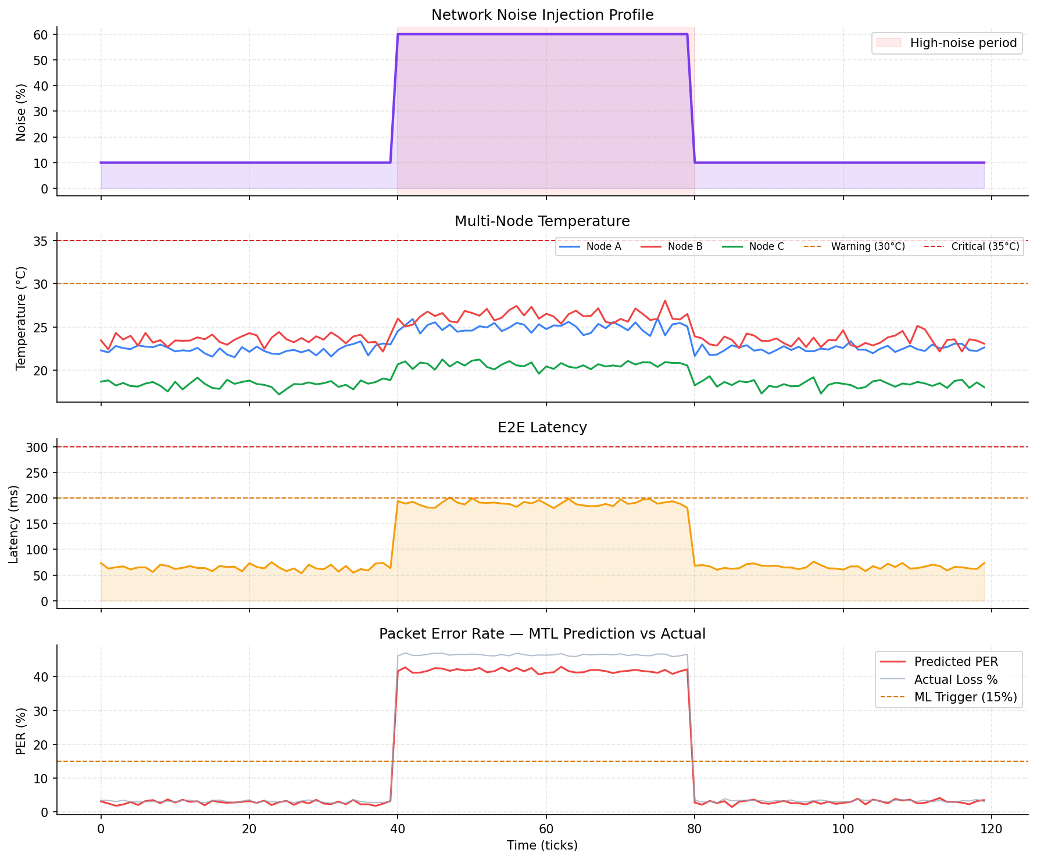
Figure 3.1 Telemetry simulation output under changing noise conditions

As shown in Figure 3.1, when the injected noise level rises during the high-noise period, end-to-end latency and predicted packet error rate rise together, while node temperature is comparatively unaffected — confirming that the simulator separates thermal and network fault behaviour as intended.

3.2 STAKEHOLDER AND ACTOR ANALYSIS
Three primary actors interact with the system, each with distinct goals. The field/maintenance operator is the main consumer of the dashboard and is primarily interested in current health and any active alerts. The reliability or maintenance engineer is more interested in trends over time and in the diagnostic detail offered by the AI/ML analysis view — for example, which telemetry feature is contributing most to a predicted risk. The system administrator is responsible for configuring noise/fault scenarios during testing and demonstration, and for confirming that the backend and inference session remain healthy. Table 3.3 summarizes these actors and their primary interactions with the system.
Table 3.3 Primary system actors
Actor | Primary Goal | Main Interface Used
Field / maintenance operator | See current health and alerts at a glance | Dashboard tab, Alerts tab
Reliability / maintenance engineer | Understand trends and contributing factors | AI/ML Analysis tab, charts
System administrator | Configure scenarios, verify system health | Node Management tab, control endpoints

3.3 FUNCTIONAL REQUIREMENTS
- The system shall simulate at least three PLC nodes with independent temperature and latency baselines.
- The system shall stream live telemetry to connected clients using a WebSocket connection.
- The system shall allow the operator to adjust a network noise parameter from 0% to 100%.
- The system shall compute a predicted packet error rate, health score, and failure risk for each node using the ONNX inference model.
- The system shall raise and log alerts when a node transitions between healthy, warning, and critical states.
- The system shall allow the operator to select which PLC node is active for focused inspection.
- The system shall expose a control endpoint to enable or disable closed-loop machine-learning polling control.
3.4 NON-FUNCTIONAL REQUIREMENTS
- Performance: model inference must complete within the one-hertz telemetry loop without perceptible delay.
- Usability: the dashboard must present health, latency, and risk information without requiring the operator to read raw logs.
- Modularity: the simulation, backend, analytics, and presentation layers must be independently replaceable.
- Portability: the trained model must run through the ONNX runtime so that it is not tied to a single training framework.
- Maintainability: configuration values (noise thresholds, alert bands, polling intervals) should be centralized rather than hard-coded across modules.
- Resilience: a temporarily disconnected frontend client must not interrupt the backend's telemetry loop or inference buffer.

3.5 REQUIREMENT TRACEABILITY MATRIX
Table 3.2 traces each major functional requirement to the architectural component responsible for satisfying it and the chapter in which that component is discussed, so that coverage can be verified at a glance.
Table 3.2 Requirement traceability matrix
Requirement | Responsible Component | Discussed In
Multi-node simulation | Simulation layer / PLC node models | Chapter 4 (4.2), Chapter 5 (5.2)
WebSocket streaming | FastAPI backend / WebSocket endpoint | Chapter 4 (4.3), Chapter 5 (5.3)
Predictive inference | MTL model + ONNX Runtime session | Chapter 4 (4.5-4.6), Chapter 5 (5.4)
Alert logging | Health-score classifier + alert log | Chapter 5 (5.5)
Adjustable noise | Simulation layer noise parameter | Chapter 4 (4.2)
Closed-loop control | Backend polling-interval controller | Chapter 4 (4.3), Chapter 5 (5.8)

3.6 USE CASE DESCRIPTION
The frontend is organized around a sidebar navigation layout. The dashboard tab shows global system health, predicted packet error rate, failure risk, ONNX latency, telemetry charts, node health distribution, and node table details.
The node management tab focuses on individual PLC nodes and noise controls. The alerts tab records status transitions. The AI/ML analysis tab visualizes model behaviour such as temporal attention and feature contribution.
The interface uses restrained enterprise dashboard styling — compact cards, neutral backgrounds, high-contrast status colours, and tabular numeric formatting — which makes the dashboard suitable for repeated monitoring rather than a marketing-style page.
Table 3.4 walks through one representative use case in structured form, showing how the actors introduced in Section 3.2 interact with the system when a node's condition degrades.
Table 3.4 Use case: operator responds to a critical alert
Field | Description
Actor | Field / maintenance operator
Precondition | Dashboard is open with an active WebSocket connection
Trigger | A node's health score crosses into the Critical band (< 40)
Main flow | 1) Backend detects the state transition and logs an alert. 2) Updated payload is pushed to the client. 3) Dashboard KPI card and node row turn to the critical colour. 4) Operator opens the Alerts tab to see the transition history. 5) Operator opens AI/ML Analysis to check which feature is driving the risk.
Postcondition | Operator has enough context to decide whether to dispatch a maintenance action

3.7 INPUT AND OUTPUT ANALYSIS
The primary input to the system is the simulated PLC telemetry stream together with the operator-controlled noise level and active fault profile. The primary output is a JSON telemetry payload — containing per-node metrics, predicted packet error rate, health score, and alert status — pushed to the frontend once per telemetry tick over the WebSocket connection.
3.8 RISK AND CONSTRAINT ANALYSIS
- The system currently relies on simulated rather than physical PLC hardware, so results describe simulator behaviour rather than a deployed network.
- Inference latency is constrained by the one-hertz telemetry loop; any future model must remain within this budget.
- Network conditions are parameterised by a single noise value, which is a simplification of real GSM channel variability.
- The frontend assumes a single active WebSocket connection per browser session; multi-user concurrency was not a design target.
3.9 DATASET AND FEATURE ANALYSIS
The predictive model consumes a sliding window of the last twenty time steps across six telemetry features, summarised in Table 5.1 of Chapter 5. This feature vector was chosen to capture both instantaneous device state (temperature, signal quality) and network-path behaviour (latency, loss, throughput, noise) within a single input to the shared temporal backbone described in Chapter 4.

3.10 FEASIBILITY STUDY
3.10.1 TECHNICAL FEASIBILITY
All components used — FastAPI, WebSocket support in modern browsers, PyTorch for training, and ONNX Runtime for inference — are freely available, well-documented, and require no specialized hardware. The measured 0.96 ms average inference latency (Chapter 6) leaves substantial headroom within the one-hertz telemetry budget, confirming that the chosen technology stack is technically adequate for the target update rate on ordinary CPU hardware.
3.10.2 OPERATIONAL FEASIBILITY
Because the dashboard summarizes health, risk, and alerts without requiring the operator to interpret raw telemetry, the learning curve for day-to-day use is low. The clearer operational question is extending the simulator to a real Modbus/GSM deployment, which would require additional engineering (SIM provisioning, gateway hardware, field commissioning) beyond this project's software scope, but does not require changes to the analytics or dashboard layers.
3.10.3 ECONOMIC FEASIBILITY
Every component in the stack is open-source, and the ONNX Runtime CPU execution provider avoids any requirement for GPU hardware in deployment, keeping the infrastructure cost of running the predictive service low relative to a GPU-serving alternative. The main recurring cost in a real deployment would be cellular data charges for the GSM link rather than the compute layer described in this report.
3.11 SUMMARY
This chapter analysed the system from the perspective of its actors, functional and non-functional requirements, use cases, inputs and outputs, risks, and feasibility. The requirement traceability matrix in Table 3.2 connects each requirement to the architectural component that satisfies it, providing the bridge to Chapter 4, which describes those components — and the design decisions behind them — in detail.
CHAPTER 4
SYSTEM DESIGN AND ARCHITECTURE
4.1 LAYERED ARCHITECTURE
The architecture contains four major layers, illustrated earlier in Figure 1.1. The simulation layer generates Modbus-style telemetry for multiple PLC nodes. The backend layer exposes API endpoints and a WebSocket stream. The analytics layer performs multi-task inference using the recent telemetry window. The presentation layer displays the operational state in the browser.
The WebSocket connection is central to the architecture. It avoids repeated polling from the browser and allows the backend to push one telemetry packet per tick — a design suitable for dashboards that must appear live and synchronized. This design decision reflects the protocol trade-off discussed in Section 2.3.3: a persistent, server-push connection is preferable to periodic REST polling for a monitoring dashboard that must reflect state changes with sub-second latency.
4.2 SIMULATION LAYER DESIGN
The simulator represents three PLC nodes with different temperature baselines and latency offsets. A noise input from 0% to 100% modifies latency, jitter, packet loss, and, indirectly, the health score.
Fault profiles model thermal and network faults. In a thermal fault, the simulated temperature is raised to imitate cooling failure or heater malfunction. In a network fault, latency and jitter increase to imitate radio congestion or poor GSM signal quality. This gives the project a controlled environment for validation: the same scenario can be repeated under clean, noisy, warning, and critical conditions while observing how the dashboard and predictive model respond.
Separating thermal and network fault channels, rather than injecting a single generic 'fault' variable, is a deliberate design choice: it lets the predictive model's diagnostic output (Section 4.6) be evaluated on whether it correctly attributes rising risk to the correct underlying cause, which would not be possible if both fault types were conflated into one signal.
4.3 BACKEND LAYER DESIGN
The backend is developed with FastAPI. It hosts status and control endpoints, manages the active PLC node, updates the noise level, and streams telemetry through a WebSocket endpoint.
Table 4.1 Backend API and WebSocket responsibilities
Component | Responsibility
Status endpoint | Reports current node and system-level state to the client
Control endpoint | Selects the active PLC node and toggles closed-loop ML control
Noise endpoint | Updates the injected network noise percentage
WebSocket stream | Pushes one telemetry packet per tick to all connected clients

The backend also implements closed-loop optimization: when machine-learning control is enabled and predicted risk is high, the polling interval is adjusted to reduce stress on the simulated link.
4.4 IoT GATEWAY AND PROTOCOL TRANSLATION
Between the simulation layer and the backend sits a conceptual Modbus/GSM gateway component (shown in Figure 1.1), which is responsible for translating device-level Modbus register reads into the JSON telemetry structure consumed by the rest of the pipeline. In a physical deployment this role would be played by a hardware or software gateway bridging a serial or TCP Modbus interface to a cellular uplink; in this project it is represented in software so that the same downstream backend, analytics, and dashboard code paths could later accept telemetry from a real gateway with no change beyond the data-ingestion boundary. This separation of concerns — keeping protocol translation isolated from analytics and presentation — is consistent with the modularity non-functional requirement set out in Section 3.4.
4.5 ANALYTICS LAYER DESIGN: MULTI-TASK LEARNING MODEL
The predictive model is designed as a multi-task learning (MTL) network. A shared temporal backbone processes the last twenty time steps of six features: temperature, latency, signal quality, normalized loss probability, approximate throughput, and normalized noise.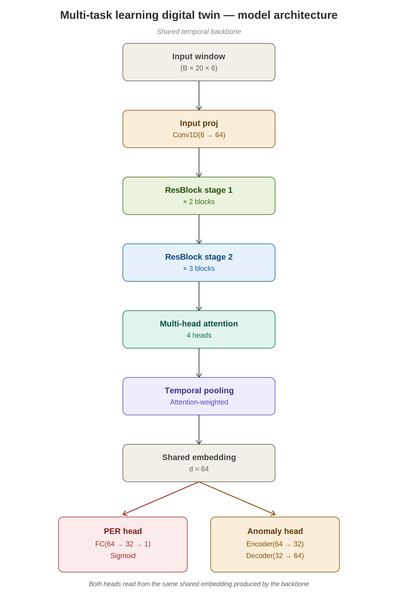
Figure 4.1 Multi-task learning model architecture
The model produces a packet-error-rate prediction, an anomaly-related reconstruction output, a health score, and temporal attention information. This lets the dashboard show both final metrics and diagnostic hints about which time positions influenced the prediction. Sharing a single temporal backbone across four output heads — rather than training four independent models — reduces both the parameter count and the number of inference calls required per tick, which directly benefits the latency budget discussed in Section 3.4.
4.6 ANALYTICS LAYER DESIGN: ONNX EXPORT AND OPTIMIZATION PIPELINE
Exporting the model to ONNX makes runtime inference faster and more portable; the backend warms up the runtime once and then reuses the same session throughout the telemetry loop. Architecturally, this is implemented as a one-time startup step, distinct from the per-tick inference call, so that graph loading and execution-provider initialization cost is paid exactly once rather than on every telemetry tick.
The export pipeline itself follows the general stages introduced in Section 2.4 and illustrated in Figure 2.2: the trained PyTorch model is traced or scripted and exported with a fixed opset version and dynamic axes for the batch dimension, the resulting graph is validated for structural correctness, the ONNX Runtime graph optimizer applies fusion and constant-folding passes, an execution provider is selected (the CPU provider, in this deployment), and the resulting optimized session is what the backend calls on every tick. Section 5.4 describes this pipeline as it was concretely applied to the multi-task model, including the benchmark and validation results.
4.7 PRESENTATION LAYER DESIGN
The frontend is implemented with React and Vite. Recharts is used for charts, while custom dashboard components present health, latency, predicted packet error rate, and node status in compact panels, consistent with the sidebar-navigation layout described in Chapter 3.
4.8 DATA AND CONTROL FLOW
On every tick, the backend reads the current node metrics, computes a summary across all nodes, updates the sliding inference buffer, runs the ONNX model once sufficient history is available, and sends the resulting JSON payload to the frontend over the open WebSocket. If closed-loop control is enabled and predicted risk crosses a threshold, the backend additionally widens the polling interval before the next tick — closing the loop between analytics output and data-acquisition behaviour. This sequence can be summarized as an ordered list of steps:
- Read current metrics for the active PLC node from the simulation layer.
- Compute a cross-node summary (min/max/average health, worst-case latency).
- Append the latest reading to the sliding twenty-step inference buffer.
- If the buffer is full, run one ONNX Runtime inference call.
- Serialize node metrics, summary, and inference output into a JSON payload.
- Push the payload to all connected WebSocket clients.
- If closed-loop control is enabled and predicted risk exceeds the configured threshold, widen the next polling interval before repeating the loop.
4.9 STORAGE CONSIDERATIONS
The current implementation keeps telemetry history entirely in memory — the sliding inference buffer plus a bounded in-memory alert log — which is sufficient for live monitoring and demonstration but does not retain data across backend restarts. This is a deliberate scope decision rather than an oversight: adding persistent storage (for example a time-series database) is identified explicitly as future work in the conclusion, since it is orthogonal to the predictive pipeline this project focuses on and can be integrated at the backend layer without changing the analytics or presentation layers.
4.10 SECURITY AND RELIABILITY CONSIDERATIONS
As a simulation-scoped prototype, the current implementation does not authenticate WebSocket clients or encrypt the local transport, which is acceptable for a local demonstration but would need to be addressed before any field deployment. A production version bridging a real Modbus/GSM gateway would need, at minimum: transport-layer security (TLS) on the WebSocket connection; authentication of dashboard clients; and network segmentation between the industrial fieldbus segment and any internet-facing service, consistent with common industrial-network security guidance that discourages exposing OT (operational technology) devices directly to untrusted networks. On the reliability side, the backend's use of a bounded sliding buffer and a stateless-per-tick computation means a dropped or reconnecting frontend client does not interrupt the telemetry loop for other clients, satisfying the resilience requirement listed in Section 3.4.
4.11 SUMMARY
This chapter described the layered architecture, from the simulation layer through the ONNX-backed analytics layer to the React presentation layer, and discussed storage, security, and reliability considerations. Chapter 5 now turns to how each of these layers was concretely implemented, including the specific steps used to export, validate, and benchmark the ONNX model.
CHAPTER 5
IMPLEMENTATION
5.1 IMPLEMENTATION OVERVIEW
This chapter describes how the architecture from Chapter 4 was realized in code, moving from the simulator through the telemetry loop, the ONNX inference path, and finally the dashboard components that present the result to the operator. Table 5.3 at the end of this chapter summarizes the complete technology stack for reference.
5.2 SIMULATOR IMPLEMENTATION
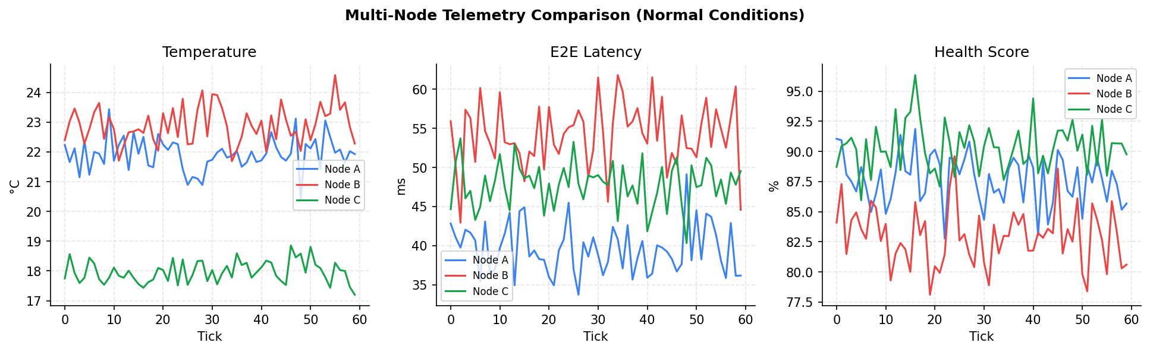
Figure 5.1 Multi-node telemetry comparison under normal conditions
Figure 5.1 compares temperature, end-to-end latency, and health score across the three simulated nodes under normal operating conditions, illustrating the distinct baselines assigned to each node by the simulator. Each node is parameterised independently so that, for example, Node C's noticeably lower baseline temperature and health-score profile in Figure 5.1 reflect a deliberately different simulated operating environment rather than measurement noise, letting the dashboard's node-comparison views be exercised meaningfully even before any fault is injected.
5.3 TELEMETRY STREAM AND BACKEND LOOP
The telemetry loop follows a fixed sequence on every tick:
- Read the current metrics for the active PLC node.
- Compute a summary across all simulated nodes.
- Update the sliding inference buffer with the latest reading.
- Run the ONNX model once the buffer holds twenty time steps.
- Serialize and push the resulting JSON payload to the frontend over WebSocket.
Table 5.1 Telemetry feature vector
# | Feature | Description
1 | Temperature | Simulated node temperature (thermal-fault indicator)
2 | Latency | End-to-end communication latency
3 | Signal quality | Approximate GSM signal quality
4 | Normalized loss probability | Estimated packet-loss probability
5 | Approximate throughput | Effective data throughput over the link
6 | Normalized noise | Injected network noise level (0-100%)

5.4 ONNX RUNTIME INTEGRATION
This section expands on the export pipeline introduced conceptually in Section 4.6, describing the concrete steps used to take the trained multi-task model from PyTorch into an ONNX Runtime session used by the FastAPI backend.
5.4.1 EXPORT PROCEDURE
The trained PyTorch model is exported using the standard torch.onnx.export tracing path. The input tensor's batch dimension is marked as a dynamic axis, so the resulting graph can accept batch sizes other than the one used during export, and the target opset version is pinned explicitly so that the exported graph's operator set matches what the deployed ONNX Runtime version supports. All four output heads (packet error rate, shared embedding, health score, and temporal attention) are named explicitly in the export call so that the backend can retrieve each output by name from the inference result rather than relying on positional ordering.
5.4.2 GRAPH VALIDATION
Immediately after export, the graph is loaded with the onnx package's structural checker, which verifies that every node's inputs and outputs are consistent with its operator definition and that the graph contains no dangling references. This check is run once, offline, before the exported .onnx file is committed for use by the backend, rather than on every backend startup, since the graph does not change between deployments of the same trained model.
5.4.3 SESSION CONFIGURATION AND WARM-UP
At backend startup, an ONNX Runtime InferenceSession is created once from the validated .onnx file using the CPU execution provider, and a small number of warm-up inferences are run against dummy input of the correct shape before the telemetry loop begins accepting real traffic. This warm-up step absorbs the one-time cost of lazy kernel selection and memory-arena allocation inside the session so that the first real telemetry tick is not penalised with an artificially high latency measurement. The same session object is then reused for every subsequent tick for the lifetime of the backend process.
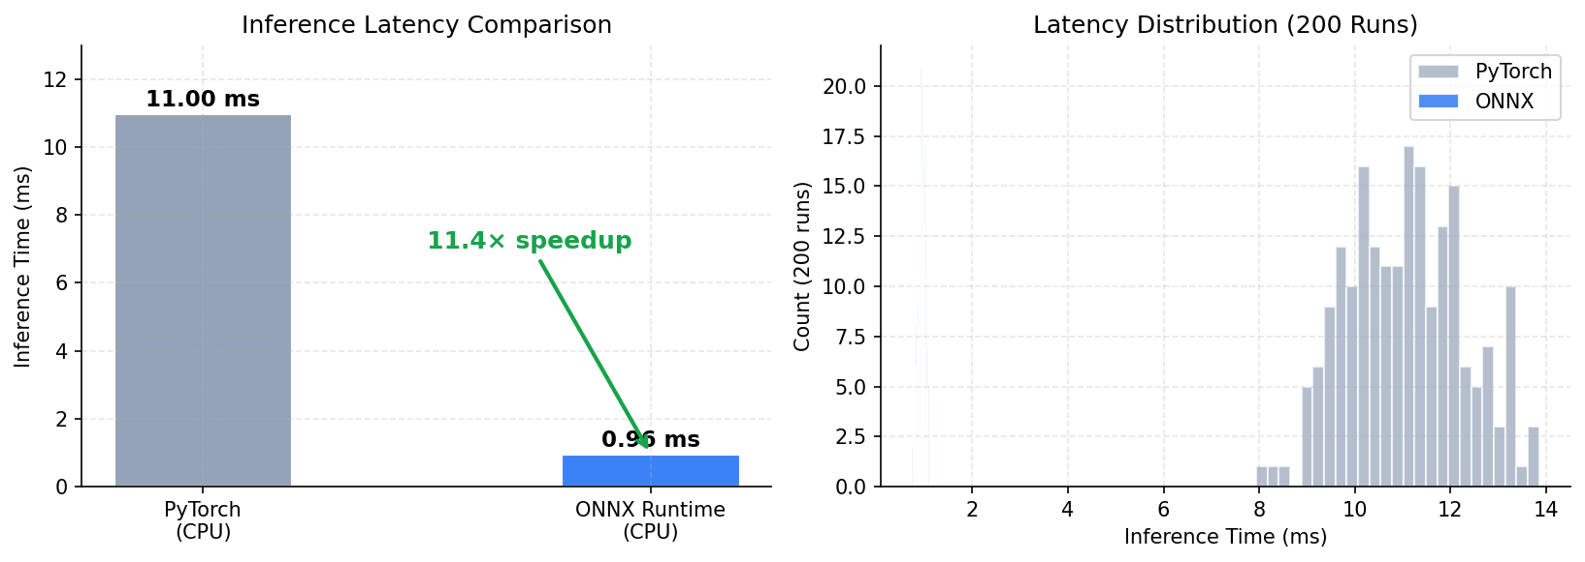
Figure 5.2 ONNX runtime inference latency benchmark
The benchmark in Figure 5.2 compares PyTorch (CPU) against the exported ONNX runtime session over 200 runs. Average inference latency dropped from 11.00 ms with PyTorch to 0.96 ms with the ONNX runtime — an approximate 11.4x speed-up — comfortably within the one-hertz telemetry budget. The right-hand panel of Figure 5.2 additionally shows that the ONNX runtime's latency distribution across the 200 runs is both lower and visibly tighter than PyTorch's, which matters for a periodic telemetry loop: a consistently low latency is preferable to an occasionally-fast-but-sometimes-slow distribution, since the loop must budget for worst-case rather than average latency to avoid missing a tick.
5.4.4 NUMERICAL VALIDATION
Because graph optimizations such as operator fusion can, in principle, change floating-point rounding behaviour relative to the original eager-mode model, the exported graph's outputs are compared against the source PyTorch model on matched inputs before the ONNX version is trusted in the backend. This validation procedure and its results are presented in full in Section 6.4.
5.5 HEALTH SCORE AND ALERT HANDLING
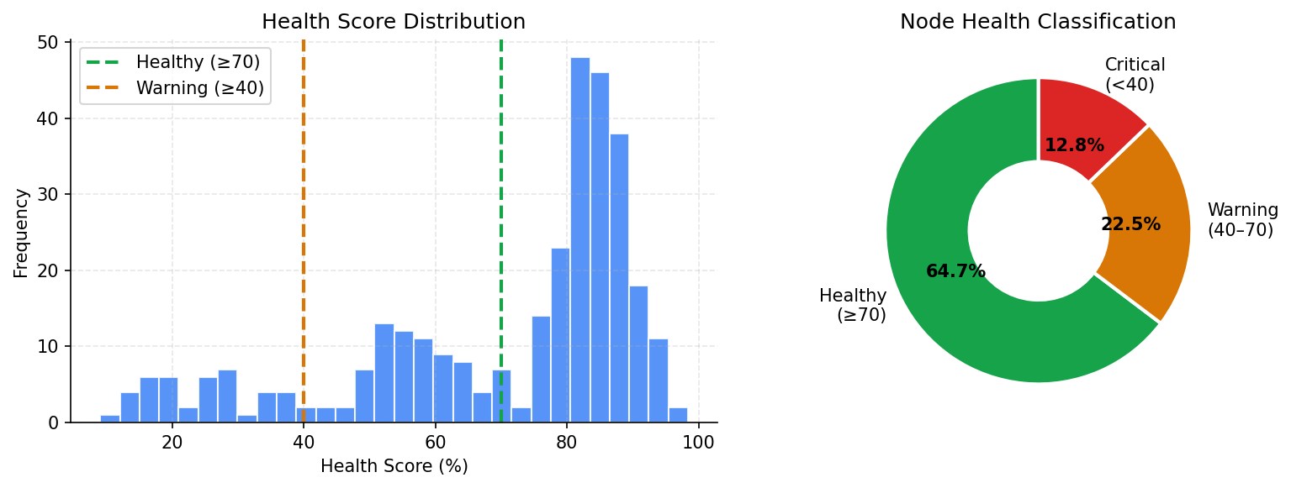
Figure 5.3 Health score distribution and node classification
Nodes are classified as Healthy (score >= 70), Warning (40 <= score < 70), or Critical (score < 40). Across the simulated test runs summarised in Figure 5.3, 64.7% of readings fell in the healthy band, 22.5% in the warning band, and 12.8% in the critical band, and each transition between bands is written to the alert log shown on the dashboard's alerts tab. Using fixed score bands rather than a purely continuous score gives the operator a small, easy-to-scan vocabulary (healthy / warning / critical) while the underlying continuous score remains available in the detailed node view for engineers who want finer resolution.
5.6 DASHBOARD COMPONENTS
The dashboard tab is composed of a small number of reusable component types rather than a single monolithic view. KPI cards summarize a single scalar (overall health, predicted PER, failure risk, ONNX latency) with a coloured status indicator; a multi-series line chart plots latency, temperature, and health over the recent window per node; a node table lists every simulated PLC with its current metrics in tabular numeric form for quick comparison; and an alerts panel lists the most recent state transitions in reverse-chronological order. Keeping these as separate, composable components — rather than one large view — mirrors the modularity requirement from Section 3.4 and made it possible to add the AI/ML analysis tab described next without modifying the existing dashboard components.
5.7 AI/ML ANALYSIS VIEW
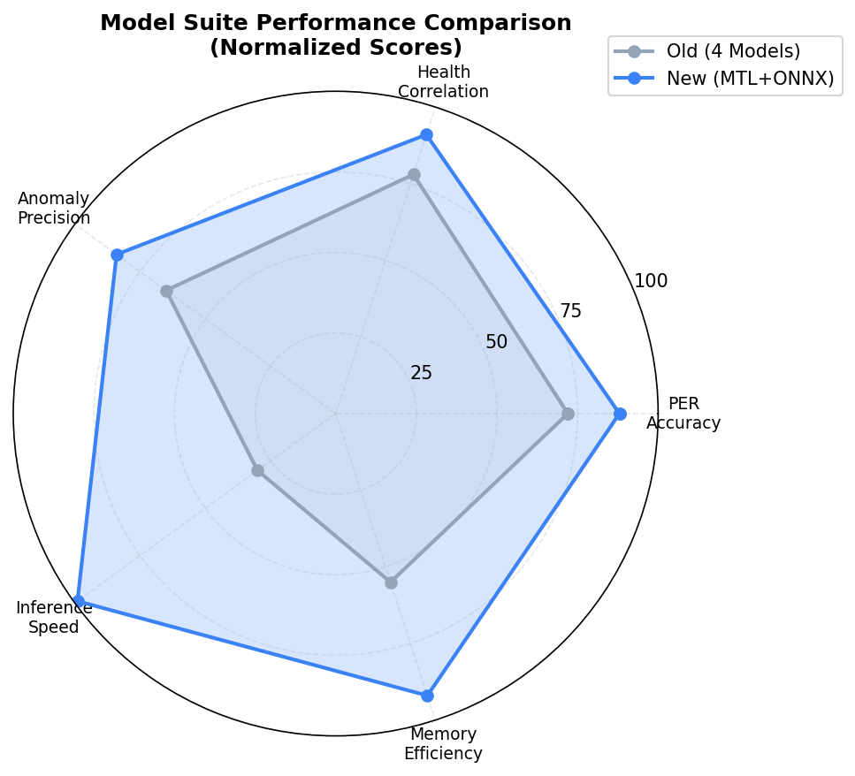
Figure 5.4 Model suite performance comparison (feature contribution)

The AI/ML analysis tab visualizes model behaviour, including a radar comparison (Figure 5.4) between an earlier four-model suite and the new combined MTL-plus-ONNX approach across health correlation, packet-error-rate accuracy, memory efficiency, inference speed, and anomaly precision. The combined approach shows a broadly larger coverage area, reflecting gains concentrated in inference speed and memory efficiency — consistent with replacing four separately-loaded models with one shared-backbone ONNX session.
5.8 CLOSED-LOOP OPTIMIZATION
When predicted risk exceeds a configured threshold and machine-learning control is enabled, the backend increases the telemetry polling interval to reduce load on the simulated GSM link. This is a deliberately simple feedback mechanism, intended to demonstrate the principle of linking analytics output back into data-acquisition behaviour rather than to model a production-grade control policy.
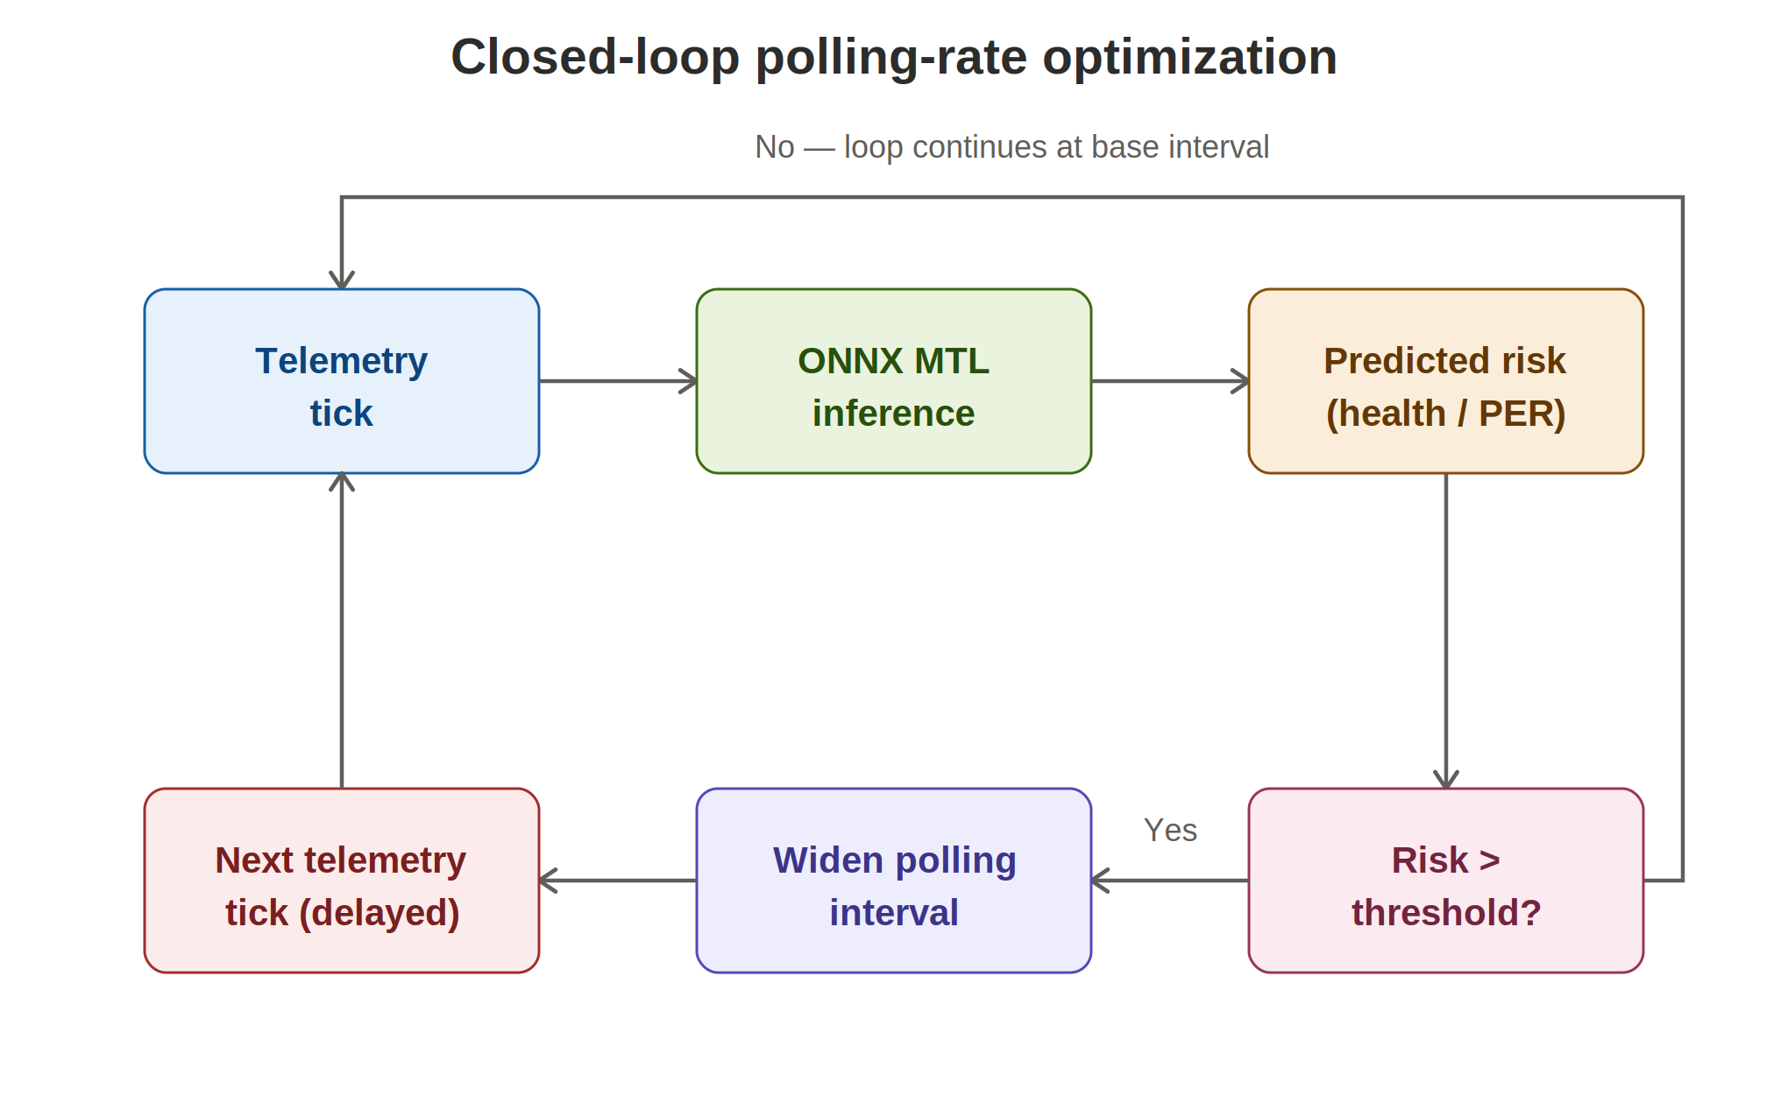
Figure 5.5 Closed-loop polling-rate optimization

Figure 5.5 traces the decision path taken on every tick: once the ONNX model produces a predicted-risk value, the backend compares it against the configured RISK_THRESHOLD (Appendix B). If the threshold is exceeded, the next polling interval is widened up to MAX_POLL_INTERVAL_S before the loop repeats; otherwise the loop continues at the base TELEMETRY_INTERVAL_S. Widening the interval under high predicted risk is a deliberately conservative policy — it trades a slightly staler view of an already-degraded link for reduced load on that same link, which is a reasonable default when the link itself is the suspected bottleneck.

5.9 CODE ORGANIZATION AND CONFIGURATION MANAGEMENT
The codebase is split into a backend/ directory (FastAPI application, simulator module, ONNX inference wrapper, and configuration) and a frontend/ directory (React components, charts, and the WebSocket client hook), matching the layer boundaries set out in Chapter 4. Runtime-tunable values — alert score thresholds, the base polling interval, the sliding-window length, and the noise range — are collected in a small configuration module rather than scattered through the codebase, so that a scenario can be retuned without editing business logic. Table 5.2 lists a representative subset of these parameters.

Table 5.2 Selected backend configuration parameters
Parameter | Default Value | Purpose
TELEMETRY_INTERVAL_S | 1.0 s | Base telemetry tick period
INFERENCE_WINDOW | 20 steps | Sliding buffer length fed to the MTL model
HEALTHY_THRESHOLD | 70 | Minimum score classified as Healthy
WARNING_THRESHOLD | 40 | Minimum score classified as Warning
NOISE_RANGE | 0-100% | Allowed range of the operator noise control
ML_CONTROL_ENABLED | False (opt-in) | Toggles closed-loop polling adjustment

5.10 TECHNOLOGY STACK SUMMARY
Table 5.3 Technology stack summary
Layer | Technology | Role
Simulation | Python | PLC / GSM noise and fault simulation
Backend | FastAPI, WebSocket | API endpoints, telemetry streaming
Analytics (training) | PyTorch | Multi-task model training
Analytics (serving) | ONNX, ONNX Runtime | Portable, optimized inference
Frontend | React, Vite | Dashboard application shell and build tooling
Charting | Recharts | Telemetry and model-output visualization

CHAPTER 6
TESTING, RESULTS AND DISCUSSION

6.1 TESTING STRATEGY
Testing was performed through functional checks of the backend telemetry stream, frontend build validation, and scenario-based simulation. Clean, warning, and critical noise levels were examined to confirm that status transitions appear correctly in the interface. The React frontend was built using the Vite production build command, which verified module imports, JSX syntax, bundling, and dashboard component integration. Backend syntax and endpoint behaviour were checked separately, and the WebSocket loop was reviewed to confirm that all telemetry fields required by the frontend are present in the streamed payload.
6.2 UNIT AND COMPONENT-LEVEL TESTING
Below the scenario level, individual components were exercised in isolation before being integrated. The simulator's noise-to-metric mapping was checked at the 0%, 50%, and 100% boundary values to confirm monotonic behaviour. The ONNX inference wrapper was tested with a synthetic all-zero and all-one input buffer to confirm it returns correctly shaped output for every head without raising a shape-mismatch error. The health-classification boundaries (70 and 40) were tested with scores placed exactly on each threshold to confirm band assignment is consistent with the definitions in Section 5.5.
In addition to validating individual modules, end-to-end testing was carried out to ensure seamless interaction between the simulator, backend, analytics engine, and frontend dashboard. Telemetry generated by the simulator was tracked throughout the processing pipeline to verify that data was correctly received, processed by the ONNX Runtime model, and transmitted to the React interface without loss or delay. This approach ensured that real-time synchronization was maintained across all system components and that prediction results, alerts, and dashboard visualizations remained consistent during continuous operation.
6.3 SCENARIO TESTING
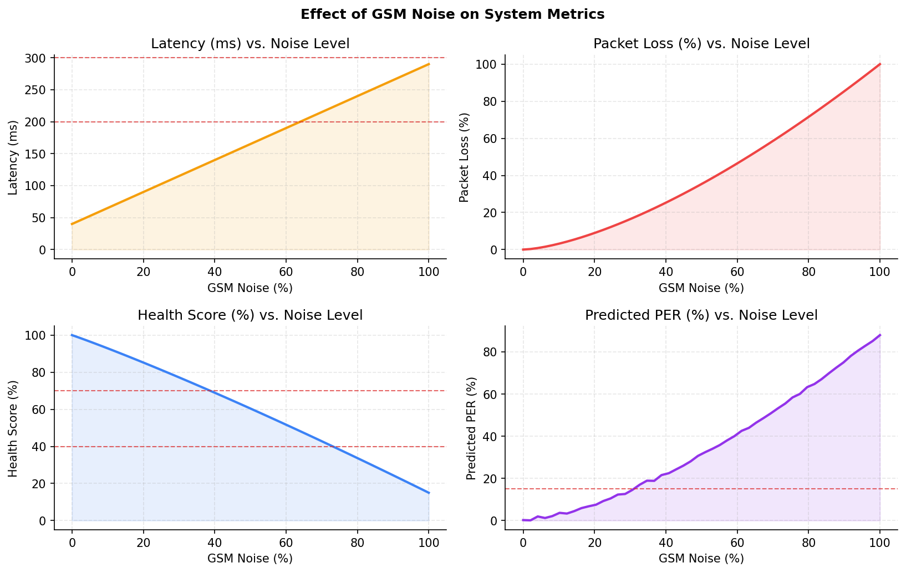
Figure 6.1 Effect of GSM noise on system metrics
Table 6.1 Testing scenarios and expected observations
Scenario | Noise Level | Expected Observation
Clean | 0-20% | Low latency, high health score, low predicted PER
Noisy | 20-50% | Rising latency and packet loss, health trending downward
Warning | 50-80% | Health score in warning band, elevated predicted PER
Critical | 80-100% | High latency and loss, health in critical band, alerts logged

As shown in Figure 6.1, latency and packet loss rise monotonically with GSM noise while health score falls and predicted packet error rate rises correspondingly — confirming that the predictive model tracks the same degradation trend that the simulator injects.
6.4 MODEL VALIDATION (PYTORCH VS. ONNX)
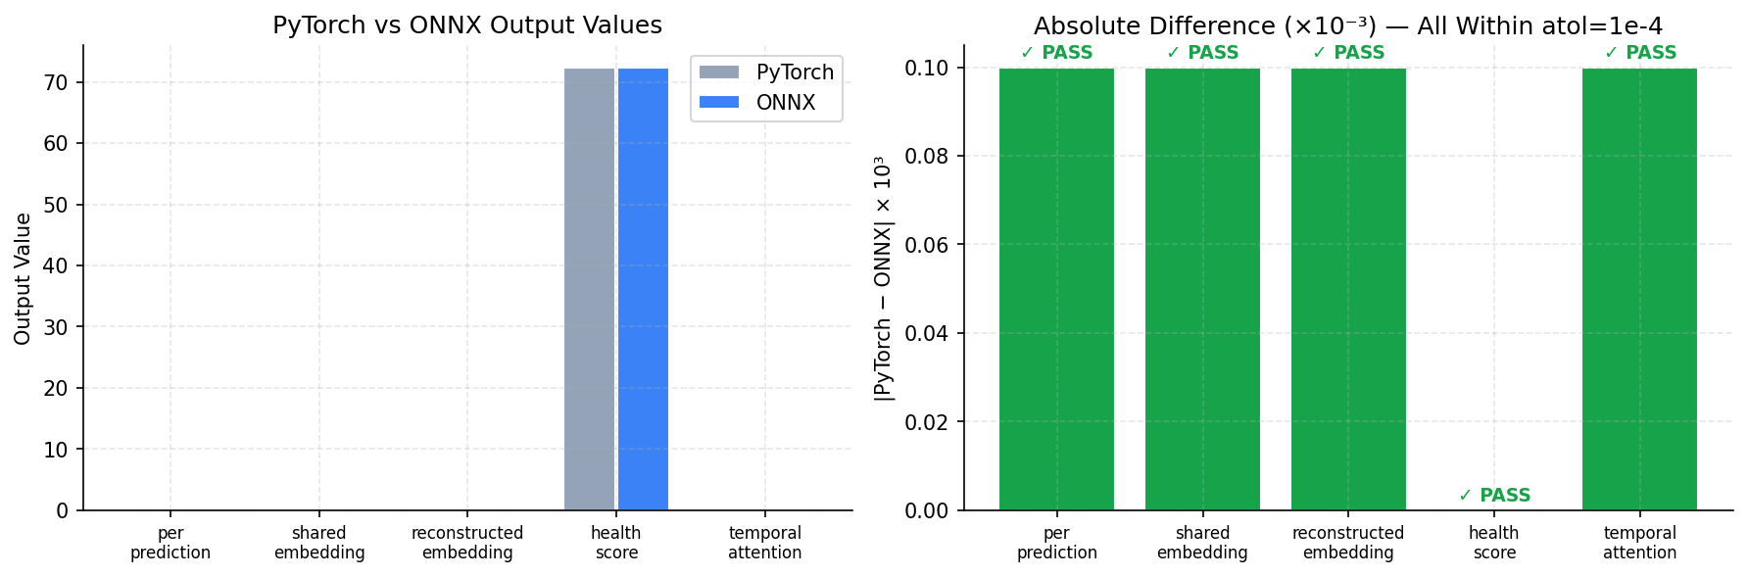
Figure 6.2 PyTorch vs ONNX output validation
To confirm that exporting the model to ONNX did not change its behaviour, outputs from the PyTorch and ONNX versions were compared across five heads — packet-error-rate prediction, shared embedding, reconstructed embedding, health score, and temporal attention. As shown in Figure 6.2, the absolute difference between the two runtimes remained within a tolerance of 1x10-4 for every head, and all five checks passed. This level of agreement is well within what would be expected from floating-point re-ordering introduced by graph optimization alone (Section 2.4.2), giving confidence that the ONNX export preserves the trained model's behaviour rather than silently altering it.
6.5 TRAINING OBSERVATION
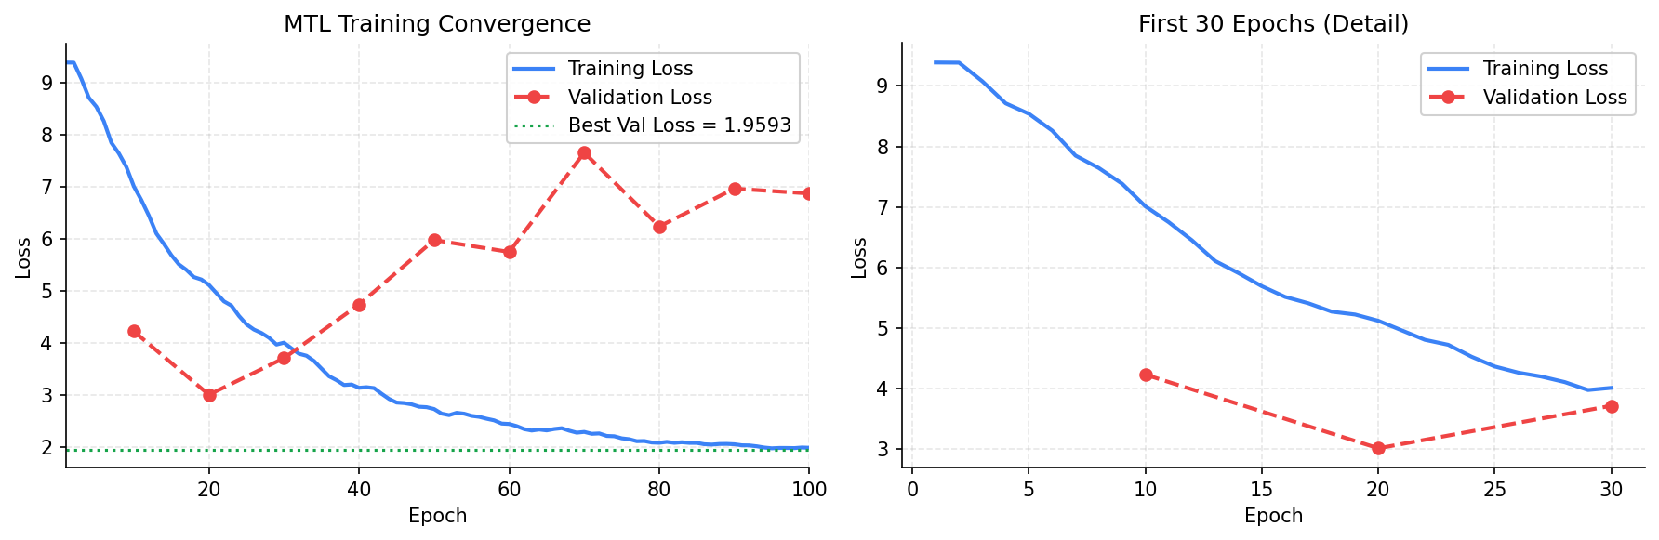
Figure 6.3 Multi-task learning training convergence
The training and validation loss curves in Figure 6.3 show rapid initial convergence over the first thirty epochs, with the best validation loss of approximately 1.9593 reached before validation loss began to fluctuate — a pattern consistent with the model reaching a useful operating point without extensive further tuning. The gap that later opens between the still-falling training loss and the fluctuating validation loss is a typical early sign of the model beginning to overfit the training window; because the best validation checkpoint (rather than the final epoch) is the one exported to ONNX, this behaviour does not affect the deployed model's quality, but it does suggest that additional regularization or early-stopping tuning would be a reasonable next step if the model were to be retrained on a larger dataset.
6.6 PERFORMANCE AND LATENCY DISCUSSION
Table 6.2 consolidates the latency figures reported separately in Section 5.4 and Figure 5.2, alongside the fraction of the one-hertz (1000 ms) telemetry budget each consumes, to make the practical margin explicit.
Table 6.2 Summary of measured ONNX vs PyTorch latency
Runtime | Average Latency | Approx. % of 1 s Telemetry Budget
PyTorch (CPU, eager) | 11.00 ms | 1.10%
ONNX Runtime (CPU) | 0.96 ms | 0.10%

Even the slower PyTorch path consumes only about one percent of the available telemetry period, and the ONNX path reduces this to roughly one-tenth of a percent, leaving substantial headroom for the backend's other per-tick work (buffer updates, JSON serialization, WebSocket transmission) without risking a missed tick.
6.7 RESULTS DISCUSSION
Overall, the implementation demonstrates that a simulated industrial telemetry stream can be converted into a live, predictive dashboard. Under low-noise conditions, system health remains high, latency is stable, and predicted packet error rate stays near the safe range. As GSM noise increases, the simulator produces higher latency and packet-loss probability, and the dashboard reflects this through changing health scores, warning states, and greater predicted communication risk. ONNX inference provides a practical runtime path for the model: the reported latency is low enough for one-hertz telemetry, making the approach suitable for lightweight monitoring demonstrations.
6.8 LIMITATIONS
- Results describe a controlled simulator rather than a physically deployed Modbus/GSM network, so real-world channel effects (multipath fading, SIM handover, carrier throttling) are only approximated by the single noise parameter.
- The model was evaluated on data generated by the same simulator used for training scenarios; generalization to a genuinely different physical installation has not been tested.
- The closed-loop polling controller uses a single fixed risk threshold rather than a tuned control policy, and was evaluated qualitatively rather than against a formal control-stability criterion.
- Multi-user concurrency, authentication, and transport encryption were explicitly out of scope, as noted in Section 4.10.

6.9 THREATS TO VALIDITY
Three considerations qualify how the results in this chapter should be read. First, construct validity: the injected noise parameter is a single scalar proxy for a range of real GSM impairments, so the strong correlations observed between noise and predicted risk (Figure 6.1) may be tighter than would be seen against a genuinely multi-dimensional channel model. Second, internal validity: because the model was trained and evaluated on data produced by the same simulator, its accuracy reflects how well it learned the simulator's own noise-to-metric mapping rather than an independently sourced ground truth. Third, external validity: the three-node scale used throughout this report is sufficient to demonstrate the pipeline end-to-end but is smaller than a typical production IIoT deployment, so conclusions about dashboard usability at scale are necessarily tentative until tested against a larger node count.

6.10 COMPARISON WITH OBJECTIVES
Table 6.3 revisits the objectives and deliverables first listed in Table 1.1 and records the outcome achieved for each.

Table 6.3 Objectives-to-outcomes comparison
Objective (from Table 1.1) | Outcome
Real-time multi-node telemetry simulation | Achieved — three-node simulator with independent baselines and noise/fault injection
Live streaming to a web client | Achieved — WebSocket stream verified to carry all required fields
Predictive health / risk estimation | Achieved — MTL model validated against ONNX export to 1e-4 tolerance
Operator-friendly visualization | Achieved — dashboard, node management, alerts, and AI/ML analysis tabs
Adaptive monitoring behaviour | Achieved (simple policy) — polling interval widens under high predicted risk
Runtime portability | Achieved — 11.4x latency improvement with outputs preserved within tolerance

CONCLUSION AND FUTURE WORK
The project successfully implements a predictive digital twin for industrial IoT monitoring. It combines a Modbus-over-GSM simulator, a FastAPI backend, ONNX-based inference, and a React dashboard to create a complete end-to-end monitoring workflow, situated within the broader IIoT reference architecture and ONNX deployment practice reviewed in Chapter 2.
The work shows that predictive indicators such as packet error rate, failure probability, health score, and anomaly status can be integrated into a live dashboard without overwhelming the user, and that exporting the trained model to ONNX gives a meaningful (approximately 11x) inference speed-up over the original PyTorch model while preserving numerical accuracy to within 1x10-4. The layered architecture — simulation, communication, analytics, presentation — proved straightforward to extend, as demonstrated by the addition of the closed-loop polling controller without changes to the presentation layer.
Future enhancements identified over the course of this project include:
- Connecting the system to real Modbus/GSM hardware, replacing the simulator with an actual gateway and PLC devices, and re-validating the noise-to-metric relationships against genuine field conditions.
- Adding persistent, time-series storage for historical trend analysis and longer-horizon remaining-useful-life estimation, as noted in Section 4.9.
- Applying INT8 or FP16 quantization to the exported ONNX model (Section 2.4.3) to further reduce latency and memory footprint if the model is deployed on constrained edge hardware.
- Hardening the system for field deployment with TLS, client authentication, and network segmentation, as discussed in Section 4.10.
- Extending the closed-loop controller from a single fixed threshold to a tuned or learned control policy, and evaluating it against formal stability criteria.
- Generalizing the fault simulator to additional fault types (e.g. gradual sensor drift) and to larger industrial networks with heterogeneous node types.
REFERENCES
Grieves, M. (2014). Digital twin: Manufacturing excellence through virtual factory replication. White paper.
Lee, E. A. (2008). Cyber physical systems: Design challenges. Proceedings of the 11th IEEE International Symposium on Object and Component-Oriented Real-Time Distributed Computing (ISORC).
Lee, J., Bagheri, B., & Kao, H. A. (2015). A cyber-physical systems architecture for Industry 4.0-based manufacturing systems. Manufacturing Letters, 3, 18-23.
Tao, F., Cheng, J., Qi, Q., Zhang, M., Zhang, H., & Sui, F. (2018). Digital twin-driven product design, manufacturing and service with big data. The International Journal of Advanced Manufacturing Technology, 94, 3563-3576.
Hochreiter, S., & Schmidhuber, J. (1997). Long short-term memory. Neural Computation, 9(8), 1735-1780.
Modbus Organization. (n.d.). Modbus application protocol specification. https://modbus.org/
FastAPI. (n.d.). FastAPI documentation. https://fastapi.tiangolo.com/
React. (n.d.). React documentation. https://react.dev/
Vite. (n.d.). Vite documentation. https://vitejs.dev/
ONNX. (n.d.). ONNX: Open Neural Network Exchange documentation. https://onnx.ai/
ONNX Runtime. (n.d.). ONNX Runtime documentation. https://onnxruntime.ai/
Recharts. (n.d.). Recharts documentation. https://recharts.org/
APPENDIX A
INSTALLATION AND EXECUTION
The following steps describe how to run the predictive digital twin locally.
A.1 BACKEND
- cd backend
- pip install -r requirements.txt
- python main.py
A.2 FRONTEND
- cd frontend
- npm install
- npm run dev
A.3 DASHBOARD
Once the backend is running on http://localhost:8000, open http://localhost:5173 in a browser to view the live dashboard.
A.4 RE-EXPORTING THE ONNX MODEL
If the multi-task model is retrained, it must be re-exported before the backend will reflect the new weights. From the training environment, run the export script to produce an updated .onnx file, run the onnx.checker validation pass described in Section 5.4.2, and replace the model file used by the backend's inference wrapper. The backend must be restarted so that the warm-up procedure (Section 5.4.3) re-initializes against the new session.
APPENDIX B
CONFIGURATION PARAMETERS
This appendix lists the complete set of backend configuration parameters referenced in Section 5.9, provided here as a single consolidated reference.
Parameter | Default | Description
TELEMETRY_INTERVAL_S | 1.0 | Base telemetry tick period, in seconds
INFERENCE_WINDOW | 20 | Number of time steps in the sliding inference buffer
HEALTHY_THRESHOLD | 70 | Minimum health score classified as Healthy
WARNING_THRESHOLD | 40 | Minimum health score classified as Warning
NOISE_MIN | 0 | Minimum allowed operator noise setting (%)
NOISE_MAX | 100 | Maximum allowed operator noise setting (%)
ML_CONTROL_ENABLED | False | Enables closed-loop polling-interval adjustment
RISK_THRESHOLD | 0.7 | Predicted-risk value above which polling widens
MAX_POLL_INTERVAL_S | 5.0 | Upper bound on the widened polling interval

APPENDIX C
GLOSSARY OF ADDITIONAL TERMS
Term | Definition
Edge inference | Running a trained model's inference step physically or logically close to the data source, rather than in a distant data centre.
Execution provider | An ONNX Runtime backend that maps graph operators onto a specific hardware target (e.g. CPU, GPU).
Graph fusion | A runtime optimization that merges multiple consecutive operators into a single combined kernel call.
Health score | A single scalar (0-100) summarizing predicted node condition, produced by the health head of the MTL model.
Opset | A versioned set of operator definitions that an ONNX graph declares itself compatible with.
Quantization | Reducing the numerical precision used to store model weights/activations (e.g. FP32 to INT8) to save memory and latency.
Remaining useful life (RUL) | An estimate of how much longer an asset can operate before maintenance is required.
Sliding window | A fixed-length buffer of the most recent time steps used as the input to a temporal model.
Telemetry tick | One iteration of the backend's periodic read-infer-stream loop, nominally once per second in this project.

APPENDIX D
ILLUSTRATIVE CODE LISTINGS
The listings below are simplified, illustrative representations of the core logic described in Chapter 5. They are included to make the report self-contained and are not a verbatim reproduction of the full project codebase.
D.1 SIMULATOR NOISE-TO-METRIC MAPPING
def step(node, noise_pct):
"""Advance one simulated PLC node by one telemetry tick."""
n = noise_pct / 100.0

# thermal channel: mild coupling to noise, independent fault hook
node.temperature += random.gauss(0, 0.15) + node.thermal_fault_bias

# network channel: latency/jitter/loss scale with injected noise
node.latency = node.base_latency * (1 + 4.0 * n) + random.gauss(0, 2 * n)
node.jitter = 2.0 + 15.0 * n * random.random()
node.loss_prob = min(0.95, 0.01 + 0.9 * n ** 1.5)

node.signal_quality = max(0.0, 1.0 - 0.8 * n)
node.throughput = node.base_throughput * (1 - 0.7 * n)
return node.to_reading()

D.2 BACKEND TELEMETRY LOOP (FASTAPI / WEBSOCKET)
@app.websocket("/ws/telemetry")
async def telemetry_stream(ws: WebSocket):
await ws.accept()
try:
while True:
reading = simulator.step(active_node, noise_pct)
summary = simulator.summarize_all_nodes()
buffer.append(reading.to_feature_vector())

inference = None
if buffer.is_full():
inference = onnx_model.predict(buffer.as_array())
maybe_adjust_polling_interval(inference["health_score"])

payload = build_payload(reading, summary, inference)
await ws.send_json(payload)
await asyncio.sleep(current_poll_interval_s)
except WebSocketDisconnect:
pass # other clients are unaffected

D.3 ONNX INFERENCE WRAPPER
class OnnxInferenceService:
def __init__(self, model_path: str):
self.session = onnxruntime.InferenceSession(
model_path, providers=["CPUExecutionProvider"])
self._warm_up()

def _warm_up(self, n=5):
dummy = np.zeros((1, 20, 6), dtype=np.float32)
for _ in range(n):
self.session.run(None, {"input_window": dummy})

def predict(self, window: np.ndarray) -> dict:
outputs = self.session.run(
["per_pred", "shared_embed", "recon_embed",
"health_score", "temporal_attention"],
{"input_window": window.astype(np.float32)})
keys = ["per_pred", "shared_embed", "recon_embed",
"health_score", "temporal_attention"]
return dict(zip(keys, outputs))

D.4 FRONTEND WEBSOCKET HOOK (REACT)
function useTelemetryStream(url) {
const [latest, setLatest] = useState(null);

useEffect(() => {
const socket = new WebSocket(url);
socket.onmessage = (event) => {
const payload = JSON.parse(event.data);
setLatest(payload); // triggers dashboard re-render
};
socket.onclose = () => {
// UI shows a "reconnecting" badge; loop is unaffected server-side
};
return () => socket.close();
}, [url]);

return latest;
}

