

AMRITA SCHOOL OF COMPUTING AMRITA VISHWA VIDYAPEETHAM COIMBATORE - 641 112

April 2025

COMPUTER SCIENCE AND ENGINEERING

Wi-Fi Coverage Optimization for a Smart Campus: A Case Study at Amrita University

***Submitted by***

***Group Number: 2***

K. Bhavya Naga Sai [CB.EN.U4CSE22328]  
N. Sreya [CB.EN.U4CSE22059]  
S. Sai Keerthana [CB.EN.U4CSE22050]  
Harini Krishna [CB.EN.U4CSE22138]

Date of Submission: April 07, 2025  
Institution: Amrita Vishwa Vidyapeetham

## Abstract

This report presents a comprehensive case study conducted at Amrita University aimed at optimizing Wi-Fi coverage across the campus. By leveraging simulation tools and data analytics, the study identifies existing network inefficiencies and proposes a strategic approach to improve coverage, reduce interference, and enhance overall performance. Techniques such as optimized access point (AP) placement, dynamic frequency planning, beamforming, and Multiple Input Multiple Output (MIMO) are explored in detail.

## **1.** Introduction

With the increasing reliance on wireless communication in educational institutions, ensuring robust and reliable Wi-Fi coverage has become essential. Amrita University has reported noticeable gaps in Wi-Fi coverage across various locations, including classrooms, hostels, and outdoor common areas. These issues are primarily attributed to high user density, signal interference, and suboptimal access point deployment.

This study aims to address these challenges by conducting a systematic evaluation of the current Wi-Fi network and recommending enhancements through simulation, measurement, and analysis.

## 2. Objectives

* To identify Wi-Fi dead zones across the Amrita University campus.
* To simulate current signal coverage and analyze performance using data-driven tools.
* To propose an optimized strategy for access point placement.
* To recommend the use of advanced wireless communication techniques such as dynamic frequency planning, beamforming, and MIMO.

## 3. Methodology

**3.1 Tools and Data Collection**

* Simulation Tool: NetSpot was used to simulate Wi-Fi coverage and measure signal strength across the campus.
* Data Analysis: Signal data (RSSI values, channels, AP distribution) was analyzed using Python libraries such as Pandas and Matplotlib.
* Clustering Algorithm: DBSCAN (Density-Based Spatial Clustering of Applications with Noise) was employed to identify and cluster regions with poor signal strength.

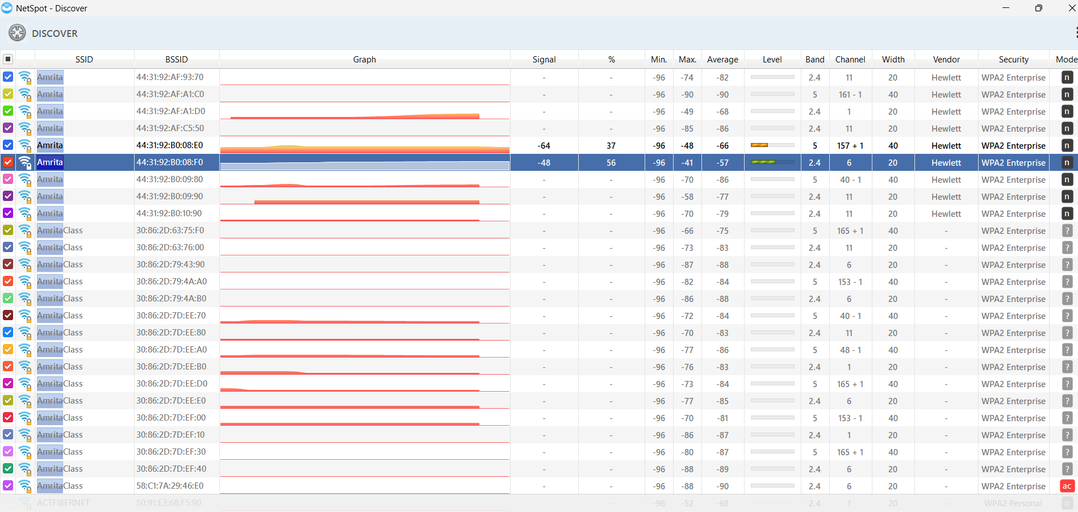

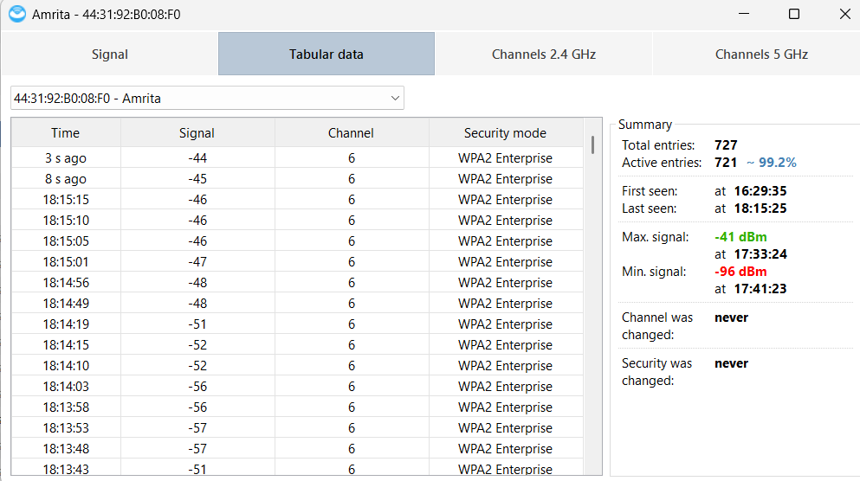

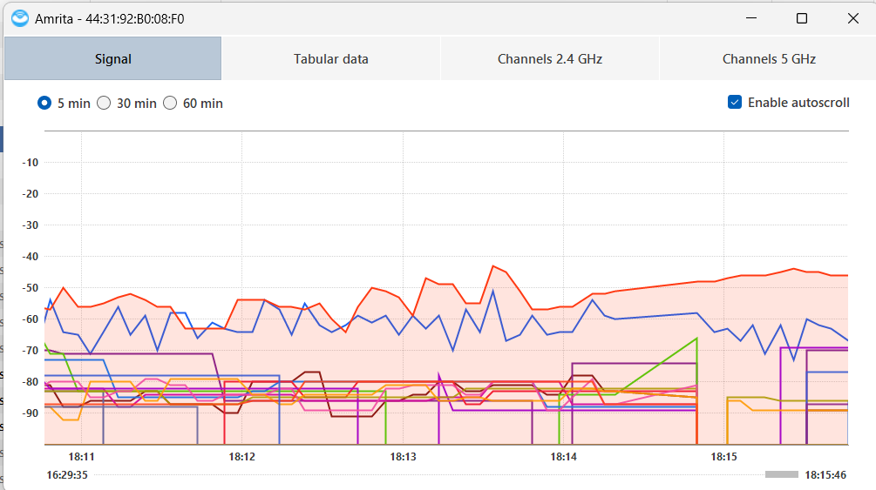

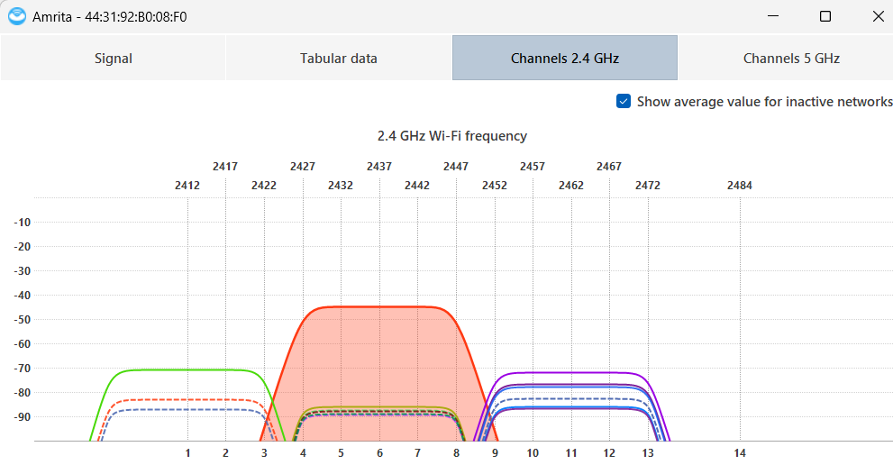

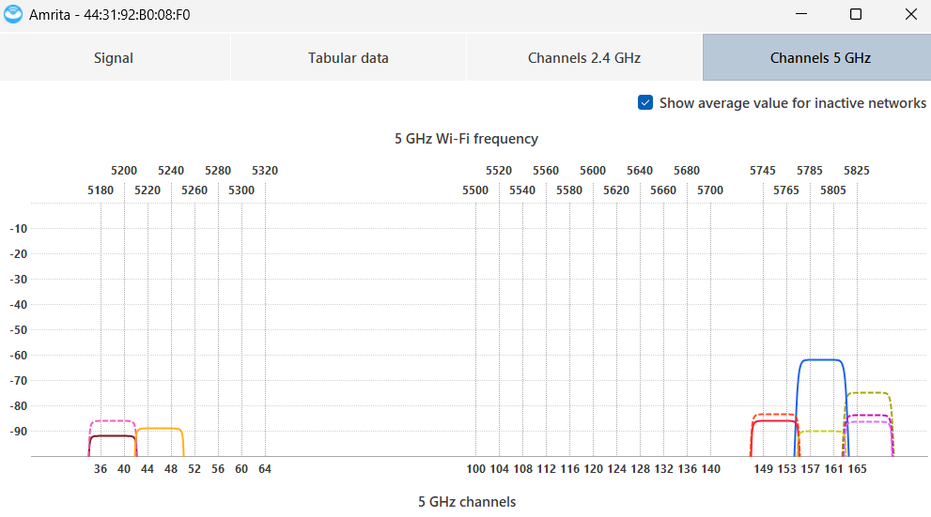

## 4. Signal Strength Analysis

The Received Signal Strength Indicator (RSSI) data revealed the following:

* Average Signal Strength: -71.50 dBm (moderate quality)
* Minimum Signal Strength: -90 dBm (poor quality)
* Dead Zones: Approximately 38.04% of measured locations recorded signals ≤ -80 dBm
* Channel Usage: Predominantly 5 GHz channels (e.g., 161), with occasional use of 2.4 GHz (e.g., channel 6)

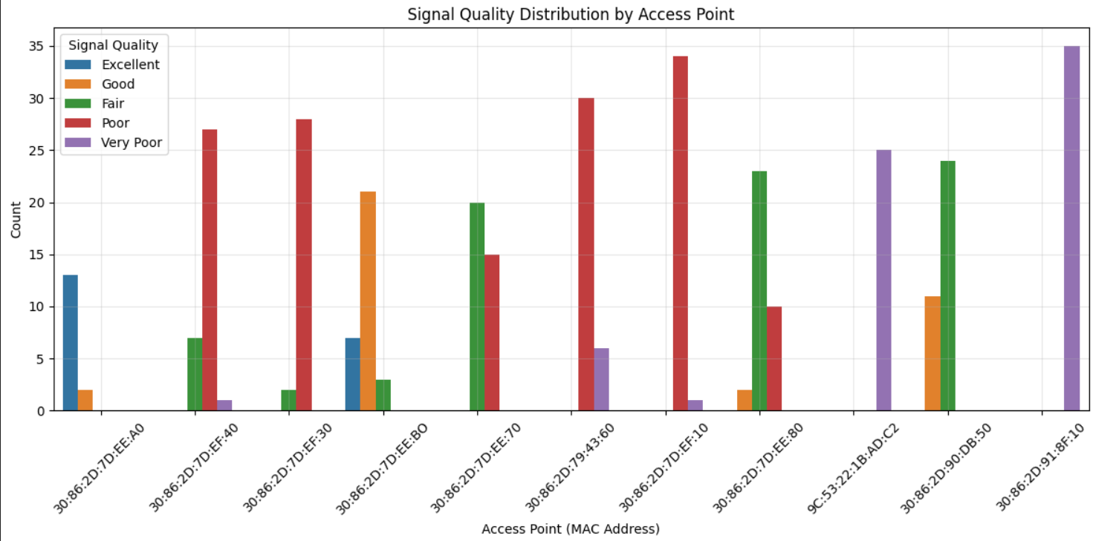

## 5. Identification of Dead Zones

The application of DBSCAN clustering to low signal regions allowed for the precise identification of Wi-Fi dead zones. These were primarily located in classrooms, student hostels, and outdoor seating areas. Despite the presence of 11 access points, the coverage was found to be uneven, with overlapping signals and coverage voids.

## 6. Network Challenges Identified

The analysis highlighted the following issues:

* Coverage Gaps: Signal strength drops to as low as -90 dBm in several key locations.
* Interference: Multiple APs using the same channel caused signal overlap and interference.
* User Density: Heavy user concentration in lecture halls and common areas contributed to signal degradation.

## 7. Optimized Access Point Placement

To address the identified issues, the following strategy is recommended:

* Deploy an additional 3 to 5 access points in areas characterized by high signal degradation.
* Prioritize the deployment of APs in classrooms, hostels, and outdoor spaces where signal strength is ≤ -80 dBm.
* Reposition existing APs to ensure uniform distribution and improved coverage balance.

## 8. Frequency Planning Strategy

To mitigate interference and improve efficiency:

* Utilize non-overlapping 5 GHz channels (e.g., 36, 44, 149, 161).
* Implement Dynamic Channel Assignment as part of Radio Resource Management (RRM), which adjusts channel use based on:
  + Signal strength
  + Channel congestion
  + Interference levels
  + Number of connected users
* Adopt 20 MHz channel width in interference-prone areas; consider 40/80 MHz in others.
* Employ intelligent channel reuse among access points.

## 9. Beamforming Techniques

Beamforming enhances the strength and directionality of Wi-Fi signals. Recommendations include:

* Enable explicit beamforming in APs supporting 802.11ac/ax standards.
* Apply adaptive beamforming to accommodate user mobility.
* Target areas with low signal strength (≤ -80 dBm) for beamforming deployment.
* Use power optimization techniques to enhance directional coverage.

## 10. MIMO (Multiple Input, Multiple Output) Recommendations

To improve network capacity and throughput:

* Deploy MU-MIMO (Multi-User MIMO), particularly using Wi-Fi 6 access points.
* Install 4x4 or 8x8 MIMO-enabled APs in high-density user areas.
* Position MIMO APs strategically at the center of identified dead zones.
* Combine with beamforming for maximum effectiveness.

## 11. Integrated Deployment Strategy

An integrated approach is recommended, combining:

* 5 GHz Frequency Planning with RRM
* Beamforming-capable Wi-Fi 6 Access Points
* High-capacity MU-MIMO Systems

Implementation Steps:

1. Conduct a pilot in a selected dead zone.
2. Measure improvements (target RSSI > -65 dBm).
3. Scale deployment based on performance evaluation.

## 12. Expected Outcomes

* Coverage Improvement: Reduce dead zone areas to less than 10% of total coverage.
* Reduced Interference: Through intelligent channel selection and beamforming.
* Increased Capacity: Enhanced support for concurrent users in high-traffic zones.
* Target Performance: Achieve an average signal strength exceeding -65 dBm across the campus.

## 13. Conclusion

This study has demonstrated that a combination of strategic AP placement, advanced frequency and antenna technologies, and data-driven network analysis can significantly enhance Wi-Fi coverage on a university campus. The proposed solutions are practical, scalable, and tailored to the specific infrastructure and usage patterns of Amrita University, providing a solid foundation for future wireless network improvements.

## 14.References

1. Cisco Systems. (2023). *Wi-Fi 6 (802.11ax): Technical Overview*.  
   https://www.cisco.com/c/en/us/products/collateral/wireless/white-paper-c11-740788.html
2. IEEE. (2021). *IEEE Standard for Information Technology—Telecommunications and Information Exchange Between Systems Local and Metropolitan Area Networks—Specific Requirements—Part 11: Wireless LAN Medium Access Control (MAC) and Physical Layer (PHY) Specifications*. IEEE Std 802.11ax™-2021.  
   <https://standards.ieee.org/standard/802_11ax-2021.html>
3. NetSpot. (2024). *Wi-Fi Site Survey, Analyzer, and Troubleshooter*.  
   <https://www.netspotapp.com/>
4. Scipy.org. (2024). *DBSCAN: Density-Based Spatial Clustering of Applications with Noise*.  
   https://scikit-learn.org/stable/modules/generated/sklearn.cluster.DBSCAN.html
5. Oppenheimer, P. (2010). *Top-Down Network Design* (3rd Edition). Cisco Press.
6. Gast, M. S. (2021). *802.11 Wireless Networks: The Definitive Guide* (2nd Edition). O’Reilly Media.
7. Ruckus Networks. (2022). *Beamforming Explained: How It Works and Why It Matters in Wi-Fi 6*.  
   https://www.ruckusnetworks.com/beamforming
8. Aruba Networks. (2022). *Best Practices for High-Density Wi-Fi Design*.  
   https://www.arubanetworks.com/techdocs/
9. MathWorks. (2024). *Wireless Communications Simulations in MATLAB*.  
   https://www.mathworks.com/solutions/wireless-communications.html
10. Tanenbaum, A. S., & Wetherall, D. J. (2011). *Computer Networks* (5th Edition). Pearson Education.
11. Cisco Meraki. (2023). *Channel Planning and RF Optimization Guide*.  
    https://documentation.meraki.com/
12. Lin, X., Andrews, J. G., Ghosh, A., & Ratasuk, R. (2014). *An Overview of 3GPP Device-to-Device Proximity Services*. IEEE Communications Magazine.
13. Kumar, S., & Rajalakshmi, P. (2018). *Wi-Fi Performance in High-Density Environments: Analysis and Case Study*. *IEEE Access*, 6, 51734–51744.
14. ITU-T. (2020). *Radio Resource Management Techniques for Wireless Networks*. ITU-T Recommendation M.3070.