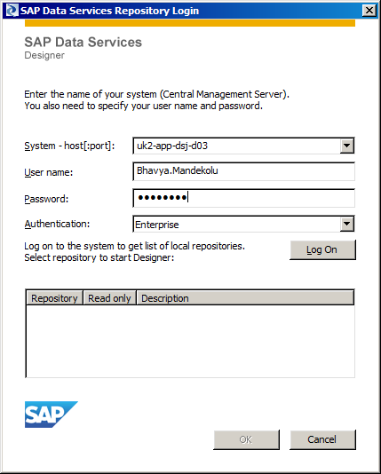

Initial Password: DSaccess

Connecting to DB of repository: dsaccess

To change connection from prod to dev, we need to import data file from the location:

L:\NTT DATA\People\VishalPrakash\DS_Local_Repos_ArunaN_Datastore_Connections.atl

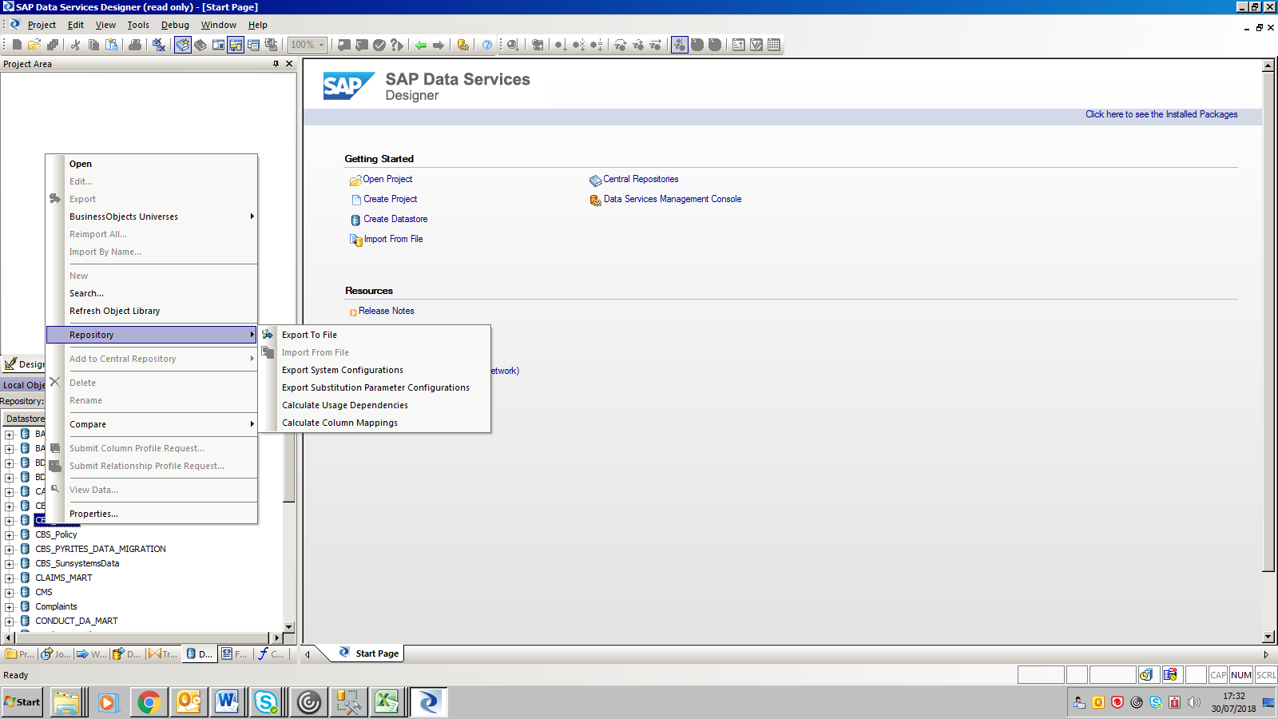

**To restart the job server**

To that server, type “Services.msc”, find out SAP Data Services->Start

I have done for system testing. System tsting job server was – UK1-APP-dsm-t01->Services.msc->SAP Data Services->Start