

Software Architecture Document

CMS Reporting

|  |  |  |  |
| --- | --- | --- | --- |
| **Version Number:** | 0.1 | **Version Date:** | 31st Dec 2018 |
| **Author** | Chandrakanth Nagaraj | **Role** | Business Intelligence Solution Architect |

Document Version History

|  |  |  |  |
| --- | --- | --- | --- |
| **Version** | **Amendment** | **Amended By** | **Date** |
| 0.1 | Initial Draft | Chandrakanth Nagaraj | 31/May/2017 |

Reviewers and Approvers

To Be Reviewed By:

|  |  |  |
| --- | --- | --- |
| **Name:** | **Department** | **Role:** |
| James Calvert | IT | Business Analyst |
| Mike Winfield | IT | Enterprise Architect |
| Sandor | IT | Enterprise Architect (CMS) |
| Solomon Alogaga | IT | Architecture Consultant |
| Luke Avery | IT | Business system Analyst |
| Vinay Jayanna | IT | NTT DATA |
| Natalie Walsh | IT | Service Delivery Manager |
| Nick Wilkinson | IT | Infrastructure Manager |
| Ann Smith | IT | Test & Service Acceptance Manager |

To Be Approved By:

|  |  |  |  |
| --- | --- | --- | --- |
| **Name:** | **Department** | **Role:** | **Signature:** |
| Mike Winfield | IT | Enterprise Architect |  |
| James Calvert | IT | Business Analyst |  |

|  |
| --- |
| Table of Contents |

1.1 Context 4

1.2 Vision 4

1.3 Business Drivers and Requirements 4

1.4 Requirement gathering Approach 4

1.4.1 Group 1 (UI to DB mapping) 4

1.4.2 Group 2 (UI to Report mapping) 5

1.4.3 Group 3 (Produce SAD for CMS Mart) 5

1.5 Reference Documents 5

2 Architectural Constraints 5

Periodic Snapshot 7

Transactional Snapshot 7

3 Architectural Principles 7

4 Technology Selection 7

5 Proposed Landscape 10

5.1 Logical View 13

5.1.1 Subject Area 13

6 Table Design principle 21

6.1 Star Schema & Flat structure 21

6.2 Data Co-Location & Distribution Key 21

6.3 Parallelism & Interleaved Sort key 21

6.4 ALL distribution 21

6.5 Bridge Tables 21

6.6 Data Access Control 21

6.7 Data Auditing / Versioning / History 21

7 Assumptions 23

8 Data Migration 23

9 ETL Program Requirement 23

9.1 ETL Scope 23

9.2 ETL High level Design Flow 23

9.2.1 Database Indexes: 24

9.2.2 Database Partitioning: 24

9.3 ETL Batch Scheduler 24

9.4 ETL Batch Job Scheduling 24

9.5 ETL Selection Criteria 24

9.6 ETL Data Mapping and Business Rules 24

9.7 ETL Recovery Process 24

9.8 Automated Reconciliation 25

9.9 Data Snapshot 25

10 Reporting Requirements 25

10.1 Business Objects (BO) Universe 25

10.1.1 Universe Objects 25

10.1.2 Universe Considerations: 25

10.1.3 Object Formatting 27

10.2 Business Objects (BO) CMC Requirement 27

10.3 Business Objects (BO) Reports 27

11 Non-Functional Requirements 33

11.1 High level Non-Functional requirements 33

11.2 Low Level Non-Functional requirements 33

12 Pending Clarifications 34

13 Infrastructure View 34

14 Operational View – Monitoring, Management and Administration 34

## Context

* TMK are in process of investing in a new Claims Management System (CMS) replacing their existing Fineos application. New Claims Management System will be a product of Guidewire Business Solutions called as Claim Center. The exercise of investing in new CMS platform will also involve data migration, adding new interfaces , changing the existing interfaces and creation of CMS reporting mart for which NTT DATA have been requested to provide required services. Ernst & Young (EY) will be undertaking all work related to CMS application and data migration.
* NTT Data will undertake all of the work related to Implementation of CMS Reporting Mart
* This document (Reporting SAD) forms the basis for Design and development of CMS reporting Mart. Goal is to help ensure technical implementation of CMS mart is in parity with Business requirement mentioned in CMS Reporting FSD

## Vision

* Bring together data from CMS system into CMS Reporting Mart
* Facilitate reporting of every field that is available in CMS UI through CMS Mart
* Facilitate creation of reports in the format as specified in CMS FSD
* Facilitate scalability of the system in-line with TMK’s Road map & as specified in FSD
* Please refer to the functional and non-functional requirements as specified by the business in the following Functional specification document [Click here](https://tokiomarinekiln.atlassian.net/wiki/pages/viewpageattachments.action?pageId=383189026&metadataLink=true)

## Business Drivers and Requirements

TMK have chosen to integrate their various Claims Management Systems into one consolidated system using Guidewire Claims Centre. In line with this they have a requirement for a reporting capability to support the Claims Team.

Key benefits of the reporting capability include:

* an ability to report claims data from a single system providing a single source of MI and consolidated view of TMK claims
* less reliance on external reporting tools and therefore: no time lag in availability of data; data availability at UCR level as opposed to SCM level; ability to use TMK measures as opposed to market measures
* efficiency savings in the reduction in manual reporting/ processes will release technical operations expertise allowing more time to be spent on analysis of claims data
* improved reporting for Underwriting purposes.

## Requirement gathering Approach

Reporting stream has been divided into three task groups

### Group 1 (UI to DB mapping)

Guide wire Claim Centre(CC) is a generic claims management system and only a portion of this product is configured for TMK’s usage/implementation. Requirement from the business is facilitate reporting of every field that is available in CC UI. Group 1 looks at identifying only those CC database tables which provide data to CC UI and use them to extract data out of CC for building CMS mart

### Group 2 (UI to Report mapping)

Task here is to identify go-live and post go-live reports along with their fields, format , frequency of creation and enrich FSD . Members of this group liaise with business to verify the fields listed in reports are also available in the CC UI and document its mapping

### Group 3 (Produce SAD for CMS Mart)

Task here is to produce Solution Architecture Document which explains design principles of CMS Mart with consideration to TMK’s DWH road map and CMS reporting FSD . This document will form the basis for

1. Estimates
2. CMS Data mart Design & development

## Reference Documents

| SNO | Document Description | Document link | Version |
| --- | --- | --- | --- |
|  | FSD document.doc | [Click here](https://tokiomarinekiln.atlassian.net/wiki/pages/viewpageattachments.action?pageId=383189026&metadataLink=true) | 0.4 |
|  | CMS Report Format.xls | [Click here](https://tokiomarinekiln.atlassian.net/wiki/spaces/CMS/pages/394428493/Reporting+Requirements) | 0.9 |

# Architectural Constraints

* Based on FSD CMS design needs to be future proofed to enable real-time dashboard so a source system may be required to enable CDC to facilitate this. Currently EY has expressed reservation on enabling CDC on CC this option needs further discussion since CMS is on SQLServer 2014. In absence of CDC ETL team would be required to identify the changes based on audit columns which may hide the granularity of the operation and increase latency associated in real-time dashboard. Business Analyst and Architects have been notified of the above constraints
* Current norms in TMK is to store data as periodic snapshot example of Periodic and Transactional snapshot is shown below . Due to storage constraints for CMS Mart Transactional snapshot has been chosen . Business analyst and Architects have been notified of this constraint who helped us finalize this choosing transactional snapshot, nevertheless there are further options being explored which can be mix of both

**Example : Periodic snapshot**

Source data

|  |  |  |
| --- | --- | --- |
| Transaction date | Policy-transaction | Amount |
| Q1 | P1-t1 | 10 |
| Q1 | P1-t2 | 20 |
| Q2 | P1-t3 | 30 |

Periodic Snapshot is stored as below

|  |  |  |  |  |
| --- | --- | --- | --- | --- |
| Load_Period | Transaction date | Policy-transaction | Durg Allocation | Amount |
| Q1 | Q1 | P1-t1 | D1 | 10 |
| Q1 | Q1 | P1-t2 | D1 | 20 |
|  |  |  |  |  |
| Q2 | Q1 | P1-t1 | D2 | 10 |
| Q2 | Q1 | P1-t2 | D2 | 20 |
| Q2 | Q2 | P1-t3 | D2 | 30 |

As at value of Q1 rolled up by Durg = D1,30

As at value of Q2 rolled up by Durg = D2,60

**Example : Transactional snapshot**

Source data

|  |  |  |
| --- | --- | --- |
| Transaction date | Policy-transaction | Amount |
| Q1 | P1-t1 | 10 |
| Q1 | P1-t2 | 20 |
| Q2 | P1-t3 | 30 |

Transactional Snapshot is stored as

|  |  |  |  |  |
| --- | --- | --- | --- | --- |
| Load_Period | Transaction date | Policy-transaction | Durg Allocation | Amount |
| Q1 | Q1 | P1-t1 | D1 | 10 |
| Q1 | Q1 | P1-t2 | D1 | 20 |
|  |  |  |  |  |
| Q2 | Q2 | P1-t3 | D2 | 30 |

As at value of Q1 rolled up by Durg = D1,30

As at value of Q2 rolled up by Durg = D1,30

D2,30

## Periodic Snapshot

**Pros of Periodic snapshot**

* Periodic snapshot provides ease of use w.r.t slice and dice when reports are generated and provides good performance
* Works well with Redshift database , as history preservation needs no updates and just inserts

**Cons of Periodic snapshot**

* Periodic snapshot is storage heavy if you need a daily snapshot of it stored then it will increase the data significantly as it stores all of the data during every run

**Mitigation of the cons**

Since latest snapshot contains all of the data older snapshots are rarely queried hence in Actuarial only last snapshot of the month is stored thus reducing the data size but here history preservation is reduced to monthly grain , same could be done in CMS too but data need not be deleted and lost rather it can be archived in S3 and queries using Redshift Spectrum or Athena

## Transactional Snapshot

**Pros of Transactional snapshot**

Transactional Snapshot are light in size offer good performance

Preserve history at daily grain

**Cons of Transaction snapshot**

May need more work after the report is generated to convert it to as-at format (not in all cases)

Adds more load to redshift DB due to updates & deletes

Recommendation : Depends on requirement if daily snapshot is an absolute necessary Transactional Snapshot is the option to be picked by users need to be mindful caveats during slice and dice

*Note : Daily refresh will still happen if Monthly snapshot grain is chosen

# Architectural Principles

The integration solution adheres to the principles defined in the [Reference Architecture](http://lonvjiracon01:8070/display/arch/Principles+-+Definition+and+Discussion).

For BI Standards which includes standards for Database, Data Model, Universe and Report design, use existing [TMK BI Standards](http://tmk-intranet.kilngroup.prv/departments/BPM/BIG/Projects%20Archive/Ancient%20Projects/2012%20Q3%20Release/Development/Standards%20Checklists%20Guidelines/BI%20Standards/Kiln%20BI%20Standards.doc).

*If Cloud based solution is chosen there will be suggestions mentioned in the document which will override some of the existing practices which would be defunct for cloud based systems*

# Technology Selection

Based on TMK’s advise on “Cloud-First” for green field projects & CMS Business requirement which listed scalability as one of the factor Cloud based solution was proposed for creating CMS Data mart . Solution proposed also aimed at adopting tools which can align CMS Mart in helping Claims team build Operational and Advisory capabilities using data analytics. Please find the details of the solution in below diagram .Note Matillion was initially suggested by NTT DATA and based on TMK’s direction Technology stack was changed to replace Matillion with AWS Glue

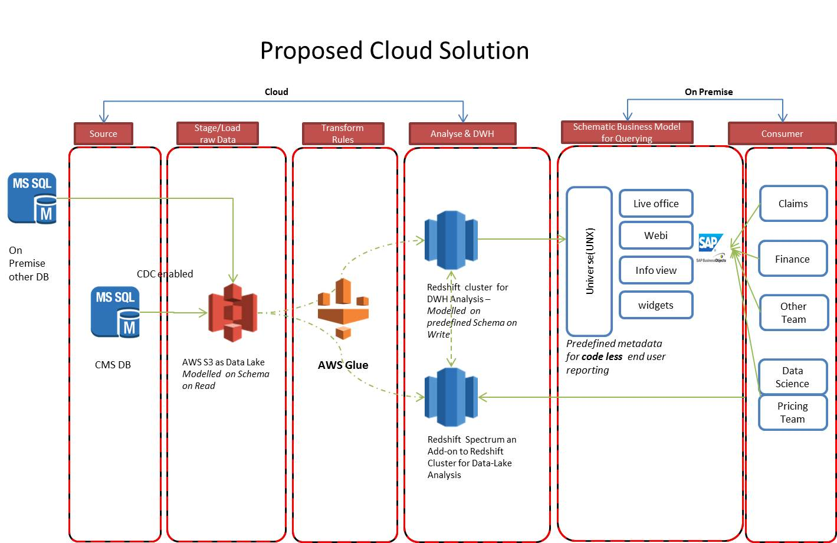

Glue replaces Matillion based on TMK’s direction in cloud solution proposed

# Proposed Landscape

**Proposed Landscape:**

As part of the ongoing review into the process and procedures of Claims Business have identified that we need several monitoring reports created to assist with this internal objective and to cover a number of regulatory returns that are due at beginning of the month after CMS Go-live. Due to nature of requirement evolution reports once created may need addition of new fields which was not requested before

Hence the project requires acquisition of all fields present in CMS UI and built them into data mart for reporting, extraction of identified fields is done through cloud based ETL tool , AWS S3 is used to stage raw data and AWS Redshift is used to facilitate storage and history preservation of extracted data

A Business Objects Universe layer would provide the semantic layer on top of the data mart and would support Pre-defined reports and all self-service reporting needs.

The Business Objects Universe should be in UNX format and would include

1. Data Foundation layer
2. Business Layer

Following table suggests the technologies selections and their compliance strategic roadmaps within the [Reference Architecture](http://lonvjiracon01:8070/display/arch/The+Kiln+Reference+Architecture)

**CMS Reporting Environments**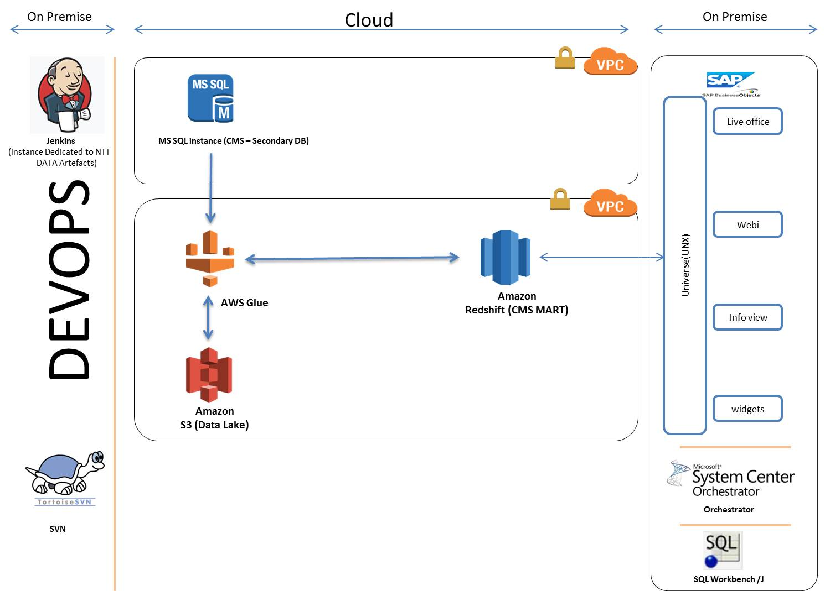

| **Technology Stack** | | **Description** | **Dev Configuration** | **SysTest Configuration** | **Region** | **Comments** |
| --- | --- | --- | --- | --- | --- | --- |
| AWS Redshift | | Scalable MPP Database for Data-warehousing | On-Demand  dc2.large  160Gb SSD x 2  15Gb x 2 | On-Demand  dc2.large  160Gb SSD x 2  15Gb x 2 | EU Ireland |  |
| AWS Glue | | Scalable ETL for Data warehousing | As suggested [here](https://docs.aws.amazon.com/glue/latest/dg/getting-started.html)  DPU’s allocated on demand by developers running the code | As suggested [here](https://docs.aws.amazon.com/glue/latest/dg/getting-started.html)  DPU’s allocated as on demand by developers | EU Ireland |  |
| AWS S3 | | Scalable Multi-purpose Storage | S3 Bucket which can be accessed by Glue & Redshift with | S3 Bucket which can be accessed by Glue & Redshift with | EU Ireland |  |
| SAP Business Objects | | TMK’s preferred reporting tool (on Premise) | UK2-APP-BOR-D06, SAP Business Objects 4.2 SP 03 | UK2-APP-BOR-U06, SAP Business Objects 4.2 SP 03 | NA | BO Project Upgrade would complete March 2019 then CMS should upgrade too |
| Jenkins | | Automated deployment | Existing one dedicated to NTT DATA | Existing one dedicated to NTT DATA |  |  |
| SVN | | Source control | Existing one used by NTT DATA | Existing one used by NTT DATA |  |  |
| Orchestrator | | TMK preferred scheduler | Re-use UK2-APP-SCO-D02, ensure this system can connect to cloud | Re-use UK1-APP-SCO-T01 ensure this system can connect to cloud |  |  |
|  | **Developer Requirements** | | | | | |
| Developer Desktop | |  | 3 Developer desktop with 16 GB RAM which have SQL Workbench/J installed |  |  | Custom logic can be developed on premise saving cost for TMK as Glue allows us to plug in custom code .. but custom codes need to exception only |
| SQL Workbench/J | | Development tool for redshift | provide developer desktop which have workbench installed [click here](http://www.sql-workbench.eu/) |  |  |  |

## Logical View

Following represents a logical view of the relationship between the entities , Physical design is work in progress which will detail the columns involved where Multivalued association exists bridge table will be created or Physical model will add fact to handle the grain

### Subject Area

#### Activity

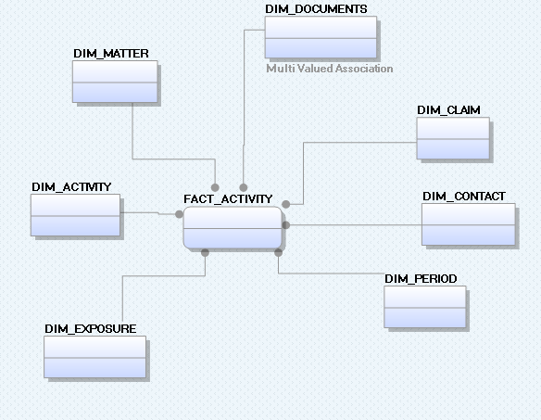

#### Claim

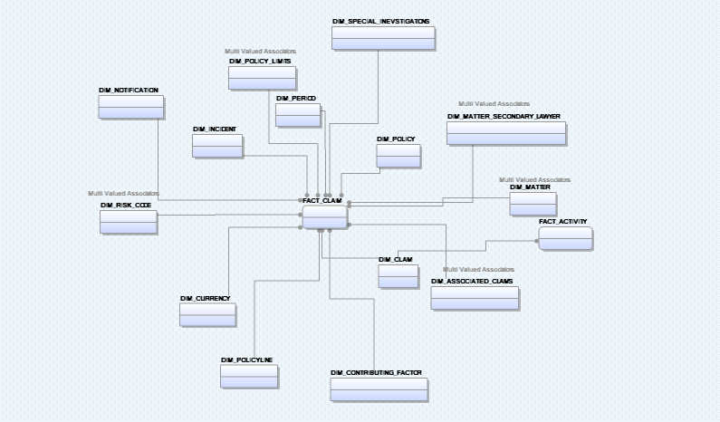

#### Contacts

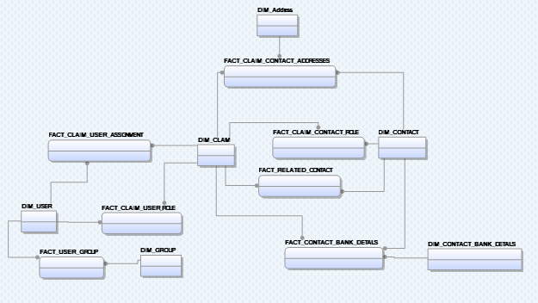

#### Evaluation

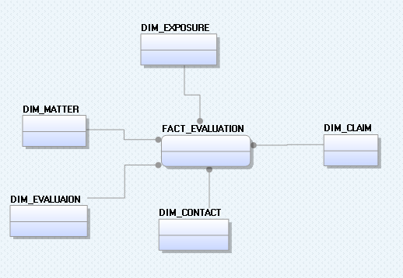

#### SCM

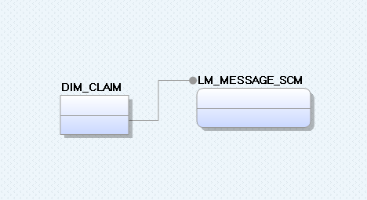

#### ECF

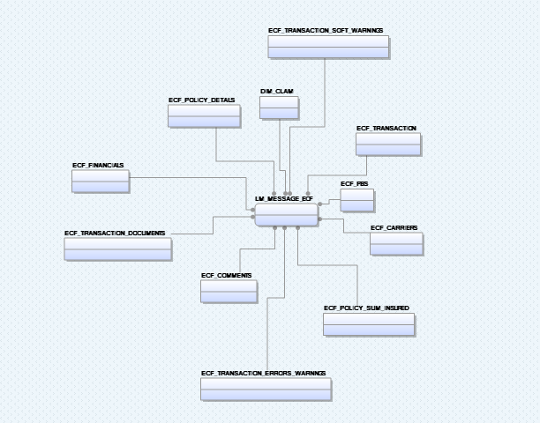

#### Litigation

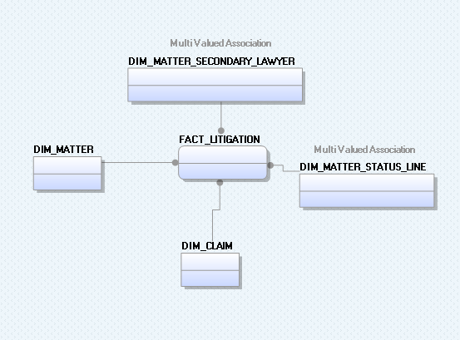

#### Notes

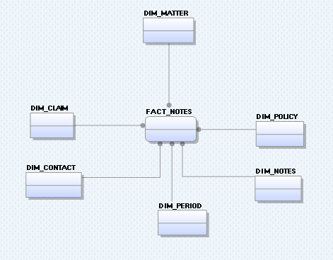

#### Summary

Summary is mix of several subject areas so not all subject areas mentioned earlier are repeated here

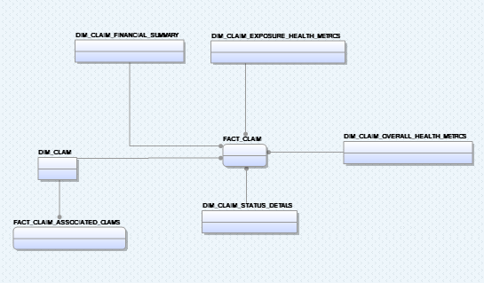

#### History

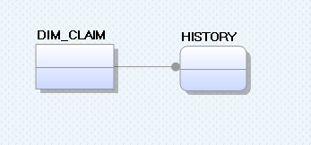

#### Documents

**TBD**

#### Financials (Requirement TBC )

**TBD**

#### Subrogation (not P1 report)

**TBD**

#### Calendar (Not used)

**TBD**

# Table Design principle

DataMart has been created to adhere best practices suggested by Amazon for AWS redshift following are some of the pointers

## Star Schema & Flat structure

A flat table structure where possible has been created but importance to ease of maintenance and impact on data duplication due to slowly changing dimensions has also been given equal consideration

## Data Co-Location & Distribution Key

Except Contact data which can act across claims much of the data and the joins are contained within a dataset of claim’s instance, and since claimid has high cardinality it has been chosen as distribution key and made available in most table, thus co-locating much of the commonly joined data set/entities

## Parallelism & Interleaved Sort key

Since recently created Claims can get mostly queried by users to avoid only few redshift nodes/slices becoming the bottle neck claimid and periodkey have been used as interleaved sort key in most table

## ALL distribution

Smaller tables which do not have Claim id have been chosen to be distributed in all nodes/slices

## Bridge Tables

Where there are multivalued dimensions bridge table may be used to keep star schema simple

## Data Access Control

There is no requirement to build data level security. Any user having access to the system will have access to all data.

## Data Auditing / Versioning / History

All dimension tables should have following fields

* CLAIM_ID
* LOAD_ID
* INSERTED_DT
* LAST_UPDATED_DT
* EFFECTIVE_START_DT
* EFFECTIVE_END_DT
* CURRENT_IND
* DELETE_IND

Fact tables in addition to the functional attributes should include following technical fields:

* CLAIM_ID
* LOAD_ID
* INSERTED_DT
* LAST_UPDATED_DT

# Assumptions

Following assumptions need to be validated by BA/BSAs

1. CMS Data will be sourced from CC Database and there are no other sources involved
   1. Thus reconciliation will be done using CC UI vs CMS Reports generated via Business objects
   2. Any Data-fixes that are applied to CC DB will have to be applied to CMS Data mart if business needs two systems to be in-line
2. Data Sourced from CC DB will only be related to what is displayed on CC UI
3. EY/TMK will be responsible for fixing CC DB related data quality issues (if found)
4. Snapshots load in CMS Mart will be driven by calendar date.
5. Snapshot definition load needs to be decided whether it has to be Periodic snapshot or Transactional Snapshot
6. SAD will change as and when additional clarifications are received.
7. CMS batch Jobs scheduling can vary based on DI tool option chosen
8. BO Licenses are available for users.
9. It is assumed that SAP BO IDT can connect to Redshift Data-warehouse using JDBC connections based on the inputs from Sap Community listed here

<https://blogs.sap.com/2015/04/28/connect-to-aws-redshift-database-from-bi4/>

1. It is assumed that the load can be taken by the existing Business Objects Environment. This can only be confirmed once  running in production. If this is not the case extra hardware/network bandwidth may be needed to cope with the increased load.
2. It is assumed that Redshift Database Spec suggested will be able to take the query load if this is not the case additional node needs to be allotted based on the need

# Data Migration

No Data Migration is required.

# ETL Program Requirement

The ETL scope is to load data from CC DB into relevant tables in new CMS Mart which will be created as part of this Project.

## ETL Scope

The ETL scope is to load data from CC DB into relevant tables in new CMS Mart which will be created as part of this Project. Data extracted from CC DB is focused only on fields related to CC UI

This solution involves creating new dimension tables and fact tables. There are no data external to CC DB or provided by Business which needs to be extracted into CMS Mart.

## ETL High level Design Flow

1. Task 1 : For list of tables mentioned <here> land/overwrite them into S3 folder mentioned <here>
2. Task 2 : For list of Dimension/bridge tables mentioned <here> load data using the mapping provided <here> under current run date/Period_Key, Pls note data should be loaded into RTL tables
3. Task 3 : For list of Fact tables mentioned <here> insert/Update data using mapping provided <here> under current run date, Pls note data should be loaded into RTL tables
4. Task 4 : Swap RTL and Live tables using Redshift rename functionality
5. Task 5 : Copy Live tables into RTL tables

**Additional Details:**

RTL and Live tables

RTL stands for “Ready to load table” which will be same as Live tables w.r.t structure and Data but these table will not be accessed by BO queries and only ETL will have access to them

### Database Indexes:

Mentioned as part of table design principle

### Database Partitioning:

Not available in Redshift

## ETL Batch Scheduler

The batch to run Monday to Sunday and must finish before 8 AM London time.?

The new Batch must be Scheduled using a Scheduler , Orchestrator is chosen tool

## ETL Batch Job Scheduling

Reporting Batch job has to be scheduled post completion of Claim Centre Internal batch (US315 - CC batch schedule) job .

## ETL Selection Criteria

NA

## ETL Data Mapping and Business Rules

| SNO | Document Description | Document link | Version |
| --- | --- | --- | --- |
|  | Functional Specification Document |  |  |
|  | CMS Data Mart Model (WIP) |  |  |
|  | Mapping Scripts (WIP) |  |  |

## ETL Recovery Process

ETL should be designed to be re-runnable following the existing BI Standards. Job should be designed to be able to restart from beginning without corrupting data, Job should also be design for re-starting from the point of failure

Please consider designing the ETL jobs by splitting them into

1. Job to land Source Data
2. Job to build Dimensions
3. Job to build Facts
4. Job to carry out reconciliation
   1. Send email as appropriate.
5. Job to Publish Dimensions and Facts for reporting
6. Job to Prepare for the next load.

## Automated Reconciliation

1. Please ensure that all exceptions related to the data are logged as per the standard in the DI_VALIDATION table in Redshift.
2. No requirement stated as such on automated Reconciliation

## Data Snapshot

Fact snapshot period should change based on Calendar Date.

# Reporting Requirements

The reporting requirements will be serviced by Business Objects.

## Business Objects (BO) Universe

### Universe Objects

To maintain parity between CC UI and Universe Objects , Universe Objects are given the same name as CC UI , also folder structure of the Universe is suggested to be modelled based on CC UI

### Universe Considerations:

**Dimension Object Folder Structure:**

Universe should list Dimensions for following Subjects

* Claim
* Work Plan
* Exposures
* Parties Involved
* Policy
* Financials
* Notes
* Documents
* Reserving Committee
* Plan of Action
* Subrogation
* Litigation
* SCM
* ECF
* Contacts
* Period

Additionally following folders should be created

* Period – This folder should contains following fields

| SNO | Object Name | Object Definition | Object Type |
| --- | --- | --- | --- |
|  | Today | Current Date | Date |
|  | First Date of Previous Month | First Date of Previous Month | Date |
|  | Last Date of Previous Month | Last Date of Previous Month | Date |
|  | First Date of current Month | First Date of current Month | Date |
|  | Last Date of current Month | Last Date of current Month | Date |
|  | Quarter Start Date | Current Quarter Start Date | Date |
|  | Quarter End Date | Current Quarter End Date | Date |
|  | Year Start Date | Current Year Start Date | Date |
|  | Year End Date | Current Year End Date | Date |
|  | 7 Days ago | Current Date minus 7 Days | Date |
|  | 14 Days ago | Current Date minus 14 Days | Date |
|  | 1 month ago | Current Date minus 1 month | Date |
|  | 30 Days ago | Current Date minus 30 Days | Date |
|  | 60 Days ago | Current Date minus 60 Days | Date |
|  | 90 Days ago | Current Date minus 90 Days | Date |

### Object Formatting

Business Analyst to verify these formats as the same will be used on the Reports and the Universe.

| SNO | Data Type | Format | Example |
| --- | --- | --- | --- |
|  | Date | DD-Mmm-YYYY | 18-Oct-2016 |
|  | Date Time | DD-Mmm-YYYY HH:MI:SS | 18-Oct-2016 15:20:23 |
|  | Text | <Match Database Size> |  |
|  | Number | ###,###,### | 123,456,789 |
|  | Percentage | ??? |  |

## Business Objects (BO) CMC Requirement

1. A New connection object is required
2. The New Universe should be in UNX format
3. BO User Group- New user groups are required for manage access of CMS Mart universe
   1. User groups should get the user list from AD. New AD groups may be required if not already available in AD.
      1. This will ensure that no special access needs to be granted to users for BO.
   2. Two user groups are required.
      1. CMS_Report_Developers – This will include list of users who’ll have Admin access on CMS Mart BO objects e.g. Universe, Report SQL, folder, objects etc.
      2. CMS_Users – This group will grant users ability to create, publish and schedule reports but not amend CMS Mart BO Objects.
4. BO Access Level- See above for details. Rest of the access should follow the access of standard BO user groups.
5. BO Folder Structure –A new BO folder ‘CMS Reporting’ is required. A sub-folder named “Pre-Built Reports” should include the requested Reports. All CMS users should have access to this CMS folder.

## Business Objects (BO) Reports

Business has requested for reports to be delivered in the following order, hence please consider phasing the report delivery in this order

Following Reports needs to be created in Business Objects.

|  |  |  |
| --- | --- | --- |
| **SR. No** | **Report Name** | **Report Details (High Level Summary)** |
| 1 | All claims /New Claims/Open claims/Closed claims | Claim volumes Management information required to analyse, within a defined period of time, the number of Claims being reported, New Claims, Claims closed.This will be presentable as over all organisation, by team, by individual, by claims line of business over a defined time period/date range  User to be able to report on indemnity, fees. Reserves & paid amounts. Positions such as total reserve, total paid, total incurred across all TMK claims. Need to be able to see movements as well as at position. At a claim level e.g. quarterly financial movements per claim for underwriters.  Potentially included as what is to be within other AM reports |
| 4 | Claims that have been denied or partially denied (with reason) | Claims that have been denied payment either partially or completely.  This will be presentable as over all organisation, by team, by individual, by claims line of business over a defined time period/date range.  Is required to be submitted to third parties to perform audit |
| 5 | Claims that have been flagged as ex-gratia | Claims that have been flagged as an exgratia payment  This will be presentable as over all organisation, by team, by individual, by claims line of business over a defined time period/date range |
| 7 | Fraudulent Claims / Special Investigation | Claims that are flagged as fraudulent or that need special investigation |
| 12 | Volatile | Claims that have been flagged as Volatile |
| 13 | Coverage Disputes | Claims that have been flagged as Disputed |
| 18 | Task Performance( filter on task type) | Ability to determine by type of task (i.e. referral, activity etc.) how a user or groups of user have performed. Some activities have target due dates, others do not.  As at = individual users tasks by a sensible visual representation - i.e. User X has 4 ECF to respond to, 3 diary activities open to work on; yesterday they completed 8 ECF activities.... Reporting can aggregate user based report into a team view on the same basis to show team level performance. |
| 24 | Peer Reviews | i) Generate a list of Claims for independent Peer review ii) Generate a list of claims for internal peer review e.g. Denial, Complaints, other |
| 25 | Actioned report - tasks actioned (breakdown by task type, team) | Report to present the numbers of activity/task items being completed by Teams & by individuals.  Purpose is to enable user running the report to judge the level of 'work' that has been undertaken.  To include a view of timeliness of completion of activity |
| 26 | Case load by adjuster & other attributes  Number of open claims Number of activities By user | Report to present the numbers of active/open activity/task items being managed by Teams & by individuals.  Purpose is to enable user running the report to judge the level of 'work' that is required to be undertaken |
| 39 | SCAP claims | Single Claims Agreement Party claims will present a challenge to the market because there is only a tactical solution being offered. Reporting will be required to identify potential SCAP claims & ensure that they are being responded to correctly. |
| 43 | Subrogation claims | Report to identify the claims on which subrogation opportunities may exist in order to produce a report for the 3rd party that manages TMK subrogation.  Monthly process |
| 44 | Salvage claims | Report to identify the claims on which salvage opportunities may exist |
| 45 | Recoveries | Report to identify the claims on which recoveries have been made by recovery category |
| 46 | Litigation claims | Report to identify the claims on which litigation proceedings are taking place. Provide information as to the next steps, indicative financials, court dates along with general claim details. |
| 49 | ECF Notify Errors | Technical reporting to show how many messages are failing to transition between the gateway & the relevant systems either side. |
| 53 | CAT/event code reporting | User to be able to extract a report showing claims by CAT & event code over a specified time frame. Fields/parameters to be confirmed |
| 56 | Manager Reports | Want to see top 10 losses per team, new advices greater than £x, litigation, top percentile claims, TBAs. Data to be real time. Average claim lifecycle by individual & by team. |
| 61 | Results Reserve Review | Known as the RRR report this is produced twice a year & contains listing of the claims that have a reserve > GBP 500,000 & or Reserve/incurred potential > GBP 500,000. Claims Managers are required to review & make comment (therefore uplifting the content of the report & not the information in the system (unless this is a process to generate the final report inclusive of CMS notes or similar)).  The report is made available to the actuarial team |
| c | Large Loss Reports  (CARD) | Provide visibility of Large Claim Movements above threshold agreed with each underwriting team.  Differing levels of requirement - some Large Loss (potentially CARD reports too) is focused on reporting of large losses over particular thresholds nominated by the underwriters. There is a general claims centric need to raise the viability of claims (and movements upon claims) that breach certain threshold with respect to the Incurred position (i.e. Incurred from the message Our Share, and/or sum of paid this time & paid to date) |
| d | Movement Reports | A more detailed report of SCM (ECF & Manual) movements within the team for review with underwriters & team meetings |
| o | Reserving Accuracy | To monitor reserving accuracy for TMK Claims closed during the previous reporting month & report against KPI  An ability to review all closed claims in relation to the calculation defined for reserving accuracy. |
| q | ECF Turnaround Report | To monitor TMK Claims performance on service.   1) Inclusive of Pure turn around on all responses in the reporting period 2) Spcifically to indentify queries as a response type as a % of all the repsonses in the period 3) Specifically to indentify post agreement query as a % of all responses in the reporting period |
| s | Speed of Reserving Report | To monitor that reserves are entered at the earliest opportunity |
| 62 | Consistency Check between Active Directory group – CMS & Administration of Users in Guidewire Claims Centre | Identification of all Users of The Active Directory (AD) Group that enables a user access/permission to CMS (Guidewire Claims Centre) and Comparison with the User Administration component within Guidewire Claims Centre – expose the permission granted within the AD group and expose the permission granted within the Administration module of Guidewire claims Centre on the same line, relevant to each user. It is necessary for the recipient of reporting to be able to determine that the roles/permissions are the same. |

|  |  |  |
| --- | --- | --- |
| **SR. No** | **Report Name** | **Report Details (High Level Summary)** |
| 2 | Claims with conflict of interest | Claims that have been flagged as conflict of interest either as Individual or Organisational  This will be presentable as over all organisation, by team, by individual, by claims line of business over a defined time period/date range |
| 3 | Claims with complaints (with reason) | Claims that have complaints recorded against them  This will be presentable as over all organisation, by team, by individual, by claims line of business over a defined time period/date range |
| 6 | Static claims | Claims with no SCM movement in the last x months( where x is configurable) |
| 19 | Query Rates | Ability to generate a view of the Claim movements queried by TMK.  A need to be able to view from the stand point of a claim with a history of queries.  A need to be able to view independently the movements that were queried along with the narrative/reasons for trending. |
| 28 | Claim lifecycle, average age of claims | Reporting required to aggregate claims lifecycle in order to profile. Number of days that a claim is open Number of days from notification to first reserve Number of days from notification to first indemnity payment Number of days from first notification to closure Number of days from final indemnity payment to closure etc. |
| 31 | Report of use/cases of non panel providers | Intention of the report is to identify the claims that have experts appointed. There is a need to be able to distinguish & filter on Panel & Non Panel 'type' of expert.  This shall be from the perspective of  i) the expert as a parameter with fields that identify the claims that they are appointed to.  ii) team or adjuster to determine the profile of non panel appointment by those criteria |
| 32 | Expert Budget | It should be possible to view & report on a history of changes to the budget on the claim - relating to the budget for experts in the management of claims |
| 33 | Expert Performance | It should be possible to report on all claims where a certain expert is appointed, & for this report to show the current performance rating & rationale |
| 36 | ECF claims without corresponding SCM | Exception report designed to identify Claims that have been created by an ECF message where there is no corresponding SCM |
| 40 | Compliance - Sanctions | General capability to report claims that are sanctions exposed Policy that the claim is attached to may have sanction (Amber/Red) Individual claim itself may be sanction exposed (Amber/Red) View the reasoning given for the sanction indicated claims |
| 50 | ECF claims without an open/managed diary | To identify claims by exception where there is not an activity of a diary open on the claim  All types of claim (not limited to Syndicate/ECF)  Parameters to be driven based on the selection of indicators & other risk based criteria. |
| j | Nil Reserve Reports | Provide management with visibility of the Nil Reserve Claims within their team |
| r | Post- Lead Query Report | To monitor TMK facilitate reduction in queries of TMK Lead ECF transactions |

|  |  |  |
| --- | --- | --- |
| **SR. No** | **Report Name** | **Report Details (High Level Summary)** |
| 34 | Exception report - Claim on Policy with Non Prop Fac Reinsurance | When a new claim is created (from a message or by a user) if an association is made & the flag is set the claim needs to be passed to the OWRI/CRACC team |
| 47 | Holder of Loss fund | Reporting required to identify the parties that are holding/managing loss funds. General claim detail Financial movement detail Balance of the loss fund |
| 58 | Extract notes related to a claim | Want to be able to report on all notes against a claim / similar notes across claims e.g.. Motor Claims, specific information captured by class of business should be retrievable |
| f | Claims Team Scorecard | Reporting Claims team performance against KPI Suite to the Board Committee  Reporting from the GWCC reporting solution will input into the Scorecard but will not be the only source. |
| g | Conduct Control Review | To report on the findings from conduct controls & their effectiveness |
| m | Conduct Reviews | Provides feedback from conduct reviews undertaken during the previous month |
| u | Conduct Paper | Provides an overview of TMK Claims performance for Conduct matters during the previous quarter |
| v | Line Of business conduct reviews | Each claim LOB will compile a conduct review within the month which is required in order that the consolidated 'Conduct Reviews' as described in 'M' |
| 63 | SCM/ECF Discrepancy | To be able to identify claims where the ECF financials do not equal (within a tolerance) the SCM financials at the point that an SCM is received – note assuming that Binder Claims will be managed in a separate way due to the Block/Individual aspects. |

# Non-Functional Requirements

## High level Non-Functional requirements

| SNO | NFR Reference | Name | Comments |
| --- | --- | --- | --- |
|  |  | Availability | None suggested by Business/IT – its assumed to ensure Availability standards as at least same as current environments |
|  |  | Backup & Recovery | Backup and Recovery would be covered by the existing process for the current Business Objects Environment.  Backup and Recovery for DB and ETL is expected to be part of LLD produced by Enterprise Architect |
|  |  | User Management |  |
|  |  | Data exposure |  |

## Low Level Non-Functional requirements

| SNO | NFR Reference | Name | Comments |
| --- | --- | --- | --- |
|  |  | Simple Query | None suggested by Business/IT – its assumed to ensure query standards as at least same as current |
|  |  | Mid-Range Query | None suggested by Business/IT – its assumed to ensure query standards as at least same as current |
|  |  | Complex Query | None suggested by Business/IT – its assumed to ensure query standards as at least same as current |
|  |  | Batch Job performance | None suggested by Business/IT – its assumed to ensure query standards as at least same as current |
|  |  | History data capture | Daily |

# Pending Clarifications

Periodic snapshot vs Transactional snapshot - Closed

# Infrastructure View

The existing On-Premise Business Objects Environment will be used for reporting

Cloud based ETL will be used for Data integration

# Operational View – Monitoring, Management and Administration

The operational view is to be covered in the operational document and it’s expected to be provided by development team.

Please refer to the Architectural Constraints, the batch run time and delivery is at risk due to the dependencies highlighted earlier.