**DevOps | Assignment – 1**

**Bhavya Mistry| Roll No – 33**

**Aim:** To enable email notification in Jenkins

**Procedure:**

**Step 1:** Installing Email Extension and Email Extension Template Plugin 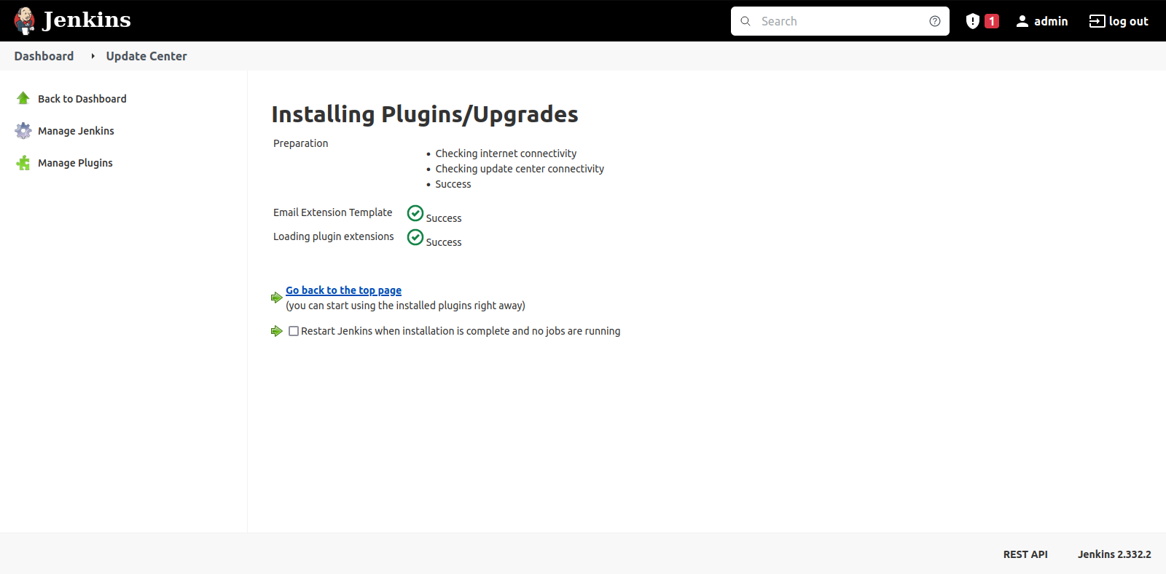Step 2: configuring smtp server

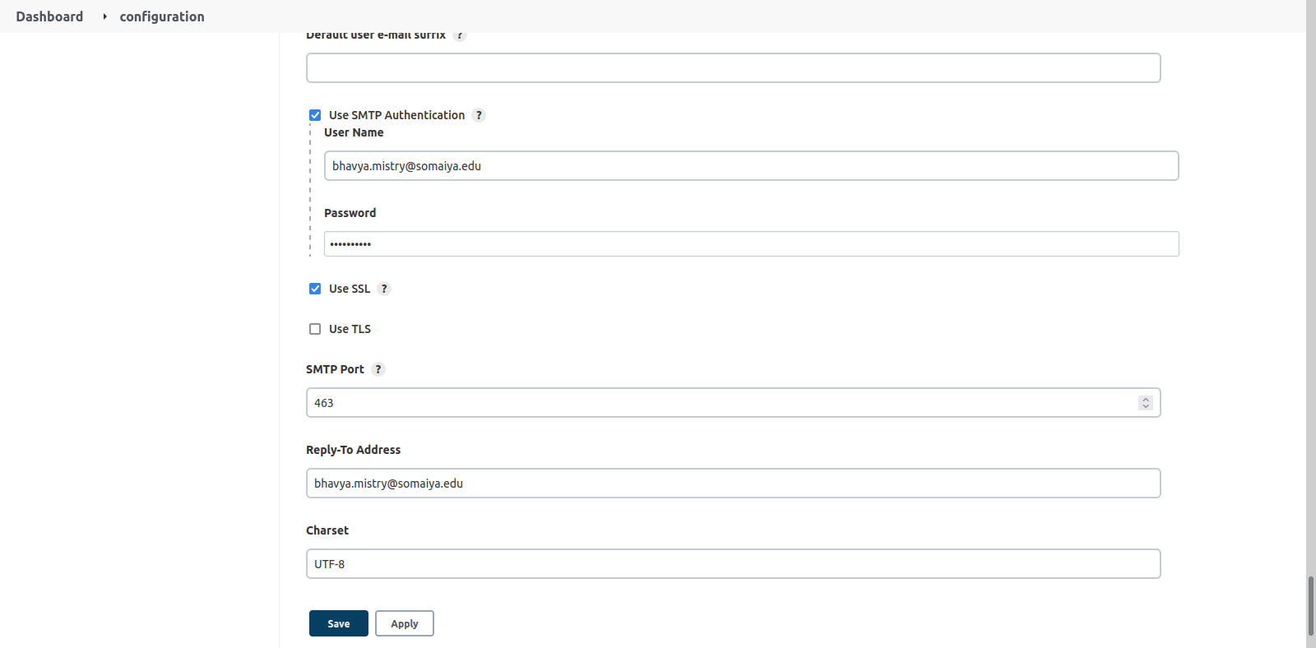

Step 3: Allowing less secure apps on sender’s email

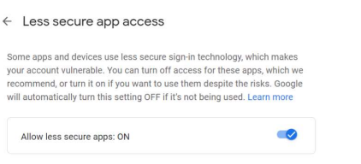Step 3: Testing the configuration by sending test email

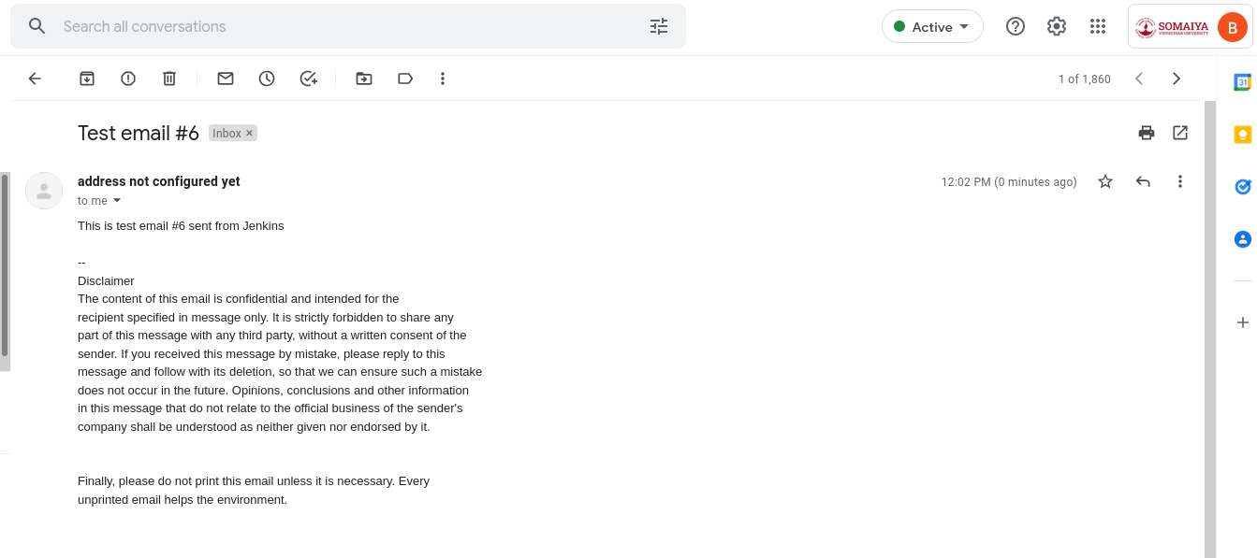

Step 4: Configuring the project in Jenkins to send email notification with each build

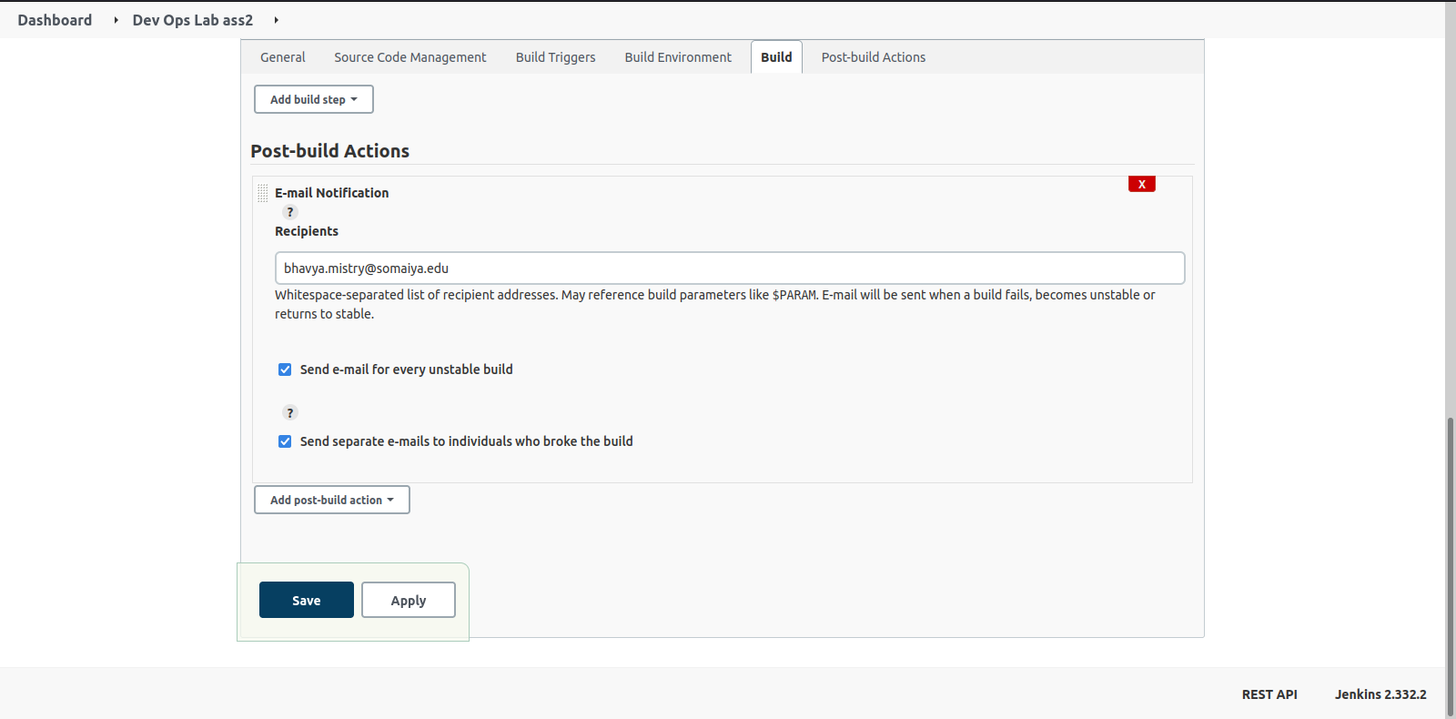

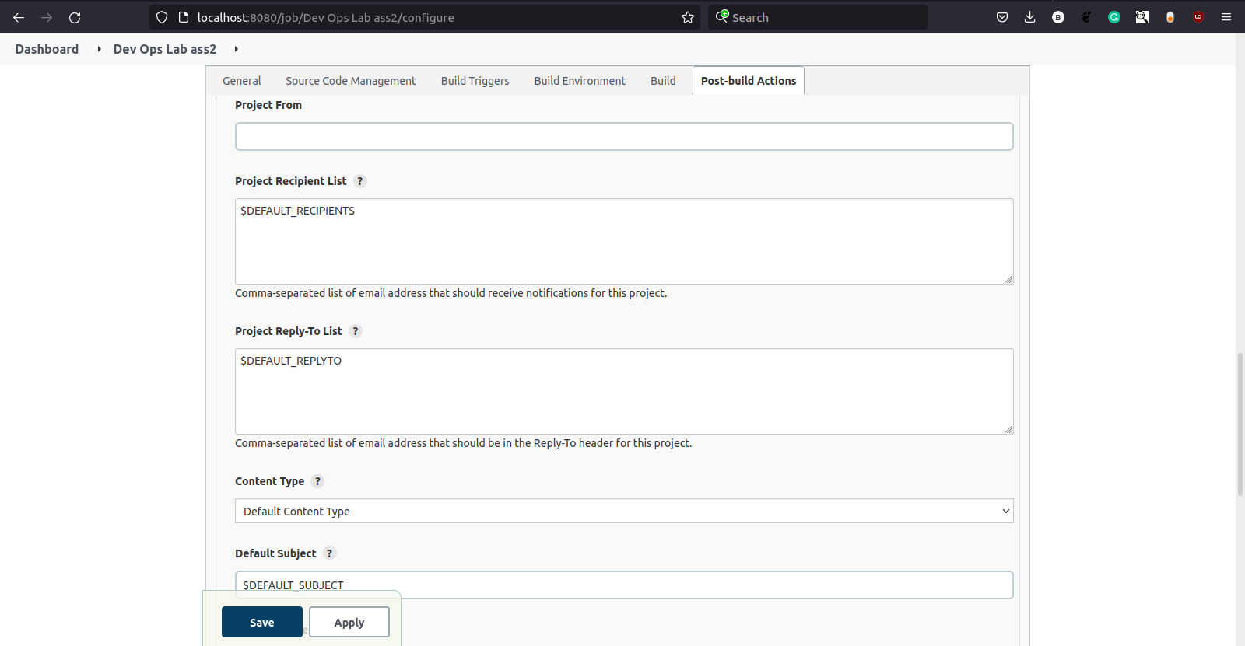

Step 5: Building the project and receiving email as soon build finishes

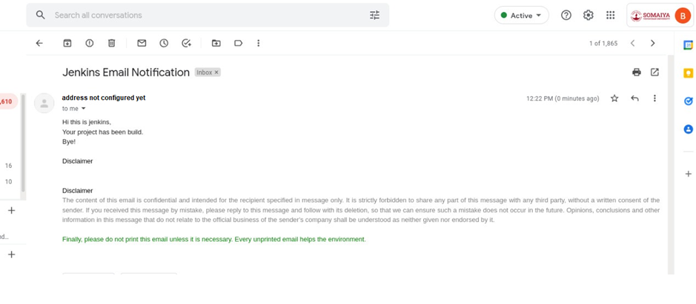

**Conclusion:** Email configuration with Jenkins was successfully done. With each build of the project, the specified recipients are notified about the build of the project whether it was successful or not. This allows user to keep a track of their project and efficient management of the same.