Part A — Practice Programs
- Vending machine
CODE:
import java.util.Scanner;
public class VendingMachine
{
enum Coin
{
ONE, TWO, FIVE, TEN
}
public static void main(String[] args)
{
int snackPrice = 15;
int totalAmount = 0;
int coinValue = 0;
Scanner sc = new Scanner(System.in);

while (totalAmount<snackPrice)
{
System.out.print("Enter coin (ONE, TWO, FIVE, TEN): ");
String input = sc.next();
Coin coin = null ;
switch (input)
{
case "ONE":
coin = Coin.ONE;
break;
case "TWO":
coin = Coin.TWO;
break;
case "FIVE":
coin = Coin.FIVE;
break;
case "TEN":
coin = Coin.TEN;
break;
default:
System.out.println("Invalid Coin!");
continue;
}
switch (coin)
{
case ONE:
coinValue=1;
break;
case TWO:
coinValue=2;
break;
case FIVE:
coinValue=5;
break;
case TEN:
coinValue=10;
break;
}
totalAmount += coinValue;
System.out.println("Total paid: " + totalAmount);
}
System.out.println("Paid. Change: " + (totalAmount-snackPrice));
sc.close();
}
}
OUTPUT:
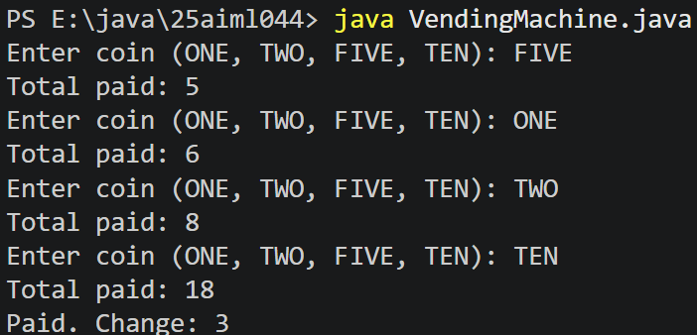

- Toll booth
CODE:
import java.util.Scanner;
public class TollBooth
{
record Vehicle(String number, String type){}
public static void main(String[] args)
{
Scanner sc = new Scanner(System.in);
int totalToll=0;
int bikeCount=0;
int carCount=0;
int truckCount=0;
while(true)
{
System.out.print("Enter vehicle number (or done to stop): ");
String number = sc.next();
if (number.equals("done"))
{
break;
}
System.out.print("Enter vehicle type (bike/car/truck): ");
String type = sc.next();
Vehicle vehicle = new Vehicle(number, type);
switch (vehicle.type())
{
case "bike":
totalToll += 20;
bikeCount++;
break;
case "car":
totalToll += 50;
carCount++;
break;
case "truck":
totalToll += 150;
truckCount++;
break;
default:
System.out.println("Invalid vehicle type!");
}
}
System.out.println("Total toll: " + totalToll);
if(bikeCount >= carCount && bikeCount >= truckCount)
{
System.out.println("Most frequent: bike");
}
else if(carCount >= bikeCount && carCount >= truckCount)
{
System.out.println("Most frequent: car");
}
else
{
System.out.println("Most frequent: truck");
}
sc.close();
}
}

OUTPUT:
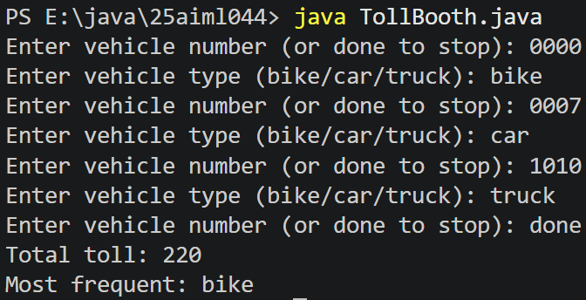

- Rock-Paper-Scissors-Lizard-Spock (RPSLS)
CODE:
import java.util.Random;
import java.util.Scanner;

public class RPSLS
{

enum Move
{
ROCK, PAPER, SCISSORS, LIZARD, SPOCK
}

static int winner(Move a, Move b)
{

if (a == b)
return 0;

switch (a)
{

case ROCK:
if (b == Move.SCISSORS || b == Move.LIZARD)
return 1;
else
return -1;

case PAPER:
if (b == Move.ROCK || b == Move.SPOCK)
return 1;
else
return -1;

case SCISSORS:
if (b == Move.PAPER || b == Move.LIZARD)
return 1;
else
return -1;

case LIZARD:
if (b == Move.PAPER || b == Move.SPOCK)
return 1;
else
return -1;

case SPOCK:
if (b == Move.ROCK || b == Move.SCISSORS)
return 1;
else
return -1;
}

return 0;
}

public static void main(String[] args)
{

Scanner sc = new Scanner(System.in);
Random random = new Random();

int playerScore = 0, computerScore = 0;

for (int i = 1; i <= 5; i++)
{

System.out.println("\n---Round " + i + "---");
System.out.println("1. ROCK");
System.out.println("2. PAPER");
System.out.println("3. SCISSORS");
System.out.println("4. LIZARD");
System.out.println("5. SPOCK");
System.out.print("Enter your choice: ");

int choice = sc.nextInt();

Move player = null;

switch (choice)

{
case 1:
player = Move.ROCK;
break;
case 2:
player = Move.PAPER;
break;
case 3:
player = Move.SCISSORS;
break;
case 4:
player = Move.LIZARD;
break;
case 5:
player = Move.SPOCK;
break;
default:
System.out.println("Invalid choice");
i--;
continue;
}

int computerChoice = random.nextInt(5) + 1;
Move computer = null;

switch (computerChoice)
{
case 1:
computer = Move.ROCK;
break;
case 2:
computer = Move.PAPER;
break;
case 3:
computer = Move.SCISSORS;
break;
case 4:
computer = Move.LIZARD;
break;
case 5:
computer = Move.SPOCK;
break;
}

System.out.println("Your Move: " + player);
System.out.println("Computer Move: " + computer);

int result = winner(player, computer);

if (result == 1)
{
System.out.println("You win this round.");
playerScore++;
}
else if (result == -1)
{
System.out.println("Computer wins this round.");
computerScore++;
}
else
{
System.out.println("Round Tie.");
}
}

System.out.println("\nFinal Score");
System.out.println("You: " + playerScore);
System.out.println("Computer: " + computerScore);

if (playerScore > computerScore)
System.out.println("You win " + playerScore + "-" + computerScore);
else if (computerScore > playerScore)
System.out.println("Computer wins " + computerScore + "-" + playerScore);
else
System.out.println("Match Tie " + playerScore + "-" + computerScore);
sc.close();}
}
OUTPUT:
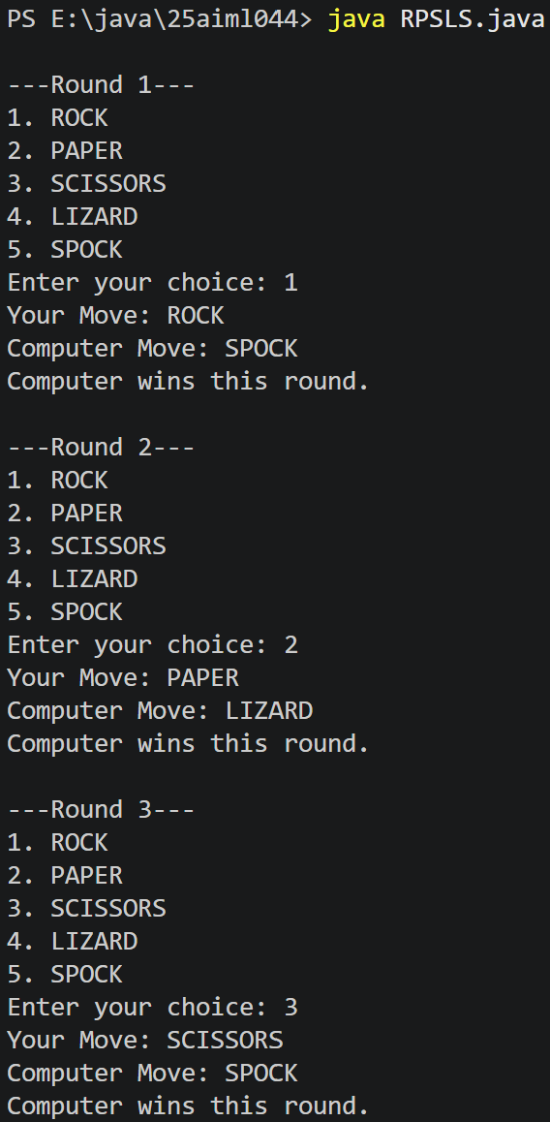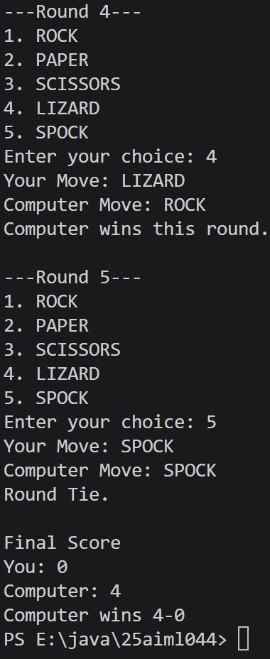

Part B — Project Work: MiniBank
CODE:
import java.util.Scanner;

public class MiniBank
{

// Record to store bank information
record BankInfo(String name, String branch) {}

// Enum for menu options
enum MenuOption
{
OPEN_ACCOUNT,
DEPOSIT,
WITHDRAW,
TRANSFER,
EXIT
}

public static void main(String[] args)
{

Scanner sc = new Scanner(System.in);

// Create and display bank information
BankInfo bankInfo = new BankInfo("MiniBank", "CHANGA Branch");

System.out.println("=================================");
System.out.println(" " + bankInfo.name());
System.out.println(" Branch: " + bankInfo.branch());
System.out.println("=================================");

while (true)
{

// Display menu
System.out.println("\n------ Main Menu ------");
System.out.println("1. Open Account");
System.out.println("2. Deposit");
System.out.println("3. Withdraw");
System.out.println("4. Transfer");
System.out.println("5. Exit");

System.out.print("Enter your choice: ");
int choice = sc.nextInt();

// Switch expression
String message = switch (choice)

{
case 1 -> "Open Account - To be implemented in a later lab.";
case 2 -> "Deposit - To be implemented in a later lab.";
case 3 -> "Withdraw - To be implemented in a later lab.";
case 4 -> "Transfer - To be implemented in a later lab.";
case 5 -> "Thank you for using MiniBank. Goodbye!";
default -> "Invalid choice! Please try again.";
};

System.out.println(message);

if (choice == 5)
{
break;
}
}
sc.close(); }
}
OUTPUT:


