Part A — Practice Programs
- Smart thermostat
CODE:
import java.util.*;

public class Thermostat
{
@SuppressWarnings("unused")
private String location;
private int temperature;
private static int MIN=16;
private static int MAX=30;
private static int activeCount=0;
public Thermostat(String l,int t)
{
if(t>MIN && t<MAX)
{
temperature=t;
}
else
{
temperature=22;
}
activeCount++;

this.location=l;

}
public Thermostat(String l)
{
this(l,22);

}
public void raise()
{
if(temperature<MAX)
{
temperature+=1;
}
else
{
System.out.println("Already at maximum(30)");
}

}
public void lower()
{
if(temperature>MIN)
{
temperature--;
}
else
{
System.out.println("Already at minimum(16)");

}
}
public int getTemperature()
{
return temperature;
}
public static int getActiveCount()
{
return activeCount;
}
public static void main(String[] args)
{

@SuppressWarnings("resource")
Scanner s1 = new Scanner(System.in);
int temp = s1.nextInt();

Thermostat t1 = new Thermostat("room");
Thermostat t2 = new Thermostat("hall", temp);

for(int i=0;i<10;i++)
{
t1.raise();
t2.raise();
System.out.println("Temp from t1 = "+t1.getTemperature()+" Temp from t2 = "+t2.getTemperature());
}
for(int j=0;j<20;j++)
{
t1.lower();
t2.lower();
System.out.println("Temp from t1 = "+t1.getTemperature()+" Temp from t2 = "+t2.getTemperature());

}
System.out.println(Thermostat.getActiveCount());

}

}

OUTPUT:
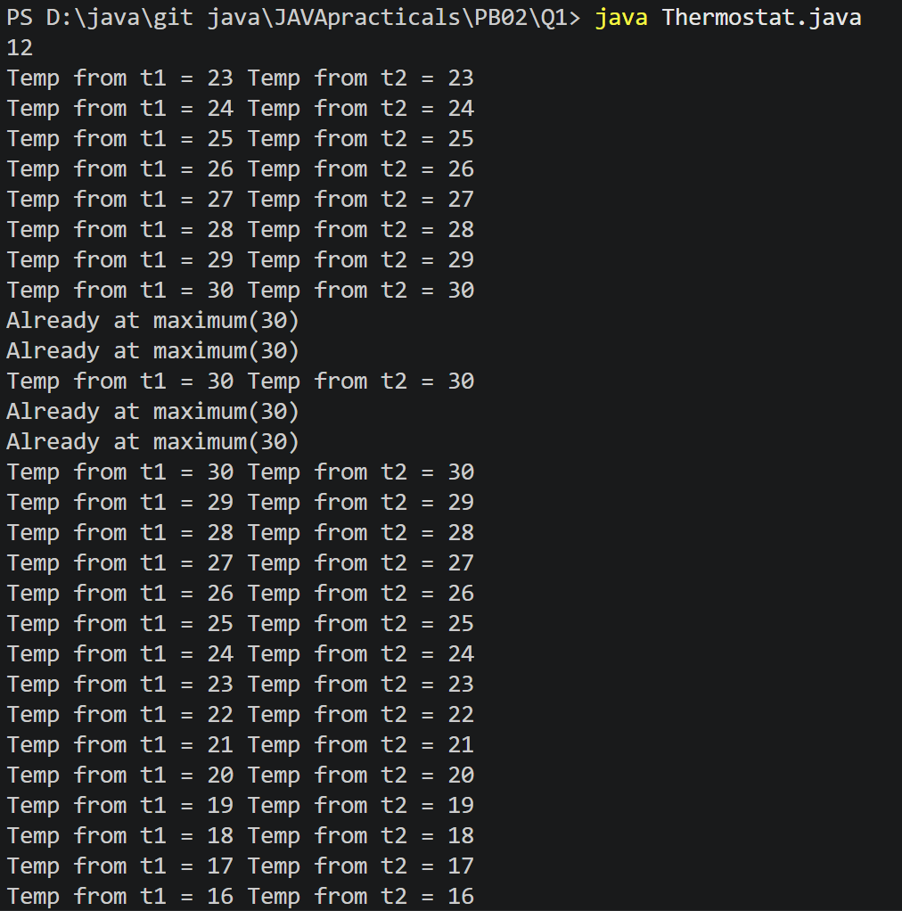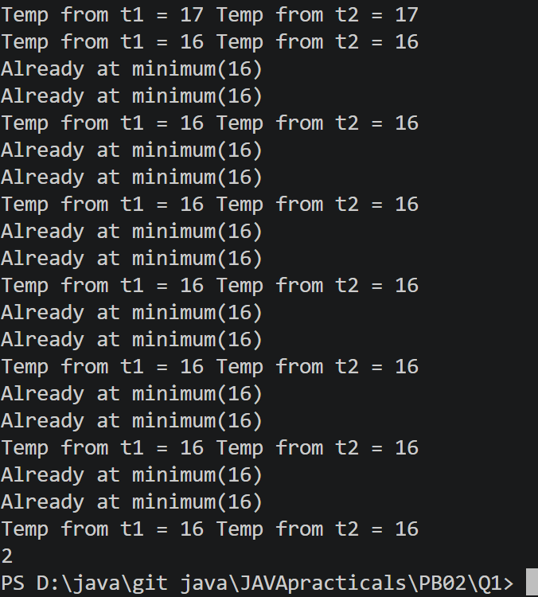

- Cinema show
CODE:
import java.util.*;

public class CinemaShow
{
@SuppressWarnings("unused")
private String title;
private int seatsAvailable;
private final int capacity;
private static int totalBooked=0;
public CinemaShow(String t,int c)
{
title=t;
capacity=c;
seatsAvailable=capacity;
}
public CinemaShow(String t)
{
this(t,100);
}

public boolean book (int n)
{
if(n<=seatsAvailable)
{
seatsAvailable-=n;
totalBooked+=n;
return true;
}
else
{
return false;
}
}
public void cancel(int n)
{
seatsAvailable+=n;
if(seatsAvailable>capacity)
{
seatsAvailable=capacity;
}
}
public int getSeatsAvailable()
{
return seatsAvailable;
}
public static int getTotalBooked()
{
return totalBooked;
}
public static void main(String[] args)
{

Scanner s= new Scanner(System.in);

int cap;
System.out.print("Enter capcaity of cinema:");
cap=s.nextInt();
s.nextLine();

String t;
System.out.print("Enter movie:");
t=s.nextLine();

CinemaShow c= new CinemaShow(t,cap);

while (true){
System.out.println("1. Book ticket");
System.out.println("2. Cancel ticket");
System.out.println("3. Show Available Seats");
System.out.println("4. Exit");
System.out.print("Enter your choice:");
int choice=s.nextInt();
switch ((choice))
{
case 1:
System.out.print("Enter number of tickets:");
int ti=s.nextInt();
boolean result = c.book(ti);
System.out.println("Booking Successful:" + result);
System.out.println("Seats Available:" + c.getSeatsAvailable());
break;

case 2:
System.out.print("Enter number of tickets to cancel:");
int cancel = s.nextInt();

c.cancel(cancel);

System.out.println("Seats Available:" + c.getSeatsAvailable());
break;
case 3:
System.out.println("Seats Available:" + c.getSeatsAvailable());
break;
case 4:

System.out.println("Total Successful Bookings: " + CinemaShow.getTotalBooked());

s.close();
return;
default:
System.out.println("Invalid Choice!");
}

}

}
}

OUTPUT:
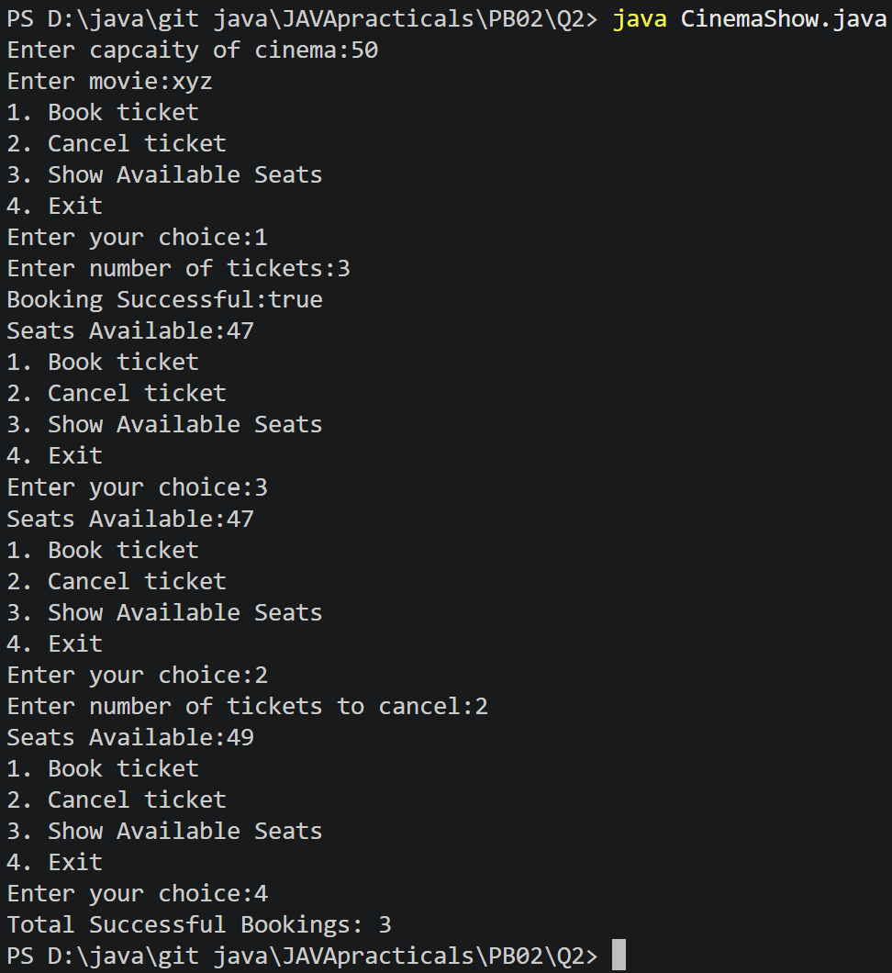

- Parking lot
CODE:
import java.util.*;

public class ParkingLot
{
private int twoWheelers;
private int fourWheelers;
private final int twoCap;
private final int fourCap;
private static long revenue=0;

public ParkingLot(int twoCap, int fourCap)
{
this.twoCap = twoCap;
this.fourCap = fourCap;
twoWheelers = 0;
fourWheelers = 0;
}
public void park(String type)
{
switch (type.toUpperCase())
{
case "TWO":

if(twoWheelers<twoCap)
{
twoWheelers++;
revenue+=20;
}
else
{
System.out.println("FULL");
}

break;
case "FOUR":

if(fourWheelers<fourCap)
{
fourWheelers++;
revenue+=40;
}
else
{
System.out.println("FULL");
}
break;

default:
System.out.println("Invalid type");

}
}
public void leave(String t)
{
switch (t.toUpperCase())
{
case "TWO":

if(twoWheelers>0)
{
twoWheelers--;

}
else
{
System.out.println("Empty");
}

break;
case "FOUR":

if(fourWheelers>0)
{
fourWheelers--;

}
else
{
System.out.println("Empty");
}
break;

default:
System.out.println("Invalid type");

}

}

public int getTwoWheelers()
{
return twoWheelers;
}

public int getFourWheelers()
{
return fourWheelers;
}

public static long getRevenue()
{
return revenue;
}
public static void main(String[] args)
{
Scanner s=new Scanner(System.in);
System.out.print("Enter two-wheeler capacity:");
int two = s.nextInt();

System.out.print("Enter four-wheeler capacity:");
int four = s.nextInt();

ParkingLot p= new ParkingLot(two, four);
while(true)
{
System.out.println("1. Park Vehicle");
System.out.println("2. Leave Vehicle");
System.out.println("3. Show Status");
System.out.println("4. Exit");

System.out.print("Enter choice: ");
int choice = s.nextInt();

switch (choice)
{

case 1:
System.out.print("Enter vehicle type: ");
String type = s.next();
p.park(type);

System.out.println("Two-Wheelers:" + p.getTwoWheelers());
System.out.println("Four-Wheelers:" + p.getFourWheelers());
break;
case 2:
System.out.print("Enter vehicle type: ");
String ty = s.next();
p.leave(ty);
System.out.println("Two-Wheelers:" + p.getTwoWheelers());
System.out.println("Four-Wheelers:" + p.getFourWheelers());
break;
case 3:
System.out.println("Two-Wheelers:" + p.getTwoWheelers());
System.out.println("Four-Wheelers:" + p.getFourWheelers());
System.out.println("Revenue: Rs. " + ParkingLot.getRevenue());
break;

case 4:
System.out.println("Final Occupancy");
System.out.println("Two-Wheelers :" + p.getTwoWheelers());
System.out.println("Four-Wheelers:" + p.getFourWheelers());
System.out.println("Total Revenue:Rs. " + ParkingLot.getRevenue());

s.close();
default:
System.out.println("Invalid Choice");

}
}
}
}

OUTPUT:
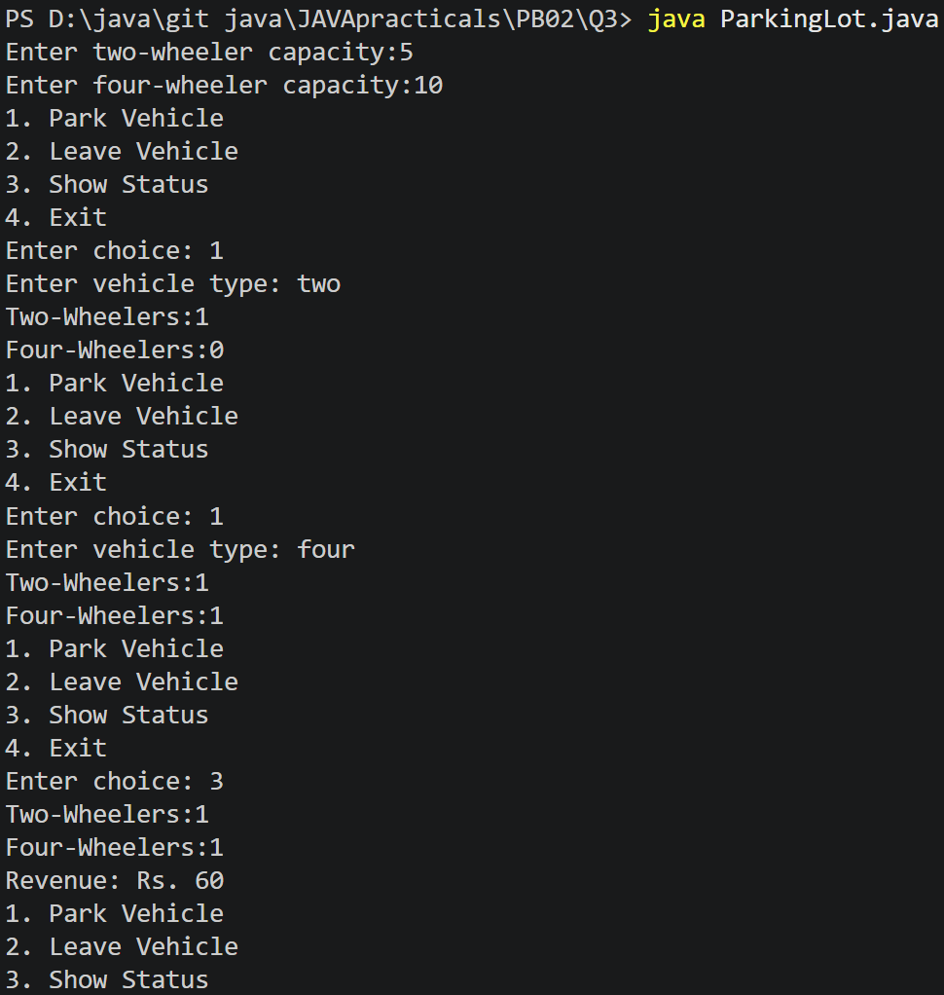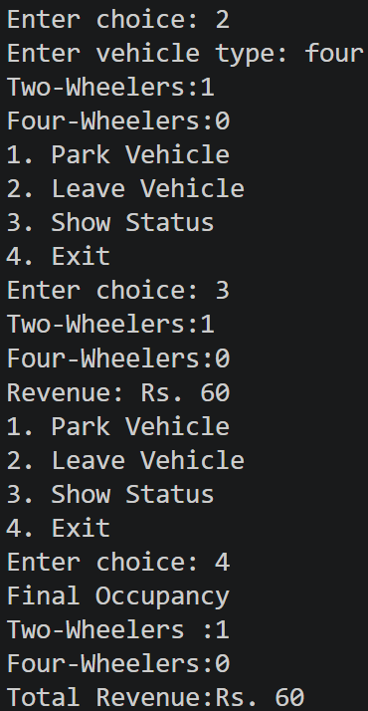

Part B — Project Work: MiniBank
CODE:
import java.util.*;

public class MiniBank {

enum MenuOption {
OPEN_ACCOUNT,
DEPOSIT,
WITHDRAW,
TRANSFER,
EXIT
}

record BankInfo(String name, String branch) {
}

public static void main(String[] args) {

BankInfo bankInfo = new BankInfo("MiniBank", "CHANGA Branch");

Scanner s = new Scanner(System.in);
boolean run = true;
Account[] accounts = new Account[3];

accounts[0] = new Account("Bhavya", 5000);
accounts[1] = new Account("Japan", 10000);
accounts[2] = new Account("Shivam" );

while (run) {

System.out.println("=================================");
System.out.println(" " + bankInfo.name());
System.out.println(" Branch: " + bankInfo.branch());
System.out.println("=================================");
System.out.println("1) Open Account");
System.out.println("2) Deposit");
System.out.println("3) Withdraw");
System.out.println("4) Transfer");
System.out.println("5) Exit");

System.out.print("Enter your choice:");

int choice = s.nextInt();

MenuOption option;

switch (choice) {
case 1:
option = MenuOption.OPEN_ACCOUNT;
break;
case 2:
option = MenuOption.DEPOSIT;
break;
case 3:
option = MenuOption.WITHDRAW;
break;
case 4:
option = MenuOption.TRANSFER;
break;
case 5:
option = MenuOption.EXIT;
break;
default:
option = null;
}

if (option == null) {
System.out.println("Invalid Choice");
continue;
}

switch (option) {

case OPEN_ACCOUNT -> {
System.out.println("\nAccounts Created Successfully");

System.out.println(accounts[0].getAccountNumber() + " | "+ accounts[0].getOwnerName() + " | Balance = " + accounts[0].getBalance());

System.out.println(accounts[1].getAccountNumber() + " | "+ accounts[1].getOwnerName() + " | Balance = " + accounts[1].getBalance());

System.out.println(accounts[2].getAccountNumber() + " | "+ accounts[2].getOwnerName() + " | Balance = " + accounts[2].getBalance());
}

case DEPOSIT -> {

System.out.println("Select Account");
System.out.println("1." + accounts[0].getOwnerName());
System.out.println("2." + accounts[1].getOwnerName());
System.out.println("3." + accounts[2].getOwnerName());

int acc = s.nextInt();

System.out.print("Enter Amount:");
long amount = s.nextLong();

switch (acc) {

case 1:
accounts[0].deposit(amount);
System.out.println("Balance =" + accounts[0].getBalance());
break;

case 2:
accounts[1].deposit(amount);
System.out.println("Balance =" + accounts[1].getBalance());
break;

case 3:
accounts[2].deposit(amount);
System.out.println("Balance =" + accounts[2].getBalance());
break;

default:
System.out.println("Invalid Account");
}
}

case WITHDRAW -> {

System.out.println("Select Account");
System.out.println("1. " + accounts[0].getOwnerName());
System.out.println("2. " + accounts[1].getOwnerName());
System.out.println("3. " + accounts[2].getOwnerName());

int acc = s.nextInt();

System.out.print("Enter Amount:");
long amount = s.nextLong();

switch (acc) {

case 1:

if (accounts[0].withdraw(amount))
System.out.println("Withdrawal Successful");
else
System.out.println("Insufficient Balance");

System.out.println("Balance =" + accounts[0].getBalance());
break;

case 2:

if (accounts[1].withdraw(amount))
System.out.println("Withdrawal Successful");
else
System.out.println("Insufficient Balance");

System.out.println("Balance =" + accounts[1].getBalance());
break;

case 3:

if (accounts[2].withdraw(amount))
System.out.println("Withdrawal Successful");
else
System.out.println("Insufficient Balance");

System.out.println("Balance =" + accounts[2].getBalance());
break;

default:
System.out.println("Invalid Account");
}
}

case TRANSFER -> {

System.out.println("Transfer feature will be implemented later");
}

case EXIT -> {

System.out.println("Thank you for using MiniBank.");
run = false;
}
}
}

s.close();
}
}

@SuppressWarnings("unused")
class Customer {

private String name;
private String email;
private String mobile;
private final String customerId;

private static long customerCounter = 100;

private static String generateCustomerId() {
customerCounter++;
return "CUST" + customerCounter;
}

public Customer(String name, String email, String mobile) {
this.name = name;
this.email = email;
this.mobile = mobile;
this.customerId = generateCustomerId();
}

public String getName() {
return name;
}

public String getEmail() {
return email;
}

public String getMobile() {
return mobile;
}

public String getCustomerId() {
return customerId;
}
}

class Account {

private final String accountNumber;
private String ownerName;
private long balance;
private boolean active;

private static int accountCounter = 0;

private static String generateAccountNumber() {

accountCounter++;
return String.format("AC%04d", accountCounter);
}

public Account(String ownerName, long openingBalance) {

this.ownerName = ownerName;
this.balance = openingBalance;
this.active = true;
this.accountNumber = generateAccountNumber();
}

public Account(String ownerName) {

this(ownerName, 0);
}

public void deposit(long amount) {

if (amount > 0) {
balance += amount;
}
}

public boolean withdraw(long amount) {

if (amount <= balance) {
balance -= amount;
return true;
}

return false;
}

public String getAccountNumber() {
return accountNumber;
}

public String getOwnerName() {
return ownerName;
}

public long getBalance() {
return balance;
}

public boolean isActive() {
return active;
}
}

OUTPUT:


