MINI BANK PROJECT
Practical 1
1) | MiniBank.java
CODE | import java.util.Scanner;  public class MiniBank  {  // Record to store bank information  record BankInfo(String name, String branch) {}  // Enum for menu options  enum MenuOption  {  OPEN_ACCOUNT,  DEPOSIT,  WITHDRAW,  TRANSFER,  EXIT  }  @SuppressWarnings("ConvertToTryWithResources")  public static void main(String[] args)  {  Scanner sc = new Scanner(System.in);  // Create and display bank information  BankInfo bankInfo = new BankInfo("MiniBank", "Kheroli Branch");  System.out.println("=================================");  System.out.println(" " + bankInfo.name());  System.out.println(" Branch: " + bankInfo.branch());  System.out.println("=================================");  while (true)  {  // Display menu  System.out.println("\n------ Main Menu ------");  System.out.println("1. Open Account");  System.out.println("2. Deposit");  System.out.println("3. Withdraw");  System.out.println("4. Transfer");  System.out.println("5. Exit");  System.out.print("Enter your choice: ");  int choice = sc.nextInt();  // Switch expression  String message = switch (choice)  {  case 1 -> "Open Account - To be implemented in a later lab.";  case 2 -> "Deposit - To be implemented in a later lab.";  case 3 -> "Withdraw - To be implemented in a later lab.";  case 4 -> "Transfer - To be implemented in a later lab.";  case 5 -> "Thank you for using MiniBank. Goodbye!";  default -> "Invalid choice! Please try again.";  };  System.out.println(message);  if (choice == 5)  {  break;  }  }  sc.close();  }  }
OUTPUT | 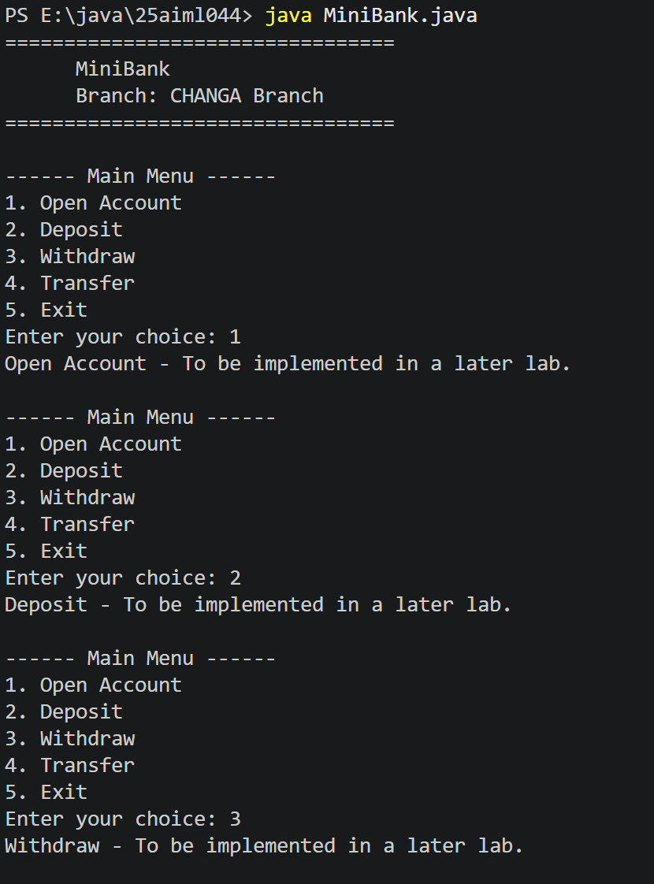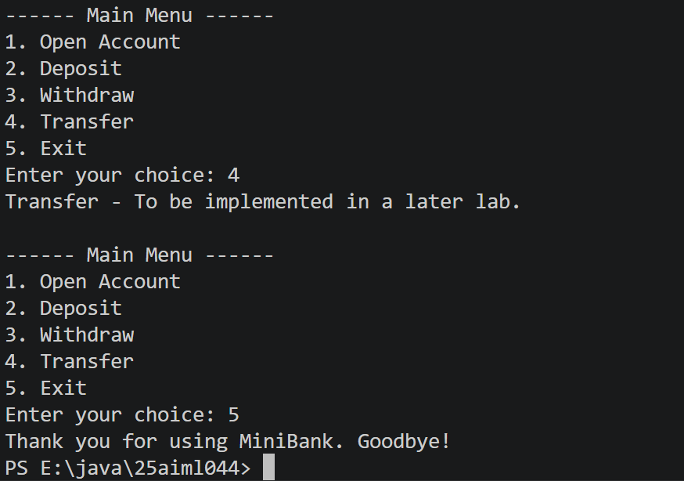

Practical 2
 | Customer.java
CODE | public class Customer {  private String name;  private String email;  private String mobile;  private final String customerId;  private static long customerCounter = 100;  public Customer(String name, String email, String mobile) {  this.name = name;  this.email = email;  this.mobile = mobile;  this.customerId = generateCustomerId();  }  private static String generateCustomerId() {  customerCounter++;  return "CUST" + customerCounter;  }  public String getName() {  return name;  }  public String getEmail() {  return email;  }  public String getMobile() {  return mobile;  }  public String getCustomerId() {  return customerId;  }  }
 | Account.java
CODE | public class Account {  private final String accountNumber;  private String ownerName;  private long balance;  private boolean active;  private static long accountCounter = 0;  public Account(String ownerName, long openingBalance) {  accountCounter++;  this.accountNumber = String.format("AC%04d", accountCounter);  this.ownerName = ownerName;  this.balance = openingBalance >= 0 ? openingBalance : 0;  this.active = true;  }  public Account(String ownerName) {  this(ownerName, 0);  }  public void deposit(long amount) {  if (amount <= 0) {  System.out.println("Deposit amount must be greater than zero.");  return;  }  balance += amount;  }  public boolean withdraw(long amount) {  if (amount <= 0) {  System.out.println("Withdrawal amount must be greater than zero.");  return false;  }  if (balance >= amount) {  balance -= amount;  return true;  }  return false;  }  public String getAccountNumber() {  return accountNumber;  }  public String getOwnerName() {  return ownerName;  }  public long getBalance() {  return balance;  }  public boolean isActive() {  return active;  }  public static boolean transfer(Account from, Account to, long amount) {  if (from == null || to == null || amount <= 0) {  return false;  }  if (from.withdraw(amount)) {  to.deposit(amount);  return true;  }  return false;  }  }
 | MiniBank.java
CODE | public class MiniBank {  public static void main(String[] args) {  Account[] accounts = {  new Account("Asha", 5000),  new Account("Ravi"),  new Account("Neha", 2500)  };  accounts[0].deposit(1000);  accounts[1].deposit(3000);  boolean withdrawalSuccessful = accounts[2].withdraw(500);  System.out.println("Neha's withdrawal successful: " + withdrawalSuccessful);  boolean transferSuccessful =  Account.transfer(accounts[0], accounts[1], 2000);  System.out.println("Transfer successful: " + transferSuccessful);  System.out.println("\nAccount balances:");  for (Account account : accounts) {  System.out.println(  account.getAccountNumber()  + " | Owner: " + account.getOwnerName()  + " | Balance: Rs. " + account.getBalance()  );  }  }  }
OUTPUT | 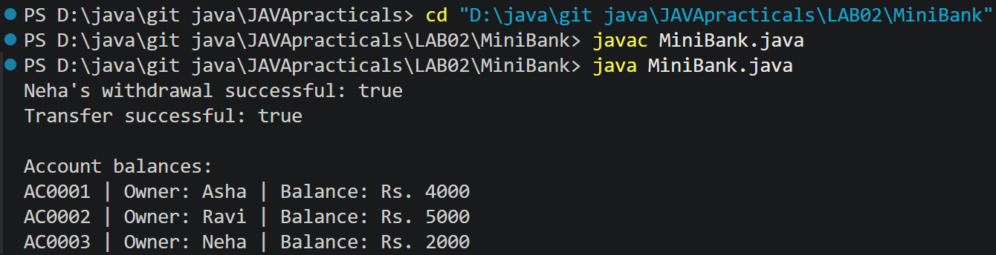

Practical 3
 | Customer.java
CODE | public class Customer implements Cloneable {  private String name;  private String email;  private String mobile;  private final String customerId;  private Address address;  private static long customerCounter = 100;  public Customer(String name, String email, String mobile, Address address) {  this.name = name;  this.email = email;  this.mobile = mobile;  this.address = address;  this.customerId = generateCustomerId();  }  private static String generateCustomerId() {  customerCounter++;  return "CUST" + customerCounter;  }  public String getName() {  return name;  }  public String getEmail() {  return email;  }  public String getMobile() {  return mobile;  }  public String getCustomerId() {  return customerId;  }  public Address getAddress() {  return address;  }  @Override  public Customer clone() {  try {  return (Customer) super.clone();  } catch (CloneNotSupportedException e) {  throw new AssertionError(e);  }  }  public static class Address {  private String line;  private String city;  private String pincode;  public Address(String line, String city, String pincode) {  this.line = line;  this.city = city;  this.pincode = pincode;  }  public String getLine() {  return line;  }  public String getCity() {  return city;  }  public String getPincode() {  return pincode;  }  @Override  public String toString() {  return line + ", " + city + " - " + pincode;  }  }  }
 | Account.java
CODE | import java.util.Objects;  public class Account {  private final String accountNumber;  private String ownerName;  private long balance;  private boolean active;  private static int accountCounter = 0;  public Account(String ownerName, long openingBalance) {  accountCounter++;  this.accountNumber = String.format("AC%04d", accountCounter);  this.ownerName = ownerName;  this.balance = Math.max(openingBalance, 0);  this.active = true;  }  public Account(String ownerName) {  this(ownerName, 0);  }  public boolean deposit(long amount) {  if (amount <= 0) {  return false;  }  balance += amount;  return true;  }  public boolean withdraw(long amount) {  if (amount <= 0 || amount > balance) {  return false;  }  balance -= amount;  return true;  }  public String getAccountNumber() {  return accountNumber;  }  public String getOwnerName() {  return ownerName;  }  public long getBalance() {  return balance;  }  public boolean isActive() {  return active;  }  @Override  public String toString() {  return "Account Number: " + accountNumber  + " | Owner: " + ownerName  + " | Balance: Rs. " + balance  + " | Active: " + active;  }  @Override  public boolean equals(Object o) {  if (this == o) {  return true;  }  if (!(o instanceof Account)) {  return false;  }  Account account = (Account) o;  return accountNumber.equals(account.accountNumber);  }  @Override  public int hashCode() {  return Objects.hash(accountNumber);  }  public String getStatement() {  return "----- Account Statement -----\n"  + "Account Number: " + accountNumber + "\n"  + "Owner: " + ownerName + "\n"  + "Balance: Rs. " + balance + "\n"  + "Active: " + active + "\n"  + "-----------------------------";  }  }
 | MiniBank.java
CODE | import java.util.Scanner;  public class MiniBank {  enum MenuOption {  OPEN_ACCOUNT,  DEPOSIT,  WITHDRAW,  TRANSFER,  EXIT  }  record BankInfo(String name, String branch) {  }  public static void main(String[] args) {  BankInfo bankInfo = new BankInfo("MiniBank", "Kheroli Branch");  Scanner s = new Scanner(System.in);  Account[] accounts = {  new Account("Bhavya", 5000),  new Account("Japan", 10000),  new Account("Shivam")  };  Customer.Address address =  new Customer.Address("Main Road", "Kheroli", "123456");  Customer customer = new Customer(  "Bhavya",  "bhavya@example.com",  "9876543210",  address  );  Customer copiedCustomer = customer.clone();  System.out.println("=================================");  System.out.println(" " + bankInfo.name());  System.out.println(" Branch: " + bankInfo.branch());  System.out.println("=================================");  // Print accounts using toString()  System.out.println("\nAccounts:");  for (Account account : accounts) {  System.out.println(account.toString());  }  // Compare two accounts using equals()  System.out.println("\nAre the first two accounts equal? "  + accounts[0].equals(accounts[1]));  // Check an object's type using instanceof  Object object = accounts[0];  if (object instanceof Account) {  System.out.println("The object is an Account.");  }  System.out.println("\nCustomer: " + copiedCustomer.getName());  System.out.println("Customer ID: " + copiedCustomer.getCustomerId());  System.out.println("Address: " + copiedCustomer.getAddress());  // Print the formatted account statement  System.out.println("\n" + accounts[0].getStatement());  boolean run = true;  while (run) {  System.out.println("\n------ Main Menu ------");  System.out.println("1) Open Account");  System.out.println("2) Deposit");  System.out.println("3) Withdraw");  System.out.println("4) Transfer");  System.out.println("5) Exit");  System.out.print("Enter your choice: ");  int choice = s.nextInt();  MenuOption option;  switch (choice) {  case 1 -> option = MenuOption.OPEN_ACCOUNT;  case 2 -> option = MenuOption.DEPOSIT;  case 3 -> option = MenuOption.WITHDRAW;  case 4 -> option = MenuOption.TRANSFER;  case 5 -> option = MenuOption.EXIT;  default -> option = null;  }  if (option == null) {  System.out.println("Invalid choice. Please try again.");  continue;  }  switch (option) {  case OPEN_ACCOUNT -> {  System.out.println("\nAccounts:");  for (Account account : accounts) {  System.out.println(account);  }  }  case DEPOSIT -> {  int index = selectAccount(s, accounts);  if (index == -1) {  break;  }  System.out.print("Enter amount: ");  long amount = s.nextLong();  if (accounts[index].deposit(amount)) {  System.out.println("Deposit successful.");  } else {  System.out.println("Amount must be greater than zero.");  }  System.out.println(accounts[index]);  }  case WITHDRAW -> {  int index = selectAccount(s, accounts);  if (index == -1) {  break;  }  System.out.print("Enter amount: ");  long amount = s.nextLong();  if (accounts[index].withdraw(amount)) {  System.out.println("Withdrawal successful.");  } else {  System.out.println(  "Withdrawal failed. Check the amount and balance."  );  }  System.out.println(accounts[index]);  }  case TRANSFER ->  System.out.println("Transfer feature will be implemented later.");  case EXIT -> {  System.out.println("Thank you for using MiniBank. Goodbye!");  run = false;  }  }  }  s.close();  }  private static int selectAccount(Scanner s, Account[] accounts) {  System.out.println("Select account:");  for (int i = 0; i < accounts.length; i++) {  System.out.println((i + 1) + ". " + accounts[i].getOwnerName());  }  int choice = s.nextInt();  if (choice < 1 || choice > accounts.length) {  System.out.println("Invalid account.");  return -1;  }  return choice - 1;  }  }
OUTPUT | 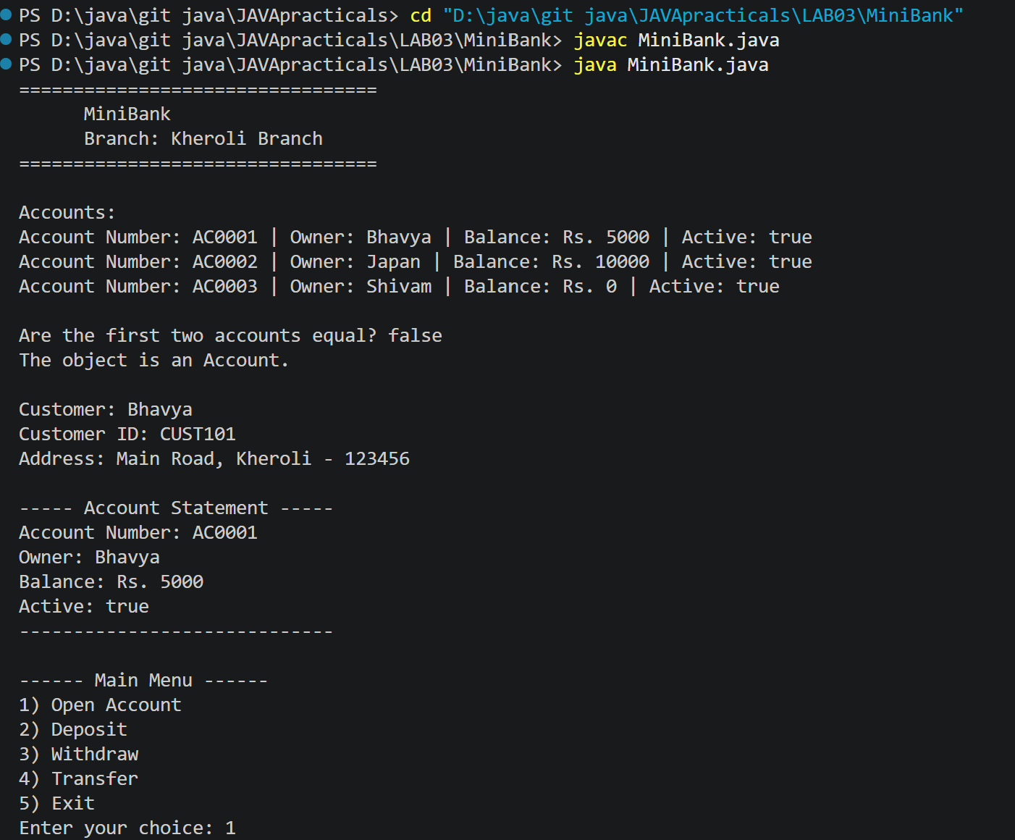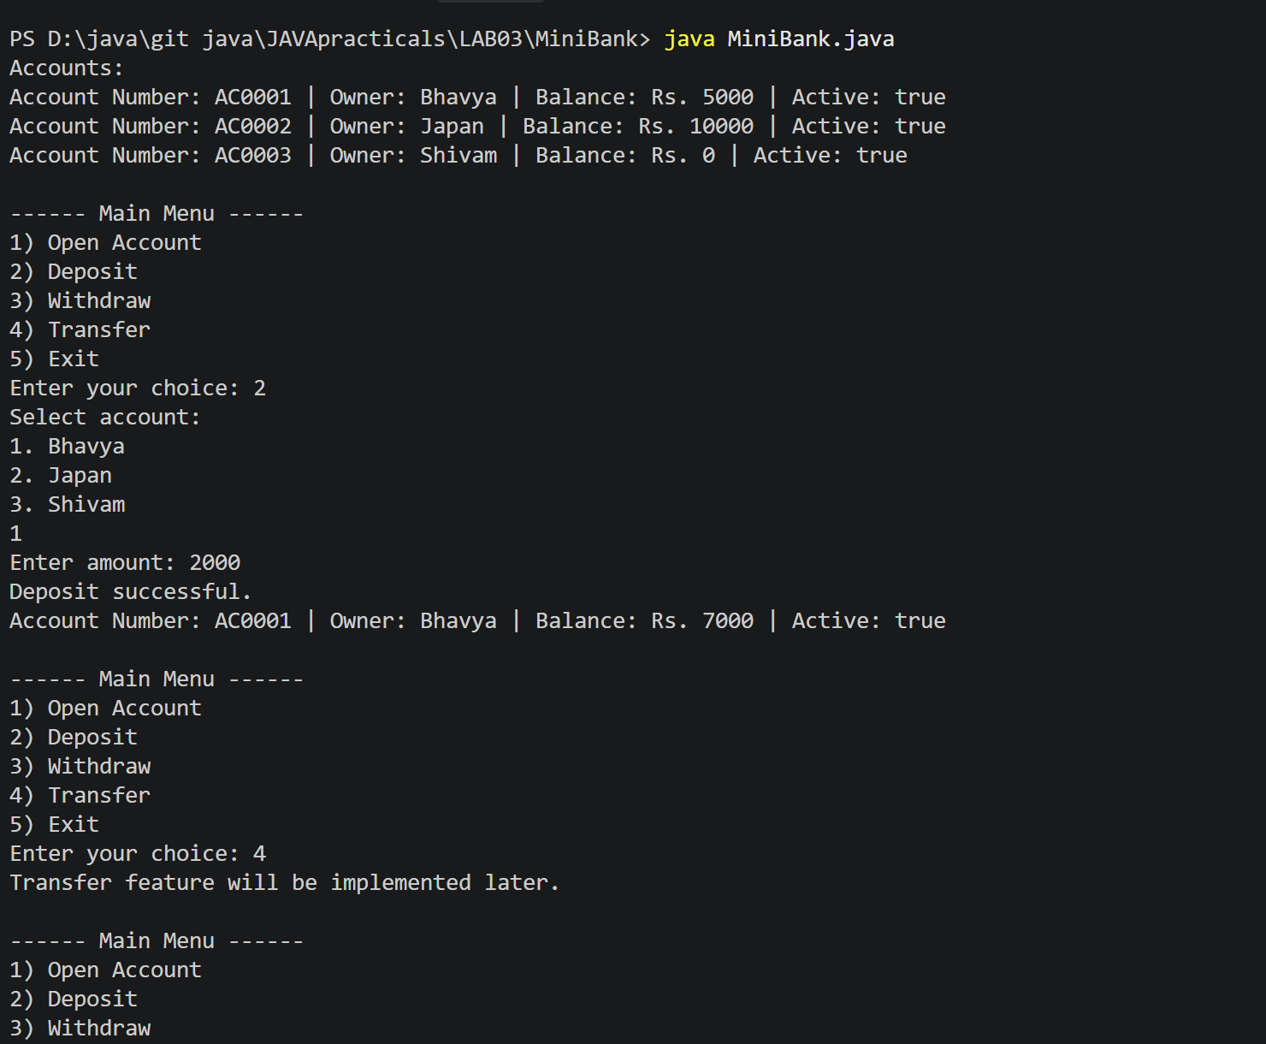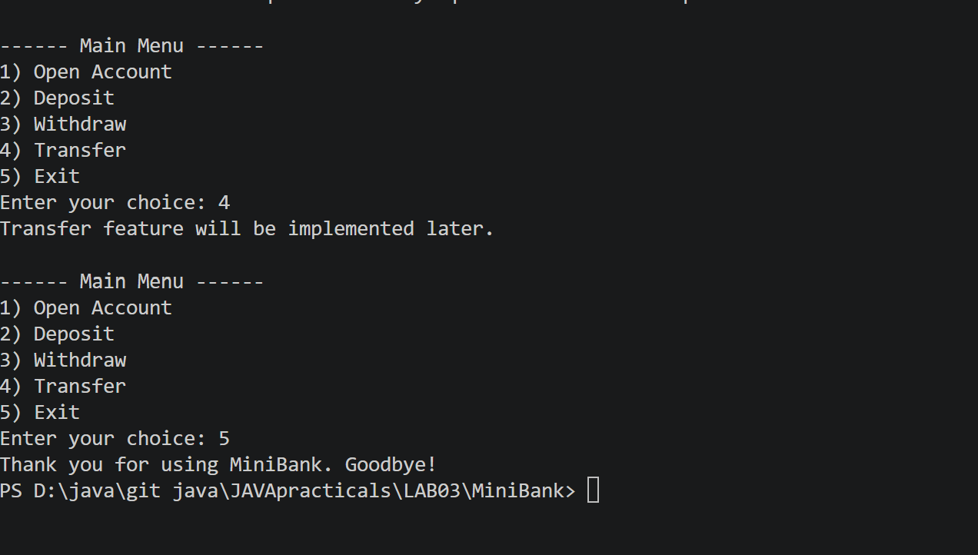

Practical 4
 | Customer.java
CODE | public class Customer implements Cloneable {  private String name;  private String email;  private String mobile;  private final String customerId;  private Address address;  private static long customerCounter = 100;  public Customer(String name, String email, String mobile, Address address) {  this.name = name;  this.email = email;  this.mobile = mobile;  this.address = address;  this.customerId = generateCustomerId();  }  private static String generateCustomerId() {  customerCounter++;  return "CUST" + customerCounter;  }  public String getName() {  return name;  }  public String getEmail() {  return email;  }  public String getMobile() {  return mobile;  }  public String getCustomerId() {  return customerId;  }  public Address getAddress() {  return address;  }  @Override  public Customer clone() {  try {  return (Customer) super.clone();  } catch (CloneNotSupportedException e) {  throw new AssertionError(e);  }  }  public static class Address {  private String line;  private String city;  private String pincode;  public Address(String line, String city, String pincode) {  this.line = line;  this.city = city;  this.pincode = pincode;  }  public String getLine() {  return line;  }  public String getCity() {  return city;  }  public String getPincode() {  return pincode;  }  @Override  public String toString() {  return line + ", " + city + " - " + pincode;  }  }  }
 | Account.java
CODE | import java.util.Objects;  public class Account {  private final String accountNumber;  private String ownerName;  private long balance;  private boolean active;  private static int accountCounter = 0;  public Account(String ownerName, long openingBalance) {  accountCounter++;  this.accountNumber = String.format("AC%04d", accountCounter);  this.ownerName = ownerName;  this.balance = Math.max(openingBalance, 0);  this.active = true;  }  public Account(String ownerName) {  this(ownerName, 0);  }  public boolean deposit(long amount) {  if (amount <= 0) {  return false;  }  balance += amount;  return true;  }  public boolean withdraw(long amount) {  if (amount <= 0 || amount > balance) {  return false;  }  balance -= amount;  return true;  }  public String getAccountNumber() {  return accountNumber;  }  public String getOwnerName() {  return ownerName;  }  public long getBalance() {  return balance;  }  public boolean isActive() {  return active;  }  @Override  public String toString() {  return "Account Number: " + accountNumber  + " | Owner: " + ownerName  + " | Balance: Rs. " + balance  + " | Active: " + active;  }  @Override  public boolean equals(Object o) {  if (this == o) {  return true;  }  if (!(o instanceof Account)) {  return false;  }  Account account = (Account) o;  return accountNumber.equals(account.accountNumber);  }  @Override  public int hashCode() {  return Objects.hash(accountNumber);  }  }
 | MiniBank.java
CODE | import java.util.regex.Pattern;  public class MiniBank {  public static void main(String[] args) {  System.out.println("Mobile tests:");  System.out.println("Valid: " + Validator.isValidMobile("9876543210"));  System.out.println("Invalid: " + Validator.isValidMobile("12345"));  System.out.println("\nEmail tests:");  System.out.println("Valid: " + Validator.isValidEmail("user@example.com"));  System.out.println("Invalid: " + Validator.isValidEmail("user@"));  System.out.println("\nPAN tests:");  System.out.println("Valid: " + Validator.isValidPan("ABCDE1234F"));  System.out.println("Invalid: " + Validator.isValidPan("ABC123"));  System.out.println("\nIFSC tests:");  System.out.println("Valid: " + Validator.isValidIfsc("SBIN0001234"));  System.out.println("Invalid: " + Validator.isValidIfsc("123"));  System.out.println("\nAmount tests:");  System.out.println("Valid: " + Validator.isValidAmount("500"));  System.out.println("Invalid: " + Validator.isValidAmount("-10"));  String line = "DEPOSIT AC0001 500";  try {  Command command = CommandParser.parse(line);  System.out.println("\nParsed command:");  System.out.println("Type: " + command.type());  System.out.println("Account number: " + command.accountNumber());  System.out.println("Amount: " + command.amount());  Account account = new Account("Bhavya", 5000);  System.out.println("\n" + StatementFormatter.buildStatement(account));  } catch (IllegalArgumentException e) {  System.out.println("Command error: " + e.getMessage());  }  }  }  class Validator {  private static final Pattern MOBILE_PATTERN =  Pattern.compile("^[6-9][0-9]{9}$");  private static final Pattern EMAIL_PATTERN =  Pattern.compile("^[A-Za-z0-9+_.-]+@[A-Za-z0-9.-]+\\.[A-Za-z]{2,}$");  private static final Pattern PAN_PATTERN =  Pattern.compile("^[A-Z]{5}[0-9]{4}[A-Z]$");  private static final Pattern IFSC_PATTERN =  Pattern.compile("^[A-Z]{4}0[A-Z0-9]{6}$");  private static final Pattern AMOUNT_PATTERN =  Pattern.compile("^[1-9][0-9]*$");  private Validator() {  }  public static boolean isValidMobile(String mobile) {  return mobile != null && MOBILE_PATTERN.matcher(mobile).matches();  }  public static boolean isValidEmail(String email) {  return email != null && EMAIL_PATTERN.matcher(email).matches();  }  public static boolean isValidPan(String pan) {  return pan != null && PAN_PATTERN.matcher(pan).matches();  }  public static boolean isValidIfsc(String ifsc) {  return ifsc != null && IFSC_PATTERN.matcher(ifsc).matches();  }  public static boolean isValidAmount(String amount) {  if (amount == null || !AMOUNT_PATTERN.matcher(amount).matches()) {  return false;  }  try {  return Long.parseLong(amount) > 0;  } catch (NumberFormatException e) {  return false;  }  }  }  enum TransactionType {  DEPOSIT,  WITHDRAW,  TRANSFER  }  record Command(TransactionType type, String accountNumber, long amount) {  }  class CommandParser {  private CommandParser() {  }  public static Command parse(String line) {  if (line == null || line.isBlank()) {  throw new IllegalArgumentException("Command cannot be empty.");  }  String[] parts = line.trim().split("\\s+");  if (parts.length != 3) {  throw new IllegalArgumentException(  "Command must have three parts: TYPE ACCOUNT_NUMBER AMOUNT."  );  }  try {  TransactionType type = TransactionType.valueOf(  parts[0].toUpperCase()  );  String accountNumber = parts[1];  if (!accountNumber.matches("AC[0-9]{4}")) {  throw new IllegalArgumentException("Invalid account number.");  }  if (!Validator.isValidAmount(parts[2])) {  throw new IllegalArgumentException(  "Amount must be a positive whole number."  );  }  long amount = Long.parseLong(parts[2]);  return new Command(type, accountNumber, amount);  } catch (IllegalArgumentException e) {  if (e instanceof IllegalArgumentException  && e.getMessage() != null  && (e.getMessage().startsWith("Invalid")  || e.getMessage().startsWith("Amount"))) {  throw e;  }  throw new IllegalArgumentException(  "Unknown transaction type: " + parts[0]  );  }  }  }  class StatementFormatter {  private StatementFormatter() {  }  public static String buildStatement(Account account) {  if (account == null) {  throw new IllegalArgumentException("Account cannot be null.");  }  StringBuilder statement = new StringBuilder();  statement.append("------ Account Statement ------\n");  statement.append("Account number: ")  .append(account.getAccountNumber()).append("\n");  statement.append("Owner: ")  .append(account.getOwnerName()).append("\n");  statement.append("Balance: Rs. ")  .append(account.getBalance()).append("\n");  statement.append("Active: ")  .append(account.isActive()).append("\n");  statement.append("-------------------------------");  return statement.toString();  }  }
OUTPUT | 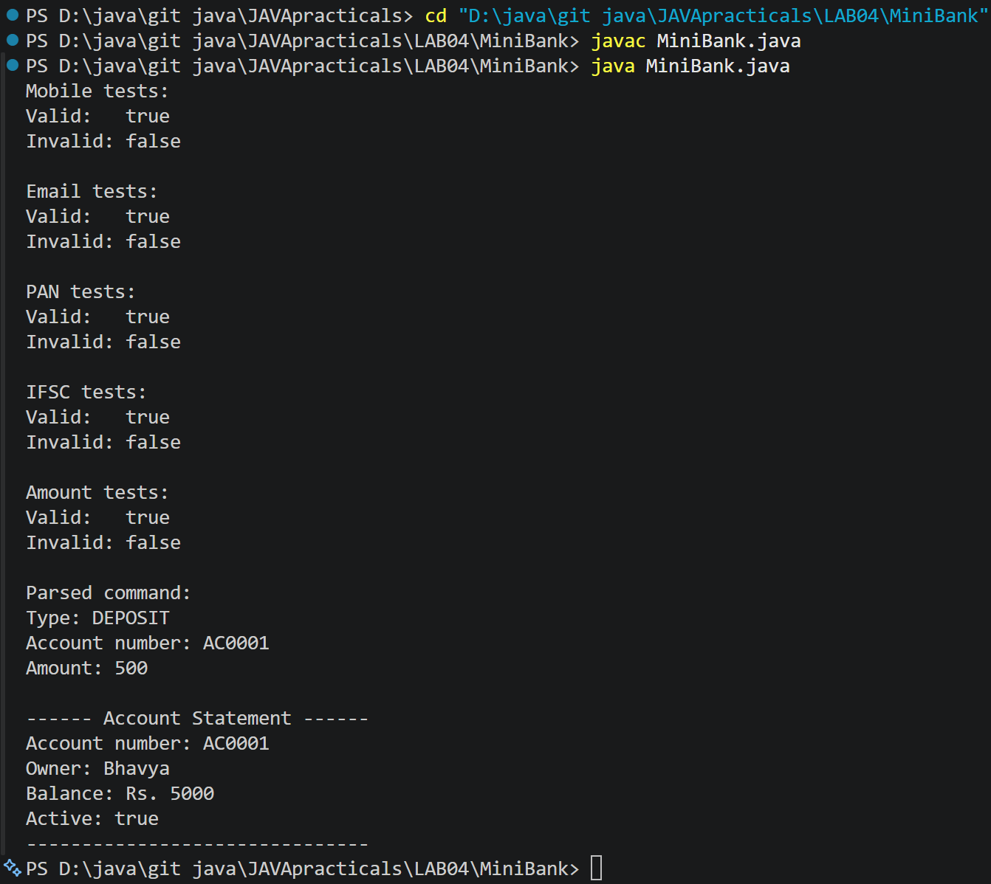

Practical 5
 | Customer.java
CODE | public class Customer implements Cloneable {  private String name;  private String email;  private String mobile;  private final String customerId;  private Address address;  private static long customerCounter = 100;  public Customer(String name, String email, String mobile, Address address) {  this.name = name;  this.email = email;  this.mobile = mobile;  this.address = address;  this.customerId = generateCustomerId();  }  private static String generateCustomerId() {  customerCounter++;  return "CUST" + customerCounter;  }  public String getName() {  return name;  }  public String getEmail() {  return email;  }  public String getMobile() {  return mobile;  }  public String getCustomerId() {  return customerId;  }  public Address getAddress() {  return address;  }  @Override  public Customer clone() {  try {  return (Customer) super.clone();  } catch (CloneNotSupportedException e) {  throw new AssertionError(e);  }  }  public static class Address {  private String line;  private String city;  private String pincode;  public Address(String line, String city, String pincode) {  this.line = line;  this.city = city;  this.pincode = pincode;  }  public String getLine() {  return line;  }  public String getCity() {  return city;  }  public String getPincode() {  return pincode;  }  @Override  public String toString() {  return line + ", " + city + " - " + pincode;  }  }  }
 | Account.java
CODE | import java.util.Objects;  public abstract class Account {  private final String accountNumber;  private String ownerName;  private long balance;  private boolean active;  private static int accountCounter = 0;  public Account(String ownerName, long openingBalance) {  accountCounter++;  this.accountNumber = String.format("AC%04d", accountCounter);  this.ownerName = ownerName;  this.balance = openingBalance;  this.active = true;  }  public Account(String ownerName) {  this(ownerName, 0);  }  public abstract double interestRate();  public abstract boolean canWithdraw(long amount);  public boolean deposit(long amount) {  if (amount <= 0) {  return false;  }  balance += amount;  return true;  }  public boolean withdraw(long amount) {  if (amount <= 0 || !canWithdraw(amount)) {  return false;  }  balance -= amount;  return true;  }  public double monthlyInterest() {  return balance * (interestRate() / 100.0) / 12.0;  }  public String getAccountNumber() {  return accountNumber;  }  public String getOwnerName() {  return ownerName;  }  public long getBalance() {  return balance;  }  public boolean isActive() {  return active;  }  @Override  public String toString() {  return "Account Number: " + accountNumber  + " | Owner: " + ownerName  + " | Balance: Rs. " + balance  + " | Active: " + active;  }  @Override  public boolean equals(Object o) {  if (this == o) {  return true;  }  if (!(o instanceof Account)) {  return false;  }  Account account = (Account) o;  return accountNumber.equals(account.accountNumber);  }  @Override  public int hashCode() {  return Objects.hash(accountNumber);  }  }  class SavingsAccount extends Account {  private long minBalance;  public SavingsAccount(String ownerName, long openingBalance, long minBalance) {  super(ownerName, openingBalance);  this.minBalance = minBalance;  }  @Override  public double interestRate() {  return 4.0;  }  @Override  public boolean canWithdraw(long amount) {  return amount > 0 && getBalance() - amount >= minBalance;  }  public long getMinBalance() {  return minBalance;  }  }  class CurrentAccount extends Account {  private long overdraftLimit;  public CurrentAccount(String ownerName, long openingBalance, long overdraftLimit) {  super(ownerName, openingBalance);  this.overdraftLimit = overdraftLimit;  }  @Override  public double interestRate() {  return 0.0;  }  @Override  public boolean canWithdraw(long amount) {  return amount > 0 && getBalance() - amount >= -overdraftLimit;  }  public long getOverdraftLimit() {  return overdraftLimit;  }  }  class FixedDepositAccount extends Account {  public FixedDepositAccount(String ownerName, long openingBalance) {  super(ownerName, openingBalance);  }  @Override  public double interestRate() {  return 7.0;  }  @Override  public boolean canWithdraw(long amount) {  return false;  }  }
 | MiniBank.java
CODE | public class MiniBank {  public static void main(String[] args) {  Account[] accounts = {  new SavingsAccount("Bhavya", 5000, 1000),  new CurrentAccount("Japan", 10000, 2000),  new FixedDepositAccount("Shivam", 20000)  };  System.out.println("MiniBank Account Details");  System.out.println("=========================");  for (Account account : accounts) {  System.out.println(account);  System.out.println("Interest rate: " + account.interestRate() + "%");  System.out.printf("Estimated monthly interest: Rs. %.2f%n",  account.monthlyInterest());  if (account instanceof SavingsAccount savingsAccount) {  System.out.println("Minimum balance: Rs. "  + savingsAccount.getMinBalance());  }  System.out.println();  }  // Demonstrate each account's withdrawal rule.  System.out.println("Withdrawal examples:");  System.out.println("Savings withdrawal of Rs. 4500: "  + accounts[0].withdraw(4500));  System.out.println("Current withdrawal of Rs. 11000: "  + accounts[1].withdraw(11000));  System.out.println("Fixed deposit withdrawal of Rs. 1000: "  + accounts[2].withdraw(1000));  }  }
OUTPUT | 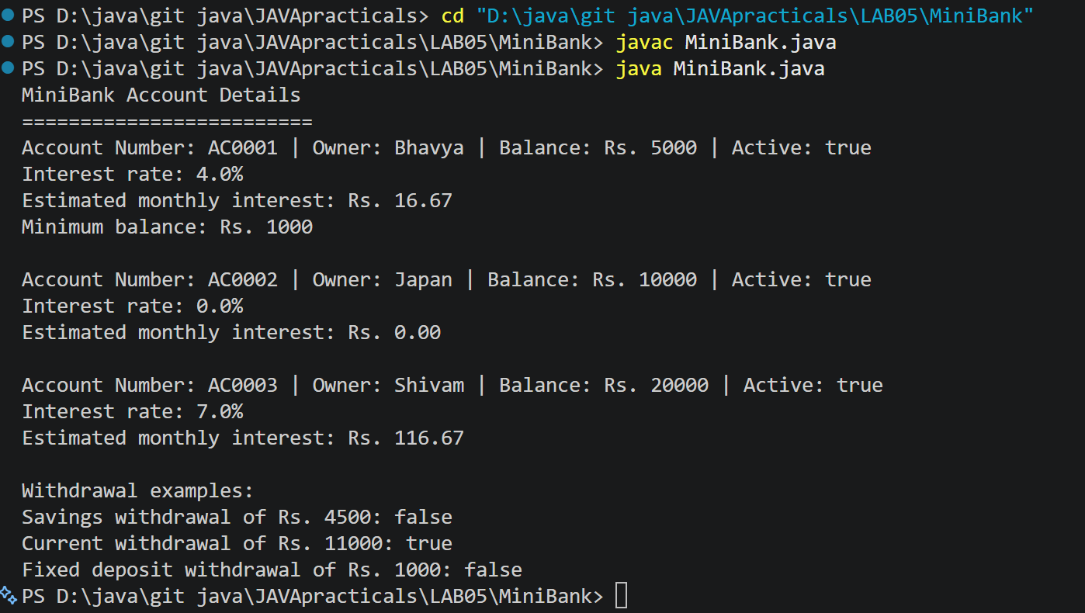

Practical 6
 | MiniBank/model/Transactable.java
CODE | package model;  public interface Transactable {  void deposit(long amount);  boolean withdraw(long amount);  }
 | MiniBank/model/InterestBearing.java
CODE | package model;  public interface InterestBearing {  double interestRate();  long getBalance();  default double yearlyInterest() {  return getBalance() * interestRate() / 100.0;  }  }
 | MiniBank/model/WithdrawRule.java
CODE | package model;  @FunctionalInterface  public interface WithdrawRule {  boolean allow(Account account, long amount);  }
 | MiniBank/model/Premium.java
CODE | package model;  public interface Premium {  }
 | MiniBank/model/Account.java
CODE | package model;  import java.util.Objects;  public abstract class Account implements Transactable, InterestBearing {  private final String accountNumber;  private final String ownerName;  private long balance;  private final boolean active;  private static int accountCounter = 0;  protected Account(String ownerName, long openingBalance) {  accountCounter++;  this.accountNumber = String.format("AC%04d", accountCounter);  this.ownerName = ownerName;  this.balance = Math.max(openingBalance, 0);  this.active = true;  }  public abstract boolean canWithdraw(long amount);  @Override  public void deposit(long amount) {  if (amount > 0) {  balance += amount;  }  }  @Override  public boolean withdraw(long amount) {  if (amount <= 0 || !canWithdraw(amount)) {  return false;  }  balance -= amount;  return true;  }  public String getAccountNumber() {  return accountNumber;  }  public String getOwnerName() {  return ownerName;  }  @Override  public long getBalance() {  return balance;  }  public boolean isActive() {  return active;  }  @Override  public String toString() {  return "Account Number: " + accountNumber  + " | Owner: " + ownerName  + " | Balance: Rs. " + balance  + " | Active: " + active;  }  @Override  public boolean equals(Object object) {  if (this == object) {  return true;  }  if (!(object instanceof Account account)) {  return false;  }  return accountNumber.equals(account.accountNumber);  }  @Override  public int hashCode() {  return Objects.hash(accountNumber);  }  }  class SavingsAccount extends Account implements Premium {  private final long minBalance;  public SavingsAccount(String ownerName, long openingBalance, long minBalance) {  super(ownerName, openingBalance);  this.minBalance = minBalance;  }  @Override  public double interestRate() {  return 4.0;  }  @Override  public boolean canWithdraw(long amount) {  return amount > 0 && getBalance() - amount >= minBalance;  }  public long getMinBalance() {  return minBalance;  }  }  class CurrentAccount extends Account {  private final long overdraftLimit;  public CurrentAccount(String ownerName, long openingBalance, long overdraftLimit) {  super(ownerName, openingBalance);  this.overdraftLimit = overdraftLimit;  }  @Override  public double interestRate() {  return 0.0;  }  @Override  public boolean canWithdraw(long amount) {  return amount > 0 && getBalance() - amount >= -overdraftLimit;  }  }  class FixedDepositAccount extends Account {  public FixedDepositAccount(String ownerName, long openingBalance) {  super(ownerName, openingBalance);  }  @Override  public double interestRate() {  return 7.0;  }  @Override  public boolean canWithdraw(long amount) {  return false;  }  }
 | MiniBank/model/Customer.java
CODE | package model;  public class Customer implements Cloneable {  private String name;  private String email;  private String mobile;  private final String customerId;  private Address address;  private static long customerCounter = 100;  public Customer(String name, String email, String mobile, Address address) {  this.name = name;  this.email = email;  this.mobile = mobile;  this.address = address;  this.customerId = generateCustomerId();  }  private static String generateCustomerId() {  customerCounter++;  return "CUST" + customerCounter;  }  public String getName() {  return name;  }  public String getEmail() {  return email;  }  public String getMobile() {  return mobile;  }  public String getCustomerId() {  return customerId;  }  public Address getAddress() {  return address;  }  @Override  public Customer clone() {  try {  return (Customer) super.clone();  } catch (CloneNotSupportedException e) {  throw new AssertionError(e);  }  }  public static class Address {  private final String line;  private final String city;  private final String pincode;  public Address(String line, String city, String pincode) {  this.line = line;  this.city = city;  this.pincode = pincode;  }  public String getLine() {  return line;  }  public String getCity() {  return city;  }  public String getPincode() {  return pincode;  }  @Override  public String toString() {  return line + ", " + city + " - " + pincode;  }  }  }
 | MiniBank/util/Validator.java
CODE | package util;  import java.util.regex.Pattern;  public class Validator {  private static final Pattern MOBILE_PATTERN =  Pattern.compile("^[6-9][0-9]{9}$");  private static final Pattern EMAIL_PATTERN =  Pattern.compile("^[A-Za-z0-9+_.-]+@[A-Za-z0-9.-]+\\.[A-Za-z]{2,}$");  private static final Pattern PAN_PATTERN =  Pattern.compile("^[A-Z]{5}[0-9]{4}[A-Z]$");  private static final Pattern IFSC_PATTERN =  Pattern.compile("^[A-Z]{4}0[A-Z0-9]{6}$");  private Validator() {  }  public static boolean isValidMobile(String mobile) {  return mobile != null && MOBILE_PATTERN.matcher(mobile).matches();  }  public static boolean isValidEmail(String email) {  return email != null && EMAIL_PATTERN.matcher(email).matches();  }  public static boolean isValidPan(String pan) {  return pan != null && PAN_PATTERN.matcher(pan).matches();  }  public static boolean isValidIfsc(String ifsc) {  return ifsc != null && IFSC_PATTERN.matcher(ifsc).matches();  }  }
 | MiniBank/service/MiniBank.java
CODE | package service;  import model.Account;  import model.CurrentAccount;  import model.FixedDepositAccount;  import model.Premium;  import model.SavingsAccount;  import model.WithdrawRule;  import static util.Validator.isValidMobile;  public class MiniBank {  public static void main(String[] args) {  Account[] accounts = {  new SavingsAccount("Bhavya", 5000, 1000),  new CurrentAccount("Japan", 10000, 2000),  new FixedDepositAccount("Shivam", 20000)  };  System.out.println("MiniBank Accounts");  System.out.println("=================");  for (Account account : accounts) {  System.out.println(account);  System.out.println("Interest rate: " + account.interestRate() + "%");  System.out.println("Yearly interest: Rs. "  + account.yearlyInterest());  if (account instanceof SavingsAccount savings) {  System.out.println("Minimum balance: Rs. "  + savings.getMinBalance());  }  System.out.println();  }  // WithdrawRule used with an anonymous class.  WithdrawRule anonymousRule = new WithdrawRule() {  @Override  public boolean allow(Account account, long amount) {  return account.canWithdraw(amount);  }  };  // WithdrawRule used with a lambda expression.  WithdrawRule lambdaRule =  (account, amount) -> account.canWithdraw(amount);  System.out.println("Anonymous rule allows withdrawal: "  + anonymousRule.allow(accounts[0], 1000));  System.out.println("Lambda rule allows withdrawal: "  + lambdaRule.allow(accounts[0], 1000));  System.out.println("Bhavya has Premium status: "  + (accounts[0] instanceof Premium));  // Static import lets us call the validator without Validator.  System.out.println("Mobile number valid: "  + isValidMobile("9876543210"));  }  }
OUTPUT | 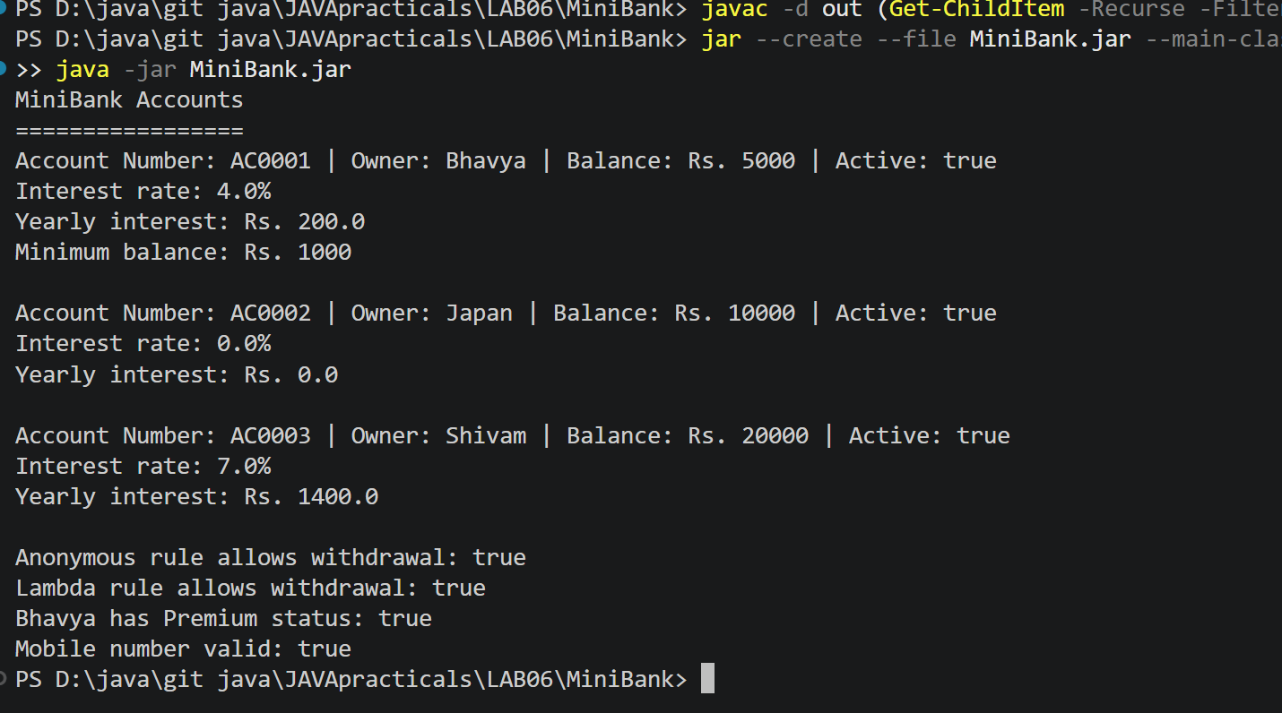

Practical 7
 | model/annotation/Id.java
CODE | package model.annotation;  import java.lang.annotation.ElementType;  import java.lang.annotation.Retention;  import java.lang.annotation.RetentionPolicy;  import java.lang.annotation.Target;  @Target(ElementType.FIELD)  @Retention(RetentionPolicy.RUNTIME)  public @interface Id {  }
 | model/annotation/Positive.java
CODE | package model.annotation;  import java.lang.annotation.ElementType;  import java.lang.annotation.Retention;  import java.lang.annotation.RetentionPolicy;  import java.lang.annotation.Target;  @Target(ElementType.FIELD)  @Retention(RetentionPolicy.RUNTIME)  public @interface Positive {  String message() default "must be > 0";  }
 | model/annotation/MaxLength.java
CODE | package model.annotation;  import java.lang.annotation.ElementType;  import java.lang.annotation.Retention;  import java.lang.annotation.RetentionPolicy;  import java.lang.annotation.Target;  @Target(ElementType.FIELD)  @Retention(RetentionPolicy.RUNTIME)  public @interface MaxLength {  int value();  }
 | model/Account.java
CODE | package model;  import java.util.Objects;  import model.annotation.Id;  import model.annotation.MaxLength;  import model.annotation.Positive;  public abstract class Account implements Transactable, InterestBearing {  @Id  private final String accountNumber;  @MaxLength(20)  private final String ownerName;  @Positive  private long balance;  private final boolean active;  private static int accountCounter = 0;  protected Account(String ownerName, long openingBalance) {  accountCounter++;  this.accountNumber = String.format("AC%04d", accountCounter);  this.ownerName = ownerName;  this.balance = openingBalance;  this.active = true;  }  public abstract boolean canWithdraw(long amount);  @Override  public void deposit(long amount) {  if (amount > 0) {  balance += amount;  }  }  @Override  public boolean withdraw(long amount) {  if (amount <= 0 || !canWithdraw(amount)) {  return false;  }  balance -= amount;  return true;  }  public String getAccountNumber() {  return accountNumber;  }  public String getOwnerName() {  return ownerName;  }  @Override  public long getBalance() {  return balance;  }  public boolean isActive() {  return active;  }  @Override  public String toString() {  return "Account Number: " + accountNumber  + " | Owner: " + ownerName  + " | Balance: Rs. " + balance  + " | Active: " + active;  }  @Override  public boolean equals(Object object) {  if (this == object) {  return true;  }  if (!(object instanceof Account account)) {  return false;  }  return accountNumber.equals(account.accountNumber);  }  @Override  public int hashCode() {  return Objects.hash(accountNumber);  }  }
 | util/AnnotationValidator.java
CODE | package util;  import java.lang.reflect.Field;  import java.util.ArrayList;  import java.util.List;  import model.annotation.MaxLength;  import model.annotation.Positive;  public class AnnotationValidator {  private AnnotationValidator() {  }  public static String[] validate(Object obj) {  if (obj == null) {  return new String[] {"Object cannot be null."};  }  List<String> errors = new ArrayList<>();  for (Field field : obj.getClass().getDeclaredFields()) {  field.setAccessible(true);  try {  Object value = field.get(obj);  if (field.isAnnotationPresent(Positive.class)  && value instanceof Number number  && number.doubleValue() <= 0) {  Positive rule = field.getAnnotation(Positive.class);  errors.add(field.getName() + " " + rule.message());  }  if (field.isAnnotationPresent(MaxLength.class)  && value instanceof String text) {  MaxLength rule = field.getAnnotation(MaxLength.class);  if (text.length() > rule.value()) {  errors.add(field.getName() + " must be at most "  + rule.value() + " characters");  }  }  } catch (IllegalAccessException e) {  errors.add("Could not validate field: " + field.getName());  }  }  return errors.toArray(new String[0]);  }  }
 | service/MiniBank.java
CODE | package service;  import model.Account;  import model.CurrentAccount;  import model.FixedDepositAccount;  import model.Premium;  import model.SavingsAccount;  import model.WithdrawRule;  import util.AnnotationValidator;  import static util.Validator.isValidMobile;  public class MiniBank {  public static void main(String[] args) {  Account[] accounts = {  new SavingsAccount("Bhavya", 5000, 1000),  new CurrentAccount("Japan", 10000, 2000),  new FixedDepositAccount("Shivam", 20000)  };  System.out.println("MiniBank Accounts");  System.out.println("=================");  for (Account account : accounts) {  System.out.println(account);  System.out.println("Interest rate: " + account.interestRate() + "%");  System.out.println("Yearly interest: Rs. "  + account.yearlyInterest());  if (account instanceof SavingsAccount savings) {  System.out.println("Minimum balance: Rs. "  + savings.getMinBalance());  }  System.out.println();  }  WithdrawRule anonymousRule = new WithdrawRule() {  @Override  public boolean allow(Account account, long amount) {  return account.canWithdraw(amount);  }  };  WithdrawRule lambdaRule =  (account, amount) -> account.canWithdraw(amount);  System.out.println("Anonymous rule allows withdrawal: "  + anonymousRule.allow(accounts[0], 1000));  System.out.println("Lambda rule allows withdrawal: "  + lambdaRule.allow(accounts[0], 1000));  System.out.println("Bhavya has Premium status: "  + (accounts[0] instanceof Premium));  System.out.println("Mobile number valid: "  + isValidMobile("9876543210"));  Account invalidAccount =  new FixedDepositAccount("Test Customer", -500);  System.out.println("\nValidation errors:");  String[] errors = AnnotationValidator.validate(invalidAccount);  if (errors.length == 0) {  System.out.println("No errors found.");  } else {  for (String error : errors) {  System.out.println(error);  }  }  }  }
OUTPUT | 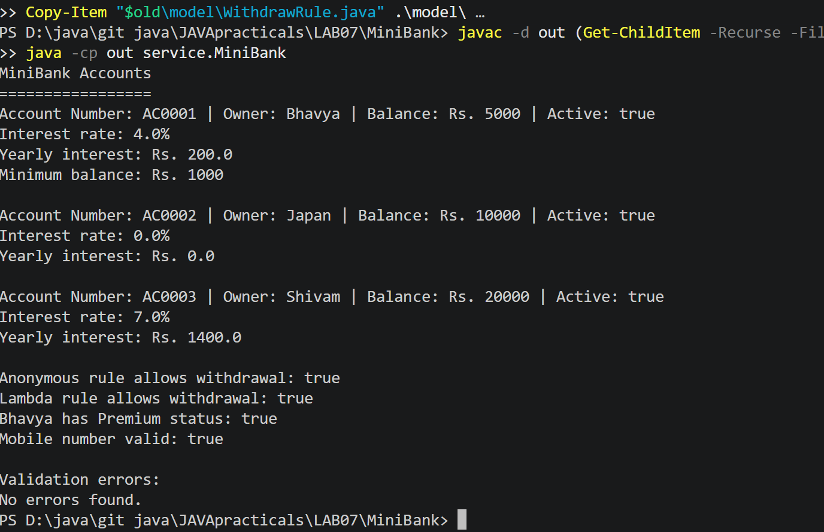

Practical 8
 | exception/BankException.java
CODE | package exception;  public class BankException extends Exception {  public BankException(String message) {  super(message);  }  }
 | exception/InsufficientFundsException.java
CODE | package exception;  public class InsufficientFundsException extends BankException {  private final long shortfall;  public InsufficientFundsException(String message, long shortfall) {  super(message);  this.shortfall = shortfall;  }  public long getShortfall() {  return shortfall;  }  }
 | exception/AccountNotFoundException.java
CODE | package exception;  public class AccountNotFoundException extends BankException {  public AccountNotFoundException(String message) {  super(message);  }  }
 | exception/InvalidAmountException.java
CODE | package exception;  public class InvalidAmountException extends BankException {  public InvalidAmountException(String message) {  super(message);  }  }
 | model/Transactable.java
CODE | package model;  import exception.InsufficientFundsException;  import exception.InvalidAmountException;  public interface Transactable {  void deposit(long amount) throws InvalidAmountException;  boolean withdraw(long amount)  throws InsufficientFundsException, InvalidAmountException;  }
 | model/Account.java
CODE | package model;  import exception.AccountNotFoundException;  import exception.BankException;  import exception.InsufficientFundsException;  import exception.InvalidAmountException;  import java.util.Objects;  import model.annotation.Id;  import model.annotation.MaxLength;  import model.annotation.Positive;  public abstract class Account implements Transactable, InterestBearing {  @Id  private final String accountNumber;  @MaxLength(20)  private final String ownerName;  @Positive  private long balance;  private final boolean active;  private static int accountCounter = 0;  protected Account(String ownerName, long openingBalance) {  accountCounter++;  this.accountNumber = String.format("AC%04d", accountCounter);  this.ownerName = ownerName;  this.balance = openingBalance;  this.active = true;  }  public abstract double interestRate();  public abstract boolean canWithdraw(long amount);  protected abstract long availableBalanceForWithdrawal();  @Override  public void deposit(long amount) throws InvalidAmountException {  if (amount <= 0) {  throw new InvalidAmountException(  "Deposit amount must be greater than zero."  );  }  balance += amount;  }  @Override  public boolean withdraw(long amount)  throws InsufficientFundsException, InvalidAmountException {  if (amount <= 0) {  throw new InvalidAmountException(  "Withdrawal amount must be greater than zero."  );  }  long available = availableBalanceForWithdrawal();  if (amount > available) {  long shortfall = amount - available;  throw new InsufficientFundsException(  "Insufficient funds. Shortfall: Rs. " + shortfall,  shortfall  );  }  balance -= amount;  return true;  }  public void transfer(Account to, long amount) throws BankException {  try {  if (to == null) {  throw new AccountNotFoundException(  "Destination account was not found."  );  }  withdraw(amount);  to.deposit(amount);  System.out.println("Transfer successful.");  } catch (BankException e) {  throw e;  } finally {  System.out.println("Transfer attempt finished.");  }  }  public String getAccountNumber() {  return accountNumber;  }  public String getOwnerName() {  return ownerName;  }  @Override  public long getBalance() {  return balance;  }  public boolean isActive() {  return active;  }  @Override  public String toString() {  return "Account Number: " + accountNumber  + " | Owner: " + ownerName  + " | Balance: Rs. " + balance  + " | Active: " + active;  }  @Override  public boolean equals(Object object) {  if (this == object) {  return true;  }  if (!(object instanceof Account account)) {  return false;  }  return accountNumber.equals(account.accountNumber);  }  @Override  public int hashCode() {  return Objects.hash(accountNumber);  }  }
 | model/SavingsAccount.java
CODE | package model;  public class SavingsAccount extends Account implements Premium {  private final long minBalance;  public SavingsAccount(String ownerName, long openingBalance, long minBalance) {  super(ownerName, openingBalance);  this.minBalance = minBalance;  }  @Override  public double interestRate() {  return 4.0;  }  @Override  public boolean canWithdraw(long amount) {  return amount > 0 && getBalance() - amount >= minBalance;  }  @Override  protected long availableBalanceForWithdrawal() {  return Math.max(0, getBalance() - minBalance);  }  public long getMinBalance() {  return minBalance;  }  }
 | model/CurrentAccount.java
CODE | package model;  public class CurrentAccount extends Account {  private final long overdraftLimit;  public CurrentAccount(String ownerName, long openingBalance, long overdraftLimit) {  super(ownerName, openingBalance);  this.overdraftLimit = overdraftLimit;  }  @Override  public double interestRate() {  return 0.0;  }  @Override  public boolean canWithdraw(long amount) {  return amount > 0 && getBalance() - amount >= -overdraftLimit;  }  @Override  protected long availableBalanceForWithdrawal() {  return Math.max(0, getBalance() + overdraftLimit);  }  }
 | model/FixedDepositAccount.java
CODE | package model;  public class FixedDepositAccount extends Account {  public FixedDepositAccount(String ownerName, long openingBalance) {  super(ownerName, openingBalance);  }  @Override  public double interestRate() {  return 7.0;  }  @Override  public boolean canWithdraw(long amount) {  return false;  }  @Override  protected long availableBalanceForWithdrawal() {  return 0;  }  }
 | service/MiniBank.java
CODE | package service;  import exception.BankException;  import exception.InsufficientFundsException;  import exception.InvalidAmountException;  import model.Account;  import model.CurrentAccount;  import model.FixedDepositAccount;  import model.SavingsAccount;  public class MiniBank {  public static void main(String[] args) {  Account savings = new SavingsAccount("Bhavya", 5000, 1000);  Account current = new CurrentAccount("Japan", 10000, 2000);  Account fixedDeposit = new FixedDepositAccount("Shivam", 20000);  try {  savings.deposit(1000);  System.out.println("Deposit successful. Balance: Rs. "  + savings.getBalance());  savings.withdraw(8000);  } catch (InsufficientFundsException e) {  System.out.println("Withdrawal failed: " + e.getMessage());  System.out.println("Shortfall: Rs. " + e.getShortfall());  } catch (InvalidAmountException e) {  System.out.println("Invalid amount: " + e.getMessage());  } finally {  System.out.println("Withdrawal operation finished.");  }  try {  savings.transfer(current, 1000);  System.out.println("Savings balance: Rs. " + savings.getBalance());  System.out.println("Current balance: Rs. " + current.getBalance());  } catch (BankException e) {  System.out.println("Transfer failed: " + e.getMessage());  }  try {  fixedDeposit.withdraw(500);  } catch (InsufficientFundsException e) {  System.out.println("Fixed deposit withdrawal failed: "  + e.getMessage());  } catch (InvalidAmountException e) {  System.out.println("Invalid amount: " + e.getMessage());  }  try (BankSession session = new BankSession()) {  session.displayMessage();  }  }  }  class BankSession implements AutoCloseable {  public void displayMessage() {  System.out.println("Bank session is open.");  }  @Override  public void close() {  System.out.println("Bank session closed automatically.");  }  }
OUTPUT | 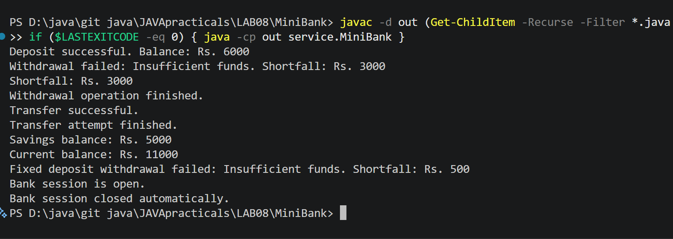

Practical 9
 | model/Account.java
CODE | package model;  import exception.AccountNotFoundException;  import exception.BankException;  import exception.InsufficientFundsException;  import exception.InvalidAmountException;  import java.util.Objects;  import model.annotation.Id;  import model.annotation.MaxLength;  import model.annotation.Positive;  public abstract class Account implements Transactable, InterestBearing {  @Id  private final String accountNumber;  @MaxLength(20)  private final String ownerName;  @Positive  private long balance;  private final boolean active;  private static int accountCounter = 0;  protected Account(String ownerName, long openingBalance) {  accountCounter++;  this.accountNumber = String.format("AC%04d", accountCounter);  this.ownerName = ownerName;  this.balance = openingBalance;  this.active = true;  }  public abstract double interestRate();  public abstract boolean canWithdraw(long amount);  protected abstract long availableBalanceForWithdrawal();  @Override  public synchronized void deposit(long amount) throws InvalidAmountException {  if (amount <= 0) {  throw new InvalidAmountException(  "Deposit amount must be greater than zero."  );  }  balance += amount;  }  @Override  public synchronized boolean withdraw(long amount)  throws InsufficientFundsException, InvalidAmountException {  if (amount <= 0) {  throw new InvalidAmountException(  "Withdrawal amount must be greater than zero."  );  }  long available = availableBalanceForWithdrawal();  if (amount > available) {  long shortfall = amount - available;  throw new InsufficientFundsException(  "Insufficient funds. Shortfall: Rs. " + shortfall,  shortfall  );  }  balance -= amount;  return true;  }  public void transfer(Account to, long amount) throws BankException {  try {  if (to == null) {  throw new AccountNotFoundException(  "Destination account was not found."  );  }  withdraw(amount);  to.deposit(amount);  System.out.println("Transfer successful.");  } catch (BankException e) {  throw e;  } finally {  System.out.println("Transfer attempt finished.");  }  }  public String getAccountNumber() {  return accountNumber;  }  public String getOwnerName() {  return ownerName;  }  @Override  public synchronized long getBalance() {  return balance;  }  public boolean isActive() {  return active;  }  @Override  public String toString() {  return "Account Number: " + accountNumber  + " | Owner: " + ownerName  + " | Balance: Rs. " + getBalance()  + " | Active: " + active;  }  @Override  public boolean equals(Object object) {  if (this == object) {  return true;  }  if (!(object instanceof Account account)) {  return false;  }  return accountNumber.equals(account.accountNumber);  }  @Override  public int hashCode() {  return Objects.hash(accountNumber);  }  }
 | service/MiniBank.java
CODE | package service;  import exception.InvalidAmountException;  import model.Account;  import model.SavingsAccount;  public class MiniBank {  public static void main(String[] args) {  Account account = new SavingsAccount("Thread Test", 0, 0);  int numberOfThreads = 10;  int depositsPerThread = 10_000;  long depositAmount = 1;  Thread[] threads = new Thread[numberOfThreads];  System.out.println("Starting deposit threads...");  for (int i = 0; i < numberOfThreads; i++) {  AccountWorker worker =  new AccountWorker(account, depositsPerThread, depositAmount);  threads[i] = new Thread(worker, "Deposit-Thread-" + (i + 1));  threads[i].start();  }  for (Thread thread : threads) {  try {  thread.join();  } catch (InterruptedException e) {  Thread.currentThread().interrupt();  System.out.println("Main thread was interrupted.");  return;  }  }  long expectedBalance =  (long) numberOfThreads * depositsPerThread * depositAmount;  System.out.println("\nAll threads have finished.");  System.out.println("Expected balance: Rs. " + expectedBalance);  System.out.println("Actual balance: Rs. " + account.getBalance());  }  }  class AccountWorker implements Runnable {  private final Account account;  private final int times;  private final long amount;  public AccountWorker(Account account, int times, long amount) {  this.account = account;  this.times = times;  this.amount = amount;  }  @Override  public void run() {  String threadName = Thread.currentThread().getName();  System.out.println(threadName + " started.");  for (int i = 0; i < times; i++) {  try {  account.deposit(amount);  } catch (InvalidAmountException e) {  System.out.println(threadName + ": " + e.getMessage());  return;  }  }  System.out.println(threadName + " finished.");  }  }
OUTPUT | 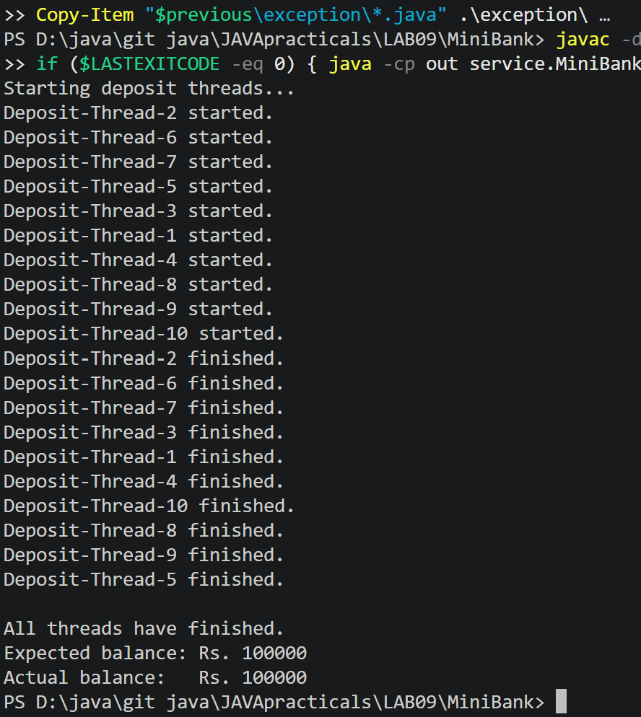

Practical 10
 | model/Account.java
CODE | package model;  import exception.AccountNotFoundException;  import exception.BankException;  import exception.InsufficientFundsException;  import exception.InvalidAmountException;  import java.util.Objects;  import model.annotation.Id;  import model.annotation.MaxLength;  import model.annotation.Positive;  public abstract class Account implements Transactable, InterestBearing {  @Id  private final String accountNumber;  @MaxLength(20)  private final String ownerName;  @Positive  private long balance;  private final boolean active;  private static int accountCounter = 0;  protected Account(String ownerName, long openingBalance) {  accountCounter++;  this.accountNumber = String.format("AC%04d", accountCounter);  this.ownerName = ownerName;  this.balance = openingBalance;  this.active = true;  }  public abstract double interestRate();  public abstract boolean canWithdraw(long amount);  protected abstract long availableBalanceForWithdrawal();  @Override  public synchronized void deposit(long amount) throws InvalidAmountException {  if (amount <= 0) {  throw new InvalidAmountException(  "Deposit amount must be greater than zero."  );  }  balance += amount;  }  @Override  public synchronized boolean withdraw(long amount)  throws InsufficientFundsException, InvalidAmountException {  if (amount <= 0) {  throw new InvalidAmountException(  "Withdrawal amount must be greater than zero."  );  }  long available = availableBalanceForWithdrawal();  if (amount > available) {  long shortfall = amount - available;  throw new InsufficientFundsException(  "Insufficient funds. Shortfall: Rs. " + shortfall,  shortfall  );  }  balance -= amount;  return true;  }  public void transfer(Account to, long amount) throws BankException {  if (to == null) {  throw new AccountNotFoundException(  "Destination account was not found."  );  }  // Both directions lock the accounts in the same order.  Account first = this;  Account second = to;  if (first.getAccountNumber().compareTo(second.getAccountNumber()) > 0) {  first = to;  second = this;  }  try {  synchronized (first) {  synchronized (second) {  withdraw(amount);  to.deposit(amount);  System.out.println("Transfer successful.");  }  }  } catch (BankException e) {  throw e;  } finally {  System.out.println("Transfer attempt finished.");  }  }  public String getAccountNumber() {  return accountNumber;  }  public String getOwnerName() {  return ownerName;  }  @Override  public synchronized long getBalance() {  return balance;  }  public boolean isActive() {  return active;  }  @Override  public double yearlyInterest() {  return getBalance() * interestRate() / 100.0;  }  @Override  public String toString() {  return "Account Number: " + accountNumber  + " | Owner: " + ownerName  + " | Balance: Rs. " + getBalance()  + " | Active: " + active;  }  @Override  public boolean equals(Object object) {  if (this == object) {  return true;  }  if (!(object instanceof Account account)) {  return false;  }  return accountNumber.equals(account.accountNumber);  }  @Override  public int hashCode() {  return Objects.hash(accountNumber);  }  }
 | model/Transactable.java
CODE | package model;  import exception.InsufficientFundsException;  import exception.InvalidAmountException;  public interface Transactable {  void deposit(long amount) throws InvalidAmountException;  boolean withdraw(long amount)  throws InsufficientFundsException, InvalidAmountException;  }
 | model/SavingsAccount.java
CODE | package model;  public class SavingsAccount extends Account implements Premium {  private final long minBalance;  public SavingsAccount(String ownerName, long openingBalance, long minBalance) {  super(ownerName, openingBalance);  this.minBalance = minBalance;  }  @Override  public double interestRate() {  return 4.0;  }  @Override  public boolean canWithdraw(long amount) {  return amount > 0 && getBalance() - amount >= minBalance;  }  @Override  protected long availableBalanceForWithdrawal() {  return Math.max(0, getBalance() - minBalance);  }  public long getMinBalance() {  return minBalance;  }  }
 | model/CurrentAccount.java
CODE | package model;  public class CurrentAccount extends Account {  private final long overdraftLimit;  public CurrentAccount(String ownerName, long openingBalance, long overdraftLimit) {  super(ownerName, openingBalance);  this.overdraftLimit = overdraftLimit;  }  @Override  public double interestRate() {  return 0.0;  }  @Override  public boolean canWithdraw(long amount) {  return amount > 0 && getBalance() - amount >= -overdraftLimit;  }  @Override  protected long availableBalanceForWithdrawal() {  return Math.max(0, getBalance() + overdraftLimit);  }  }
 | model/FixedDepositAccount.java
CODE | package model;  public class FixedDepositAccount extends Account {  public FixedDepositAccount(String ownerName, long openingBalance) {  super(ownerName, openingBalance);  }  @Override  public double interestRate() {  return 7.0;  }  @Override  public boolean canWithdraw(long amount) {  return false;  }  @Override  protected long availableBalanceForWithdrawal() {  return 0;  }  }
 | service/MiniBank.java
CODE | package service;  import exception.BankException;  import exception.InsufficientFundsException;  import exception.InvalidAmountException;  import java.util.concurrent.ExecutorService;  import java.util.concurrent.Executors;  import java.util.concurrent.TimeUnit;  import model.Account;  import model.CurrentAccount;  import model.SavingsAccount;  public class MiniBank {  public static void main(String[] args) throws InterruptedException {  Account account = new SavingsAccount("Bhavya", 10000, 0);  // Submit deposit and withdrawal tasks to a four-thread pool.  TransactionProcessor processor = new TransactionProcessor();  for (int i = 0; i < 10; i++) {  processor.submit(new TransactionTask(account, true, 100));  processor.submit(new TransactionTask(account, false, 50));  }  processor.stop();  System.out.println("Balance after thread-pool tasks: Rs. "  + account.getBalance());  // Producer-consumer example using a shared array buffer.  TransactionBuffer buffer = new TransactionBuffer(3);  Thread producer = new Thread(() -> {  try {  for (int i = 1; i <= 5; i++) {  buffer.put(new TransactionTask(account, true, 10));  System.out.println("Produced transaction " + i);  }  buffer.finish();  } catch (InterruptedException e) {  Thread.currentThread().interrupt();  }  }, "Producer");  Thread consumer = new Thread(() -> {  try {  Runnable task;  while ((task = buffer.take()) != null) {  task.run();  System.out.println("Consumer processed a transaction.");  }  } catch (InterruptedException e) {  Thread.currentThread().interrupt();  }  }, "Consumer");  producer.start();  consumer.start();  producer.join();  consumer.join();  System.out.println("Balance after producer-consumer: Rs. "  + account.getBalance());  // Opposite-direction transfers acquire locks in account-number order.  Account accountA = new CurrentAccount("Account A", 1000, 0);  Account accountB = new CurrentAccount("Account B", 1000, 0);  Thread transferAtoB = new Thread(  () -> doTransfer(accountA, accountB, 100),  "Transfer-A-to-B"  );  Thread transferBtoA = new Thread(  () -> doTransfer(accountB, accountA, 100),  "Transfer-B-to-A"  );  transferAtoB.start();  transferBtoA.start();  transferAtoB.join();  transferBtoA.join();  System.out.println("Account A balance: Rs. " + accountA.getBalance());  System.out.println("Account B balance: Rs. " + accountB.getBalance());  }  private static void doTransfer(Account from, Account to, long amount) {  try {  System.out.println(Thread.currentThread().getName() + " started.");  from.transfer(to, amount);  System.out.println(Thread.currentThread().getName() + " finished.");  } catch (BankException e) {  System.out.println("Transfer failed: " + e.getMessage());  }  }  }  class TransactionProcessor {  private final ExecutorService executor =  Executors.newFixedThreadPool(4);  public void submit(Runnable task) {  executor.execute(task);  }  public void stop() throws InterruptedException {  executor.shutdown();  if (!executor.awaitTermination(30, TimeUnit.SECONDS)) {  executor.shutdownNow();  executor.awaitTermination(30, TimeUnit.SECONDS);  }  }  }  class TransactionTask implements Runnable {  private final Account account;  private final boolean deposit;  private final long amount;  public TransactionTask(Account account, boolean deposit, long amount) {  this.account = account;  this.deposit = deposit;  this.amount = amount;  }  @Override  public void run() {  String threadName = Thread.currentThread().getName();  try {  if (deposit) {  account.deposit(amount);  System.out.println(threadName + " deposited Rs. " + amount);  } else {  account.withdraw(amount);  System.out.println(threadName + " withdrew Rs. " + amount);  }  } catch (InsufficientFundsException | InvalidAmountException e) {  System.out.println(threadName + ": " + e.getMessage());  }  }  }  class TransactionBuffer {  private final Runnable[] items;  private int head;  private int tail;  private int count;  private boolean finished;  public TransactionBuffer(int capacity) {  items = new Runnable[capacity];  }  public synchronized void put(Runnable task) throws InterruptedException {  while (count == items.length) {  wait();  }  items[tail] = task;  tail = (tail + 1) % items.length;  count++;  notifyAll();  }  public synchronized Runnable take() throws InterruptedException {  while (count == 0 && !finished) {  wait();  }  if (count == 0 && finished) {  return null;  }  Runnable task = items[head];  items[head] = null;  head = (head + 1) % items.length;  count--;  notifyAll();  return task;  }  public synchronized void finish() {  finished = true;  notifyAll();  }  }
OUTPUT | 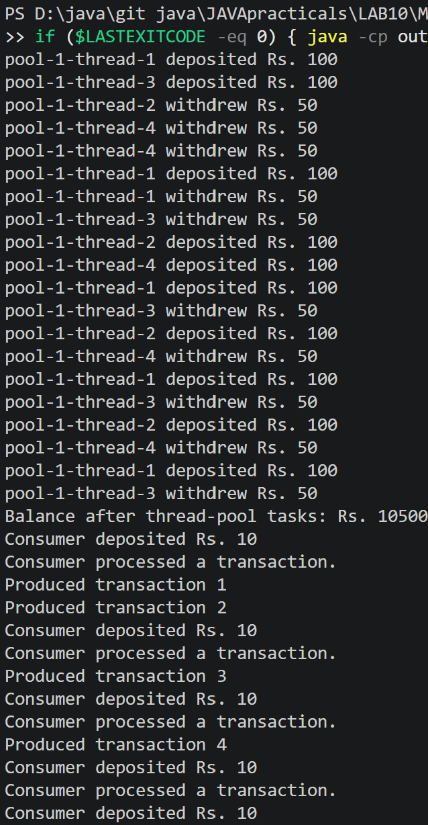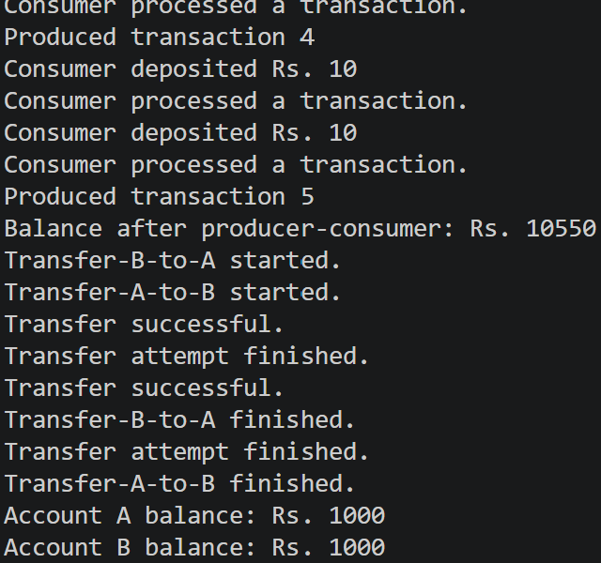
Practical 11
 | exception/BankException.java
CODE | package exception;  public class BankException extends Exception {  public BankException(String message) {  super(message);  }  }
 | exception/AccountNotFoundException.java
CODE | package exception;  public class AccountNotFoundException extends BankException {  public AccountNotFoundException(String message) {  super(message);  }  }
 | exception/InsufficientFundsException.java
CODE | package exception;  public class InsufficientFundsException extends BankException {  private final long shortfall;  public InsufficientFundsException(String message, long shortfall) {  super(message);  this.shortfall = shortfall;  }  public long getShortfall() {  return shortfall;  }  }
 | exception/InvalidAmountException.java
CODE | package exception;  public class InvalidAmountException extends BankException {  public InvalidAmountException(String message) {  super(message);  }  }
 | model/annotation/Id.java
CODE | package model.annotation;  import java.lang.annotation.ElementType;  import java.lang.annotation.Retention;  import java.lang.annotation.RetentionPolicy;  import java.lang.annotation.Target;  @Target(ElementType.FIELD)  @Retention(RetentionPolicy.RUNTIME)  public @interface Id {  }
 | model/annotation/MaxLength.java
CODE | package model.annotation;  import java.lang.annotation.ElementType;  import java.lang.annotation.Retention;  import java.lang.annotation.RetentionPolicy;  import java.lang.annotation.Target;  @Target(ElementType.FIELD)  @Retention(RetentionPolicy.RUNTIME)  public @interface MaxLength {  int value();  }
 | model/annotation/Positive.java
CODE | package model.annotation;  import java.lang.annotation.ElementType;  import java.lang.annotation.Retention;  import java.lang.annotation.RetentionPolicy;  import java.lang.annotation.Target;  @Target(ElementType.FIELD)  @Retention(RetentionPolicy.RUNTIME)  public @interface Positive {  String message() default "must be > 0";  }
 | model/Transactable.java
CODE | package model;  import exception.InsufficientFundsException;  import exception.InvalidAmountException;  public interface Transactable {  void deposit(long amount) throws InvalidAmountException;  boolean withdraw(long amount)  throws InsufficientFundsException, InvalidAmountException;  }
 | model/InterestBearing.java
CODE | package model;  public interface InterestBearing {  double interestRate();  long getBalance();  default double yearlyInterest() {  return getBalance() * interestRate() / 100.0;  }  }
 | model/Premium.java
CODE | package model;  public interface Premium {  }
 | model/Account.java
CODE | package model;  import exception.AccountNotFoundException;  import exception.BankException;  import exception.InsufficientFundsException;  import exception.InvalidAmountException;  import java.io.Serializable;  import java.util.Objects;  import model.annotation.Id;  import model.annotation.MaxLength;  import model.annotation.Positive;  public abstract class Account  implements Transactable, InterestBearing, Serializable {  private static final long serialVersionUID = 1L;  @Id  private final String accountNumber;  @MaxLength(20)  private final String ownerName;  @Positive  private long balance;  private final boolean active;  private static int accountCounter = 0;  protected Account(String ownerName, long openingBalance) {  accountCounter++;  this.accountNumber = String.format("AC%04d", accountCounter);  this.ownerName = ownerName;  this.balance = openingBalance;  this.active = true;  }  public abstract boolean canWithdraw(long amount);  protected abstract long availableBalanceForWithdrawal();  @Override  public synchronized void deposit(long amount) throws InvalidAmountException {  if (amount <= 0) {  throw new InvalidAmountException(  "Deposit amount must be greater than zero."  );  }  balance += amount;  }  @Override  public synchronized boolean withdraw(long amount)  throws InsufficientFundsException, InvalidAmountException {  if (amount <= 0) {  throw new InvalidAmountException(  "Withdrawal amount must be greater than zero."  );  }  long available = availableBalanceForWithdrawal();  if (amount > available) {  long shortfall = amount - available;  throw new InsufficientFundsException(  "Insufficient funds. Shortfall: Rs. " + shortfall,  shortfall  );  }  balance -= amount;  return true;  }  public void transfer(Account to, long amount) throws BankException {  if (to == null) {  throw new AccountNotFoundException(  "Destination account was not found."  );  }  // Lock accounts in the same order to avoid deadlock.  Account first = this;  Account second = to;  if (first.getAccountNumber().compareTo(second.getAccountNumber()) > 0) {  first = to;  second = this;  }  try {  synchronized (first) {  synchronized (second) {  withdraw(amount);  to.deposit(amount);  System.out.println("Transfer successful.");  }  }  } catch (BankException e) {  throw e;  } finally {  System.out.println("Transfer attempt finished.");  }  }  public String getAccountNumber() {  return accountNumber;  }  public String getOwnerName() {  return ownerName;  }  @Override  public synchronized long getBalance() {  return balance;  }  public boolean isActive() {  return active;  }  @Override  public String toString() {  return "Account Number: " + accountNumber  + " | Owner: " + ownerName  + " | Balance: Rs. " + getBalance()  + " | Active: " + active;  }  @Override  public boolean equals(Object object) {  if (this == object) {  return true;  }  if (!(object instanceof Account account)) {  return false;  }  return accountNumber.equals(account.accountNumber);  }  @Override  public int hashCode() {  return Objects.hash(accountNumber);  }  }
 | model/SavingsAccount.java
CODE | package model;  import java.io.Serializable;  public class SavingsAccount extends Account implements Premium, Serializable {  private static final long serialVersionUID = 1L;  private final long minBalance;  public SavingsAccount(String ownerName, long openingBalance, long minBalance) {  super(ownerName, openingBalance);  this.minBalance = minBalance;  }  @Override  public double interestRate() {  return 4.0;  }  @Override  public boolean canWithdraw(long amount) {  return amount > 0 && getBalance() - amount >= minBalance;  }  @Override  protected long availableBalanceForWithdrawal() {  return Math.max(0, getBalance() - minBalance);  }  public long getMinBalance() {  return minBalance;  }  }
 | model/CurrentAccount.java
CODE | package model;  import java.io.Serializable;  public class CurrentAccount extends Account implements Serializable {  private static final long serialVersionUID = 1L;  private final long overdraftLimit;  public CurrentAccount(String ownerName, long openingBalance, long overdraftLimit) {  super(ownerName, openingBalance);  this.overdraftLimit = overdraftLimit;  }  @Override  public double interestRate() {  return 0.0;  }  @Override  public boolean canWithdraw(long amount) {  return amount > 0 && getBalance() - amount >= -overdraftLimit;  }  @Override  protected long availableBalanceForWithdrawal() {  return Math.max(0, getBalance() + overdraftLimit);  }  }
 | model/FixedDepositAccount.java
CODE | package model;  import java.io.Serializable;  public class FixedDepositAccount extends Account implements Serializable {  private static final long serialVersionUID = 1L;  public FixedDepositAccount(String ownerName, long openingBalance) {  super(ownerName, openingBalance);  }  @Override  public double interestRate() {  return 7.0;  }  @Override  public boolean canWithdraw(long amount) {  return false;  }  @Override  protected long availableBalanceForWithdrawal() {  return 0;  }  }
 | model/Customer.java
CODE | package model;  import java.io.Serializable;  public class Customer implements Cloneable, Serializable {  private static final long serialVersionUID = 1L;  private String name;  private String email;  private String mobile;  private final String customerId;  private Address address;  private static long customerCounter = 100;  public Customer(String name, String email, String mobile, Address address) {  this.name = name;  this.email = email;  this.mobile = mobile;  this.address = address;  this.customerId = generateCustomerId();  }  private static String generateCustomerId() {  customerCounter++;  return "CUST" + customerCounter;  }  public String getName() {  return name;  }  public String getEmail() {  return email;  }  public String getMobile() {  return mobile;  }  public String getCustomerId() {  return customerId;  }  public Address getAddress() {  return address;  }  @Override  public Customer clone() {  try {  return (Customer) super.clone();  } catch (CloneNotSupportedException e) {  throw new AssertionError(e);  }  }  public static class Address implements Serializable {  private static final long serialVersionUID = 1L;  private final String line;  private final String city;  private final String pincode;  public Address(String line, String city, String pincode) {  this.line = line;  this.city = city;  this.pincode = pincode;  }  public String getLine() {  return line;  }  public String getCity() {  return city;  }  public String getPincode() {  return pincode;  }  @Override  public String toString() {  return line + ", " + city + " - " + pincode;  }  }  }
 | util/StatePersister.java
CODE | package util;  import java.io.IOException;  import java.io.ObjectInputStream;  import java.io.ObjectOutputStream;  import java.nio.file.Files;  import java.nio.file.Path;  import model.Account;  public class StatePersister {  private StatePersister() {  }  public static void save(Account[] accounts, Path file) throws IOException {  Path parent = file.getParent();  if (parent != null) {  Files.createDirectories(parent);  }  try (ObjectOutputStream output = new ObjectOutputStream(  Files.newOutputStream(file))) {  output.writeObject(accounts);  }  }  public static Account[] load(Path file)  throws IOException, ClassNotFoundException {  try (ObjectInputStream input = new ObjectInputStream(  Files.newInputStream(file))) {  return (Account[]) input.readObject();  }  }  }
 | util/TransactionLog.java
CODE | package util;  import java.io.IOException;  import java.nio.charset.StandardCharsets;  import java.nio.file.Files;  import java.nio.file.Path;  import java.nio.file.StandardOpenOption;  public class TransactionLog {  private TransactionLog() {  }  public static void append(Path file, String line) throws IOException {  Path parent = file.getParent();  if (parent != null) {  Files.createDirectories(parent);  }  Files.write(  file,  (line + System.lineSeparator()).getBytes(StandardCharsets.UTF_8),  StandardOpenOption.CREATE,  StandardOpenOption.APPEND  );  }  }
 | util/ReportGenerator.java
CODE | package util;  import java.io.BufferedReader;  import java.io.IOException;  import java.nio.file.DirectoryStream;  import java.nio.file.Files;  import java.nio.file.Path;  import java.nio.file.StandardOpenOption;  import java.nio.file.attribute.BasicFileAttributes;  public class ReportGenerator {  private ReportGenerator() {  }  public static String generate(Path logsFolder, Path reportFile)  throws IOException {  long totalDeposits = 0;  long totalWithdrawals = 0;  StringBuilder report = new StringBuilder();  report.append("MiniBank End-of-Day Report\n");  report.append("==========================\n");  try (DirectoryStream<Path> entries =  Files.newDirectoryStream(logsFolder)) {  for (Path file : entries) {  if (!Files.isRegularFile(file)  || !file.getFileName().toString().endsWith(".log")) {  continue;  }  BasicFileAttributes attributes = Files.readAttributes(  file, BasicFileAttributes.class  );  if (attributes.size() == 0) {  continue;  }  report.append("\nFile: ")  .append(file.getFileName())  .append(" | Size: ")  .append(attributes.size())  .append(" bytes | Last modified: ")  .append(attributes.lastModifiedTime())  .append("\n");  try (BufferedReader reader = Files.newBufferedReader(file)) {  String line;  while ((line = reader.readLine()) != null) {  String[] parts = line.trim().split("\\s+");  if (parts.length != 2) {  continue;  }  try {  long amount = Long.parseLong(parts[1]);  if (amount <= 0) {  continue;  }  if (parts[0].equalsIgnoreCase("DEPOSIT")) {  totalDeposits += amount;  } else if (parts[0].equalsIgnoreCase("WITHDRAW")) {  totalWithdrawals += amount;  }  } catch (NumberFormatException ignored) {  // Ignore malformed log lines.  }  }  }  }  }  report.append("\nTotal deposits: Rs. ")  .append(totalDeposits)  .append("\nTotal withdrawals: Rs. ")  .append(totalWithdrawals)  .append("\n");  Path parent = reportFile.getParent();  if (parent != null) {  Files.createDirectories(parent);  }  Files.writeString(  reportFile,  report.toString(),  StandardOpenOption.CREATE,  StandardOpenOption.TRUNCATE_EXISTING  );  return report.toString();  }  }
 | service/MiniBank.java
CODE | package service;  import java.nio.file.Files;  import java.nio.file.Path;  import model.Account;  import model.CurrentAccount;  import model.FixedDepositAccount;  import model.SavingsAccount;  import util.ReportGenerator;  import util.StatePersister;  import util.TransactionLog;  public class MiniBank {  public static void main(String[] args) throws Exception {  Account[] accounts = {  new SavingsAccount("Bhavya", 5000, 1000),  new CurrentAccount("Japan", 10000, 2000),  new FixedDepositAccount("Shivam", 20000)  };  Path stateFile = Path.of("data", "accounts.dat");  StatePersister.save(accounts, stateFile);  Account[] loadedAccounts = StatePersister.load(stateFile);  System.out.println("Reloaded accounts:");  for (Account account : loadedAccounts) {  System.out.println(account);  }  Path logsFolder = Path.of("logs");  Files.createDirectories(logsFolder);  Path transactionFile = logsFolder.resolve("transactions.log");  TransactionLog.append(transactionFile, "DEPOSIT 500");  TransactionLog.append(transactionFile, "WITHDRAW 200");  TransactionLog.append(transactionFile, "DEPOSIT 1000");  Path reportFile = Path.of("reports", "eod-summary.txt");  String report = ReportGenerator.generate(logsFolder, reportFile);  System.out.println("\n" + report);  System.out.println("Report saved to: " + reportFile.toAbsolutePath());  }  }
OUTPUT | 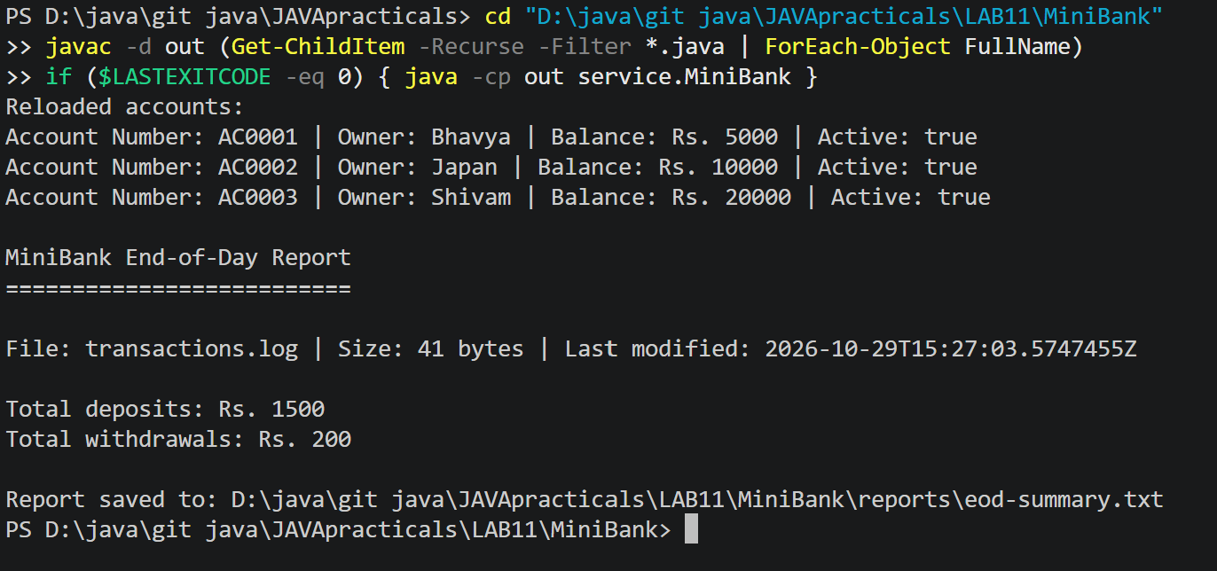

Practical 12
 | model/Account.java
CODE | package model;  import exception.AccountNotFoundException;  import exception.BankException;  import exception.InsufficientFundsException;  import exception.InvalidAmountException;  import java.io.Serializable;  import java.util.Objects;  import model.annotation.Id;  import model.annotation.MaxLength;  import model.annotation.Positive;  public abstract class Account  implements Transactable, InterestBearing, Serializable,  Comparable<Account> {  private static final long serialVersionUID = 1L;  @Id  private final String accountNumber;  @MaxLength(20)  private final String ownerName;  @Positive  private long balance;  private final boolean active;  private static int accountCounter = 0;  protected Account(String ownerName, long openingBalance) {  accountCounter++;  this.accountNumber = String.format("AC%04d", accountCounter);  this.ownerName = ownerName;  this.balance = openingBalance;  this.active = true;  }  public abstract boolean canWithdraw(long amount);  protected abstract long availableBalanceForWithdrawal();  @Override  public synchronized void deposit(long amount) throws InvalidAmountException {  if (amount <= 0) {  throw new InvalidAmountException(  "Deposit amount must be greater than zero."  );  }  balance += amount;  }  @Override  public synchronized boolean withdraw(long amount)  throws InsufficientFundsException, InvalidAmountException {  if (amount <= 0) {  throw new InvalidAmountException(  "Withdrawal amount must be greater than zero."  );  }  long available = availableBalanceForWithdrawal();  if (amount > available) {  long shortfall = amount - available;  throw new InsufficientFundsException(  "Insufficient funds. Shortfall: Rs. " + shortfall,  shortfall  );  }  balance -= amount;  return true;  }  public void transfer(Account to, long amount) throws BankException {  if (to == null) {  throw new AccountNotFoundException(  "Destination account was not found."  );  }  Account first = this;  Account second = to;  if (first.getAccountNumber().compareTo(second.getAccountNumber()) > 0) {  first = to;  second = this;  }  try {  synchronized (first) {  synchronized (second) {  withdraw(amount);  to.deposit(amount);  System.out.println("Transfer successful.");  }  }  } catch (BankException e) {  throw e;  } finally {  System.out.println("Transfer attempt finished.");  }  }  public String getAccountNumber() {  return accountNumber;  }  public String getOwnerName() {  return ownerName;  }  @Override  public synchronized long getBalance() {  return balance;  }  public boolean isActive() {  return active;  }  @Override  public double compareTo(Account other) {  return accountNumber.compareTo(other.accountNumber);  }  @Override  public String toString() {  return "Account Number: " + accountNumber  + " | Owner: " + ownerName  + " | Balance: Rs. " + getBalance()  + " | Active: " + active;  }  @Override  public boolean equals(Object object) {  if (this == object) {  return true;  }  if (!(object instanceof Account account)) {  return false;  }  return accountNumber.equals(account.accountNumber);  }  @Override  public int hashCode() {  return Objects.hash(accountNumber);  }  }
 | service/AccountStore.java
CODE | package service;  import java.util.ArrayList;  import java.util.Comparator;  import java.util.HashMap;  import model.Account;  public class AccountStore {  private final HashMap<String, Account> accounts = new HashMap<>();  private final ArrayList<String> transactionHistory = new ArrayList<>();  public void add(Account account) {  if (account == null) {  throw new IllegalArgumentException("Account cannot be null.");  }  accounts.put(account.getAccountNumber(), account);  }  public Account get(String accountNumber) {  return accounts.get(accountNumber);  }  public ArrayList<Account> getAll() {  return new ArrayList<>(accounts.values());  }  public void addTransaction(String transaction) {  transactionHistory.add(transaction);  }  public ArrayList<String> getTransactionHistory() {  return new ArrayList<>(transactionHistory);  }  public ArrayList<Account> sortedByBalance() {  ArrayList<Account> sorted = getAll();  sorted.sort(Comparator.comparingLong(Account::getBalance));  return sorted;  }  public ArrayList<Account> getAccountsAbove(long amount) {  ArrayList<Account> result = new ArrayList<>();  for (Account account : accounts.values()) {  if (account.getBalance() > amount) {  result.add(account);  }  }  return result;  }  }
 | service/TransactionProcessor.java
CODE | package service;  import java.util.concurrent.ConcurrentHashMap;  import java.util.concurrent.ExecutorService;  import java.util.concurrent.Executors;  import java.util.concurrent.TimeUnit;  import model.Account;  public class TransactionProcessor {  private final ExecutorService executor =  Executors.newFixedThreadPool(4);  private final ConcurrentHashMap<String, Account> accounts =  new ConcurrentHashMap<>();  public void addAccount(Account account) {  accounts.put(account.getAccountNumber(), account);  }  public Account getAccount(String accountNumber) {  return accounts.get(accountNumber);  }  public void submit(Runnable task) {  executor.execute(task);  }  public void stop() throws InterruptedException {  executor.shutdown();  if (!executor.awaitTermination(30, TimeUnit.SECONDS)) {  executor.shutdownNow();  executor.awaitTermination(30, TimeUnit.SECONDS);  }  }  }
 | service/MiniBank.java
CODE | package service;  import exception.InsufficientFundsException;  import exception.InvalidAmountException;  import model.Account;  import model.CurrentAccount;  import model.FixedDepositAccount;  import model.SavingsAccount;  public class MiniBank {  public static void main(String[] args) throws InterruptedException {  AccountStore store = new AccountStore();  Account account1 = new SavingsAccount("Bhavya", 5000, 1000);  Account account2 = new CurrentAccount("Japan", 10000, 2000);  Account account3 = new FixedDepositAccount("Shivam", 20000);  store.add(account1);  store.add(account2);  store.add(account3);  store.addTransaction("Bhavya opened account " + account1.getAccountNumber());  store.addTransaction("Japan opened account " + account2.getAccountNumber());  store.addTransaction("Shivam opened account " + account3.getAccountNumber());  System.out.println("Accounts sorted by balance:");  for (Account account : store.sortedByBalance()) {  System.out.println(account);  }  System.out.println("\nFind account by number:");  Account found = store.get(account1.getAccountNumber());  System.out.println(found);  System.out.println("\nTransaction history:");  for (String transaction : store.getTransactionHistory()) {  System.out.println(transaction);  }  // Give the transaction processor its thread-safe account map.  TransactionProcessor processor = new TransactionProcessor();  for (Account account : store.getAll()) {  processor.addAccount(account);  }  processor.submit(new AccountTransactionTask(  processor, account1.getAccountNumber(), true, 500  ));  processor.submit(new AccountTransactionTask(  processor, account2.getAccountNumber(), false, 1000  ));  processor.stop();  System.out.println("\nBalances after concurrent transactions:");  for (Account account : store.getAll()) {  System.out.println(account);  }  System.out.println("\nAccounts with balance above Rs. 5000:");  for (Account account : store.getAccountsAbove(5000)) {  System.out.println(account);  }  }  }  class AccountTransactionTask implements Runnable {  private final TransactionProcessor processor;  private final String accountNumber;  private final boolean deposit;  private final long amount;  public AccountTransactionTask(  TransactionProcessor processor,  String accountNumber,  boolean deposit,  long amount) {  this.processor = processor;  this.accountNumber = accountNumber;  this.deposit = deposit;  this.amount = amount;  }  @Override  public void run() {  Account account = processor.getAccount(accountNumber);  if (account == null) {  System.out.println("Account not found: " + accountNumber);  return;  }  try {  if (deposit) {  account.deposit(amount);  System.out.println("Deposited Rs. " + amount  + " into " + accountNumber);  } else {  account.withdraw(amount);  System.out.println("Withdrew Rs. " + amount  + " from " + accountNumber);  }  } catch (InsufficientFundsException | InvalidAmountException e) {  System.out.println("Transaction failed: " + e.getMessage());  }  }  }
OUTPUT | 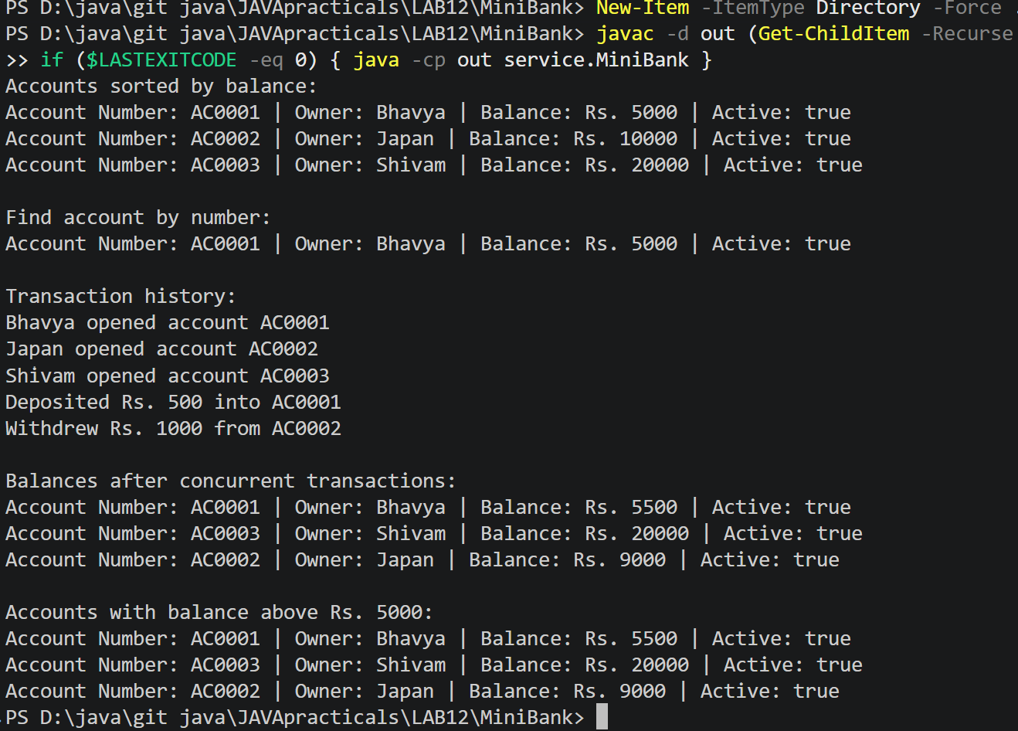

Practical 13
 | service/Repository.java
CODE | package service;  import java.lang.reflect.Field;  import java.util.ArrayList;  import java.util.HashMap;  import model.annotation.Id;  public class Repository<T> {  private final HashMap<String, T> data = new HashMap<>();  private String getId(T entity) {  if (entity == null) {  throw new IllegalArgumentException("Entity cannot be null.");  }  for (Class<?> type = entity.getClass();  type != null;  type = type.getSuperclass()) {  for (Field field : type.getDeclaredFields()) {  if (field.isAnnotationPresent(Id.class)) {  try {  field.setAccessible(true);  Object id = field.get(entity);  if (id == null) {  throw new IllegalArgumentException(  "The @Id field cannot be null."  );  }  return id.toString();  } catch (IllegalAccessException e) {  throw new IllegalStateException(  "Could not read the @Id field.", e  );  }  }  }  }  throw new IllegalArgumentException(  "No field marked with @Id was found."  );  }  public synchronized T save(T entity) {  data.put(getId(entity), entity);  return entity;  }  public synchronized T findById(String id) {  return data.get(id);  }  public synchronized ArrayList<T> findAll() {  return new ArrayList<>(data.values());  }  public synchronized boolean delete(String id) {  return data.remove(id) != null;  }  @SafeVarargs  public final synchronized void saveAll(T... items) {  for (T item : items) {  save(item);  }  }  public static <N extends Number> double average(N[] values) {  if (values == null || values.length == 0) {  throw new IllegalArgumentException("Array cannot be empty.");  }  double total = 0;  for (N number : values) {  total += number.doubleValue();  }  return total / values.length;  }  }
 | model/Customer.java
CODE | package model;  import java.io.Serializable;  import model.annotation.Id;  public class Customer implements Cloneable, Serializable {  private static final long serialVersionUID = 1L;  private String name;  private String email;  private String mobile;  @Id  private final String customerId;  private Address address;  private static long customerCounter = 100;  public Customer(String name, String email, String mobile) {  this(name, email, mobile, null);  }  public Customer(  String name,  String email,  String mobile,  Address address) {  this.name = name;  this.email = email;  this.mobile = mobile;  this.address = address;  this.customerId = generateCustomerId();  }  private static String generateCustomerId() {  return "CUST" + (++customerCounter);  }  public String getName() {  return name;  }  public String getEmail() {  return email;  }  public String getMobile() {  return mobile;  }  public String getCustomerId() {  return customerId;  }  public Address getAddress() {  return address;  }  @Override  public Customer clone() {  try {  return (Customer) super.clone();  } catch (CloneNotSupportedException e) {  throw new AssertionError(e);  }  }  public static class Address implements Serializable {  private static final long serialVersionUID = 1L;  private final String line;  private final String city;  private final String pincode;  public Address(String line, String city, String pincode) {  this.line = line;  this.city = city;  this.pincode = pincode;  }  public String getLine() {  return line;  }  public String getCity() {  return city;  }  public String getPincode() {  return pincode;  }  @Override  public String toString() {  return line + ", " + city + " - " + pincode;  }  }  }
 | service/MiniBank.java
CODE | package service;  import model.Account;  import model.Customer;  import model.CurrentAccount;  import model.FixedDepositAccount;  import model.SavingsAccount;  public class MiniBank {  public static void main(String[] args) {  Repository<Account> accounts = new Repository<>();  Account bhavyaAccount =  new SavingsAccount("Bhavya", 5000, 1000);  Account japanAccount =  new CurrentAccount("Japan", 10000, 2000);  Account shivamAccount =  new FixedDepositAccount("Shivam", 0);  accounts.saveAll(bhavyaAccount, japanAccount, shivamAccount);  System.out.println("Account found by ID:");  Account foundAccount =  accounts.findById(bhavyaAccount.getAccountNumber());  System.out.println(foundAccount);  System.out.println("\nAll accounts:");  for (Account account : accounts.findAll()) {  System.out.println(account);  }  Repository<Customer> customers = new Repository<>();  Customer bhavya = new Customer(  "Bhavya",  "bhavya@example.com",  "9876543210",  new Customer.Address("Main Road", "Kheroli", "123456")  );  customers.save(bhavya);  System.out.println("\nCustomer found by ID:");  Customer foundCustomer =  customers.findById(bhavya.getCustomerId());  if (foundCustomer != null) {  System.out.println("Customer ID: "  + foundCustomer.getCustomerId());  System.out.println("Name: " + foundCustomer.getName());  System.out.println("Email: " + foundCustomer.getEmail());  System.out.println("Mobile: " + foundCustomer.getMobile());  System.out.println("Address: " + foundCustomer.getAddress());  }  System.out.println("\nAverage of the account balances:");  System.out.println(  Repository.average(new Long[] {5000L, 10000L, 0L})  );  }  }
OUTPUT | 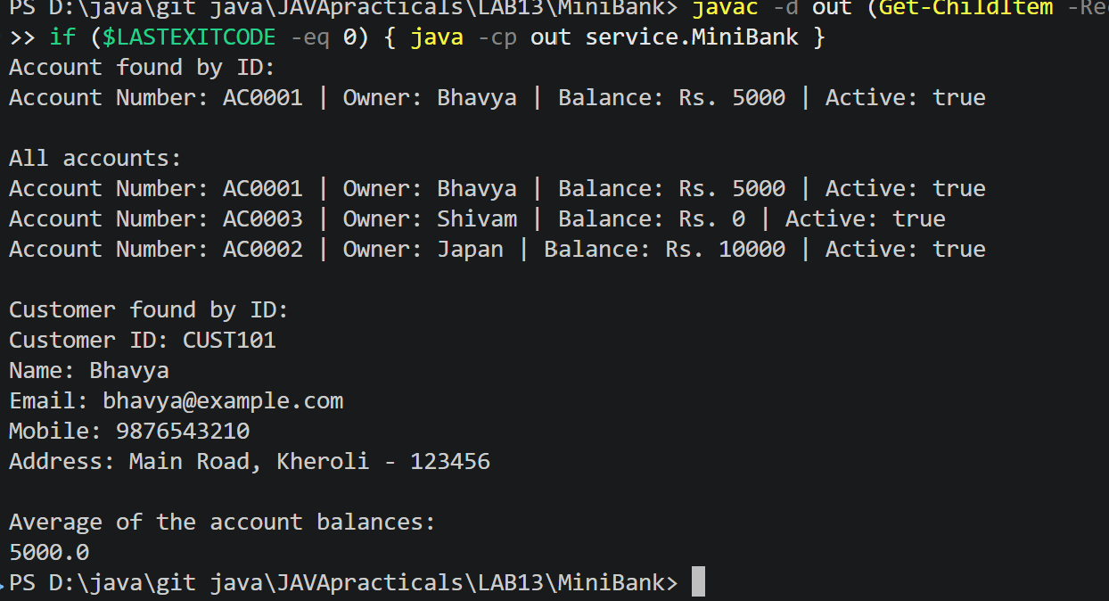

Practical 14
 | service/BankService.java
CODE | package service;  import exception.AccountNotFoundException;  import exception.BankException;  import exception.InsufficientFundsException;  import exception.InvalidAmountException;  import java.io.IOException;  import java.nio.file.Path;  import java.util.ArrayList;  import java.util.concurrent.CountDownLatch;  import model.Account;  import model.SavingsAccount;  import util.ReportGenerator;  import util.TransactionLog;  import util.Validator;  public class BankService {  private final Repository<Account> repository;  private final TransactionProcessor processor;  private final Path transactionLog;  private final Path reportFile;  public BankService(  Repository<Account> repository,  TransactionProcessor processor,  Path transactionLog,  Path reportFile) {  this.repository = repository;  this.processor = processor;  this.transactionLog = transactionLog;  this.reportFile = reportFile;  }  public Account openAccount(  String name,  String email,  String mobile,  long openingBalance) throws InvalidAmountException {  if (name == null || name.isBlank() || name.length() > 20) {  throw new InvalidAmountException(  "Name must contain 1 to 20 characters."  );  }  if (!Validator.isValidEmail(email)) {  throw new InvalidAmountException("Invalid email address.");  }  if (!Validator.isValidMobile(mobile)) {  throw new InvalidAmountException("Invalid mobile number.");  }  if (openingBalance < 0) {  throw new InvalidAmountException(  "Opening balance cannot be negative."  );  }  // Avoid reusing an account number after loading saved accounts.  Account account;  do {  account = new SavingsAccount(name, openingBalance, 0);  } while (repository.get(account.getAccountNumber()) != null);  registerAccount(account);  return account;  }  public void registerAccount(Account account) {  repository.save(account);  processor.addAccount(account);  }  public void deposit(String accountNumber, long amount)  throws BankException, IOException {  Account account = findAccount(accountNumber);  account.deposit(amount);  TransactionLog.append(transactionLog, "DEPOSIT " + amount);  }  public void withdraw(String accountNumber, long amount)  throws BankException, IOException {  Account account = findAccount(accountNumber);  account.withdraw(amount);  TransactionLog.append(transactionLog, "WITHDRAW " + amount);  }  public void transfer(String fromNumber, String toNumber, long amount)  throws BankException, IOException {  Account from = findAccount(fromNumber);  Account to = findAccount(toNumber);  from.transfer(to, amount);  TransactionLog.append(transactionLog, "TRANSFER " + amount);  }  public String statement(String accountNumber)  throws AccountNotFoundException {  return findAccount(accountNumber).toString();  }  public ArrayList<Account> listAccounts() {  return repository.findAll();  }  public String generateReport() throws IOException {  return ReportGenerator.generate(  transactionLog.getParent(),  reportFile  );  }  public void processDepositBatch(  String accountNumber,  int numberOfDeposits,  long amount) throws AccountNotFoundException, InterruptedException {  if (numberOfDeposits <= 0 || amount <= 0) {  throw new IllegalArgumentException(  "Deposit count and amount must be positive."  );  }  findAccount(accountNumber);  CountDownLatch completed = new CountDownLatch(numberOfDeposits);  for (int i = 0; i < numberOfDeposits; i++) {  processor.submit(() -> {  try {  Account sharedAccount = processor.getAccount(accountNumber);  if (sharedAccount != null) {  sharedAccount.deposit(amount);  TransactionLog.append(  transactionLog,  "DEPOSIT " + amount  );  }  } catch (InvalidAmountException | IOException e) {  System.out.println("Batch transaction failed: "  + e.getMessage());  } finally {  completed.countDown();  }  });  }  completed.await();  }  public void stopProcessor() throws InterruptedException {  processor.stop();  }  private Account findAccount(String accountNumber)  throws AccountNotFoundException {  Account account = repository.findById(accountNumber);  if (account == null) {  throw new AccountNotFoundException(  "Account not found: " + accountNumber  );  }  return account;  }  }
 | service/MiniBank.java
CODE | package service;  import exception.BankException;  import java.nio.file.Files;  import java.nio.file.Path;  import model.Account;  import model.CurrentAccount;  import model.FixedDepositAccount;  import model.SavingsAccount;  import util.StatePersister;  public class MiniBank {  public static void main(String[] args) throws Exception {  Path dataFolder = Path.of("data");  Path stateFile = dataFolder.resolve("accounts.dat");  Path logFile = dataFolder.resolve("logs").resolve("transactions.log");  Path reportFile = dataFolder.resolve("reports").resolve("eod-report.txt");  Files.createDirectories(dataFolder);  Repository<Account> repository = new Repository<>();  TransactionProcessor processor = new TransactionProcessor();  BankService bank = new BankService(  repository,  processor,  logFile,  reportFile  );  if (Files.exists(stateFile)) {  for (Account account : StatePersister.load(stateFile)) {  bank.registerAccount(account);  }  System.out.println("Saved accounts loaded.");  } else {  // Your account data from the earlier MiniBank practicals.  bank.registerAccount(new SavingsAccount("Bhavya", 5000, 1000));  bank.registerAccount(new CurrentAccount("Japan", 10000, 2000));  bank.registerAccount(new FixedDepositAccount("Shivam", 0));  }  boolean running = true;  try (var scanner = new java.util.Scanner(System.in)) {  while (running) {  System.out.println("\n====== MiniBank ======");  System.out.println("1. Open Account");  System.out.println("2. Deposit");  System.out.println("3. Withdraw");  System.out.println("4. Transfer");  System.out.println("5. Statement");  System.out.println("6. List Accounts");  System.out.println("7. Process Deposit Batch");  System.out.println("8. End-of-Day Report");  System.out.println("9. Exit");  System.out.print("Enter choice: ");  String choice = scanner.nextLine().trim();  try {  switch (choice) {  case "1" -> {  System.out.print("Enter name: ");  String name = scanner.nextLine();  System.out.print("Enter email: ");  String email = scanner.nextLine();  System.out.print("Enter mobile: ");  String mobile = scanner.nextLine();  System.out.print("Enter opening balance: ");  long openingBalance =  Long.parseLong(scanner.nextLine());  Account account = bank.openAccount(  name, email, mobile, openingBalance  );  System.out.println("Account opened: " + account);  }  case "2" -> {  showAccounts(bank);  System.out.print("Enter account number: ");  String accountNumber = scanner.nextLine();  System.out.print("Enter deposit amount: ");  long amount = Long.parseLong(scanner.nextLine());  bank.deposit(accountNumber, amount);  System.out.println("Deposit successful.");  }  case "3" -> {  showAccounts(bank);  System.out.print("Enter account number: ");  String accountNumber = scanner.nextLine();  System.out.print("Enter withdrawal amount: ");  long amount = Long.parseLong(scanner.nextLine());  bank.withdraw(accountNumber, amount);  System.out.println("Withdrawal successful.");  }  case "4" -> {  showAccounts(bank);  System.out.print("Transfer from account: ");  String from = scanner.nextLine();  System.out.print("Transfer to account: ");  String to = scanner.nextLine();  System.out.print("Enter transfer amount: ");  long amount = Long.parseLong(scanner.nextLine());  bank.transfer(from, to, amount);  }  case "5" -> {  System.out.print("Enter account number: ");  String accountNumber = scanner.nextLine();  System.out.println(bank.statement(accountNumber));  }  case "6" -> showAccounts(bank);  case "7" -> {  showAccounts(bank);  System.out.print("Enter account number: ");  String accountNumber = scanner.nextLine();  System.out.print("Number of deposits: ");  int count = Integer.parseInt(scanner.nextLine());  System.out.print("Amount per deposit: ");  long amount = Long.parseLong(scanner.nextLine());  bank.processDepositBatch(  accountNumber, count, amount  );  System.out.println("Deposit batch completed.");  }  case "8" -> System.out.println(bank.generateReport());  case "9" -> running = false;  default -> System.out.println(  "Invalid choice. Enter a number from 1 to 9."  );  }  } catch (BankException e) {  System.out.println("Banking error: " + e.getMessage());  } catch (NumberFormatException e) {  System.out.println("Please enter a valid whole number.");  } catch (InterruptedException e) {  Thread.currentThread().interrupt();  System.out.println("The operation was interrupted.");  } catch (Exception e) {  System.out.println("Operation failed: " + e.getMessage());  }  }  } finally {  // Finish queued transactions before saving application state.  bank.stopProcessor();  StatePersister.save(  bank.listAccounts().toArray(new Account[0]),  stateFile  );  System.out.println("Accounts saved. Goodbye!");  }  }  private static void showAccounts(BankService bank) {  System.out.println("\nAccounts:");  for (Account account : bank.listAccounts()) {  System.out.println(account);  }  }  }
 | test/service/BankServiceTest.java
CODE | package service;  import static org.junit.jupiter.api.Assertions.assertEquals;  import static org.junit.jupiter.api.Assertions.assertThrows;  import exception.InsufficientFundsException;  import java.nio.file.Path;  import java.util.ArrayList;  import java.util.concurrent.ExecutorService;  import java.util.concurrent.Executors;  import java.util.concurrent.Future;  import model.Account;  import model.SavingsAccount;  import org.junit.jupiter.api.AfterEach;  import org.junit.jupiter.api.BeforeEach;  import org.junit.jupiter.api.Test;  import org.junit.jupiter.api.io.TempDir;  class BankServiceTest {  @TempDir  Path tempDirectory;  private TransactionProcessor processor;  private BankService bank;  @BeforeEach  void setUp() {  processor = new TransactionProcessor();  bank = new BankService(  new Repository<>(),  processor,  tempDirectory.resolve("logs").resolve("test.log"),  tempDirectory.resolve("report.txt")  );  }  @AfterEach  void tearDown() throws InterruptedException {  bank.stopProcessor();  }  @Test  void depositIncreasesBalance() throws Exception {  Account account = new SavingsAccount("Test User", 1000, 0);  bank.registerAccount(account);  bank.deposit(account.getAccountNumber(), 500);  assertEquals(1500, account.getBalance());  }  @Test  void withdrawalOverBalanceThrowsInsufficientFundsException()  throws Exception {  Account account = new SavingsAccount("Test User", 1000, 0);  bank.registerAccount(account);  assertThrows(  InsufficientFundsException.class,  () -> bank.withdraw(account.getAccountNumber(), 1500)  );  }  @Test  void concurrentDepositsKeepCorrectBalance() throws Exception {  Account account = new SavingsAccount("Test User", 0, 0);  int threadCount = 8;  int depositsPerThread = 1000;  ExecutorService executor =  Executors.newFixedThreadPool(threadCount);  ArrayList<Future<?>> futures = new ArrayList<>();  try {  for (int thread = 0; thread < threadCount; thread++) {  futures.add(executor.submit(() -> {  for (int i = 0; i < depositsPerThread; i++) {  try {  account.deposit(1);  } catch (Exception e) {  throw new RuntimeException(e);  }  }  }));  }  for (Future<?> future : futures) {  future.get();  }  } finally {  executor.shutdown();  }  assertEquals((long) threadCount * depositsPerThread,  account.getBalance());  }  }
README.md | # MiniBank  MiniBank is a Java console banking application. It supports account creation,  deposits, withdrawals, transfers, statements, account listing, concurrent  deposit batches, saved account state, and end-of-day transaction reports.  ## Requirements  - JDK 17 or later  - JUnit 5 standalone JAR for running tests  ## Compile the application  Run these PowerShell commands from the project root:  ```powershell  $mainSources = Get-ChildItem .\model, .\util, .\service, .\exception `  -Recurse -Filter *.java |  ForEach-Object FullName  javac -d out $mainSources
OUTPUT
 | 

