PRACTICAL - 07
Part A — Practice Programs (Hour 1)

PROBLEM1 | 1. Form validator: define @NotBlank and @MaxLength(int) for fields and annotate a SignupForm. Write a checker that uses reflection to read each field’s annotations and returns the list of validation errors for a given object.
CODE | import java.lang.annotation.*;  import java.lang.reflect.Field;  import java.util.*;  @Retention(RetentionPolicy.RUNTIME)  @Target(ElementType.FIELD)  @interface NotBlank {  }  @Retention(RetentionPolicy.RUNTIME)  @Target(ElementType.FIELD)  @interface MaxLength {  int value();  }  class SignupForm {  @NotBlank  @MaxLength(10)  String username;  @NotBlank  @MaxLength(20)  String email;  SignupForm(String username, String email) {  this.username = username;  this.email = email;  }  }  public class Main {  public static void main(String[] args) throws Exception {  SignupForm form = new SignupForm("", "abcdefghijklmnop@gmail.com");  List<String> errors = new ArrayList<>();  for (Field field : form.getClass().getDeclaredFields()) {  field.setAccessible(true);  String value = (String) field.get(form);  // Check NotBlank  if (field.isAnnotationPresent(NotBlank.class)) {  if (value == null || value.trim().isEmpty()) {  errors.add(field.getName() + " cannot be blank");  }  }  // Check MaxLength  if (field.isAnnotationPresent(MaxLength.class)) {  MaxLength max = field.getAnnotation(MaxLength.class);  if (value != null && value.length() > max.value()) {  errors.add(field.getName()  + " is too long. Maximum "  + max.value() + " characters allowed");  }  }  }  if (errors.isEmpty()) {  System.out.println("Form is valid");  } else {  for (String error : errors) {  System.out.println(error);  }  }  }  }
OUTPUT | 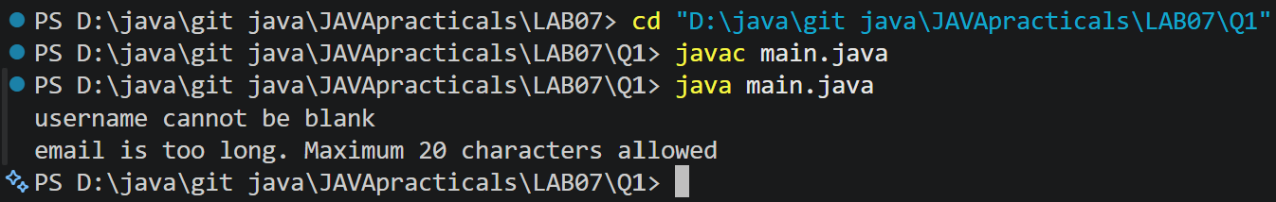
PROBLEM2 | 2. Mini test runner: define a @Run annotation and mark some no-arg methods of a class with it. Use reflection to find and invoke only the @Run methods and report how many ran — the idea behind how JUnit finds @Test methods.
CODE | import java.lang.annotation.*;  import java.lang.reflect.Method;  @Retention(RetentionPolicy.RUNTIME)  @Target(ElementType.METHOD)  @interface Run {  }  class MyTests {  @Run  public void test1() {  System.out.println("Test 1 executed");  }  @Run  public void test2() {  System.out.println("Test 2 executed");  }  public void normalMethod() {  System.out.println("Normal method");  }  }  public class Mini {  public static void main(String[] args) throws Exception {  MyTests obj = new MyTests();  int count = 0;  Method[] methods = obj.getClass().getDeclaredMethods();  for (Method method : methods) {  if (method.isAnnotationPresent(Run.class)  && method.getParameterCount() == 0) {  method.invoke(obj);  count++;  }  }  System.out.println("Total methods executed: " + count);  }  }
OUTPUT | 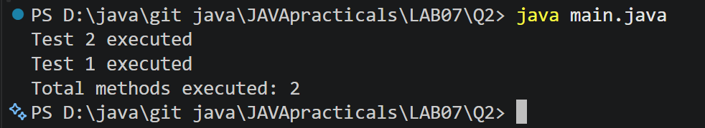
PROBLEM3 | 3. (For Advanced Learners – home) Define a @Column(name) annotation and, by reflection, populate an object’s fields from a header row and a data row by matching column names; decide how to handle a missing column.
CODE | import java.lang.annotation.*;  import java.lang.reflect.Field;  @Retention(RetentionPolicy.RUNTIME)  @Target(ElementType.FIELD)  @interface Column {  String name();  }  class Student {  @Column(name = "id")  String id;  @Column(name = "name")  String name;  @Column(name = "email")  String email;  }  public class Columns {  public static void main(String[] args) throws Exception {  String[] headers = {"id", "name", "email"};  String[] data = {"101", "Om", "om@gmail.com"};  Student student = new Student();  Field[] fields = student.getClass().getDeclaredFields();  for (Field field : fields) {  if (field.isAnnotationPresent(Column.class)) {  Column column = field.getAnnotation(Column.class);  for (int i = 0; i < headers.length; i++) {  if (headers[i].equals(column.name())) {  field.setAccessible(true);  field.set(student, data[i]);  break;  }  }  }  }  System.out.println("ID: " + student.id);  System.out.println("Name: " + student.name);  System.out.println("Email: " + student.email);  }  }
OUTPUT | 

