PRACTICAL - 08
Part A — Practice Programs (Hour 1)

PROBLEM1 | 1. Guarded calculator: read two numbers and an operator; throw a custom  DivideByZeroException and catch invalid-number input separately, printing a clear  message each time; loop until a valid calculation succeeds and use finally to log each  attempt.
CODE | import java.util.Scanner;  public class Calculator {  public static void main(String[] args) {  Scanner sc = new Scanner(System.in);  try {  System.out.print("Enter first number: ");  double num1 = sc.nextDouble();  System.out.print("Enter second number: ");  double num2 = sc.nextDouble();  if (num1 < 0 || num2 < 0) {  throw new InvalidNumberException("Negative numbers are not allowed!");  }  if(num1==0 || num2==0){  throw new InvalidNumberException("Multiplication By Zero is not allowed!");  }  System.out.print("Enter operator (+, -, *, /): ");  char op = sc.next().charAt(0);  System.out.println("You entered: " + num1 + " " + op + " " + num2);  double result = 0;  if (op == '+') {  result = num1 + num2;  } else if (op == '-') {  result = num1 - num2;  } else if (op == '*') {  result = num1 * num2;  } else if (op == '/') {  if (num2 == 0) {  throw new DivideByZeroException("Cannot divide by zero!");  }  result = num1 / num2;  } else {  throw new InvalidNumberException("Invalid operator entered!");  }  System.out.println(num1 + " " + op + " " + num2 + " = " + result);  } catch (DivideByZeroException e) {  System.out.println("Error: " + e.getMessage());  } catch (InvalidNumberException e) {  System.out.println("Error: " + e.getMessage());  } catch (Exception e) {  System.out.println("Unexpected error: " + e.getMessage());  } finally {  System.out.println("Exiting the program.");  sc.close();  }  }  }  class DivideByZeroException extends Exception {  public DivideByZeroException(String message) {  super(message);  }  }  class InvalidNumberException extends Exception {  public InvalidNumberException(String message) {  super(message);  }  }
OUTPUT | 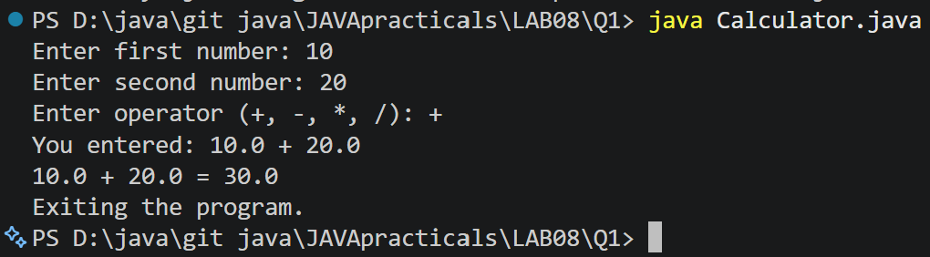
PROBLEM2 | 2. Stock issue: a Warehouse where issue(item, qty) throws a custom checked  OutOfStockException carrying the shortfall, and InvalidQuantityException for qty ≤ 0.  Process a list of requests, catching and reporting each failure without stopping the run.
CODE | import java.util.Scanner;  class outofstockexception extends Exception {  private int shortage;  public outofstockexception(int shortage) {  super("out of stock! shortage: " + shortage);  this.shortage = shortage;  }  public int getshortage() {  return shortage;  }  }  class invalidquantityexception extends Exception {  public invalidquantityexception() {  super("invalid quantity! must be greater than 0.");  }  }  class store {  private int stock;  public store(int stock) {  this.stock = stock;  }  public void issue(String item, int qty)  throws outofstockexception, invalidquantityexception {  if (qty <= 0) {  throw new invalidquantityexception();  }  if (qty > stock) {  int shortage = qty - stock;  throw new outofstockexception(shortage);  }  stock -= qty;  System.out.println("issued: " + qty + " " + item);  System.out.println("left in stock: " + stock);  }  }  public class storemanagement {  public static void main(String[] args) {  Scanner sc = new Scanner(System.in);  System.out.print("enter starting stock: ");  int stock = sc.nextInt();  store s = new store(stock);  System.out.print("enter number of requests: ");  int requests = sc.nextInt();  sc.nextLine();  for (int i = 1; i <= requests; i++) {  System.out.println("\nrequest " + i);  System.out.print("enter item name: ");  String item = sc.nextLine();  System.out.print("enter quantity: ");  int qty = sc.nextInt();  sc.nextLine();  try {  s.issue(item, qty);  } catch (outofstockexception e) {  System.out.println("error: " + e.getMessage());  } catch (invalidquantityexception e) {  System.out.println("error: " + e.getMessage());  }  }  sc.close();  }  }
OUTPUT | 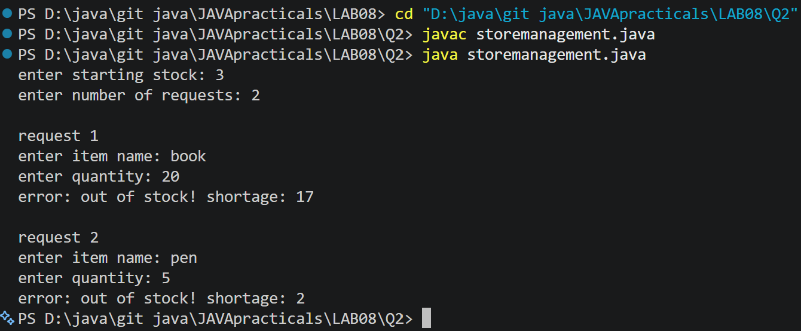
PROBLEM3 | 3. (For Advanced Learners – home) Create an AutoCloseable resource and use try-with-  resources to prove it always closes — even when an exception is thrown inside the block  — and that the original error is the one reported. Decide what to model as the resource.
CODE | class MyResource implements AutoCloseable {  void doWork() {  System.out.println("Resource is doing some work...");  throw new RuntimeException("Original error occurred");  }  @Override  public void close() {  System.out.println("Resource is closed");  throw new RuntimeException("Error while closing resource");  }  }  public class Main {  public static void main(String[] args) {  try (MyResource resource = new MyResource()) {  System.out.println("Resource is opened");  resource.doWork();  } catch (Exception e) {  System.out.println("Main error: " + e.getMessage());  for (Throwable error : e.getSuppressed()) {  System.out.println("Suppressed error: " + error.getMessage());  }  }  }  }
OUTPUT | 

