CEUE203 : Object Oriented Programming 25AIML044

PRACTICAL – 9
AIM:
1. Counter race: several threads each increment a shared counter many times. Run it without synchronization to watch the total come out too low, then make the increment synchronized and confirm it is exactly right every run.
.CODE:
import java.util.Scanner;

class Counter {
int count = 0;

// Unsynchronized increment void increment() {
count++;
}

// Synchronized increment
synchronized void synchronizedIncrement() { count++;
}
}

class MyThread extends Thread { Counter counter;
int increments;
boolean useSynchronization;

MyThread(Counter counter, int increments, boolean useSynchronization) { this.counter = counter;
this.increments = increments;
this.useSynchronization = useSynchronization;
}

public void run() {
for (int i = 0; i < increments; i++) {

if (useSynchronization) {
counter.synchronizedIncrement();
} else {
counter.increment();
}
}
}
}
ccCSPIT - AIML | 1

CEUE203 : Object Oriented Programming 25AIML044

public class CounterRace {

public static void main(String[] args) throws Exception { Scanner sc = new Scanner(System.in);
System.out.print("Enter number of threads: "); int numberOfThreads = sc.nextInt();

System.out.print("Enter number of increments per thread: "); int increments = sc.nextInt();

System.out.print("Use synchronization? (yes/no): "); String choice = sc.next();

boolean useSynchronization = choice.equalsIgnoreCase("yes"); Counter counter = new Counter();
MyThread[] threads = new MyThread[numberOfThreads];

// Creating threads
for (int i = 0; i < numberOfThreads; i++) { threads[i] = new MyThread(
counter,
increments,
useSynchronization);
}

// Starting threads
for (int i = 0; i < numberOfThreads; i++) { threads[i].start();
}

// Waiting for all threads to finish
for (int i = 0; i < numberOfThreads; i++) { threads[i].join();
}
int expectedValue = numberOfThreads * increments; System.out.println("\n----- Result ");
System.out.println("Number of Threads: " + numberOfThreads); System.out.println("Increments per Thread: " + increments);
System.out.println("Expected Counter Value: " + expectedValue); System.out.println("Actual Counter Value: " + counter.count);
ccCSPIT - AIML | 2

CEUE203 : Object Oriented Programming 25AIML044

if (counter.count == expectedValue) {
System.out.println("Result is correct.");
} else {
System.out.println("Race condition occurred.");
}

sc.close();
}
}

OUTPUT SCREENSHOT:
With synchronization :

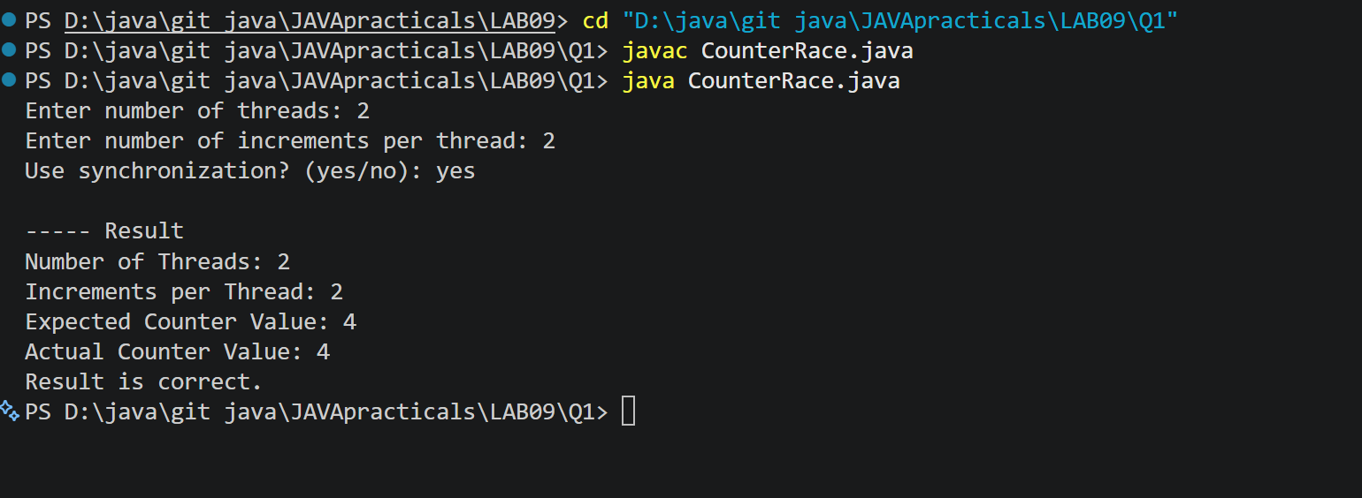
Without synchronization :

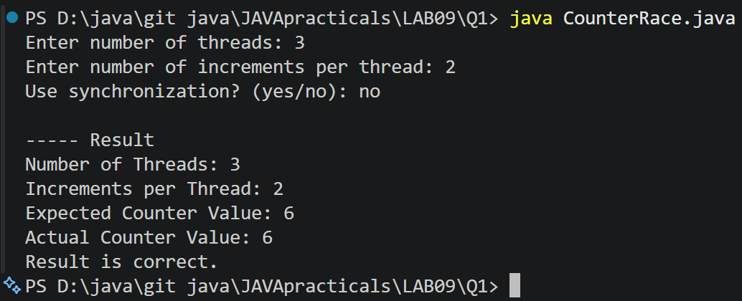
LEARNING OUTCOME:
- How to create and use multiple threads in Java.
- How threads share common data.
- What a race condition is.
ccCSPIT - AIML | 3

CEUE203 : Object Oriented Programming 25AIML044

- Why race conditions can produce incorrect results.
- How the synchronized keyword prevents simultaneous access to shared data.
- How start() starts a thread and join() waits for a thread to finish.
- How synchronization helps maintain data consistency in multithreaded programs.
2. Seat booking race: a shared seatsLeft of 5 with about 10 threads each trying to book one seat. Without synchronization show that more than 5 can succeed (oversell); with a synchronized book() exactly 5 do..
CODE:
import java.util.Scanner; class SeatBooking {
int seatsLeft;
int successfulBookings = 0;

SeatBooking(int seats) { seatsLeft = seats;
}

// Booking without synchronization void book(String userName) {

if (seatsLeft > 0) {

// Small delay makes the race condition easier to observe try {
Thread.sleep(10);
} catch (InterruptedException e) { System.out.println(e);
}

seatsLeft--;
successfulBookings++;

System.out.println(userName + " booked a seat.");
} else {
System.out.println(userName + " could not book a seat.");
}
}

// Booking with synchronization
synchronized void synchronizedBook(String userName) { if (seatsLeft > 0) {
ccCSPIT - AIML | 4

CEUE203 : Object Oriented Programming 25AIML044

try {
Thread.sleep(10);
} catch (InterruptedException e) { System.out.println(e);
}

seatsLeft--;
successfulBookings++;

System.out.println(userName + " booked a seat.");
} else {
System.out.println(userName + " could not book a seat.");
}
}
}
class BookingThread extends Thread { SeatBooking booking;
String userName;
boolean useSynchronization;

BookingThread(
SeatBooking booking, String userName,
boolean useSynchronization) { this.booking = booking;
this.userName = userName;
this.useSynchronization = useSynchronization;
}

public void run() {

if (useSynchronization) {
booking.synchronizedBook(userName);
} else {
booking.book(userName);
}
}
}

public class SeatBookingRace {

public static void main(String[] args) throws Exception { Scanner sc = new Scanner(System.in);
ccCSPIT - AIML | 5

CEUE203 : Object Oriented Programming 25AIML044

System.out.print("Enter number of seats: "); int totalSeats = sc.nextInt();

System.out.print("Enter number of users: "); int numberOfUsers = sc.nextInt();

System.out.print("Use synchronization? (yes/no): "); String choice = sc.next();

boolean useSynchronization = choice.equalsIgnoreCase("yes"); SeatBooking booking = new SeatBooking(totalSeats);
BookingThread[] users = new BookingThread[numberOfUsers];

// Creating booking threads
for (int i = 0; i < numberOfUsers; i++) { String userName = "User-" + (i + 1);
users[i] = new BookingThread( booking,
userName,
useSynchronization);
}

// Starting all users
for (int i = 0; i < numberOfUsers; i++) { users[i].start();
}

// Waiting for all users to finish
for (int i = 0; i < numberOfUsers; i++) { users[i].join();
}

System.out.println("\n----- Booking Result ");

System.out.println("Total Seats: "
+ totalSeats);

System.out.println("Total Users: "
+ numberOfUsers);

System.out.println("Successful Bookings: "
+ booking.successfulBookings); System.out.println("Seats Left: "
ccCSPIT - AIML | 6

CEUE203 : Object Oriented Programming 25AIML044
+ booking.seatsLeft);

if (booking.successfulBookings > totalSeats) {
System.out.println("Overselling occurred!");
} else {
System.out.println("No overselling occurred.");
}

sc.close();
}
}

OUTPUT SCREENSHOT:

With synchronization :

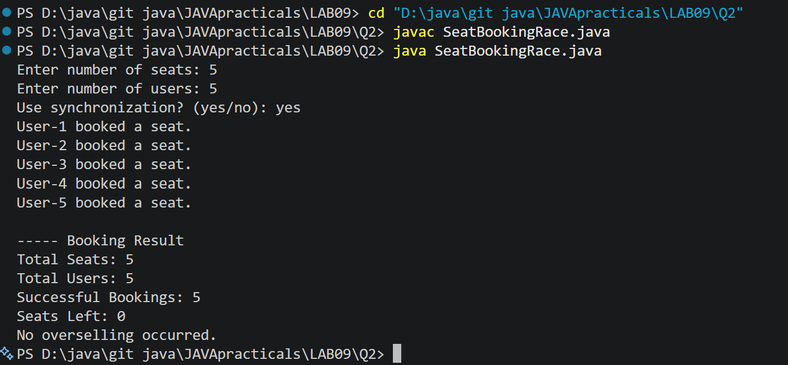

Without synchronization :

ccCSPIT - AIML 7

CEUE203 : Object Oriented Programming 25AIML044

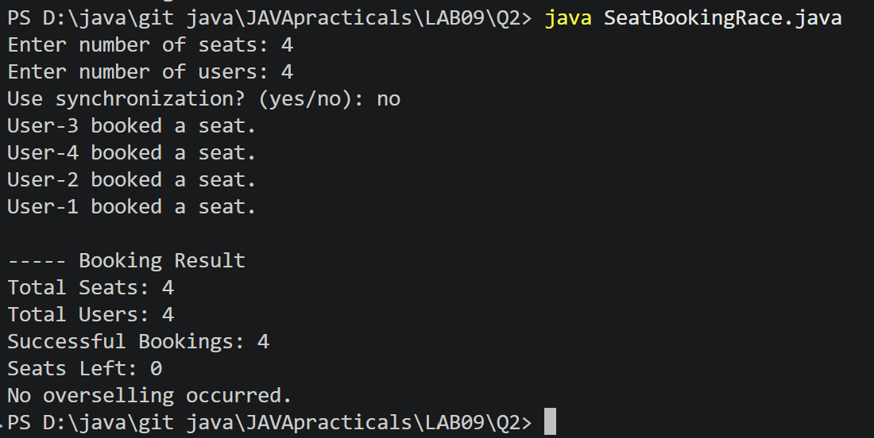
LEARNING OUTCOME:
- How multiple threads can access a shared resource.
- What a race condition is in a real-world booking system.
- How race conditions can cause overselling.
- Why checking and modifying shared data must be synchronized.
- How the synchronized keyword provides thread safety.
- How multiple users can be simulated using Java threads.
- How start() is used to run threads and join() is used to wait for them.
- How synchronization ensures that the number of successful bookings never exceeds the available seats.
ccCSPIT - AIML | 8

CEUE203 : Object Oriented Programming 25AIML044

3. (For Advanced Learners – home) Split a large array of numbers across several threads that add into one shared total, show the wrong result, then fix it two ways and compare;
decide how to measure the difference. CODE:
import java.util.Scanner; class SharedTotal {
long total = 0;

// Method 1: Without synchronization void add(long value) {
total += value;
}

// Method 2: Using synchronized method
synchronized void synchronizedAdd(long value) { total += value;
}
}

class SumThread extends Thread { int[] numbers;
ccCSPIT - AIML | 9

CEUE203 : Object Oriented Programming 25AIML044

int start; int end;
SharedTotal sharedTotal; int method;

SumThread(int[] numbers, int start, int end,
SharedTotal sharedTotal, int method) {

this.numbers = numbers; this.start = start;
this.end = end;
this.sharedTotal = sharedTotal; this.method = method;
}

public void run() {
for (int i = start; i < end; i++) { if (method == 1) {
// No synchronization
sharedTotal.add(numbers[i]);

} else {
// Synchronized method
sharedTotal.synchronizedAdd(numbers[i]);
}
}
}
}

public class ParallelArraySum {

public static void main(String[] args) throws Exception { Scanner sc = new Scanner(System.in);
System.out.print("Enter array size: "); int size = sc.nextInt();

System.out.print("Enter number of threads: "); int numberOfThreads = sc.nextInt();

System.out.print("Enter maximum value of array elements: "); int maxValue = sc.nextInt();

// Creating array
int[] numbers = new int[size];
ccCSPIT - AIML | 10

CEUE203 : Object Oriented Programming 25AIML044

// Filling array with values
for (int i = 0; i < size; i++) {
numbers[i] = (i % maxValue) + 1;
}

// Calculate correct answer using single thread long correctTotal = 0;

for (int number : numbers) { correctTotal += number;
}

System.out.println("\nCorrect Total: " + correctTotal);

// Run both methods
for (int method = 1; method <= 2; method++) {

SharedTotal sharedTotal = new SharedTotal();

SumThread[] threads = new SumThread[numberOfThreads]; int part = size / numberOfThreads;
long startTime = System.nanoTime();

// Creating threads
for (int i = 0; i < numberOfThreads; i++) { int start = i * part;
int end;

if (i == numberOfThreads - 1) { end = size;
} else {
end = start + part;
}

threads[i] = new SumThread( numbers,
start, end,
sharedTotal, method);
}

// Starting threads
ccCSPIT - AIML | 11

CEUE203 : Object Oriented Programming 25AIML044

for (int i = 0; i < numberOfThreads; i++) { threads[i].start();
}

// Waiting for threads
for (int i = 0; i < numberOfThreads; i++) { threads[i].join();
}

long endTime = System.nanoTime();

long timeTaken = endTime - startTime;

System.out.println("\n----- Method " + method + " ");

if (method == 1) {
System.out.println(
"Method: Without Synchronization");
} else {
System.out.println(
"Method: Synchronized Method");
}

System.out.println(
"Calculated Total: "
+ sharedTotal.total);

System.out.println(
"Time Taken: "
+ timeTaken
+ " nanoseconds");

if (sharedTotal.total == correctTotal) {
System.out.println("Result is CORRECT.");
} else {
System.out.println("Result is WRONG.");
}
}

sc.close();
}
}

OUTPUT SCREENSHOT:
ccCSPIT - AIML | 12

CEUE203 : Object Oriented Programming 25AIML044

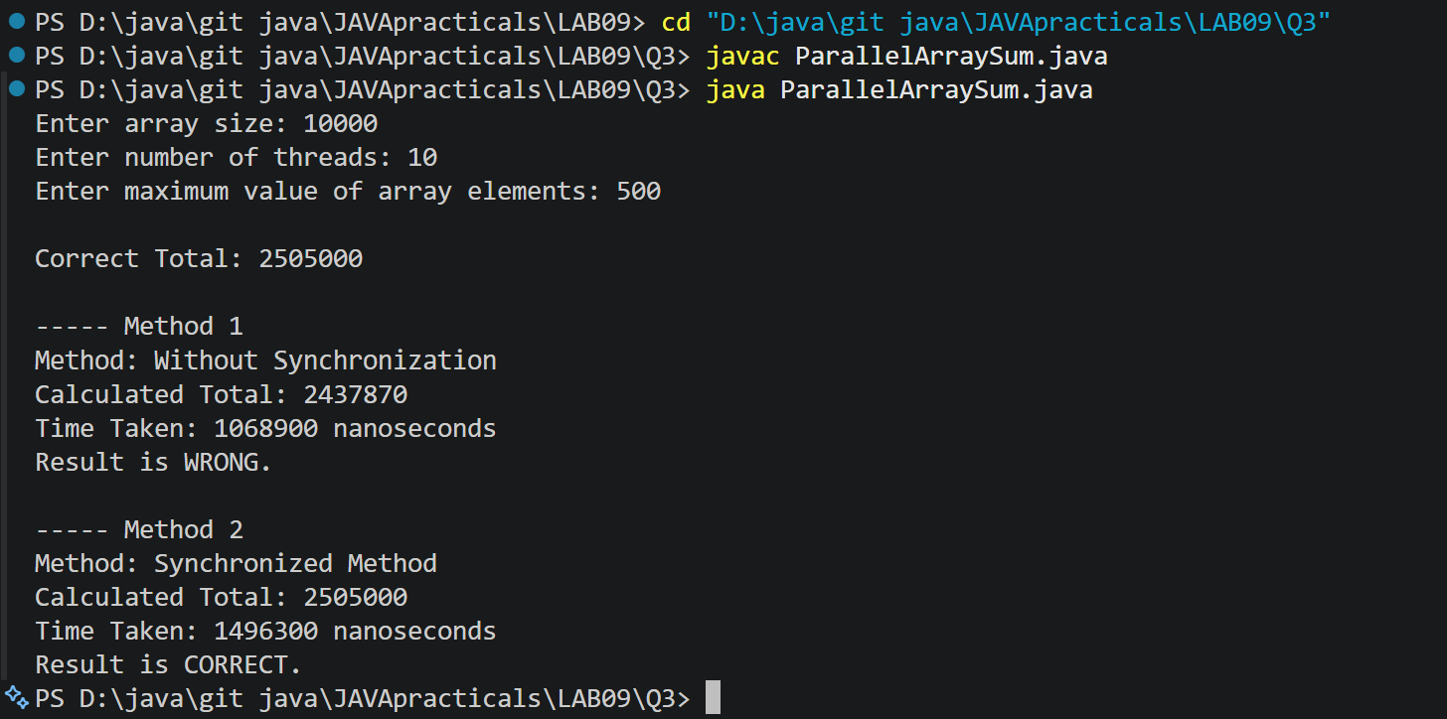
LEARNING OUTCOME:
- How to divide a large array among multiple threads.
- How multiple threads can perform calculations in parallel.
- What a shared resource is.
- How a race condition can produce an incorrect result.
- How synchronization can make a shared variable thread-safe.
- How local variables can reduce the need for synchronization.
- How to measure program execution time using System.nanoTime().
- How to compare different approaches based on correctness and performance.
- Why the fastest method is not always the safest method.
- How multithreading can improve performance for suitable tasks.
ccCSPIT - AIML | 13

