PRACTICAL - 10
Part A — Practice Programs (Hour 1)

PROBLEM1 | 1. Thread-pool runner: with a fixed pool of 3 (ExecutorService), submit about 10 Runnable  tasks that print their id and sleep briefly; shut down and await completion, observing the  few threads being reused.
CODE | import java.util.concurrent.ExecutorService;  import java.util.concurrent.Executors;  import java.util.concurrent.TimeUnit;  public class ThreadPoolRunner {  public static void main(String[] args) {  ExecutorService executor = Executors.newFixedThreadPool(3);  for (int i = 1; i <= 10; i++) {  final int taskId = i;  executor.execute(() -> {  System.out.println(  "Task " + taskId + " executed by "  + Thread.currentThread().getName()  );  try {  Thread.sleep(500);  } catch (InterruptedException e) {  Thread.currentThread().interrupt();  }  });  }  executor.shutdown();  try {  if (!executor.awaitTermination(30, TimeUnit.SECONDS)) {  executor.shutdownNow();  }  } catch (InterruptedException e) {  executor.shutdownNow();  Thread.currentThread().interrupt();  }  System.out.println("All tasks completed.");  }  }
OUTPUT | 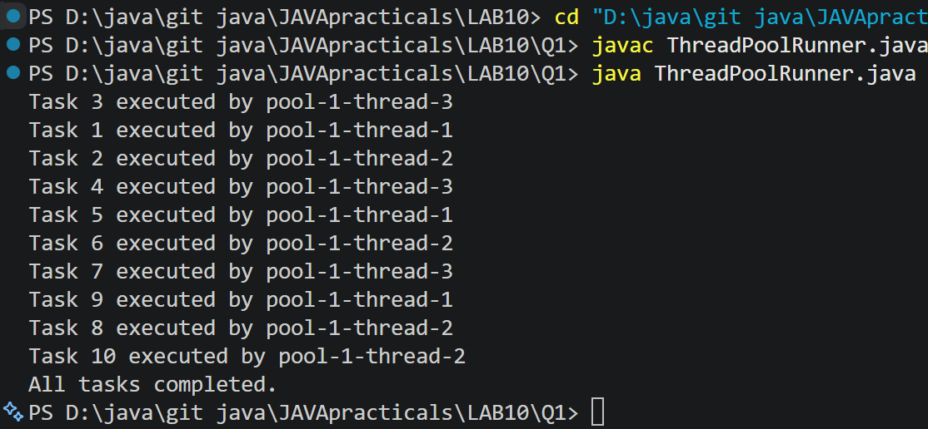
PROBLEM2 | 2Producer–consumer: one thread adds numbers to a small shared buffer and another  removes them, coordinated with wait()/notify(); produce and consume a fixed number of  items in order with none lost.
CODE | class SharedBuffer {  private final int[] buffer = new int[3];  private int count = 0;  private int in = 0;  private int out = 0;  public synchronized void produce(int value)  throws InterruptedException {  while (count == buffer.length) {  wait();  }  buffer[in] = value;  in = (in + 1) % buffer.length;  count++;  System.out.println("Produced: " + value);  notifyAll();  }  public synchronized int consume()  throws InterruptedException {  while (count == 0) {  wait();  }  int value = buffer[out];  out = (out + 1) % buffer.length;  count--;  System.out.println("Consumed: " + value);  notifyAll();  return value;  }  }  public class ProducerConsumer {  public static void main(String[] args)  throws InterruptedException {  SharedBuffer buffer = new SharedBuffer();  Thread producer = new Thread(() -> {  try {  for (int i = 1; i <= 10; i++) {  buffer.produce(i);  }  } catch (InterruptedException e) {  Thread.currentThread().interrupt();  }  });  Thread consumer = new Thread(() -> {  try {  for (int i = 1; i <= 10; i++) {  buffer.consume();  }  } catch (InterruptedException e) {  Thread.currentThread().interrupt();  }  });  producer.start();  consumer.start();  producer.join();  consumer.join();  System.out.println("Production and consumption completed.");  }  }
OUTPUT | 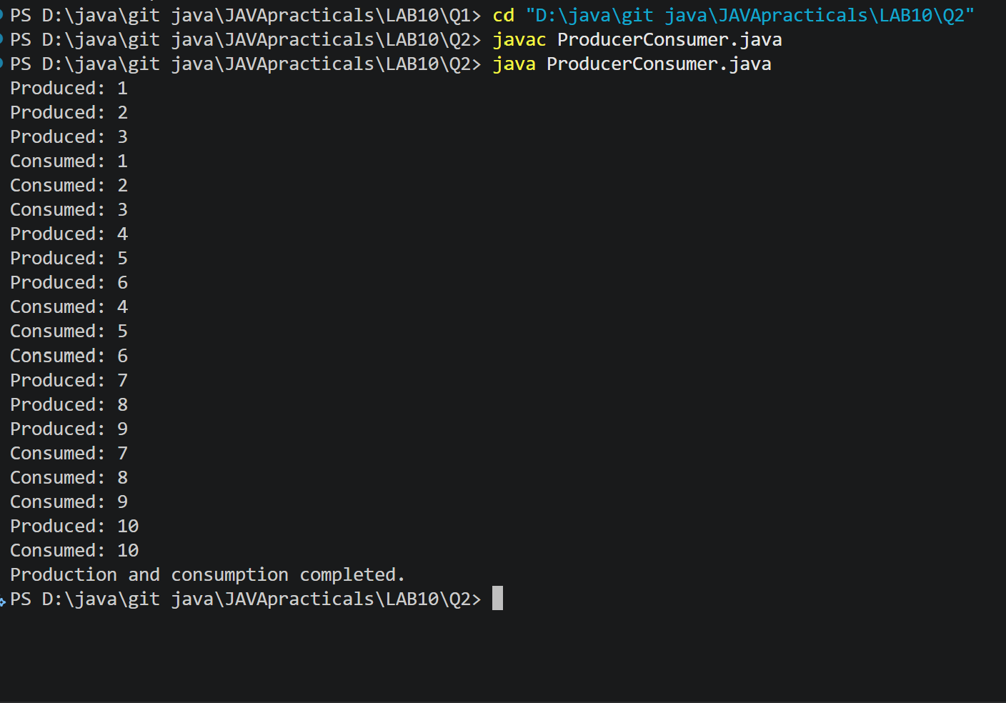
PROBLEM3 | 3. (For Advanced Learners – home) Reproduce a deadlock between two threads that lock  two objects in opposite order, then remove it with a consistent lock order. Choose the  scenario yourself.
CODE | public class DeadlockDemo {  static final Object lockA = new Object();  static final Object lockB = new Object();  public static void main(String[] args)  throws InterruptedException {  Thread t1 = new Thread(() -> {  synchronized (lockA) {  System.out.println("Thread 1 locked A");  try {  Thread.sleep(100);  } catch (InterruptedException e) {  Thread.currentThread().interrupt();  return;  }  synchronized (lockB) {  System.out.println("Thread 1 locked B");  }  }  });  Thread t2 = new Thread(() -> {  synchronized (lockB) {  System.out.println("Thread 2 locked B");  try {  Thread.sleep(100);  } catch (InterruptedException e) {  Thread.currentThread().interrupt();  return;  }  synchronized (lockA) {  System.out.println("Thread 2 locked A");  }  }  });  t1.start();  t2.start();  t1.join();  t2.join();  System.out.println("Program completed.");  }  }
OUTPUT | 

