PRACTICAL - 11

PROBLEM1 | 1. Save/load: make a small class Serializable, save an array of its objects to a file with  ObjectOutputStream, then read it back into fresh objects and confirm the values survived.  Mark one field transient and show it is not saved.
CODE | import java.io.*;  class Student implements Serializable {  int id;  String name;  transient String password;  Student(int id, String name, String password) {  this.id = id;  this.name = name;  this.password = password;  }  }  public class SerializationDemo {  public static void main(String[] args) {  try {  Student[] students = {  new Student(1, "Bhavya", "abc123"),  new Student(2, "Rahul", "xyz456")  };  // Save objects to file  ObjectOutputStream out =  new ObjectOutputStream(new FileOutputStream("student.dat"));  out.writeObject(students);  out.close();  // Read objects from file  ObjectInputStream in =  new ObjectInputStream(new FileInputStream("student.dat"));  Student[] loadedStudents = (Student[]) in.readObject();  in.close();  // Display loaded objects  for (Student s : loadedStudents) {  System.out.println("ID: " + s.id);  System.out.println("Name: " + s.name);  System.out.println("Password: " + s.password);  System.out.println();  }  } catch (Exception e) {  System.out.println(e);  }  }  }
OUTPUT | 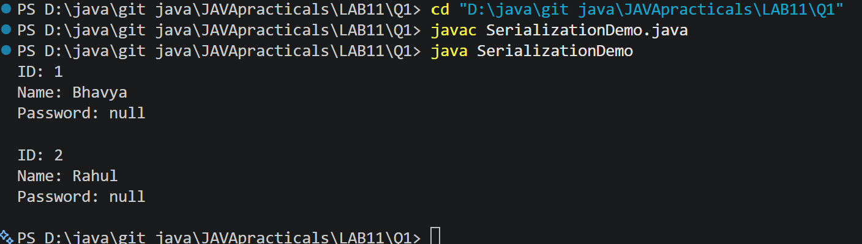
PROBLEM2 | 2. Log analyzer: create a few text files, then use Path/Files to read each line by line and  count the total lines and how many contain a keyword across all files; also print each  file’s size from its attributes.
CODE | import java.io.*;  import java.nio.file.*;  import java.nio.file.attribute.BasicFileAttributes;  import java.util.*;  public class LogAnalyzer {  public static void main(String[] args) {  try {  // Create sample text files  Files.write(Paths.get("log1.txt"), Arrays.asList(  "Application started",  "Error: File not found",  "User logged in"  ));  Files.write(Paths.get("log2.txt"), Arrays.asList(  "Connection successful",  "Error: Connection failed",  "Application closed"  ));  int totalLines = 0;  int keywordCount = 0;  String keyword = "Error";  String[] fileNames = {"log1.txt", "log2.txt"};  for (String fileName : fileNames) {  Path path = Paths.get(fileName);  // Read file line by line  List<String> lines = Files.readAllLines(path);  totalLines += lines.size();  for (String line : lines) {  if (line.contains(keyword)) {  keywordCount++;  }  }  // Get file attributes  BasicFileAttributes attr =  Files.readAttributes(path, BasicFileAttributes.class);  System.out.println("File: " + fileName);  System.out.println("Size: " + attr.size() + " bytes");  System.out.println();  }  System.out.println("Total lines: " + totalLines);  System.out.println("Lines containing '" + keyword +  "': " + keywordCount);  } catch (IOException e) {  System.out.println("Error: " + e.getMessage());  }  }  }
OUTPUT | 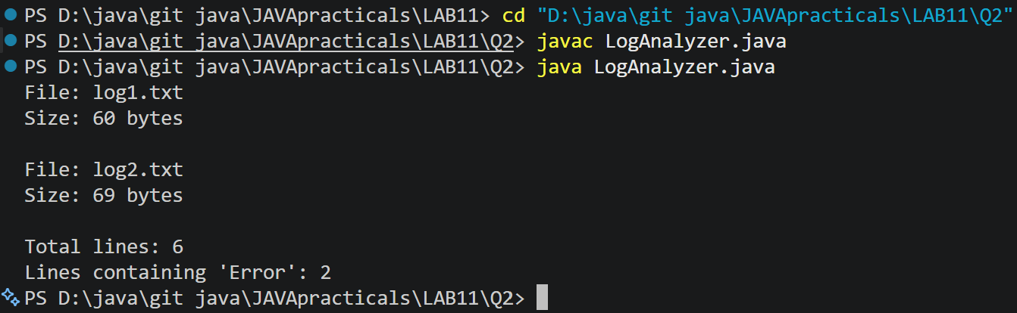
PROBLEM3 | 3. (For Advanced Learners – home) Walk a folder tree with NIO and produce a report of  the files it contains (name, size, modified time), writing the summary to a file; decide  what to include.
CODE | import java.io.*;  import java.nio.file.*;  import java.nio.file.attribute.BasicFileAttributes;  import java.time.Instant;  public class FolderTreeReport  {  public static void main(String[] args)  {  Path folder = Paths.get("sample");  Path report = Paths.get("report.txt");  try  {  // Create a sample folder and files  Files.createDirectories(folder.resolve("subfolder"));  Files.write(folder.resolve("file1.txt"),"Hello Java".getBytes());  Files.write(folder.resolve("subfolder/file2.txt"),"Java NIO".getBytes());  try (BufferedWriter writer =Files.newBufferedWriter(report))  {  writer.write("FOLDER TREE REPORT");  writer.newLine();  writer.write("------------------");  writer.newLine();  Files.walkFileTree(folder,new SimpleFileVisitor<Path>()  {  @Override  public FileVisitResult visitFile(Path file, BasicFileAttributes attrs)  throws IOException  {  writer.write("Name: " +folder.relativize(file));  writer.newLine();  writer.write("Size: " + attrs.size() + " bytes");  writer.newLine();  writer.write("Modified: " + Instant.ofEpochMilli(attrs.lastModifiedTime().toMillis()));  writer.newLine();  writer.newLine();  return FileVisitResult.CONTINUE;  }  }  );  }  System.out.println("Report created successfully!");  System.out.println("Report file: report.txt");  }  catch (IOException e)  {  System.out.println("Error: " + e.getMessage());  }  }  }
OUTPUT | 

