PRACTICAL - 12

PROBLEM1 | 1. Word frequency: split a paragraph into words, count each in a HashMap, and print the  words sorted by frequency (highest first) using a Comparator.
CODE | import java.util.*;  public class WordFrequency  {  public static void main(String[] args)  {  String paragraph = "java is easy and java is powerful";  String[] words = paragraph.toLowerCase().split("\\s+");  HashMap<String, Integer> map = new HashMap<>();  for (String word : words)  {  map.put(word, map.getOrDefault(word, 0) + 1);  }  List<String> list = new ArrayList<>(map.keySet());  Collections.sort(list, new Comparator<String>()  {  public int compare(String a, String b)  {  return map.get(b).compareTo(map.get(a));  }  }  );  System.out.println("Word Frequency:");  for (String word : list)  {  System.out.println(word + " : " + map.get(word));  }  }  }
OUTPUT | 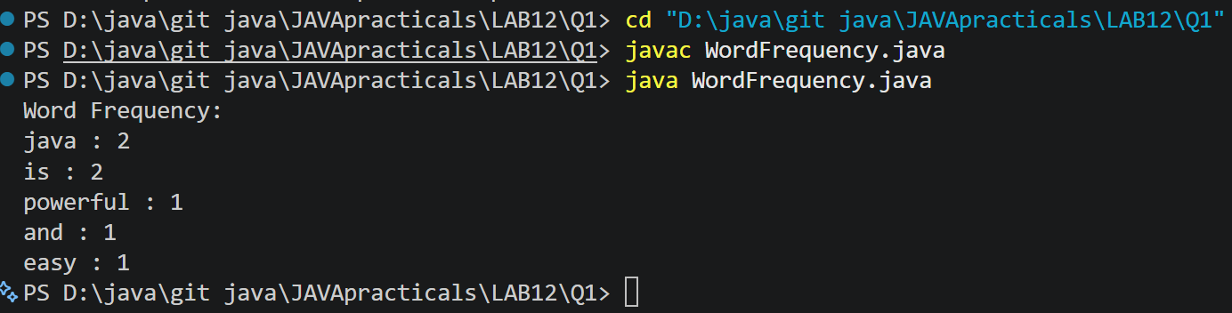
PROBLEM2 | 2. Unique visitors: from a list of login names with repeats, use a HashSet to count unique  users and a LinkedHashSet to keep first-seen order; print the unique count and the first  three distinct names.
CODE | import java.util.*;  public class UniqueVisitors  {  public static void main(String[] args)  {  String[] logins = {  "Bhavya", "Rahul", "Jay", "Bhavya",  "Het", "Rahul", "Fenil"  };  HashSet<String> uniqueUsers = new HashSet<>();  LinkedHashSet<String> orderedUsers = new LinkedHashSet<>();  for (String name : logins) {uniqueUsers.add(name);orderedUsers.add(name);}  System.out.println("Unique users count: " + uniqueUsers.size());  System.out.println("First three distinct users:");  int count = 0;  for (String name : orderedUsers)  {  if (count == 3)  {  break;  }  System.out.println(name);  count++;  }  }  }
OUTPUT | 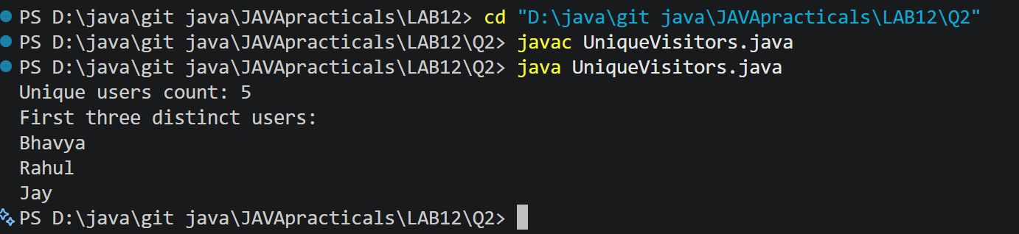
PROBLEM3 | 3. (For Advanced Learners – home) Build a leaderboard from player scores held in a Map  and print the top-N sorted by score (ties broken by name); choose the data and sorting  details.
CODE | import java.util.*;  public class Leaderboard  {  public static void main(String[] args)  {  Map<String, Integer> scores = new HashMap<>();  scores.put("Bhavya", 95);  scores.put("Rahul", 88);  scores.put("Jay", 95);  scores.put("Het", 78);  scores.put("Fenil", 88);  List<Map.Entry<String, Integer>> players =new ArrayList<>(scores.entrySet());  Collections.sort(players, new Comparator<Map.Entry<String, Integer>>()  {  public int compare(Map.Entry<String, Integer> p1,Map.Entry<String, Integer> p2)  {  int result = p2.getValue().compareTo(p1.getValue());  if (result == 0)  {  return p1.getKey().compareTo(p2.getKey());  }  return result;  }  }  );  int topN = 3;  System.out.println("Top " + topN + " Players:");  System.out.println("-------------------");  for (int i = 0; i < Math.min(topN, players.size()); i++)  {  Map.Entry<String, Integer> player = players.get(i);  System.out.println(player.getKey() + " - " + player.getValue());  }  }  }
OUTPUT | 

