PRACTICAL - 13

PROBLEM1 | Generic containers: a generic Box<T> with get/set and a Pair<A,B>; use them with different types to show type safety without casts, and write a generic method that returns the first element of any array.
CODE | class Box<T>  {  private T value;  void set(T value)  {  this.value = value;  }  T get()  {  return value;  }  }  class Pair<A, B>  {  private A first;  private B second;  Pair(A first, B second)  {  this.first = first;  this.second = second;  }  A getFirst()  {  return first;  }  B getSecond()  {  return second;  }  }  public class ContainerDemo  {  static <T> T first(T[] values)  {  if (values.length == 0)  {  throw new IllegalArgumentException("Empty array");  }  return values[0];  }  public static void main(String[] args)  {  Box<String> names = new Box<>();  names.set("Bhavya");  Box<Integer> marks = new Box<>();  marks.set(90);  Pair<String, Integer> pair =new Pair<>(names.get(), marks.get());  System.out.println(pair.getFirst() + " " + pair.getSecond());  System.out.println(first(new String[]{"Java", "Python"}));  System.out.println(first(new Integer[]{10, 20}));  }  }
OUTPUT | 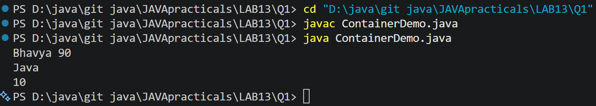
PROBLEM2 | Bounded stats: a generic method <N extends Number> double average(N[] values) that works for Integer[], Double[] and Long[]; note why it refuses non-Number types.
CODE | public class Stats  {  static <N extends Number> double average(N[] values)  {  if (values.length == 0)  {  throw new IllegalArgumentException("Empty array");  }  double sum = 0;  for (N n : values)  {  sum += n.doubleValue();  }  return sum / values.length;  }  public static void main(String[] args)  {  System.out.println(average(new Integer[]{10, 20, 30}));  System.out.println(average(new Double[]{1.5, 2.5}));  System.out.println(average(new Long[]{100L, 200L}));  }  }
OUTPUT | 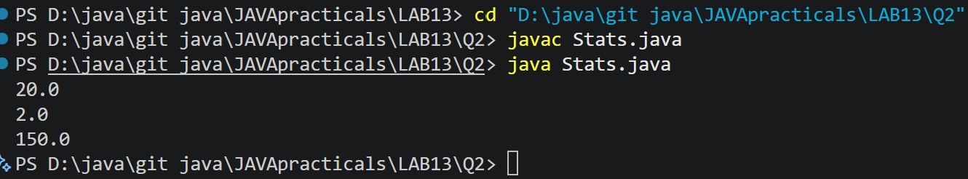
PROBLEM3 | (For Advanced Learners – home) Implement a small generic container of your choice (e.g. a stack) backed by an array, reuse it for two different types, and handle the empty case sensibly.
CODE | import java.util.EmptyStackException;  class Stack<T>  {  private Object[] data;  private int size;  Stack(int capacity)  {  data = new Object[capacity];  }  void push(T item)  {  if (size == data.length)  {  throw new IllegalStateException("Stack full");  }  data[size++] = item;  }  @SuppressWarnings("unchecked")  T pop()  {  if (size == 0)  {  throw new EmptyStackException();  }  T item = (T) data[--size];  data[size] = null;  return item;  }  }  public class StackDemo  {  public static void main(String[] args)  {  Stack<Integer> numbers = new Stack<>(3);  numbers.push(10);  numbers.push(20);  Stack<String> names = new Stack<>(2);  names.push("Bhavya");  System.out.println(numbers.pop());  System.out.println(names.pop());  try  {  names.pop();  }  catch (EmptyStackException e)  {  System.out.println("Stack empty");  }  }  }
OUTPUT | 

