PRACTICAL – 14

1) | Assemble and test: build a tiny layered app (a model, a service using an ArrayList, and a menu main), then write two or three JUnit @Test methods checking that adding increases the count and an invalid action throws — practice before testing MiniBank.
 | Item.java
CODE | public class Item {  private String name;  public Item(String name) {  this.name = name;  }  public String getName() {  return name;  }  }
 | ItemService.java
CODE | import java.util.ArrayList;  public class ItemService {  private ArrayList<Item> items = new ArrayList<>();  public void add(String name) {  if (name == null || name.isBlank()) {  throw new IllegalArgumentException("Name required");  }  items.add(new Item(name));  }  public int count() {  return items.size();  }  public ArrayList<Item> all() {  return new ArrayList<>(items);  }  public void invalidAction() {  throw new IllegalArgumentException("Invalid action");  }  }
 | ItemApp.java
CODE | import java.util.Scanner;  public class ItemApp {  public static void main(String[] args) {  ItemService service = new ItemService();  Scanner sc = new Scanner(System.in);  while (true) {  System.out.println("\n1. Add");  System.out.println("2. List");  System.out.println("3. Exit");  System.out.print("Enter choice: ");  String choice = sc.nextLine();  try {  switch (choice) {  case "1":  System.out.print("Enter item name: ");  service.add(sc.nextLine());  System.out.println("Item added successfully");  break;  case "2":  for (Item item : service.all()) {  System.out.println(item.getName());  }  break;  case "3":  System.out.println("Exiting...");  sc.close();  return;  default:  service.invalidAction();  }  } catch (IllegalArgumentException e) {  System.out.println(e.getMessage());  }  }  }  }
 | ItemServiceTest.java
CODE | import org.junit.jupiter.api.Test;  import static org.junit.jupiter.api.Assertions.*;  public class ItemServiceTest {  @Test  void addIncreasesCount() {  ItemService service = new ItemService();  service.add("Book");  assertEquals(1, service.count());  }  @Test  void blankNameThrowsException() {  ItemService service = new ItemService();  assertThrows(  IllegalArgumentException.class,  () -> service.add("")  );  }  @Test  void invalidActionThrowsException() {  ItemService service = new ItemService();  assertThrows(  IllegalArgumentException.class,  () -> service.invalidAction()  );  }  }
OUTPUT | 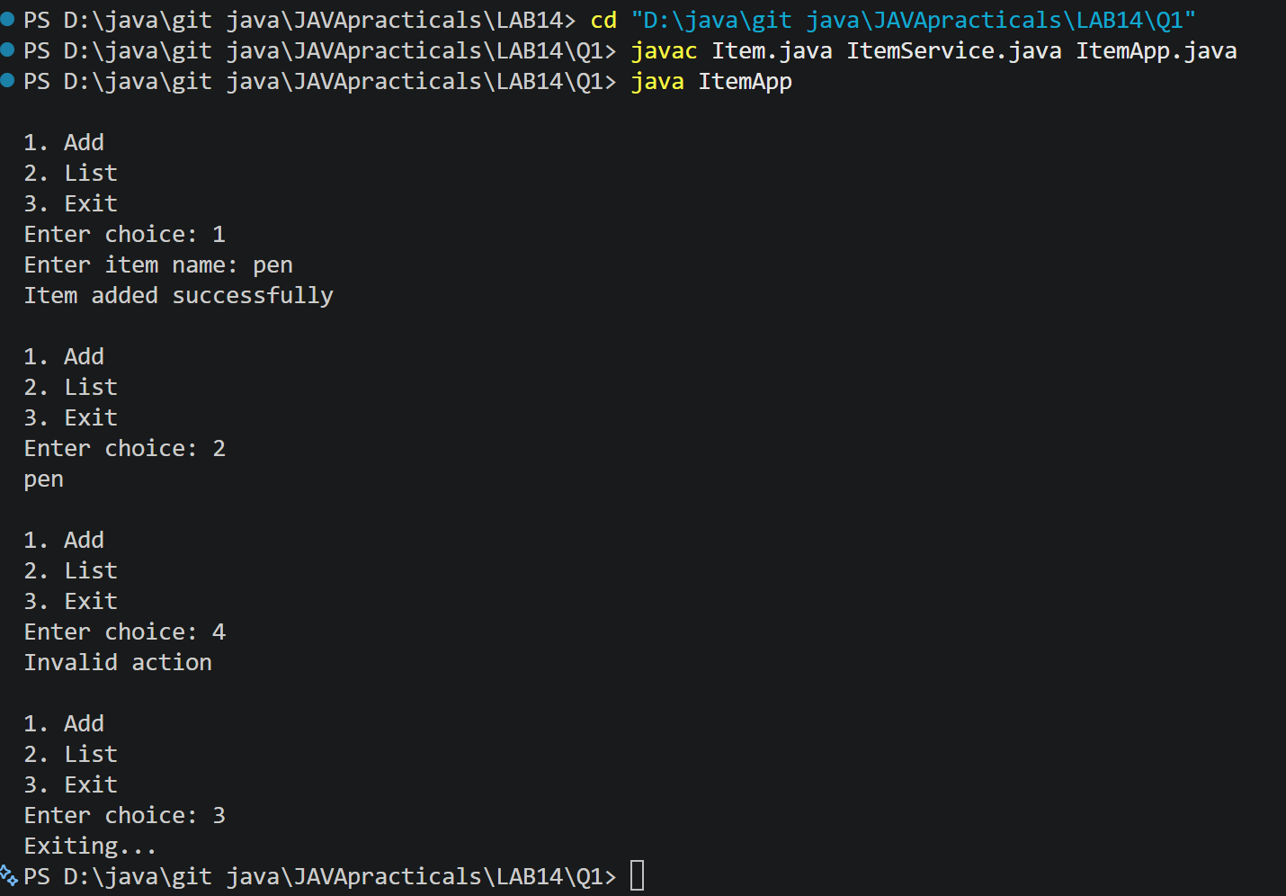
2) | (For Advanced Learners – home) Organise that app into packages, build a runnable JAR,  and add a test that saves and reloads its data unchanged.
 | Sec/model/Item.java
Code | package app.model;  import java.io.Serializable;  public class Item implements Serializable {  private static final long serialVersionUID = 1L;  private String name;  public Item(String name) {  this.name = name;  }  public String getName() {  return name;  }  @Override  public String toString() {  return name;  }  }
 | Src/service/ItemService.java
Code | package app.service;  import app.model.Item;  import java.io.*;  import java.nio.file.*;  import java.util.ArrayList;  import java.util.List;  public class ItemService {  private ArrayList<Item> items = new ArrayList<>();  public void add(String name) {  if (name == null || name.isBlank()) {  throw new IllegalArgumentException("Name required");  }  items.add(new Item(name));  }  public int count() {  return items.size();  }  public ArrayList<Item> all() {  return new ArrayList<>(items);  }  public void save(Path file) throws IOException {  try (ObjectOutputStream out = new ObjectOutputStream(  Files.newOutputStream(file))) {  out.writeObject(items);  }  }  @SuppressWarnings("unchecked")  public void load(Path file)  throws IOException, ClassNotFoundException {  try (ObjectInputStream in = new ObjectInputStream(  Files.newInputStream(file))) {  Object data = in.readObject();  if (!(data instanceof ArrayList<?>)) {  throw new IOException("Invalid data file");  }  ArrayList<?> loaded = (ArrayList<?>) data;  for (Object obj : loaded) {  if (!(obj instanceof Item)) {  throw new IOException("Invalid item data");  }  }  items = new ArrayList<>((List<Item>) loaded);  }  }  }
 | Src/app/ItemApp.java
Code | package app.main;  import app.model.Item;  import app.service.ItemService;  import java.nio.file.Path;  import java.nio.file.Paths;  import java.util.Scanner;  public class ItemApp {  public static void main(String[] args) {  ItemService service = new ItemService();  Path file = Paths.get("items.dat");  try {  if (java.nio.file.Files.exists(file)) {  service.load(file);  System.out.println("Data loaded successfully.");  }  } catch (Exception e) {  System.out.println("Could not load data: " + e.getMessage());  }  try (Scanner sc = new Scanner(System.in)) {  while (true) {  System.out.println("\n1. Add item");  System.out.println("2. List items");  System.out.println("3. Save data");  System.out.println("4. Exit");  System.out.print("Enter choice: ");  String choice = sc.nextLine();  try {  switch (choice) {  case "1":  System.out.print("Enter item name: ");  service.add(sc.nextLine());  System.out.println("Item added.");  break;  case "2":  for (Item item : service.all()) {  System.out.println(item.getName());  }  break;  case "3":  service.save(file);  System.out.println("Data saved successfully.");  break;  case "4":  System.out.println("Goodbye!");  return;  default:  System.out.println("Invalid choice.");  }  } catch (Exception e) {  System.out.println("Error: " + e.getMessage());  }  }  }  }  }
 | test/ItemServiceTest.java
Code | import app.model.Item;  import app.service.ItemService;  import org.junit.jupiter.api.Test;  import java.nio.file.Files;  import java.nio.file.Path;  import static org.junit.jupiter.api.Assertions.*;  public class ItemServiceTest {  @Test  void saveAndLoadPreservesData() throws Exception {  Path file = Files.createTempFile("items", ".dat");  try {  ItemService original = new ItemService();  original.add("Book");  original.add("Pen");  original.save(file);  ItemService restored = new ItemService();  restored.load(file);  assertEquals(original.count(), restored.count());  assertEquals("Book", restored.all().get(0).getName());  assertEquals("Pen", restored.all().get(1).getName());  } finally {  Files.deleteIfExists(file);  }  }  @Test  void addIncreasesCount() {  ItemService service = new ItemService();  service.add("Book");  assertEquals(1, service.count());  }  @Test  void blankNameThrowsException() {  ItemService service = new ItemService();  assertThrows(  IllegalArgumentException.class,  () -> service.add(" ")  );  }  }
Output | 

