PRACTICAL 1
Title: System call commands in Linux such as fork(), exec(), getpid, pipe, exit, open, close, stat, uname.
Step 1.1: Create file -> process.c
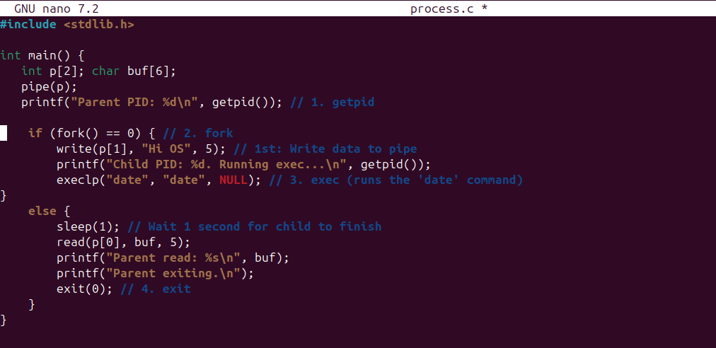
*ps write() command also featured in it..
Step 1.2: Demonstrate pipe(), fork(), getpid(), exec(), exit(), and write()
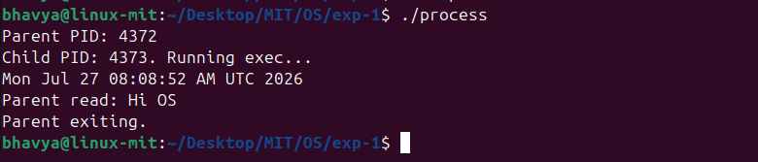
Step 2.1: Create file -> file.c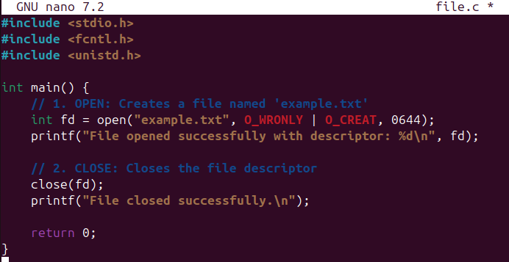
Step 2.2: Demonstrate open() and close()
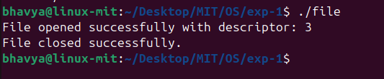
Step 3: Demonstrate stat and uname
