PRACTICAL 2
Title: Process related commands in Linux-top, ps, kill, wait, sleep, nice, renice, bg, fg
Step 1:
Created file -> process.c
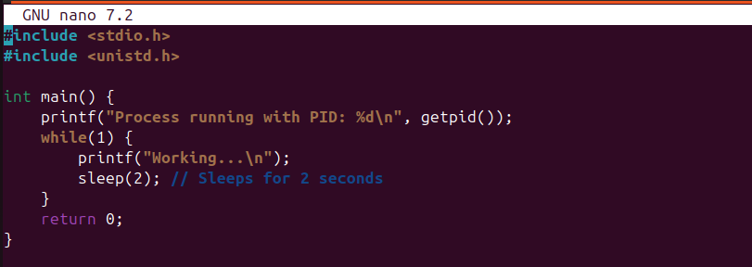
Step 2: Demonstrate sleep and ps
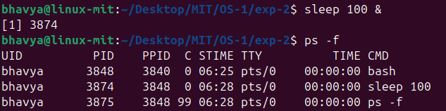
Step 3: Demonstrate top
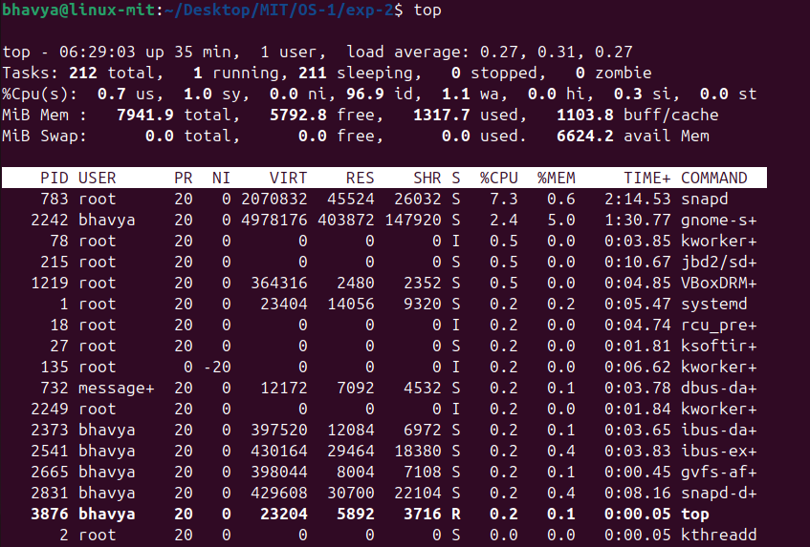
Press q to exit.

Step 4: Demonstrate bg (Background) and fg (Foreground)
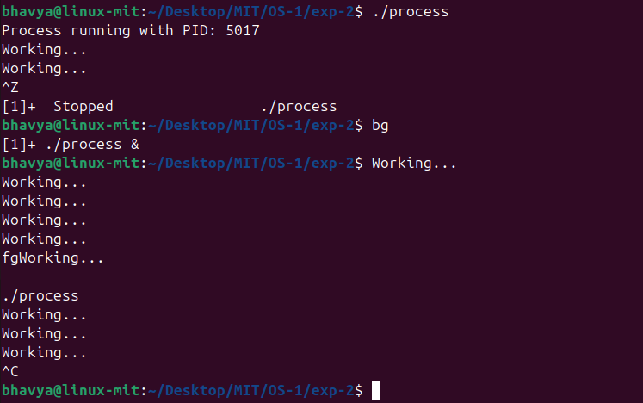
Step 5: Demonstrate nice and renice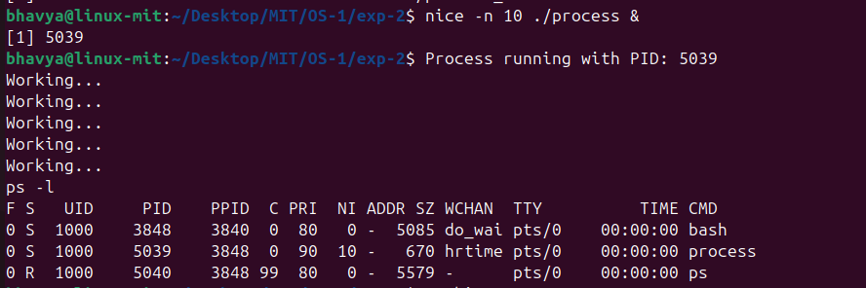
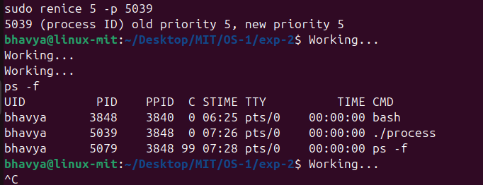
Step 6: Demonstrate kill and wait
