PRACTICAL 3
Title: a. Commands for Sending Messages to Logged-In Use who,cat,wall,write, mesg.
Step 1: cat
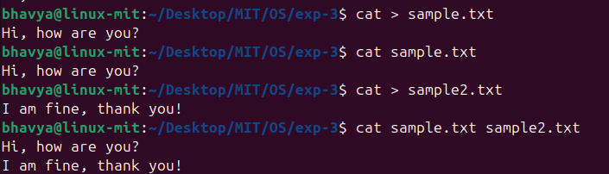
Step 2: mesg
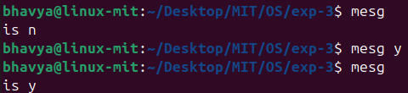
Step 3: who
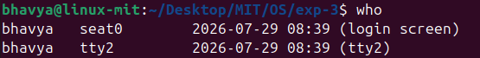
Step 4: wall
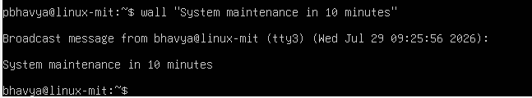
Step 5: write
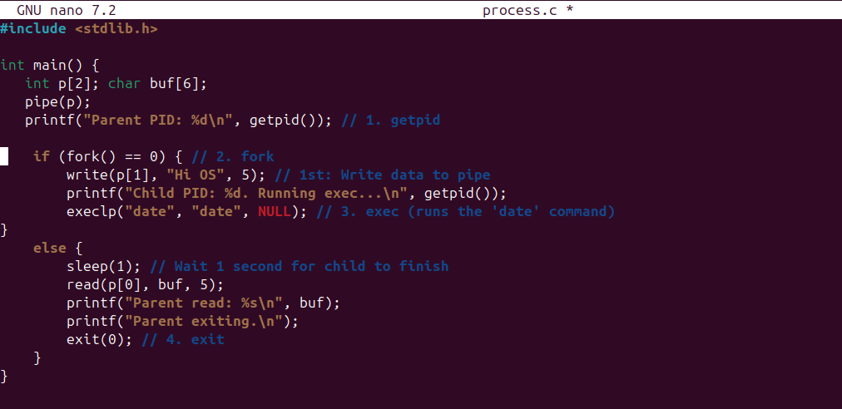
Output: 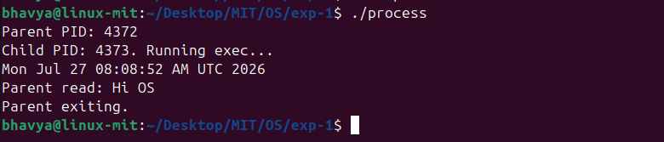

b. List Processes Attached to a Shared Memory Segment: ipcs.
