**Problem Statement**: **Deepfake Detection System**

**Problem Statement:**

With the rising prevalence of deepfake technology, there is an urgent need for effective systems that can detect and mitigate the impact of manipulated multimedia content. Deepfake videos and images can be used to spread misinformation, damage reputations, and manipulate public opinion. To address this issue, design and implement a Deepfake Detection System that can analyze multimedia content to identify and flag potential instances of deepfakes.

**Solution:**

1. **User Interface:**

- Develop a user-friendly web-based interface for users to upload multimedia content.

- Include clear instructions for users on how to submit videos or images for deepfake analysis.

2. **Deepfake Detection Algorithm:**

- Implement a robust deepfake detection algorithm that can analyze multimedia content for signs of manipulation.

- Explore machine learning techniques, such as neural networks, to train the system on a diverse dataset of authentic and manipulated content.

3. **Results Presentation:**

- Create an interface to display the results of the deepfake analysis.

- Clearly communicate whether the submitted content is likely to be authentic or if it shows signs of manipulation.

4. **Data Security:**

- Ensure the secure handling of user-submitted multimedia content to protect privacy.

- Implement measures to prevent unauthorized access to the uploaded content and analysis results.

5. **Scalability:**

- Design the system to handle a large volume of multimedia content submissions.

- Optimize the deepfake detection algorithm for efficiency and scalability.

6. **Deployment:**

- Provide detailed instructions for deploying the Deepfake Detection System in a production environment.

- Consider compatibility with cloud platforms for scalability and accessibility.

7. **Usability and Accessibility:**

- Ensure the system is user-friendly and accessible to users with varying levels of technical expertise.

- Implement features that enhance the overall user experience.

8. **Testing:**

- Conduct rigorous testing, including both positive and negative test cases, to evaluate the accuracy and reliability of the deepfake detection algorithm.

- Perform system testing to identify and address any potential issues or vulnerabilities.

9. **Documentation:**

- Document the architecture, components, and deployment process for future maintenance and improvements.

- Provide clear documentation on how the deepfake detection algorithm works for transparency.

**Software and Technology:**

1. **Programming Language:**

- Python: The primary programming language for developing the deepfake detection algorithm.

2. **Machine Learning Framework:**

- TensorFlow or PyTorch: Frameworks suitable for implementing machine learning models for deepfake detection.

3. **Web Framework (Optional):**

- Flask or Django: If a web-based user interface is required.

4. **Security Measures:**

- Implement encryption for secure data transmission and storage.

- Regularly update dependencies to address security vulnerabilities.

5. **Version Control (Optional):**

- Git: Use for tracking changes in the codebase and collaboration among team members.

6. **Testing:**

- Unit testing and integration testing frameworks such as pytest.

- Use diverse datasets for training and testing the deepfake detection model.

**Block Diagram for Deepfake Detection System:**

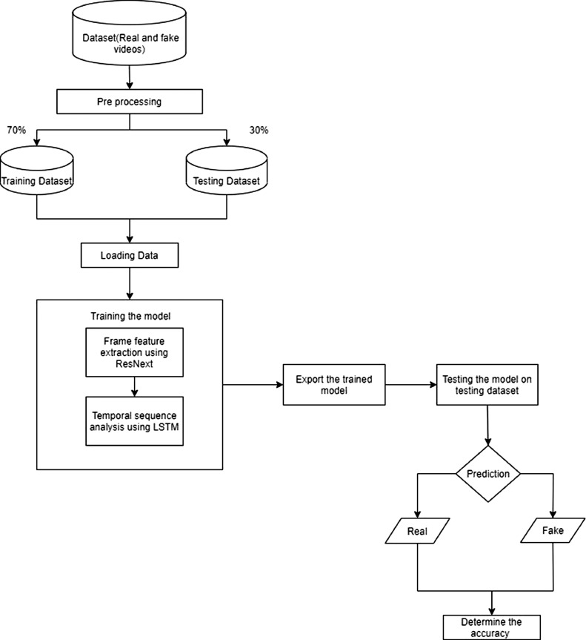

**Team Members:**

1. **Prince Tiwari**: Development and Algorithm Implementation

2. **Akhil Sharma**: Testing and Deployment

3. **Bhavya Saini**: Prototyping and User Interface

4. **Deepansu**: Documentation and User Instructions