WEEK 1 TASK
Risk Identification and Documentation
Virtual Construction Projects

Technical • Operational • Safety • Financial • Legal/Governance

Prepared as a professional preliminary risk register and research report

1. Executive Summary
Virtual construction management relies on Building Information Modeling (BIM), common data environments (CDEs), cloud collaboration, remote inspections, digital scheduling, and other connected technologies. These tools can improve coordination and visibility, but they also introduce or amplify risks involving information quality, interoperability, cybersecurity, connectivity, human factors, safety visibility, cost, schedule, third parties, and governance.
This Week 1 report identifies 12 preliminary risks and classifies them using a qualitative 5×5 likelihood–impact matrix. The register is intended for early project planning; scores should be validated with project-specific evidence, stakeholders, contracts, site conditions, and applicable regulations before being used as a formal project risk baseline.
Research reviewed for this report indicates that BIM and related digital technologies can support systematic construction risk management, while interoperability, infrastructure, cost, skills, and safety remain important implementation challenges. A 2020 review of BIM-based modular construction risk management documented 47 potential risks and emphasized schedule/cost risks while identifying gaps in safety and practical automated risk-management systems. A 2022 systematic review of immersive technology in architecture and construction identified infrastructure, interoperability, health and safety, cost, and skills among the critical challenges.
Key research sources: Darko et al. (2020); Prabhakaran et al. (2022); Zou et al. (2017).

2. Task Objective and Scope
- Identify potential risks that could affect the successful delivery of a construction project managed substantially through virtual/digital workflows.
- Cover technical, operational, safety, financial, legal, governance, and quality dimensions.
- Describe each risk, its causes, potential project impact, and preliminary mitigation strategy.
- Assign preliminary likelihood, impact/severity, and overall risk level using a consistent scoring method.
- Document the rationale so the register can be reviewed and refined by a project team.
Scope assumption: “Virtual construction” is treated broadly as construction delivery supported by BIM/CDE platforms, cloud collaboration, remote coordination, digital models, digital field information, and related technologies. Physical construction hazards remain in scope because virtual management affects how they are detected, communicated, and controlled.

3. Risk Identification and Classification Methodology
The identification process combined a focused review of publicly available construction/BIM risk-management literature with practical analysis of virtual project workflows. Risks were grouped by their dominant source, while recognizing that a single risk can affect multiple project objectives.
The workflow used is shown below:
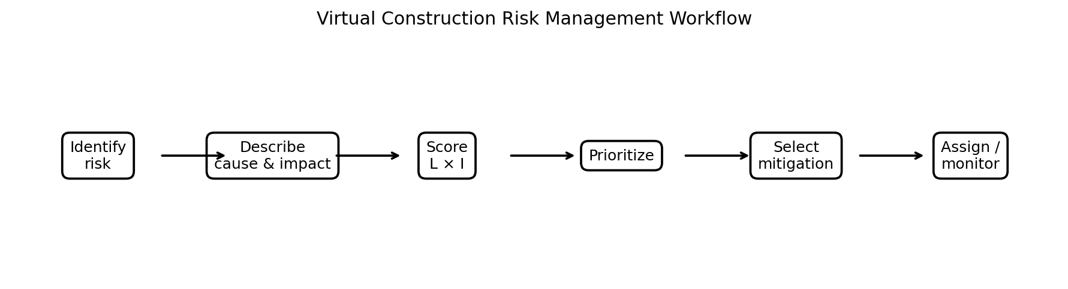

3.1 Likelihood and Impact Scoring
Each risk receives a preliminary Likelihood (L) and Impact/Severity (I) score from 1 to 5. The risk score is calculated as Risk Score = L × I. The resulting score is used to prioritize attention; it is not a substitute for detailed quantitative analysis.
Score | Likelihood | Meaning
1 | Rare | Unlikely to occur during the project
2 | Unlikely | Could occur, but not expected in normal conditions
3 | Possible | May occur during the project
4 | Likely | Expected to occur at least once without strong controls
5 | Almost certain | Very likely or recurring without controls

Score | Impact / Severity | Meaning
1 | Minor | Small disruption; easily recoverable
2 | Moderate | Limited cost/time/quality effect
3 | Significant | Noticeable effect requiring management action
4 | Major | Serious cost, schedule, quality, safety, or contractual effect
5 | Severe | Potential for major loss, serious harm, critical disruption, or severe non-compliance

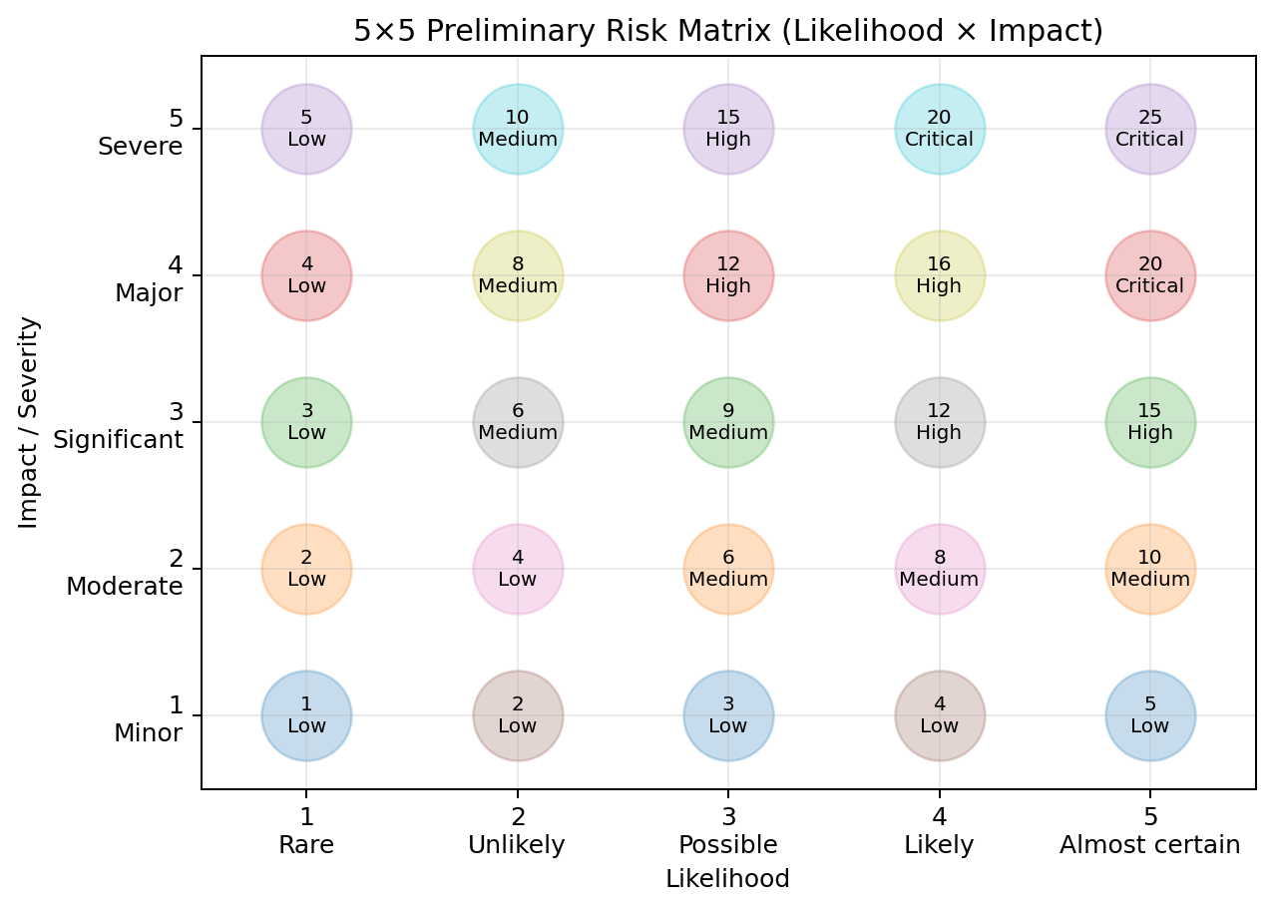
Risk-level interpretation used in this report: 20–25 = Critical; 12–19 = High; 6–11 = Medium; 1–5 = Low. This is a preliminary qualitative scheme adapted from standard likelihood–impact construction risk-matrix practice.

4. Preliminary Risk Register – Summary
ID | Risk | Category | L | I | Score | Level | Primary objective affected
R01 | BIM/model interoperability failure | Technical | 4 | 4 | 16 | High | Quality / time / cost
R02 | Cybersecurity attack or unauthorized access | Technical | 3 | 5 | 15 | High | Security / continuity
R03 | Poor data quality / version-control failure | Technical / Operational | 4 | 4 | 16 | High | Quality / decision-making
R04 | Network/connectivity and cloud-service outage | Technical / Operational | 4 | 4 | 16 | High | Time / continuity
R05 | Communication and coordination breakdown | Operational | 4 | 4 | 16 | High | Time / coordination
R06 | Insufficient digital skills / resistance to technology | Operational | 4 | 3 | 12 | High | Productivity / quality
R07 | Remote inspection / safety-visibility limitations | Safety / Operational | 3 | 5 | 15 | High | Safety
R08 | Design/model error leading to rework | Technical / Quality | 3 | 5 | 15 | High | Quality / time / cost
R09 | Cost overrun / inaccurate digital estimating | Financial | 3 | 5 | 15 | High | Cost / commercial
R10 | Schedule delay and dependency failure | Operational / Financial | 4 | 4 | 16 | High | Time / cost
R11 | Third-party/vendor and platform dependency | Operational / Financial | 3 | 4 | 12 | High | Continuity / cost
R12 | Privacy, contractual and regulatory non-compliance | Legal / Governance | 3 | 4 | 12 | High | Compliance / reputation

5. Detailed Risk Identification and Preliminary Mitigation

R01 – BIM/model interoperability failure
Category: Technical | Likelihood: 4 | Impact: 4 | Score: 16 | Level: High
Description: Different design and construction platforms may not exchange models or metadata reliably, creating missing, duplicated, or misinterpreted information.
Potential causes: Different software versions; incompatible file formats; poor IFC/export settings; weak information standards; inconsistent object naming.
Potential impact: Clashes or design errors may survive coordination, causing rework, delays, and cost growth.
Preliminary mitigation: Define BIM execution/information requirements; use common data environment (CDE); establish exchange standards; perform scheduled model federation and clash checks; validate exports before issue.
Categorization rationale: The 4/5 likelihood rating reflects the extent to which this issue can reasonably arise in a digitally connected construction workflow; the 4/5 impact rating reflects its potential effect on project objectives. Because the resulting score is 16, the preliminary priority is High.

R02 – Cybersecurity attack or unauthorized access
Category: Technical | Likelihood: 3 | Impact: 5 | Score: 15 | Level: High
Description: Virtual projects concentrate drawings, models, contracts, schedules, and commercial information in connected digital platforms that may be targeted or misused.
Potential causes: Weak passwords; excessive permissions; phishing; unpatched systems; insecure file sharing; third-party access.
Potential impact: Data loss or theft, project disruption, confidentiality breaches, reputational damage, and possible contractual/legal consequences.
Preliminary mitigation: Role-based access; multi-factor authentication; encryption; least-privilege permissions; patching; backups; security awareness; incident-response plan; vendor security checks.
Categorization rationale: The 3/5 likelihood rating reflects the extent to which this issue can reasonably arise in a digitally connected construction workflow; the 5/5 impact rating reflects its potential effect on project objectives. Because the resulting score is 15, the preliminary priority is High.

R03 – Poor data quality / version-control failure
Category: Technical / Operational | Likelihood: 4 | Impact: 4 | Score: 16 | Level: High
Description: Teams may work from outdated, incomplete, duplicated, or incorrectly approved information.
Potential causes: Multiple uncontrolled file locations; unclear naming; manual updates; weak approval workflows; delayed synchronization.
Potential impact: Incorrect decisions, rework, procurement errors, field confusion, and schedule disruption.
Preliminary mitigation: Use one controlled CDE; define status codes and naming conventions; maintain revision history; approval gates; automated notifications; periodic data audits.
Categorization rationale: The 4/5 likelihood rating reflects the extent to which this issue can reasonably arise in a digitally connected construction workflow; the 4/5 impact rating reflects its potential effect on project objectives. Because the resulting score is 16, the preliminary priority is High.

R04 – Network/connectivity and cloud-service outage
Category: Technical / Operational | Likelihood: 4 | Impact: 4 | Score: 16 | Level: High
Description: Virtual coordination depends on reliable internet, cloud applications, video conferencing, and remote access.
Potential causes: Internet outages; server downtime; bandwidth limits; regional service disruption; equipment failure.
Potential impact: Meetings, model access, approvals, and remote inspections may stop or be delayed.
Preliminary mitigation: Redundant internet connections; offline copies where appropriate; service-level agreements; outage procedures; backup communication channels; tested business-continuity plan.
Categorization rationale: The 4/5 likelihood rating reflects the extent to which this issue can reasonably arise in a digitally connected construction workflow; the 4/5 impact rating reflects its potential effect on project objectives. Because the resulting score is 16, the preliminary priority is High.

R05 – Communication and coordination breakdown
Category: Operational | Likelihood: 4 | Impact: 4 | Score: 16 | Level: High
Description: Distributed teams can misunderstand instructions, responsibilities, design changes, or decisions when communication is fragmented.
Potential causes: Time-zone differences; unclear roles; excessive channels; poor meeting discipline; incomplete action tracking.
Potential impact: Late decisions, conflicting work, missed approvals, rework, disputes, and schedule delays.
Preliminary mitigation: RACI/responsibility matrix; structured meeting agenda/minutes; action register; single source of truth; escalation rules; defined response times.
Categorization rationale: The 4/5 likelihood rating reflects the extent to which this issue can reasonably arise in a digitally connected construction workflow; the 4/5 impact rating reflects its potential effect on project objectives. Because the resulting score is 16, the preliminary priority is High.

R06 – Insufficient digital skills / resistance to technology
Category: Operational | Likelihood: 4 | Impact: 3 | Score: 12 | Level: High
Description: Project participants may lack the skills or willingness to use BIM, CDE, digital field tools, VR/AR, or analytics consistently.
Potential causes: Limited training; high staff turnover; change resistance; different competency levels across organizations.
Potential impact: Incorrect data entry, low adoption, duplicated manual work, slow workflows, and reduced benefits from digital systems.
Preliminary mitigation: Competency assessment; role-based training; onboarding; super-users; simple procedures; refresher sessions; adoption KPIs and feedback.
Categorization rationale: The 4/5 likelihood rating reflects the extent to which this issue can reasonably arise in a digitally connected construction workflow; the 3/5 impact rating reflects its potential effect on project objectives. Because the resulting score is 12, the preliminary priority is High.

R07 – Remote inspection / safety-visibility limitations
Category: Safety / Operational | Likelihood: 3 | Impact: 5 | Score: 15 | Level: High
Description: Virtual reviews may not fully capture physical site hazards, changing conditions, or worker behavior that an in-person inspection would reveal.
Potential causes: Camera blind spots; poor image quality; delayed reporting; reliance on self-reporting; rapidly changing site conditions.
Potential impact: Hazards can remain unidentified, increasing the probability of injury, property damage, or unsafe work.
Preliminary mitigation: Combine virtual monitoring with planned physical inspections; use 360°/wearable cameras where suitable; maintain hazard registers; verify critical controls onsite; escalate serious observations immediately.
Categorization rationale: The 3/5 likelihood rating reflects the extent to which this issue can reasonably arise in a digitally connected construction workflow; the 5/5 impact rating reflects its potential effect on project objectives. Because the resulting score is 15, the preliminary priority is High.

R08 – Design/model error leading to rework
Category: Technical / Quality | Likelihood: 3 | Impact: 5 | Score: 15 | Level: High
Description: Errors in digital models, assumptions, or coordination can propagate into procurement and construction.
Potential causes: Incorrect dimensions; incomplete discipline coordination; unverified changes; modeling errors; inadequate constructability review.
Potential impact: Rework, material waste, schedule delay, quality defects, and additional cost.
Preliminary mitigation: Independent model checks; multidisciplinary coordination; constructability reviews; design freeze points; automated rule checking where feasible; field verification for critical dimensions.
Categorization rationale: The 3/5 likelihood rating reflects the extent to which this issue can reasonably arise in a digitally connected construction workflow; the 5/5 impact rating reflects its potential effect on project objectives. Because the resulting score is 15, the preliminary priority is High.

R09 – Cost overrun / inaccurate digital estimating
Category: Financial | Likelihood: 3 | Impact: 5 | Score: 15 | Level: High
Description: Virtual estimating can become unreliable if model quantities, rates, scope changes, or assumptions are incomplete or outdated.
Potential causes: Incomplete model quantities; price volatility; scope creep; inconsistent cost codes; delayed updates.
Potential impact: Budget overrun, cash-flow pressure, procurement changes, and commercial disputes.
Preliminary mitigation: Link model objects to cost structures; establish estimate baselines; update cost plans at defined gates; contingency allowances; change-control board; independent estimate reviews.
Categorization rationale: The 3/5 likelihood rating reflects the extent to which this issue can reasonably arise in a digitally connected construction workflow; the 5/5 impact rating reflects its potential effect on project objectives. Because the resulting score is 15, the preliminary priority is High.

R10 – Schedule delay and dependency failure
Category: Operational / Financial | Likelihood: 4 | Impact: 4 | Score: 16 | Level: High
Description: Virtual projects contain many linked design, approval, procurement, logistics, and site activities; delays in one can cascade.
Potential causes: Late information; approval bottlenecks; unreliable dependencies; supplier delays; poor coordination of remote teams.
Potential impact: Milestone slippage, extended overheads, liquidated damages exposure, and client dissatisfaction.
Preliminary mitigation: Integrated master schedule; dependency mapping; weekly look-ahead; critical-path monitoring; early-warning indicators; recovery plans; clear approval SLAs.
Categorization rationale: The 4/5 likelihood rating reflects the extent to which this issue can reasonably arise in a digitally connected construction workflow; the 4/5 impact rating reflects its potential effect on project objectives. Because the resulting score is 16, the preliminary priority is High.

R11 – Third-party/vendor and platform dependency
Category: Operational / Financial | Likelihood: 3 | Impact: 4 | Score: 12 | Level: High
Description: Virtual delivery may depend on cloud vendors, software suppliers, specialist consultants, and external data services.
Potential causes: Vendor lock-in; supplier failure; licensing changes; platform incompatibility; limited support.
Potential impact: Service interruption, unexpected costs, data migration problems, and loss of continuity.
Preliminary mitigation: Due diligence; contractual SLAs; data portability requirements; exit plans; backup suppliers; documented interfaces; regular vendor performance reviews.
Categorization rationale: The 3/5 likelihood rating reflects the extent to which this issue can reasonably arise in a digitally connected construction workflow; the 4/5 impact rating reflects its potential effect on project objectives. Because the resulting score is 12, the preliminary priority is High.

R12 – Privacy, contractual and regulatory non-compliance
Category: Legal / Governance | Likelihood: 3 | Impact: 4 | Score: 12 | Level: High
Description: Remote collaboration can involve personal data, surveillance imagery, proprietary models, and cross-border information transfers.
Potential causes: Unclear data ownership; excessive data collection; weak retention rules; inappropriate sharing; unclear contractual responsibilities.
Potential impact: Fines, claims, disputes, loss of trust, forced remediation, and project disruption.
Preliminary mitigation: Data-classification policy; privacy-by-design; retention/deletion rules; contract clauses for ownership and permitted use; access logs; compliance reviews.
Categorization rationale: The 3/5 likelihood rating reflects the extent to which this issue can reasonably arise in a digitally connected construction workflow; the 4/5 impact rating reflects its potential effect on project objectives. Because the resulting score is 12, the preliminary priority is High.

6. Cross-Risk Analysis and Priority Themes
The register shows that the highest-priority exposures are not limited to software. Virtual construction creates dependencies between digital information, people, physical site activities, commercial decisions, and external platforms.
- Information integrity is foundational: interoperability, version control, and model quality can directly affect design, procurement, construction, and cost.
- Cybersecurity and privacy require governance in addition to technical controls because project information can have commercial, personal, and contractual sensitivity.
- Virtual communication must be structured. A CDE, responsibility matrix, action register, approval workflow, and escalation path reduce ambiguity.
- Safety cannot be treated as fully virtual. Digital monitoring should supplement, not automatically replace, appropriate physical inspections and verification of critical controls.
- Financial and schedule risks can propagate from information problems: a late or incorrect digital deliverable can trigger procurement changes, rework, and downstream delay.
- Skills and change management are enabling controls. Even strong technology can produce weak outcomes if users do not understand the workflow or do not adopt it consistently.

6.1 Recommended Priority Actions for Week 2
- Confirm the project’s digital delivery strategy, BIM/CDE requirements, and information ownership.
- Validate the 12 risks with project stakeholders and add project-specific risks, triggers, existing controls, and risk owners.
- Establish a formal 5×5 risk matrix and agree escalation thresholds.
- Perform an information-flow and interoperability test across the main design, CDE, scheduling, estimating, and field platforms.
- Complete a cybersecurity/privacy review covering identities, permissions, sharing, backups, suppliers, and incident response.
- Define remote-inspection boundaries and identify activities requiring physical verification.
- Create measurable early-warning indicators for schedule, cost, data quality, connectivity, and adoption.

7. Risk Monitoring and Documentation Plan
Control area | Indicator | Review frequency | Responsible role | Escalation trigger
Data quality | Open data issues, outdated revisions, unresolved clashes | Weekly | BIM / Information Manager | Critical model/data issue unresolved past agreed SLA
Cybersecurity | Access exceptions, incidents, patch status | Monthly + incident-based | IT/Security Lead | Suspected breach or unauthorized access
Connectivity | Outage minutes, failed remote sessions | Weekly | Digital Delivery Lead | Repeated outage affecting critical path
Coordination | Open actions and overdue approvals | Weekly | Project Manager | Critical decision/action overdue
Safety visibility | Remote observations, verified critical controls | Daily/weekly as applicable | HSE Lead | Any serious uncontrolled hazard
Cost | Forecast variance, approved changes, estimate confidence | Monthly | Commercial Manager | Forecast exceeds contingency threshold
Schedule | Critical-path variance, late information | Weekly | Planner | Milestone threatened

8. Conclusion
Effective risk management in virtual construction requires more than identifying technology failures. The project team must manage the interaction between digital information, people, processes, physical construction, commercial controls, and external service providers. The 12 risks documented in this report provide a practical starting register. The preliminary scoring identifies the risks that should receive early management attention, while the proposed mitigations provide a first layer of controls. The register should be treated as a living document and updated as project design, procurement, construction, technology, and stakeholder conditions change.

9. References and Research Basis
- Darko, A., Chan, A. P. C., Yang, Y., & Tetteh, M. O. (2020). Building information modeling (BIM)-based modular integrated construction risk management – Critical survey and future needs. Computers in Industry, 123, 103327. https://doi.org/10.1016/j.compind.2020.103327
- Prabhakaran, A., Mahamadu, A.-M., & Mahdjoubi, L. (2022). Understanding the challenges of immersive technology use in the architecture and construction industry: A systematic review. Automation in Construction, 137, 104228. https://doi.org/10.1016/j.autcon.2022.104228
- Zou, Y., Kiviniemi, A., & Jones, S. W. (2017). A review of risk management through BIM and BIM-related technologies. Safety Science, 97, 88–98. https://doi.org/10.1016/j.ssci.2015.12.027
- Construction risk-management guidance reviewed for the likelihood–impact approach: Risk matrix concepts using probability/likelihood and impact/severity to prioritize construction risks.
- Additional current context: recent research on BIM, information management, interoperability, security, and digital workflows was used to cross-check the risk themes.

Appendix A – Risk Register Template for Project Continuation
Use this template to convert the preliminary register into a live project control document.
ID | Risk event | Cause | Existing controls | L | I | Score | Owner | Treatment/action | Status
R01 | BIM/model interoperability failure | Different software versions; incompatible file formats; poor IFC/export settings; weak information standards; inconsistent object naming. | To be validated | 4 | 4 | 16 | To assign | Define BIM execution/information requirements; use common data environment (CDE); establish exchange standards; perform scheduled model federation and clash checks; validate exports before issue. | Open
R02 | Cybersecurity attack or unauthorized access | Weak passwords; excessive permissions; phishing; unpatched systems; insecure file sharing; third-party access. | To be validated | 3 | 5 | 15 | To assign | Role-based access; multi-factor authentication; encryption; least-privilege permissions; patching; backups; security awareness; incident-response plan; vendor security checks. | Open
R03 | Poor data quality / version-control failure | Multiple uncontrolled file locations; unclear naming; manual updates; weak approval workflows; delayed synchronization. | To be validated | 4 | 4 | 16 | To assign | Use one controlled CDE; define status codes and naming conventions; maintain revision history; approval gates; automated notifications; periodic data audits. | Open
R04 | Network/connectivity and cloud-service outage | Internet outages; server downtime; bandwidth limits; regional service disruption; equipment failure. | To be validated | 4 | 4 | 16 | To assign | Redundant internet connections; offline copies where appropriate; service-level agreements; outage procedures; backup communication channels; tested business-continuity plan. | Open
R05 | Communication and coordination breakdown | Time-zone differences; unclear roles; excessive channels; poor meeting discipline; incomplete action tracking. | To be validated | 4 | 4 | 16 | To assign | RACI/responsibility matrix; structured meeting agenda/minutes; action register; single source of truth; escalation rules; defined response times. | Open

