**1. Create HOCList component that display ProductList, EmployeeList using boostrap table.**

import React from 'react';

import 'bootstrap/dist/css/bootstrap.min.css';

// Higher-Order Component (HOC) to render a list in a Bootstrap table

const HOCList = ({ title, items, columns }) => {

  return (

    <div className="container mt-4">

      <h2>{title}</h2>

      <table className="table table-bordered">

        <thead>

          <tr>

            {columns.map((column, index) => (

              <th key={index}>{column}</th>

            ))}

          </tr>

        </thead>

        <tbody>

          {items.map((item, index) => (

            <tr key={index}>

              {columns.map((column, index) => (

                <td key={index}>{item[column]}</td>

              ))}

            </tr>

          ))}

        </tbody>

      </table>

    </div>

  );

};

// Main App Component

const App = () => {

  // Product List Data

  const productList = [

    { id: 1, name: 'Laptop', price: 120000 },

    { id: 2, name: 'Smartphone', price: 8000 },

    { id: 3, name: 'Tablet', price: 5000 },

  ];

  // Employee List Data

  const employeeList = [

    { id: 1, name: 'Bhavyasri', position: 'Developer' },

    { id: 2, name: 'Poojitha', position: 'Designer' },

    { id: 3, name: 'Akanksha', position: 'Manager' },

    { id: 4, name: 'Farha', position: 'Manager' },

  ];

  return (

    <div>

      <HOCList

        title="Product List"

        items={productList}

        columns={['id', 'name', 'price']}

      />

      <HOCList

        title="Employee List"

        items={employeeList}

        columns={['id', 'name', 'position']}

      />

    </div> );};

export default App;

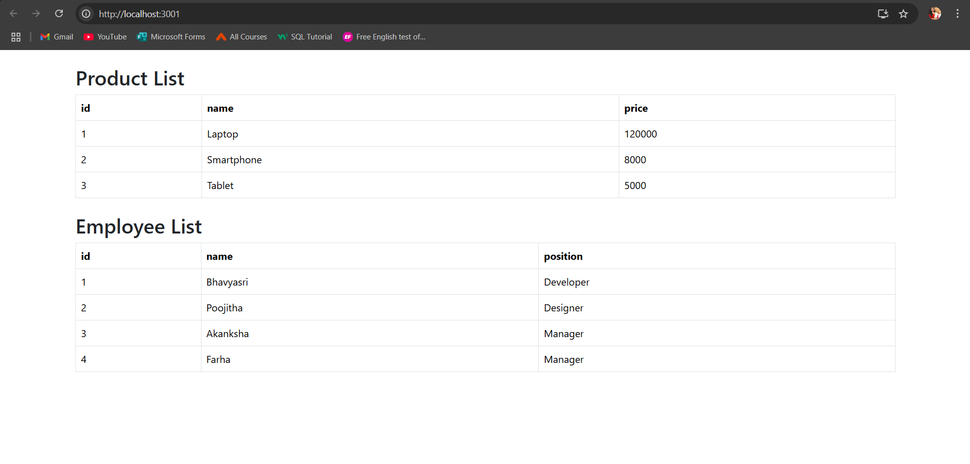

**2. Create ProductComponent using FetchAPi to display product details in tabular format.**

import React, { useState, useEffect } from 'react';

import 'bootstrap/dist/css/bootstrap.min.css';

const App = () => {

  const [products, setProducts] = useState([]); // State to store product data

  const [loading, setLoading] = useState(true); // State to handle loading

  const [error, setError] = useState(null); // State to handle errors

  // Fetch data from JSONPlaceholder API

  useEffect(() => {

    fetch('https://jsonplaceholder.typicode.com/posts')

      .then((response) => {

        if (!response.ok) {

          throw new Error('Network response was not ok');

        }

        return response.json();

      })

      .then((data) => {

        setProducts(data); // Set the fetched data to state

        setLoading(false); // Set loading to false

      })

      .catch((error) => {

        setError(error.message); // Set error message

        setLoading(false); // Set loading to false

      });

  }, []);

  // Display loading message while data is being fetched

  if (loading) {

    return <div className="text-center mt-4">Loading...</div>;

  }

  // Display error message if there is an error

  if (error) {

    return <div className="text-center mt-4 text-danger">Error: {error}</div>;

  }

  return (

    <div className="container mt-4">

      <h2 className="mb-4">Product List</h2>

      <table className="table table-bordered table-striped">

        <thead>

          <tr>

            <th>ID</th>

            <th>Title</th>

            <th>Body</th>

          </tr>

        </thead>

        <tbody>

          {products.map((product) => (

            <tr key={product.id}>

              <td>{product.id}</td>

              <td>{product.title}</td>

              <td>{product.body}</td>

            </tr>

          ))}

        </tbody>

      </table>

    </div>

  );

};

export default App;

**3) 3.Create Routing path for HomePage, LoginComponent,SignupComponent.**

import React from 'react';

import { BrowserRouter as Router, Routes, Route, Link } from 'react-router-dom';

// HomePage Component

const HomePage = () => {

return (

<div>

<h1>Welcome to the Home Page</h1>

<p>This is the home page of the application.</p>

</div>

);

};

// LoginComponent

const LoginComponent = () => {

return (

<div>

<h1>Login</h1>

<form>

<div>

<label>Email:</label>

<input type="email" placeholder="Enter your email" />

</div>

<div>

<label>Password:</label>

<input type="password" placeholder="Enter your password" />

</div>

<button type="submit">Login</button>

</form>

</div>

);

};

// SignupComponent

const SignupComponent = () => {

return (

<div>

<h1>Sign Up</h1>

<form>

<div>

<label>Name:</label>

<input type="text" placeholder="Enter your name" />

</div>

<div>

<label>Email:</label>

<input type="email" placeholder="Enter your email" />

</div>

<div>

<label>Password:</label>

<input type="password" placeholder="Enter your password" />

</div>

<button type="submit">Sign Up</button>

</form>

</div>

);

};

// Main App Component with Routing

const App = () => {

return (

<Router>

<nav style={{ marginBottom: '20px' }}>

<ul style={{ listStyle: 'none', display: 'flex', gap: '20px' }}>

<li>

<Link to="/">Home</Link>

</li>

<li>

<Link to="/login">Login</Link>

</li>

<li>

<Link to="/signup">Sign Up</Link>

</li>

</ul>

</nav>

<Routes>

<Route path="/" element={<HomePage />} />

<Route path="/login" element={<LoginComponent />} />

<Route path="/signup" element={<SignupComponent />} />

</Routes>

</Router>

);

};

export default App;