VirtualMagic

Description

Intended User

Features

User Interface Mocks

Screen 1

Screen 2

Key Considerations

How will your app handle data persistence?

Describe any corner cases in the UX.

Describe any libraries you’ll be using and share your reasoning for including them.

Describe how you will implement Google Play Services.

Next Steps: Required Tasks

Task 1: Project Setup

Task 2: Implement UI for Each Activity and Fragment

Task 3: Your Next Task

Task 4: Your Next Task

Task 5: Your Next Task

**GitHub Username**: sri-99

VirtualMagic

# Description

Information related to the appearance of different super heroes are loaded from “superhero API”. The user can view the details of the superheroes and add to favourites ,can also upload them to the LiveDataBase(Room). The user will be authenticated by Google Sign in (Firebase). The title of the last super hero added to favourites will be shown on the HomeScreenWidget.

# Intended User

 Anyone who is interested in knowing the appearance facts about the superheroes from different comic universes.

# Features

* application will be written solely in the Java Programming Language
* add yours favourite hero to the favourites and also uploads to the Livedatabase(Room).
* Fetches the super hero appearance details.
* Widget for displaying the title of the last added favourite hero .
* Authenticate the user through Firebase Google Sign in .
* All resources in the project stored in their corresponding resource files including colors, strings, and themes.

# User Interface Mocks

These can be created by hand (take a photo of your drawings and insert them in this flow), or using a program like Google Drawings, [www.ninjamock.com](http://www.ninjamock.com), Paper by 53, Photoshop or Balsamiq.

## Screen 1

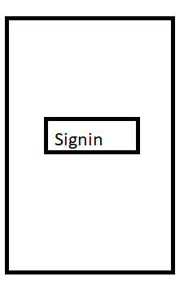

This is the first screen which is used to authenticate the users with firebase google signIn.

## Screen 2

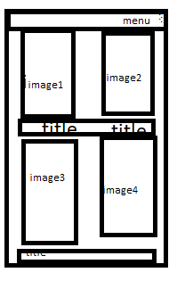

This is the second screen after logged in and display of the all the images of super heroes.

# Screen 3:

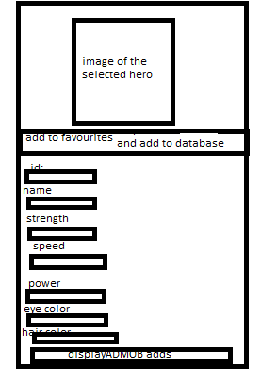

This is the details screen launched when the we click on any hero and the details of that hero are shown along with the adds by admob .

Screen-4

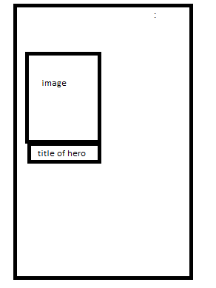

This is the screen launched when we click the menu which shows the favourite and uploaded movie into the database.

Screen-5



This is the Home Screen Widget and it displays the title of the last favourited hero uploaded in the database

Add as many screens as you need to portray your app’s UI flow.

# Key Considerations

### How will your app handle data persistence?

To fetch the hero details AsyncTask will be used and to store them Livedatabase(Room) is used.

### Describe any edge or corner cases in the UX.

Display appropriate error messages & alerts to the user.

### Describe any libraries you’ll be using and share your reasoning for including them.

SuperHero Api : To get super hero images and appearance data- from superheroapi.com

Picasso: To load images from the network - Version 2.5.1.

LiveDataBase(Room):to store the heroes(version-1.1.1)

Firebase-Auth:To authenticate the user -version:16.1.0

Google-play-services -version:17.1.1

Butterknife : To reduce the code. -version 8.8.0

AndroidStudio version:3.4.1

Gradle version:5.1.1

AdMobs : To display Ads To the user -Version

### Describe how you will implement Google Play Services or other external services.

I use –Firebase Google sigIn to authenticate the users.

I Use – admobs to display Ads to the user.

### How app supports accessibility ?

All Images will have Content Description Attributes to Correctly tell the visually impaired Users a Correct Message about the image. App uses Content Descriptions on every possible view. App Uses Proper grouping of elements in the container. App maintains the proper View Sizes to make them easy to interact with.

# Next Steps: Required Tasks

This is the section where you can take the main features of your app (declared above) and break them down into tangible technical tasks that you can complete one at a time until you have a finished app.

## Task 1: Create Project

● Create a project, name it VirtualMagic

● Configure the dependencies.

## Task 2: Fetch Data form the API Properly

● Implement the code to properly fetch JSON Data from URL.

## Task 3: Implement UI for Each Activity

● Design layout for authentication.

● Design layout for grid list of images .

● Design layout for details activity of the super hero details along with button to add it to favourites and upload it to the database at the same time.

● Display Ads

## Task 4:

## Creation Of Home Screen Widget

Design and implement Home Screen Widget to show the title of the last added super hero upon clicking the make favourite and upload to database button.

## Task 5:create a menu :

This menu contains an option titled view uploads which upon clicking shows the favourite and uploaded superheroes to database.

Add as many tasks as you need to complete your app.

**Submission Instructions**

* After you’ve completed all the sections, download this document as a PDF [ File → Download as PDF ]
  + Make sure the PDF is named “**Capstone_Stage1.pdf**”
* Submit the PDF as a zip or in a GitHub project repo using the project submission portal

If using GitHub:

* Create a new GitHub repo for the capstone. Name it “**Capstone Project**”
* Add this document to your repo. Make sure it’s named “**Capstone_Stage1.pdf**”