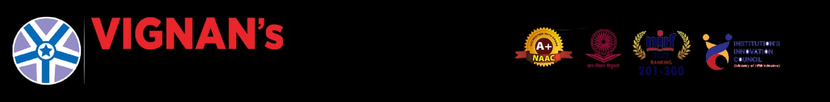

A REPORT
On
Community Service Project

Name of the Students: PEELA BHAVYA SRI, RONGALA VINAY VARSHIT, SARA VAKOTA SHANMUKHA ASHRITH, TELU SRINIVASA CHANDRA MOULI
Name of the College: Vignan's Institute of Information Technology (A)
Registration Numbers: 24L31A43D1, 24L31A43F3, 24L31A43F7, 24L31A43H6
Period of Community Service Project: 11 May – 20 June 2026
Year: II B. Tech
Name and Address of the Habitation for Community Service Project (CSP):
Gajuwaka PHC, Gajuwaka, Visakhapatnam, Andhra Pradesh.


Community Service Project Report
on
Smart Heal — Integrated Hospital Management and Patient Care System
Submitted in partial fulfilment of the requirements for the award of the Community Service
Project of
Bachelor of Technology
in
Department of Computer Science Engineering – Artificial Intelligence
By
Name of Student: PEELA BHAVYA SRI Roll No: 24L31A43D1
Name of Student: RONGALA VINAY VARSHIT Roll No: 24L31A43F3
Name of Student: SARA VAKOTA SHANMUKHA ASHRITH Roll No: 24L31A43F7
Name of Student: TELU SRINIVASA CHANDRA MOULI Roll No: 24L31A43H6
Under the Faculty Guidance of
Mrs .Y. Swathi
Assistant Professor
Department of Computer Science Engineering – Artificial Intelligence
Vignan's Institute of Information Technology (A)
Duvvada, Visakhapatnam
June 2026


Duvvada, Visakhapatnam
June 2026
Vignan's Institute of Information Technology (A)
Department of Computer Science Engineering – Artificial Intelligence
Student Declaration
We, PEELA BHAVYA SRI (Reg. No.: 24L31A43D1), RONGALA VINAY VARSHIT (Reg. No.: 24L31A43F3), SARA VAKOTA SHANMUKHA ASHRITH (Reg. No.: 24L31A43F7), and TELU SRINIVASA CHANDRA MOULI (Reg. No.: 24L31A43H6), are 2nd year students of Bachelor of Technology in the Department of Computer Science Engineering – Artificial Intelligence, Vignan's Institute of Information Technology (A), Duvvada, Visakhapatnam. We hereby declare that the presented report of the Community Service Project titled "Smart Heal — Integrated Hospital Management and Patient Care System" is uniquely prepared by us after the successful completion of a summer Community Service Project from 11 May – 20 June 2026 at Gajuwaka PHC, Gajuwaka, Visakhapatnam, Andhra Pradesh. under the faculty guidance of Mrs.Y.Swathi , Assistant Professor, Department of Computer Science Engineering – Artificial Intelligence, Vignan's Institute of Information Technology (A), Duvvada, Visakhapatnam, during the academic year 2025-26.
We also confirm that the report is prepared only for our academic requirement and not for any other purpose. The contents are based on our project study, community observations, and development work carried out as part of the Community Service Project.
Names of Students: PEELA BHAVYA SRI, RONGALA VINAY VARSHIT, SARA VAKOTA SHANMUKHA ASHRITH, TELU SRINIVASA CHANDRA MOULI
Regd. Nos.: 24L31A43D1, 24L31A43F3, 24L31A43F7, 24L31A43H6

 Department of Computer Science Engineering – Artificial Intelligence

CERTIFICATE

This is to certify that PEELA BHAVYA SRI (Reg. No.: 24L31A43D1), RONGALA VINAY VARSHIT (Reg. No.: 24L31A43F3), SARA VAKOTA SHANMUKHA ASHRITH (Reg. No.: 24L31A43F7), and TELU SRINIVASA CHANDRA MOULI (Reg. No.: 24L31A43H6) have completed the Community Service Project titled "Smart Heal — Integrated Hospital Management and Patient Care System" at Gajuwaka PHC, Gajuwaka, Visakhapatnam, Andhra Pradesh. from 11 May – 20 June 2026 under the faculty guidance of Mrs.Y.Swathi, Assistant Professor. The batch submitted the Community Service Project report to the department during the academic year 2025-26, in partial fulfilment of the requirements for the award of the Community Service Project of Bachelor of Technology in the Department of Computer Science Engineering – Artificial Intelligence, Vignan's Institute of Information Technology (A), Duvvada, Visakhapatnam.

Faculty Supervisor | Head of the Department
Mrs .Y. Swathi | Mrs. K. Swathi

ABSTRACT
Public healthcare centres manage a continuous flow of patients, doctors, records, consultations, and administrative activities every day. During community observations at Gajuwaka PHC, it was found that manual registration, paper-based token handling, difficulty in tracking consultation status, and scattered medical records can increase waiting time and reduce transparency in hospital service delivery.
Smart Heal is a web-based Integrated Hospital Management and Patient Care System designed to simplify these hospital operations through a centralized digital platform. The system provides separate role-based dashboards for patients, doctors, and administrators. Patients can register, log in securely, select a department, generate consultation tokens, view live queue status, access MediVault records, and submit feedback. Doctors can view department-wise queues, handle emergency cases, update consultation status, enter prescriptions, and maintain consultation history. Administrators can approve doctor registrations, monitor queues, supervise hospital activity, review feedback, and manage the overall workflow.
The system uses HTML, CSS, and JavaScript for the frontend interface, Firebase Authentication for secure role-based login, and Cloud Firestore for real-time storage and synchronization of hospital data. The deployed application is available at https://fabulous-genie-2336c7.netlify.app/. By integrating patient registration, queue management, consultation tracking, digital medical records, feedback, and administration into one platform, Smart Heal reduces paperwork and improves communication among hospital stakeholders.
The Community Service Project helped the team understand practical healthcare workflow challenges and convert them into a socially useful software solution. Smart Heal demonstrates how simple web technologies and cloud-based services can support faster patient services, transparent queue management, organized medical records, and improved hospital administration at the community level.

Acknowledgements
It has been a pleasure for us to work on this Community Service Project. The project reported here has been carried out in the Department of Computer Science Engineering – Artificial Intelligence, Vignan's Institute of Information Technology (A).
We extend our sincere gratitude towards our supervisor Mrs.Y.Swathi, Assistant Professor, Department of CSE – AI, who has always been a constant motivation and guiding factor throughout the project. Her continuous encouragement and valuable guidance have been instrumental in the successful completion of this work.
We express our gratitude from the bottom of our hearts to Dr. L. Rathaiah, Chairman of Vignan's Group of Institutions and Mr. L. Sri Krishna Devarayalu, Vice-Chairman of Vignan's Group of Institutions, for providing all necessary facilities and a congenial learning environment.
Our heartfelt thanks to Mr. N. Srikanth, CEO and Dr. V. Madhusudhana Rao, Rector, for their intellectual management and support throughout our project work.
Our hearty thanks to Dr. J. Sudhakar, Principal, for his support, encouragement, and valuable suggestions that helped us participate in the Community Service Project programme.
Our sincere thanks to Mrs. K. Swathi, Head of the Department of CSE – AI, for her great support, encouragement, and for providing all facilities and the environment needed to carry out this project work.
We also thank the doctors, staff, patients, and community members of Gajuwaka PHC, Gajuwaka, Visakhapatnam, Andhra Pradesh. for their cooperation and participation during our survey and awareness sessions.
PEELA BHAVYA SRI, RONGALA VINAY VARSHIT, SARA VAKOTA SHANMUKHA ASHRITH, TELU SRINIVASA CHANDRA MOULI
24L31A43D1, 24L31A43F3, 24L31A43F7, 24L31A43H6

TABLE OF CONTENTS
S.No. | Title | Page No.
1 | Executive Summary | 1
2 | Overview of the Community | 2
3 | Community Service Part | 3
4 | Activity Log – Week 1 | 5
5 | Weekly Report – Week 1 | 5
6 | Activity Log – Week 2 | 6
7 | Weekly Report – Week 2 | 6
8 | Activity Log – Week 3 | 7
9 | Weekly Report – Week 3 | 7
10 | Activity Log – Week 4 | 8
11 | Weekly Report – Week 4 | 8
12 | Outcomes Description | 9
13 | Mini-Project Report: Smart Heal Platform | 11
14 | Recommendations and Conclusions | 17
15 | References | 18
16 | Project Completion Certificate | 19
17 | Survey Photos | 20

LIST OF FIGURES

Figure No. | Description | Page No.
Fig 1 | System Architecture – Smart Heal Platform | 13
Fig 2 | Patient Dashboard | 14
Fig 3 | Doctor Dashboard Flow | 14
Fig 4 | Admin Dashboard-Doctor Management | 15
Fig 5 | Smart Heal Future Enhancement Plan | 16

CHAPTER 1: EXECUTIVE SUMMARY
The Community Service Project was carried out with the objective of understanding the challenges faced by patients, doctors, and hospital staff in managing day-to-day healthcare services at Gajuwaka PHC, Gajuwaka, Visakhapatnam, Andhra Pradesh. The survey and observation process revealed that manual patient registration, paper-based token handling, non-centralized medical records, and limited real-time queue visibility create delays and increase workload for hospital staff.
To address these challenges, Smart Heal, a web-based Integrated Hospital Management and Patient Care System, was designed and developed. The platform enables patients to register, generate department-wise tokens, monitor live queue status, access MediVault medical records, and submit feedback. It also supports doctors with organized patient queues, emergency patient priority, prescription entry, and consultation history. Administrators can supervise doctor approvals, patient queues, feedback, and hospital activities from a centralized dashboard.
Several activities were undertaken during the project, including studying hospital workflows, conducting community observations, identifying functional requirements, designing role-based dashboards, integrating Firebase Authentication and Cloud Firestore, testing the modules, and demonstrating the platform for awareness and feedback.
Learning Objectives
- To understand the practical challenges involved in patient registration, queue management, and medical record maintenance.
- To study how digital platforms can improve transparency and coordination in healthcare service delivery.
- To learn about role-based dashboards for patients, doctors, and administrators.
- To develop skills in designing user-friendly web applications using HTML, CSS, and JavaScript.
- To understand Firebase Authentication and Cloud Firestore for secure login and real-time database synchronization.
- To create awareness about how digital healthcare systems can reduce manual effort in public health centres.
Learning Outcomes
- Acquired practical knowledge of hospital workflow and community healthcare management.
- Understood the need for real-time queue tracking and centralized patient information.
- Gained experience in designing secure role-based web applications.
- Developed problem-solving and systems-thinking skills through real-world community engagement.
- Improved communication and documentation skills through survey, observation, and awareness activities.
- Recognized the social importance of digital transformation in healthcare services.

CHAPTER 2: OVERVIEW OF THE COMMUNITY
The Community Service Project survey was conducted at Gajuwaka PHC, Gajuwaka, Visakhapatnam, Andhra Pradesh. Gajuwaka is a busy urban locality in Visakhapatnam, and the Primary Health Centre serves patients from nearby residential areas, workers, families, and local communities. The PHC handles routine consultations, outpatient care, basic medical guidance, and public health-related services.
During the survey, it was observed that healthcare centres such as Gajuwaka PHC play an important role in providing accessible medical services to the public. Patients visit the centre for general health issues, follow-up consultations, prescriptions, and basic medical advice. Because patient flow can vary throughout the day, efficient registration and queue management become essential for smooth functioning.
The community using the PHC includes people from different age groups and socio-economic backgrounds. Some patients are familiar with digital services, while others depend more on direct assistance from hospital staff. Therefore, any digital healthcare solution designed for such an environment must be simple, clear, responsive, and easy to use.
The survey revealed that manual processes can create practical difficulties. Patients may not have clear information about their queue position, staff may need to manage records repeatedly, and doctors may require quick access to consultation details. These observations highlighted the need for Smart Heal as a centralized hospital management system that connects patients, doctors, and administrators through a single digital platform.
Based on these observations, Smart Heal was designed with role-based access, real-time queue management, digital medical records, emergency patient handling, feedback management, and administrative supervision. The system aims to improve service delivery while remaining suitable for a community-level healthcare environment.
CHAPTER 3: COMMUNITY SERVICE PART
As part of the Community Service Project, a survey and awareness activity were conducted at Gajuwaka PHC, Gajuwaka, Visakhapatnam, Andhra Pradesh. The primary objective was to understand existing hospital workflows and identify challenges faced by patients, doctors, administrative staff, and other healthcare personnel in day-to-day operations.
The project began with planning and preparing a questionnaire to collect information about patient registration, consultation flow, token generation, queue tracking, medical record handling, emergency patient management, and feedback collection. Observations were made at different stages of the hospital process to understand how information moves between patients, doctors, and administration.
Awareness sessions and discussions were conducted to explain how Smart Heal could support a more organized healthcare workflow. The team demonstrated the idea of department-wise token generation, live queue monitoring, role-based dashboards, MediVault digital records, and feedback management. These interactions helped validate the usefulness of the proposed platform.
Based on the survey observations, the Smart Heal platform architecture was finalized and documented. Activities included defining patient, doctor, and administrator modules; designing queue management flow; planning Firebase Authentication roles; creating Firestore database collections; and testing the integrated web application.
Values Acquired
- Social responsibility towards improving community healthcare services.
- Commitment to reducing manual effort through meaningful digital solutions.
- Respect for healthcare workers and their role in serving the public.
- Ethical handling of patient-related information and awareness of privacy concerns.
Life Skills Acquired
- Communication and interaction skills through discussions with hospital staff and patients.
- Teamwork and collaboration in designing and documenting the platform.
- Problem-solving and critical thinking while addressing real-world healthcare challenges.
- Leadership and presentation skills during awareness and demonstration activities.
- Data collection and analysis through the community healthcare survey.
Technical Skills Acquired
- Understanding of web application design using HTML, CSS, and JavaScript.
- Knowledge of Firebase Authentication for secure role-based login.
- Cloud Firestore database design for real-time hospital data synchronization.
- Dashboard design for patient, doctor, and administrator roles.
- Queue management logic and emergency patient prioritization.
- Testing and debugging of integrated web application modules.

ACTIVITY LOG FOR WEEK-1
Day | Date | Brief Description of Daily Activity | Learning  Outcome | Person  In-Charge
Day-1 | 11-05-2026 | Team formation and project ideation — identified hospital workflow management as the focus area for the Community Service Project. | Understanding project objectives and teamwork.
Day-2 | 12-05-2026 | Studied common challenges in public healthcare centres, including patient registration, queue handling, and medical records. | Awareness of real-world healthcare problems.
Day-3 | 13-05-2026 | Conducted literature survey on existing hospital management systems and identified gaps in integrated queue tracking. | Research and analytical skills.
Day-4 | 14-05-2026 | Identified project requirements — patient portal, doctor dashboard, admin dashboard, MediVault, and queue management. | Project planning skills.
Day-5 | 15-05-2026 | Studied Firebase Authentication, Cloud Firestore, and web development tools required for implementation. | Understanding technology fundamentals.
Day-6 | 16-05-2026 | Finalized project scope, objectives, and overall development roadmap for Smart Heal. | Requirement analysis and documentation skills.

WEEKLY REPORT — WEEK 1 (From Date: 11-05-2026 to Date: 16-05-2026)
Objective of Activity
To initiate the Smart Heal project, understand hospital workflow challenges, and define project objectives and requirements.
Detailed Report
During the first week, our project team focused on understanding the challenges faced in manual hospital management. Existing systems and project references were studied to identify suitable approaches. Discussions were conducted regarding patient portals, doctor dashboards, admin monitoring, queue management, and digital records. The team finalized the project objectives, technologies to be used, and the initial platform design plan.
ACTIVITY LOG FOR WEEK-2
Day | Date | Brief Description of Daily Activity | Learning  Outcome | Person  In-Charge
Day-7 | 18-05-2026 | Designed the patient registration and department-wise token generation flow. | Patient workflow design skills.
Day-8 | 19-05-2026 | Planned the doctor dashboard flow for queue viewing, emergency priority, consultation update, and prescriptions. | Dashboard design and UX skills.
Day-9 | 20-05-2026 | Planned the admin dashboard for doctor approval, queue supervision, patient monitoring, and feedback management. | Administrative workflow analysis.
Day-10 | 21-05-2026 | Designed Firestore database collections for patients, doctors, queues, consultations, and feedback. | Database design skills.
Day-11 | 22-05-2026 | Prepared UI layouts for login, patient portal, doctor dashboard, and admin dashboard. | Interface planning and prototyping.
Day-12 | 23-05-2026 | Finalized system architecture and integration plan using Firebase services. | Full-stack system architecture skills.

WEEKLY REPORT — WEEK 2 (From Date: 18-05-2026 to Date: 23-05-2026)
Objective of Activity
To design the Smart Heal platform, including user roles, dashboard flows, database structure, and system architecture.
Detailed Report
The second week focused on platform design. The patient workflow was mapped from registration to token generation and feedback. Doctor and administrator functions were planned separately. Firestore collections and authentication roles were documented. The complete system architecture was finalized with components for frontend pages, Firebase Authentication, Cloud Firestore, and deployment.

ACTIVITY LOG FOR WEEK-3
Day | Date | Brief Description of Daily Activity | Learning  Outcome | Person  In-Charge
Day-13 | 25-05-2026 | Prepared survey questionnaire for Gajuwaka PHC covering registration, queues, records, and feedback. | Survey design and research skills.
Day-14 | 26-05-2026 | Visited Gajuwaka PHC and conducted preliminary observations of patient flow and registration activity. | Community engagement and observation.
Day-15 | 27-05-2026 | Collected responses and notes from hospital staff and patients regarding queue and record management. | Data collection and field research skills.
Day-16 | 28-05-2026 | Conducted awareness discussion explaining how Smart Heal can simplify queue tracking and digital records. | Public awareness and presentation skills.
Day-17 | 29-05-2026 | Demonstrated the planned patient portal and dashboard workflow to available stakeholders. | Technical demonstration and user education.
Day-18 | 30-05-2026 | Analyzed initial survey responses and identified key problem areas in the PHC workflow. | Data analysis and problem identification.

WEEKLY REPORT — WEEK 3 (From Date: 25-05-2026 to Date: 30-05-2026)
Objective of Activity
To conduct the community survey at Gajuwaka PHC and create awareness about the Smart Heal platform among stakeholders.
Detailed Report
The third week was dedicated to community engagement. The team visited Gajuwaka PHC and observed patient registration, queue handling, and consultation movement. Discussions were conducted with available staff and patients. Awareness was created about digital queue tracking, MediVault records, and role-based dashboards. The responses helped refine the project features.
ACTIVITY LOG FOR WEEK-4
Day | Date | Brief Description of Daily Activity | Learning  Outcome | Person  In-Charge
Day-19 | 01-06-2026 | Conducted detailed workflow study covering patient registration, consultation status, and record access. | Healthcare workflow analysis skills.
Day-20 | 02-06-2026 | Interacted with staff regarding manual token handling and difficulty in tracking patient status. | Community interaction and insight gathering.
Day-21 | 03-06-2026 | Gathered observations on medical record maintenance, emergency patient handling, and feedback collection. | Survey analysis and gap identification.
Day-22 | 04-06-2026 | Conducted follow-up awareness session on benefits of centralized digital hospital management. | Leadership and awareness creation.
Day-23 | 05-06-2026 | Demonstrated Smart Heal modules and explained real-time queue, doctor dashboard, and admin monitoring. | Technical presentation skills.
Day-24 | 06-06-2026 | Compiled all survey findings and prepared final community analysis report. | Data synthesis and reporting skills.

WEEKLY REPORT — WEEK 4 (From Date: 01-06-2026 to Date: 06-06-2026)
Objective of Activity
To complete the workflow survey, finalize community observations, and prepare the comprehensive analysis report for Smart Heal.
Detailed Report
During the fourth week, the team completed the survey and observation activities at Gajuwaka PHC. Key findings revealed the need for faster registration, digital token tracking, better consultation status visibility, centralized medical records, and structured feedback management. Follow-up awareness sessions were conducted and the Smart Heal platform was demonstrated. All findings were compiled into the final project report.
CHAPTER 5: OUTCOMES DESCRIPTION
Details of the Healthcare Workflow Survey
As part of the Community Service Project, a healthcare workflow survey was conducted at Gajuwaka PHC, Gajuwaka, Visakhapatnam, Andhra Pradesh. to understand patient registration, queue management, consultation flow, medical record maintenance, and administrative supervision. The survey involved observation of hospital activities and interactions with available staff and patients from different backgrounds.
The survey revealed that patients often depend on staff for queue updates and consultation status. Manual token handling and paper-based records increase staff workload and make it difficult to retrieve information quickly. Feedback collection and emergency patient prioritization also require better organization. These findings highlighted the need for a simple and centralized system like Smart Heal.
Problems Identified in the Community
- Manual patient registration and token generation increase waiting time.
- Patients have limited real-time visibility of queue position and consultation status.
- Paper-based medical records are difficult to maintain, search, and retrieve quickly.
- Doctors need a more organized way to view department-wise patient queues.
- Emergency cases require a clear digital priority mechanism.
- Hospital administrators need centralized monitoring of doctors, patients, queues, and feedback.
- Feedback collection is not always structured for service improvement analysis.
Short-Term and Long-Term Action Plan
Short-Term Action Plan
- Deploy Smart Heal at Gajuwaka PHC with patient, doctor, and admin login facilities.
- Train staff on patient registration, token generation, and queue monitoring.
- Display the Smart Heal website link and instructions near registration areas.
- Introduce MediVault awareness so patients understand the value of digital records.
- Collect feedback through the system and review it regularly for improvement.
Long-Term Action Plan
- Extend Smart Heal to nearby clinics and healthcare centres.
- Add online appointment booking with time-slot allocation.
- Introduce SMS and email notifications for tokens, appointments, and consultation updates.
- Integrate laboratory reports, pharmacy inventory, and online payment support.
- Develop Android and iOS mobile applications for wider accessibility.
- Integrate with government healthcare schemes and digital health records in future versions.
- Use analytics dashboards for patient load prediction and hospital resource planning.

Community Awareness Programs Conducted
Awareness programmes were conducted at Gajuwaka PHC to address the identified problems, particularly the lack of real-time queue information, manual record maintenance, and limited centralized monitoring. The programmes included interactive discussions, demonstrations of the Smart Heal platform, and explanations of how patients, doctors, and administrators can use the system.
Patients and staff were educated about registration, department selection, token generation, live queue monitoring, MediVault, and feedback. The doctor and admin dashboard concepts were also explained to show how the system supports consultation management and hospital supervision.
Outcomes of the Awareness Programme
- Patients understood the benefit of digital token generation and queue tracking.
- Hospital staff gained awareness of how centralized dashboards reduce manual workload.
- Doctors could see how organized queues and consultation history support better workflow.
- Administrators understood the usefulness of feedback and queue monitoring.
- The Smart Heal platform was received as a practical solution for improving hospital operations.
- The project team gained practical experience in applying technology to a healthcare community problem.

REPORT OF THE MINI-PROJECT WORK
SMART HEAL — INTEGRATED HOSPITAL MANAGEMENT AND PATIENT CARE SYSTEM
1. Introduction
Hospitals and primary health centres handle several patient-related activities every day, including registration, consultation, queue management, prescriptions, medical records, and feedback. When these activities are managed manually, patients may experience delays and staff may face difficulty in maintaining accurate and updated information.
During the survey at Gajuwaka PHC, Gajuwaka, Visakhapatnam, Andhra Pradesh., it was observed that a centralized web-based system could help improve patient convenience and hospital workflow. Smart Heal was therefore developed as an Integrated Hospital Management and Patient Care System that uses role-based dashboards and real-time database synchronization.
2. Problem Statement
The following key problems were identified during the survey:
- Manual registration and token management increase patient waiting time.
- Patients do not always receive clear real-time information about their consultation status.
- Medical records and prescriptions are difficult to maintain in paper-based form.
- Doctors require an organized view of patient queues and emergency cases.
- Administrators need a centralized system to supervise hospital activities.
- Feedback management is not fully structured for continuous service improvement.
3. Objectives of the Project
- Digitize patient registration and department-wise token generation.
- Provide live queue monitoring for patients, doctors, and administrators.
- Enable secure role-based login for patients, doctors, and administrators.
- Maintain consultation history and prescriptions through MediVault.
- Support emergency patient prioritization and consultation status updates.
- Provide an admin dashboard for doctor approval, feedback review, and hospital monitoring.
- Reduce paperwork and improve transparency in healthcare service delivery.
4. Scope of the Project
Smart Heal covers the essential workflow of a community-level healthcare centre. The system includes patient registration, login, department selection, token generation, live queue tracking, doctor consultation management, MediVault records, feedback submission, doctor approval, and admin monitoring. Future scope includes appointment booking, SMS notifications, lab reports, pharmacy management, mobile applications, and government healthcare integration.
5. Methodology
Step 1: Community Survey: Conducted workflow observations at Gajuwaka PHC to understand patient registration, queue handling, consultation flow, records, and feedback.
Step 2: Requirement Analysis: Identified functional requirements for patient, doctor, and admin modules based on survey findings.
Step 3: Platform Design: Designed role-based dashboards, queue workflow, MediVault structure, and feedback process.
Step 4: Firebase Integration: Implemented Firebase Authentication for secure login and Cloud Firestore for real-time database synchronization.
Step 5: Module Implementation: Developed Patient Portal, Doctor Dashboard, Admin Dashboard, MediVault, Queue Management, Emergency Handling, and Feedback Management modules.
Step 6: Testing and Deployment: Tested module-wise and integrated workflows, resolved synchronization issues, and deployed the application online.
6. Tools and Technologies
Frontend: HTML, CSS, and JavaScript. Authentication: Firebase Authentication. Database: Cloud Firestore. Development Environment: Visual Studio Code. Version Control: Git and GitHub. Deployment: Netlify. The deployed platform is available at https://fabulous-genie-2336c7.netlify.app/
7. System Architecture
The Smart Heal architecture consists of four core layers: (1) User Interface Layer containing patient, doctor, and admin dashboards; (2) Authentication Layer using Firebase Authentication; (3) Cloud Database Layer using Cloud Firestore for patient, doctor, queue, consultation, and feedback data; and (4) Deployment Layer hosting the web application through Netlify.
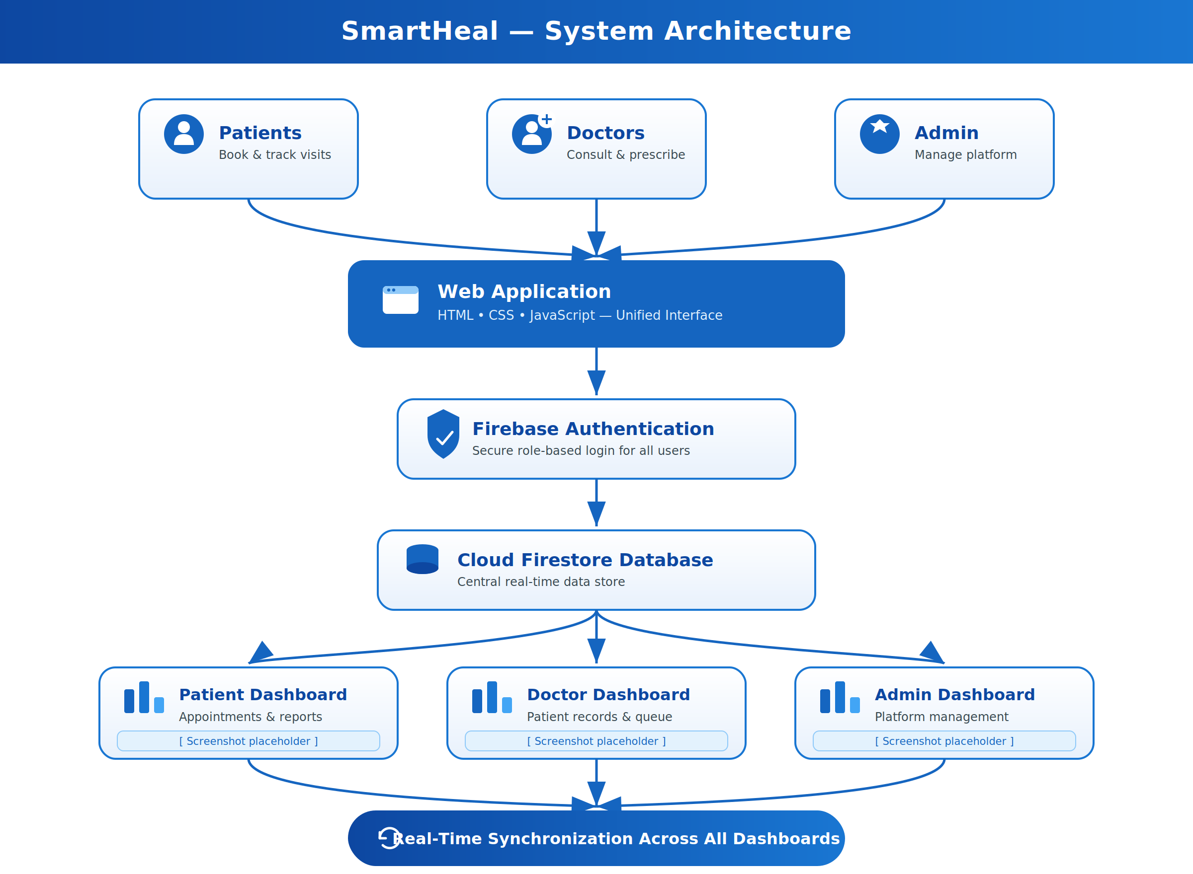

Fig1:System Architecture-Smart Heal Platform
8. Key Features
- Patient Portal: Registration, login, department selection, token generation, queue status, MediVault, and feedback.
- Doctor Dashboard: Department-wise queue, emergency patient priority, consultation status, prescriptions, and history.
- Admin Dashboard: Doctor approval, patient monitoring, queue monitoring, feedback review, and hospital supervision.
- MediVault: Secure digital storage of consultation history and prescriptions.
- Queue Management: Real-time department-wise token generation and queue tracking.
- Emergency Handling: Priority indication for emergency patients
- Feedback Management: Patient feedback collection and review by admin.
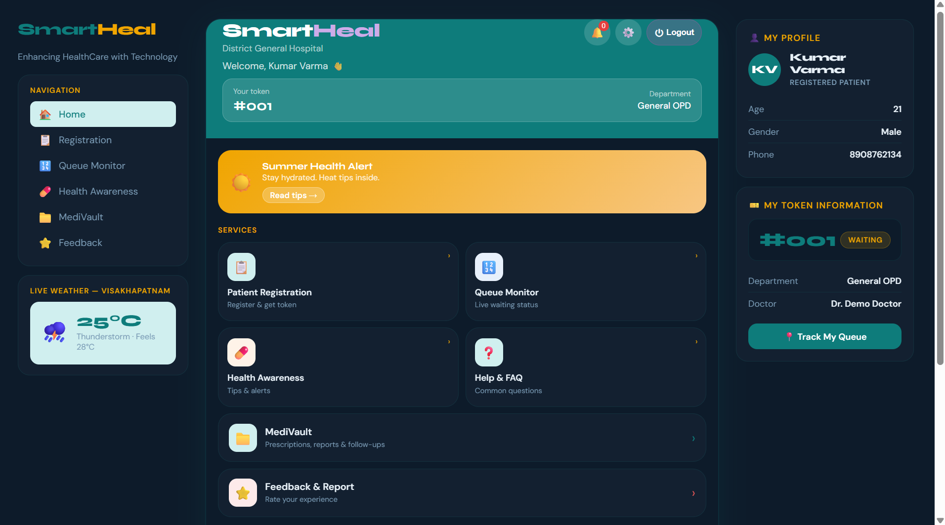
Fig2:Patient Dashboard

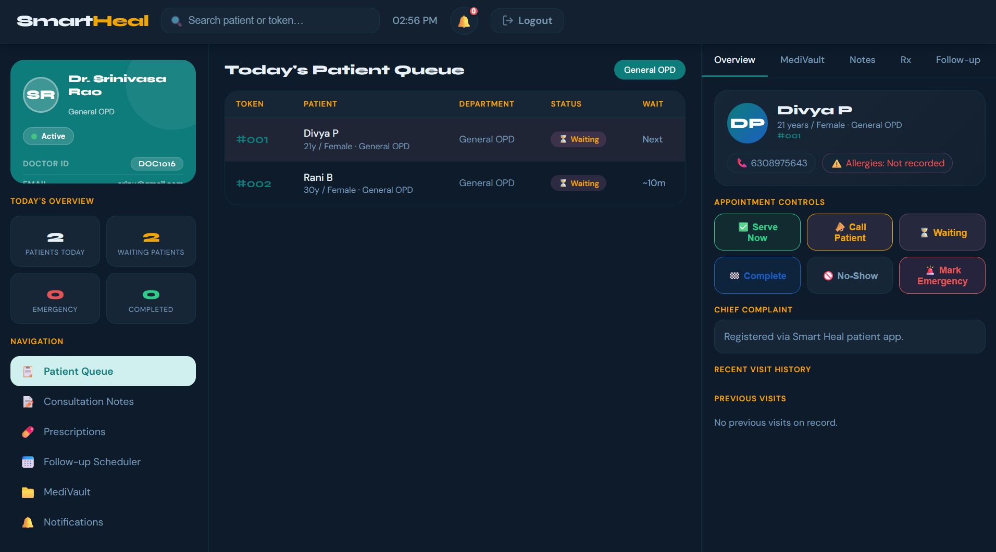
Fig3:Doctor Dashboard Flow

9. Results and Discussion
The Smart Heal platform successfully addresses the major workflow needs identified during the Gajuwaka PHC survey. Patient registration, token generation, live queue monitoring, doctor consultation updates, prescription management, MediVault records, and admin monitoring were implemented in a single web-based application. The use of Firestore enables real-time synchronization, which is essential for queue tracking and consultation status updates.
10. Benefits of the Project
- Reduces manual paperwork and repeated record maintenance.
- Improves patient convenience through digital registration and queue tracking.
- Helps doctors manage consultations in an organized manner.
- Provides administrators with centralized supervision of hospital activities.
- Stores medical records digitally for easier future access.
- Improves transparency and communication among patients, doctors, and administrators.
- Creates a scalable base for future healthcare technology enhancements.
11. Survey Findings
The survey at Gajuwaka PHC revealed that:
- Manual registration and token handling are time-consuming during patient rush hours.
- Patients benefit from knowing queue position and consultation status in real time.
- Staff require a centralized system to reduce repeated manual coordination.
- Doctors benefit from organized department-wise patient queues and consultation history.
- Digital medical records can reduce dependency on physical files.
- Feedback management can help administrators improve patient service quality.

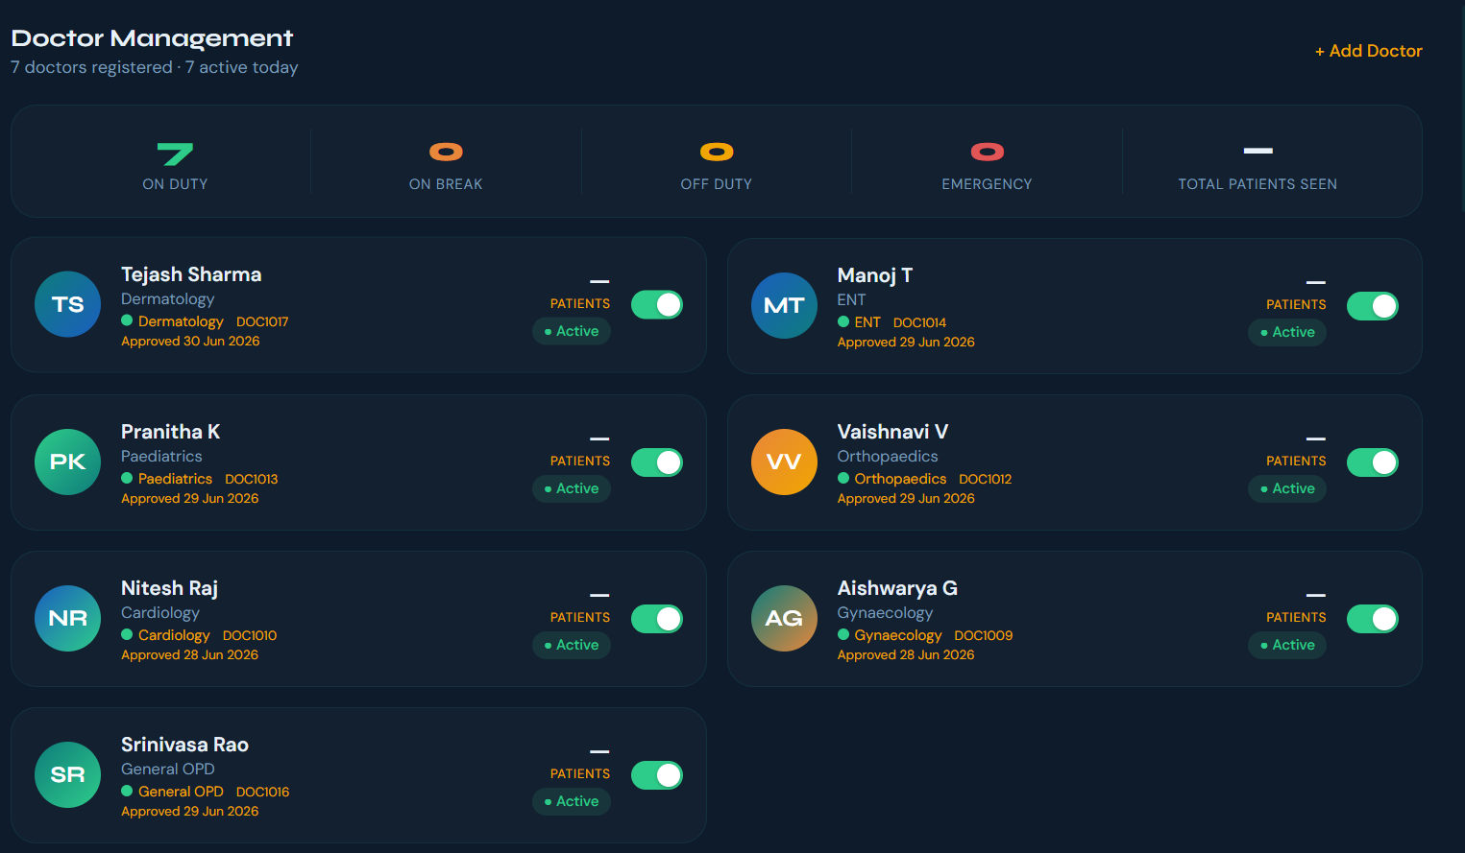

Fig4:Admin Dashboard-Doctor Management

12. Future Enhancements
- Online appointment booking with time-slot allocation.
- AI-based healthcare assistant for common patient queries.
- Video consultation facilities for remote healthcare services.
- SMS and email notifications for appointments and consultation updates.
- QR code-based patient identification and hospital check-in.
- Online payment gateway integration for consultation fees.
- Laboratory report management and pharmacy inventory integration.
- Mobile application development for Android and iOS platforms.
- Integration with government healthcare schemes and digital health records.
- Advanced analytics for patient load prediction and resource planning.

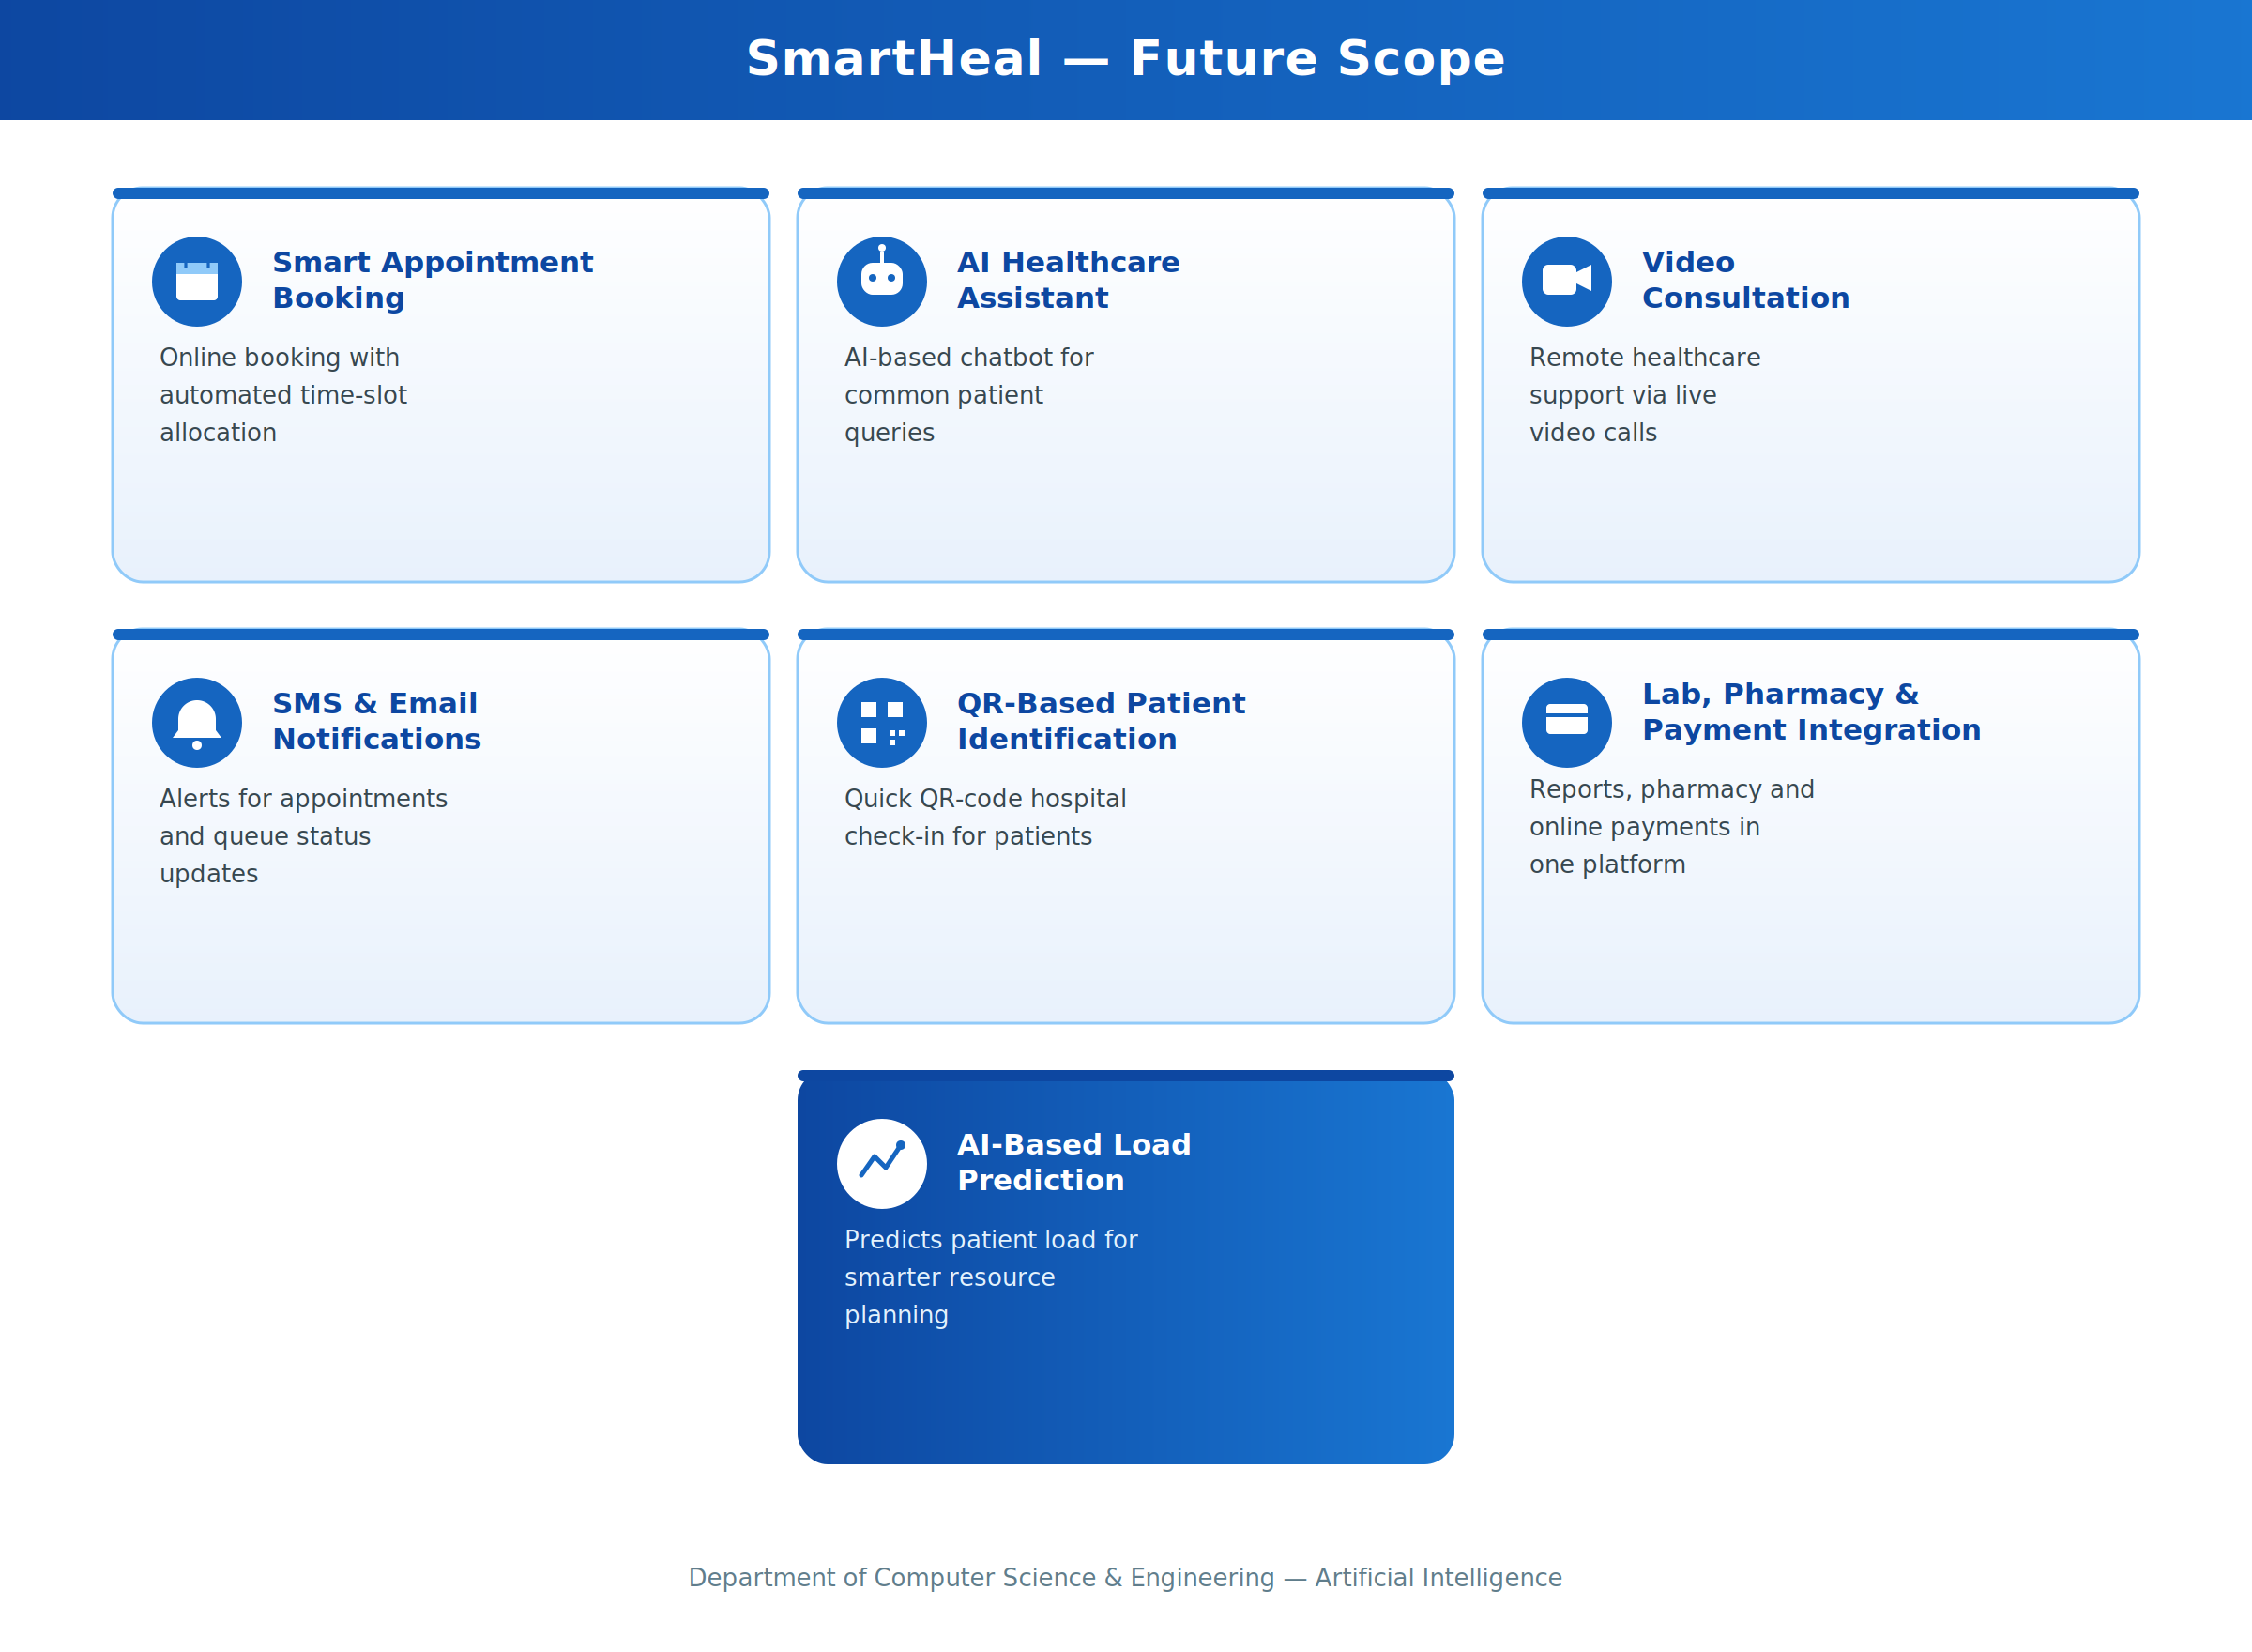

Fig5:Smart Heal Future Enhancement Plan

13. Conclusion
The Smart Heal platform was successfully designed and developed to address practical challenges in hospital management. By combining patient registration, queue tracking, doctor consultation management, MediVault, feedback, and admin supervision, the system provides a unified solution for improving healthcare workflow. The Community Service Project at Gajuwaka PHC highlighted the need for such a system and confirmed the importance of digital transformation in community healthcare. With future enhancements, Smart Heal can be expanded to support larger hospitals, clinics, and public health centres.

CHAPTER 6: RECOMMENDATIONS AND CONCLUSIONS
Recommendations
Deploy Smart Heal in Pilot Mode: The Smart Heal system should be deployed initially at Gajuwaka PHC in a controlled pilot mode, where staff can use patient registration, token generation, queue monitoring, and feedback features with proper guidance.
Train Hospital Staff: Training sessions should be conducted for registration staff, doctors, and administrators so that each user understands their dashboard and responsibilities.
Promote Patient Awareness: Simple instructions, posters, and QR codes should be displayed near registration counters so that patients can understand how to use the digital token and queue tracking features.
Strengthen Data Security: Role-based access rules and Firestore security rules should be reviewed regularly to ensure that patient information remains protected.
Add Notification Services: SMS or email notifications should be integrated in the future to inform patients about token status, appointment reminders, and consultation updates.
Monitor and Evaluate: Patient feedback, queue waiting time, doctor workload, and system usage should be reviewed regularly to measure the impact of Smart Heal and guide future improvements.
Conclusion
The Smart Heal — Integrated Hospital Management and Patient Care System was successfully developed to address the growing need for digital healthcare workflow management at the community level. The project demonstrated the effective use of web technologies, Firebase Authentication, and Cloud Firestore to provide secure login, real-time queue tracking, digital medical records, doctor consultation management, and administrative supervision.
The Community Service Project survey conducted at Gajuwaka PHC, Gajuwaka, Visakhapatnam, Andhra Pradesh. highlighted the importance of a simple and centralized digital platform for patients, doctors, and administrators. The project not only provided a technological solution but also helped create awareness about digital healthcare practices and the benefits of reducing manual paperwork.
The outcomes of the project enhanced our technical knowledge in web development, Firebase integration, database design, and dashboard implementation, while also developing communication, teamwork, and community engagement skills. Overall, Smart Heal serves as a valuable tool for promoting efficient healthcare service delivery and improving patient satisfaction. With future enhancements and wider adoption, the platform has the potential to support hospitals, clinics, and primary health centres across different communities.

References
[1] World Health Organization — Global Strategy on Digital Health 2020–2025. https://www.who.int/health-topics/digital-health
[2] Ayushman Bharat Digital Mission. National Health Authority, Government of India. https://abdm.gov.in
[3] National Health Portal of India. Government of India. https://www.nhp.gov.in
[4] Firebase Authentication Documentation. Google Firebase. https://firebase.google.com/docs/auth
[5] Cloud Firestore Documentation. Google Firebase. https://firebase.google.com/docs/firestore
[6] Firebase Security Rules Documentation. Google Firebase. https://firebase.google.com/docs/rules
[7] MDN Web Docs — HTML Documentation. https://developer.mozilla.org/en-US/docs/Web/HTML
[8] MDN Web Docs — CSS Documentation. https://developer.mozilla.org/en-US/docs/Web/CSS
[9] MDN Web Docs — JavaScript Documentation. https://developer.mozilla.org/en-US/docs/Web/JavaScript
[10] Netlify Documentation. https://docs.netlify.com

Project Completion Certificate

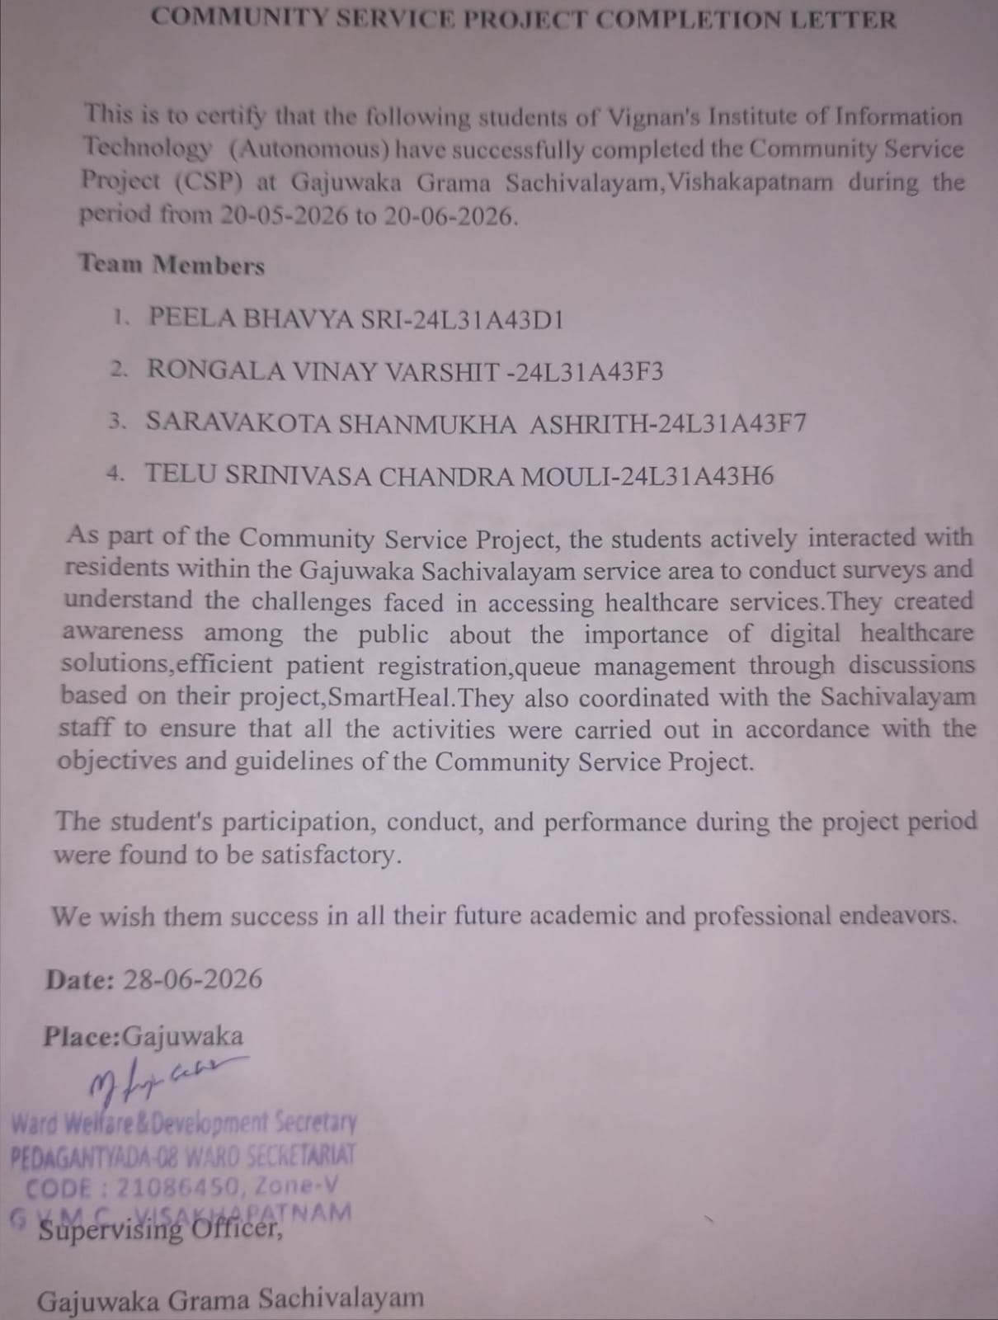

SURVEY PHOTOS
