Design and Implementation of an AI-Powered Resume Analysis and Recommendation System
NTCC REPORT
On
AI-Powered Resume Analysis and Recommendation System
Submitted to
Amity University, Uttar Pradesh

In partial fulfillment of the requirements for the award of the degree
Of
Bachelor Of Technology
In
Information Technology
Bhavya Srivastava(A7605324011)
Under the guidance of
Prof (Dr)Syed Wajahat Abbas Rizvi

DEPARTMENT OF COMPUTER SCIENCE AND ENGINEERING
AMITY SCHOOL OF ENGINEERING AND TECHNOLOGY
AMITY UNIVERSITY UTTAR PRADESH
DECLARATION

I, Bhavya Srivastava, hereby declare that the NTCC report titled “Design and Implementation of an AI-Powered Resume Analysis and Recommendation System”, submitted in partial fulfillment of the requirements for the Non-Term Credit Course (NTCC) of B. Tech (IT) 5th Semester at Amity University, Uttar Pradesh, Lucknow is a record of my original and independent work carried out under the guidance of Prof. (Dr.) Syed Wajahat Abbas Rizvi, Department of Computer Science and Engineering.
I affirm that this report has not been submitted in full or in part to any other institution or university for the award of any academic degree or diploma. All the information provided in this report has been acquired through my personal research and the sources referred to have been acknowledged appropriately.
This project has been conducted with academic integrity and ethical responsibility. The content has been written in my own words to ensure minimal similarity and plagiarism, as required by university regulations.

Name: Bhavya Srivastava
Enrollment number: A7605324011
Date:

CERTIFICATE

This is to certify that the project titled “Design and Implementation of an AI-Powered Resume Analysis and Recommendation System” has been successfully completed and submitted by Bhavya Srivastava (Enrollment No. A7605324011) of B. Tech (IT) – 5th Semester under the supervision of Prof. (Dr.) Syed Wajahat Abbas Rizvi, towards partial fulfillment of the requirements for the Non-Term Credit Course (NTCC) at Amity University, Uttar Pradesh.

Date: ____________
Faculty Guide Signature: ____________
Prof. (Dr.) Syed Wajahat Abbas Rizvi
Amity School of Engineering and Technology

ACKNOWLEDGEMENT

I take this opportunity to express my sincere gratitude to all those who contributed to the successful completion of my Non-Term Credit Course (NTCC) project titled “Design and Implementation of an AI Resume Analyzer and recommendation System”
First and foremost, I would like to extend my deepest appreciation to my respected guide, Prof. (Dr.) Syed Wajahat Abbas Rizvi, for his support, timely feedback, and expert guidance throughout the course of this project. His suggestions and encouragement kept me motivated and helped me stay focused.
I am extremely thankful to the faculty and staff of the Department of Computer Science and Engineering, Amity University, Uttar Pradesh, for creating this project and made us do research on the topics of or choice.
A special thanks to my friends and classmates for their continuous moral support, brainstorming discussions, and for sharing ideas that enriched my understanding of the topic.
Last but not least, I am grateful to my family for their unconditional love, patience, and encouragement during this academic journey. Their belief in me has always been a source of strength and inspiration.
This project is a result of collective effort, and I humbly extend my thanks to everyone who contributed directly or indirectly to its completion.

INDEX

S.NO | TOPIC | PG.NO
1. | ABSTRACT | 1
2. | INTRODUCTION | 2
3. | LITERATURE REVIEW | 3
4. | PROBLEM STATEMENT | 4
5. | OBJECTIVE/SCOPE | 5
6. | SYSTEM REQUIREMENT | 6
7. | ARCHITECTURE | 7-8
8. | TOOLS | 9
9. | METHOD/IMPLEMENTATION/ADVANTAGE | 10
10. | TESTING | 11
11. | NON-FUNCTIONAL REQUIREMENT | 12
12. | RESULTS/CONCLUSION | 12
13 | OUTPUT | 13-14
14 | REFERENCES | 10

Abstract
Crafting a resume that effectively highlights a candidate's strengths while satisfying automated recruitment software is a major hurdle for students and entry-level job seekers. Many applicants are unfamiliar with how Applicant Tracking Systems (ATS) evaluate and rank documents, leading to frequent rejections despite possessing the necessary qualifications. To solve this problem, ResumePilot: AI Resume Analyzer and Recommendation System was developed to offer job seekers an accessible platform for evaluating and improving their resumes.
The application allows users to upload PDF-formatted resumes, extracting content using Python-based text processing libraries. The system calculates an estimated ATS compatibility score, identifies critical skill gaps, and generates targeted recommendations for improvement. Additionally, users can directly compare their resume against a target job description, making it easy to identify missing industry keywords.
Built with Python and the Flask web framework alongside standard web technologies (HTML/CSS), ResumePilot demonstrates how lightweight web tools and text analytics can solve practical recruitment challenges. The project aims to empower applicants with actionable feedback, improving their chances of passing initial screening filters and securing interview opportunities.

Introduction
Over the past decade, recruitment processes have shifted heavily toward automation. Traditional methods of handing in physical copies or emailing resumes directly to hiring managers have largely been replaced by online applicant portals powered by Applicant Tracking Systems (ATS). These systems serve as the initial filter, processing thousands of applications before a human recruiter ever sees them.
For fresh graduates and entry-level applicants, this shift creates a distinct disadvantage. While candidates may possess solid academic backgrounds and technical knowledge, they often lack insight into how automated screeners parse resume content. As a result, resumes that appear visually appealing may still be rejected by an ATS due to missing keywords, non-standard formatting, or unaligned phrasing.
ResumePilot was created to bridge this gap by providing an intuitive, web-based tool for resume evaluation. The system analyses uploaded resumes, highlights core strengths, identifies missing skills, and measures alignment against specific job descriptions. Beyond providing utility to job seekers, developing this project offered valuable hands-on experience in full-stack web development, Python backend integration, PDF parsing, and text analysis techniques.

Literature Review
ATS systems have become essential in recruitment. Studies show that over 90% of large companies use ATS to manage applications. This makes resume optimization critical.
Existing platforms like Jobscan and resume worded offer similar services but often require paid subscriptions. For students, this creates a barrier. Resume Pilot was designed to be free and accessible, focusing on basic but effective text processing techniques.
Research in document processing and NLP has shown that keyword matching and content evaluation can significantly improve resume screening. Resume Pilot builds on these concepts but keeps the system lightweight and easy to use.

Problem Statement
In modern recruitment, a resume serves as more than a simple list of qualifications; it is a primary screening document evaluated by automated software before reaching human hands. However, many job seekers—particularly fresh graduates—struggle to format and phrase their skills in ways that align with Applicant Tracking System (ATS) criteria.
A central issue with automated screeners is their rigid reliance on exact keyword matching. For instance, a candidate applying for a data analyst position might describe their experience as "worked with spreadsheets" rather than using specific industry keywords such as "Excel," "SQL," or "Data Visualization." Even if the candidate possesses the required skill set, the ATS will likely filter out the resume due to missing term matches.
Because recruiters face high application volumes, they rely heavily on these pre-filtered lists to narrow down applicants, causing many well-qualified candidates to be turned away early in the process. Most students lack direct insight into how automated parsers interpret their documents. ResumePilot addresses this challenge by evaluating resumes against target job descriptions in real time, pinpointing missing keywords and structural gaps so candidates can improve their applications before submitting them.

Objectives
The project was designed with clear goals:
- Web-based platform: Create a user-friendly application where resumes can be uploaded and analysed.
- Text extraction: Use Python libraries to convert PDF resumes into analysable text.
- ATS compatibility scoring: Provide an estimate of how well a resume aligns with recruiter expectations.
- Personalized suggestions: Offer clear, actionable feedback for improvement.
- Job description comparison: Highlight missing skills and keywords.
- Simple interface: Ensure accessibility for non-technical users.
- Educational value: Demonstrate practical applications of web development and AI concepts.
Scope
Resume Pilot is primarily aimed at students, fresh graduates, and job seekers preparing for internships or entry-level jobs. It provides a straightforward way to upload resumes, analyse them, and receive feedback.
The system focuses on:
- Text analysis
- ATS scoring
- Keyword identification
- Resume-job description comparison
It is not intended to replace professional career counselling but serves as an accessible guidance tool. Future enhancements could include natural language processing (NLP), machine learning-based recommendations, support for multiple document formats, and integration with online job portals.

System Requirements
Hardware:
- Intel Core i3 or higher
- 4 GB RAM (8 GB recommended)
- 500 MB free storage
- 1366 × 768 resolution display
- Internet connection
Software:
- Windows 10/11, Linux, or macOS
- Python 3.x
- Flask framework
- HTML5, CSS3
- Visual Studio Code
- PyPDF2 for PDF parsing
- Git/GitHub for version control
- Chrome, Edge, or Firefox for testing

System Architecture
The system follows a three-layer structure:
- User Interface (HTML & CSS): Allows users to upload resumes and job descriptions.
- Flask Application (Python): Manages workflow and processing.
- Processing Module: Extracts text, analyses keywords, calculates ATS score, and generates suggestions.
Results are displayed clearly on the web interface, making the process easy to follow.

+----------------------+
| User |
+----------+-----------+
|
v
+----------------------+
| Web Interface |
| (HTML & CSS) |
+----------+-----------+
|
v
+----------------------+
| Flask Application |
| (Python Backend) |
+----------+-----------+
|
+----------------+----------------+
| |
v v
+----------------------+ +-----------------------+
| PDF Text Extraction | | Job Description Input |
| (PyPDF2) | +-----------+-----------+
+----------+-----------+ |
| |
+---------------+----------------+
|
v
+----------------------+
| Resume Analysis |
| Keyword Matching |
| ATS Score |
| Suggestions |
+----------+-----------+
|
v
+----------------------+
| Display Results |
+----------------------+
Tools and Technologies Used
Building Resume Pilot: AI Resume Analyzer and Recommendation System required a thoughtful mix of tools and technologies. Each was chosen to ensure the application remained lightweight, efficient, and user-friendly.
- Python Served as the backbone of the project. Its clean syntax, rich library ecosystem, and strong text-processing capabilities made it ideal for handling resume analysis and document parsing.
- Flask A lightweight web framework that powered the backend. Flask managed routes, handled file uploads, processed user requests, and connected the frontend with the resume analysis logic.
- HTML Used to structure the web pages — from the homepage and upload form to the job description input and results page.
- CSS Brought the interface to life. CSS ensured the application was visually appealing, responsive, and easy to navigate.
- PyPDF2 Extracted text from uploaded PDF resumes, providing the raw content for keyword matching and deeper analysis.
- Visual Studio Code The primary code editor. Its debugging tools, extensions, and Git integration streamlined development and project management.
- Git and GitHub Git tracked code changes, while GitHub acted as the central repository — enabling collaboration, version history, and source code management.
- Web Browser Google Chrome was used to test and run the application locally, ensuring the interface worked smoothly and the system behaved as expected.

Methodology
The development process followed these steps:
- Resume Upload: Users submit resumes in PDF format.
- Text Extraction: PyPDF2 converts PDF content into text.
- Data Processing: Text is cleaned and prepared for analysis.
- Resume Analysis: Keywords and skills are identified.
- ATS Score Calculation: Compatibility score is estimated.
- Recommendation Generation: Suggestions for improvement are created.
- Result Display: Results are shown in a clear, user-friendly format.
Implementation
- Backend: Python + Flask for handling uploads and processing.
- Frontend: HTML + CSS for a clean interface.
- Resume Processing: PyPDF2 extracts text.
- Analysis: Compares resume with job description.
- ATS Score: Provides estimated match percentage.
- Recommendations: Personalized suggestions for improvement.
- Results: Clear display of ATS score, keywords, and feedback.
- Advantages
- Quick, convenient resume analysis.
- ATS compatibility estimation.
- Keyword and skill identification.
- Resume-job description comparison.
- Personalized improvement suggestions.
- Simple, user-friendly interface.
Testing
Testing confirmed smooth functionality across modules. Sample resumes and job descriptions verified text extraction, keyword matching, ATS scoring, and recommendation accuracy.

Table: Test Cases
Test Case ID | Test Scenario | Expected Result | Actual Result | Status
TC-01 | Upload a valid PDF resume | Resume is uploaded successfully | Resume uploaded successfully | Pass
TC-02 | Upload a non-PDF file | System displays an error message | Error handled successfully | Pass
TC-03 | Extract text from uploaded resume | Resume text is extracted correctly | Text extracted successfully | Pass
TC-04 | Enter a job description | System accepts the job description | Job description processed successfully | Pass
TC-05 | Compare resume with job description | Matching skills are identified | Matching skills displayed | Pass
TC-06 | Generate ATS compatibility score | ATS score is calculated | Score displayed successfully | Pass
TC-07 | Display personalized recommendations | Suggestions are generated | Recommendations displayed correctly | Pass
TC-08 | Display analysis results | All results appear on the result page | Results displayed successfully | Pass

Non-Functional Requirements
- Performance: Quick processing.
- Usability: Simple interface.
- Reliability: Consistent evaluation.
- Maintainability: Modular design.
- Scalability: Future-ready.
- Security: Safe handling of resumes.
- Compatibility: Works across OS and browsers.

Results and Discussion
Testing showed Resume Pilot successfully extracts text, compares resumes with job descriptions, and generates ATS scores. While not identical to commercial ATS, it provides a useful estimate. Recommendations were clear and actionable, making the tool especially valuable for students and fresh graduates.

Conclusion
Resume Pilot delivers on its promise: a simple, accessible platform for resume evaluation. It extracts text, analyses content, compares resumes with job descriptions, estimates ATS scores, and provides actionable suggestions.
The project offered hands-on experience in Python, Flask, PDF processing, and text evaluation, while solving a real-world recruitment challenge. Though currently keyword-based, it lays the groundwork for future improvements with machine learning and NLP.
Ultimately, Resume Pilot helps candidates create stronger resumes and improve their chances of being shortlisted.

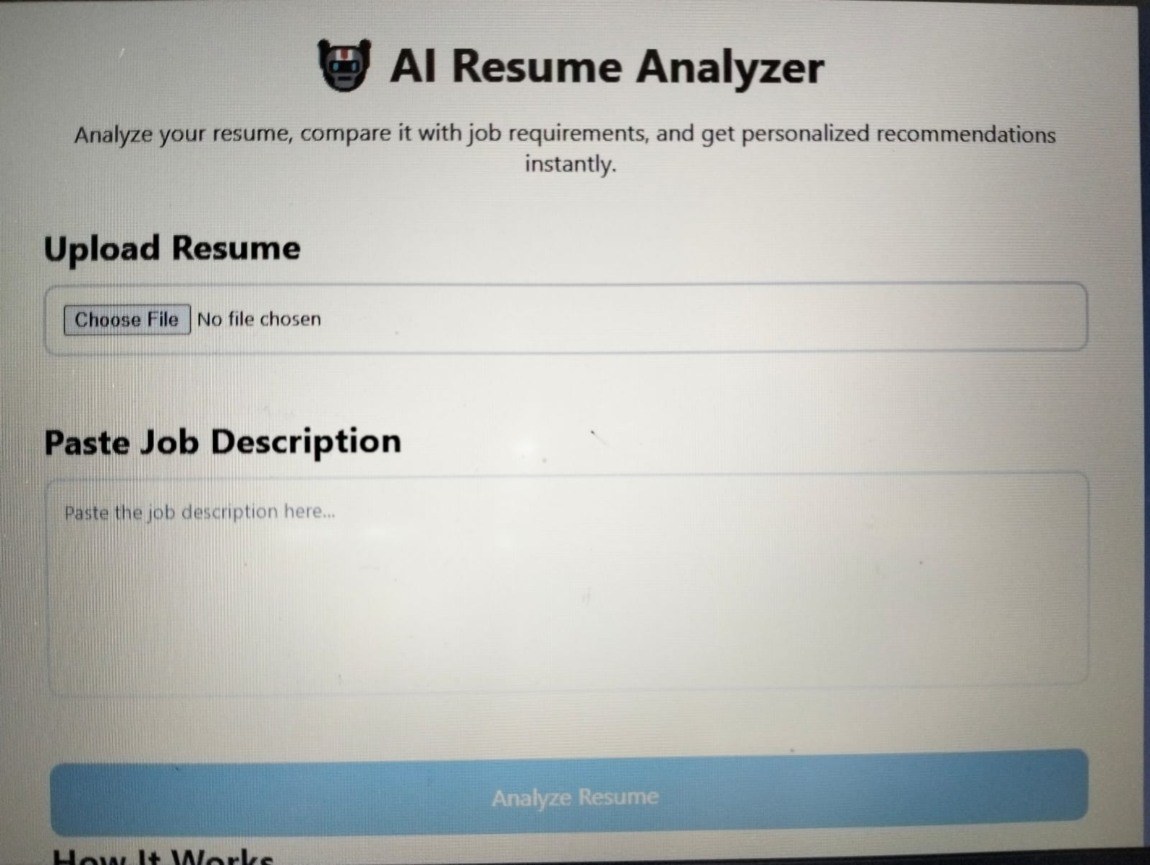
Home Page of Resume Pilot

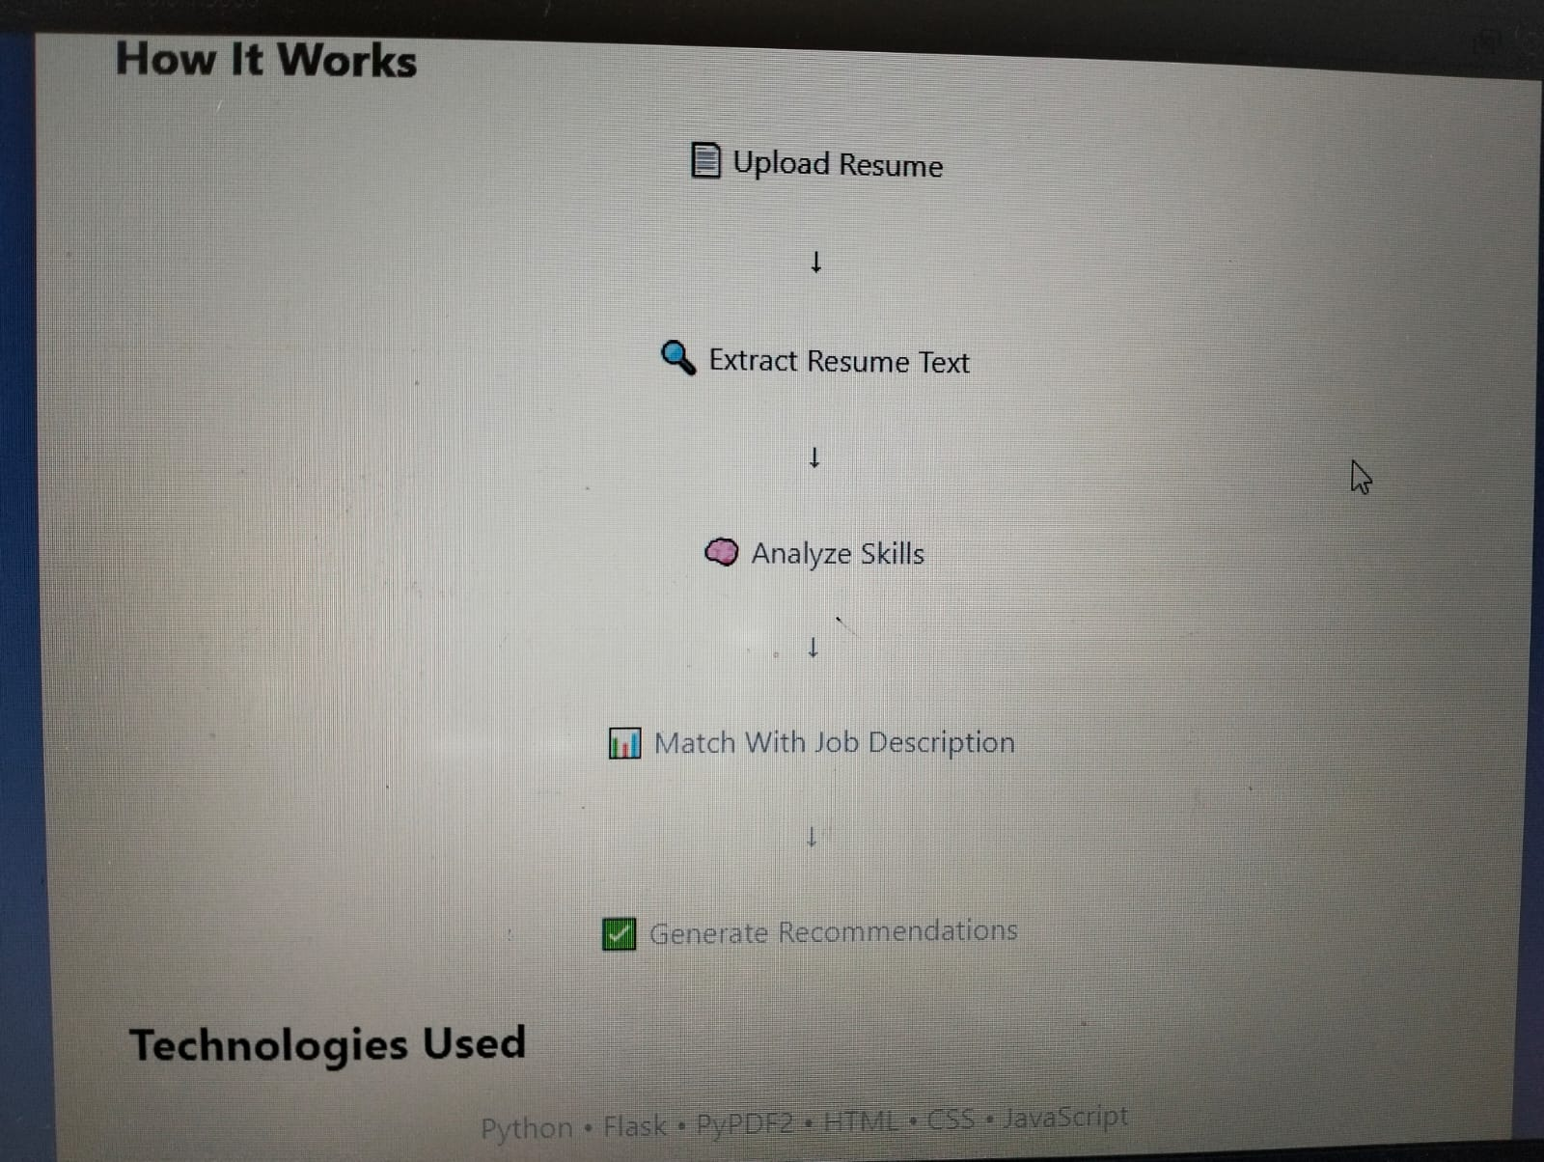
Application Workflow
