Software Requirements Specification
For
ZERO DAY MARKET
5 October 2026

Prepared by

Specialization | SAP ID | Name
AIML | 500122453 | Pranav Singh Puri
AIML | 500121992 | Bhavya Talwar
AIML | 500119603 | Dhrumi Upadhyay
AIML | 500120543 | Jahanvi Sengar

[Insert UPES logo]

School Of Computer Science
UNIVERSITY OF PETROLEUM & ENERGY STUDIES,
DEHRADUN- 248007. Uttarakhand

Topic |  | Page No
Table of Content
1 | Introduction | 3
 | 1.1 Purpose of the Project | 3
 | 1.2 Target Beneficiary | 3
 | 1.3 Project Scope | 4
 | 1.4 References | 4
2 | Project Description | 5
 | 2.1 Reference Algorithm | 5
 | 2.2 Characteristic of Data | 7
 | 2.3 SWOT Analysis | 8
 | 2.4 Project Features | 9
 | 2.5 User Classes and Characteristics | 14
 | 2.6 Design and Implementation Constraints | 15
 | 2.7 Design Diagrams | 17
 | 2.8 Assumptions and Dependencies | 23
3 | System Requirements | 23
 | 3.1 User Interface | 23
 | 3.2 Software Interface | 25
 | 3.3 Database Interface | 27
 | 3.4 Protocols | 27
4 | Non-functional Requirements | 28
 | 4.1 Performance Requirements | 28
 | 4.2 Security Requirements | 29
 | 4.3 Software Quality Attributes | 30
5 | Other Requirements | 31
Appendix A: Glossary |  | 32
Appendix B: Analysis Model |  | 33
Appendix C: Issues List |  | 34

1 INTRODUCTION

1.1 Purpose of the Project
Zero Day Market is a web platform where people learn to trade by living through real market days that have already happened. A user gets virtual money, opens a day such as 9 March 2020, when Covid fears sent Indian markets into a crash, and trades it minute by minute without knowing how the day ends.
Most beginners do not lose money because they have never read about markets. They lose it because of habits that show up under pressure: selling in a panic after a sharp fall, buying more of a stock that keeps dropping, reacting to every headline, or trading far too often. Behavioural finance has studied these habits for decades, yet a learner almost never gets told about one at the moment it happens.
That moment is what this project is built around. When a user makes a decision that fits one of six well-known mistakes, the simulation stops the clock and an AI coach explains what just happened and why it matters. The explanation only uses information that was available at that minute of the day, so the coach cannot cheat by looking ahead.
When the session ends, the user gets a scorecard. It compares their result with a few simple strategies and shows how their habits change from one session to the next.
The project has four goals:
- Give learners a safe place to practise real trading decisions on real historical events.
- Point out behavioural mistakes while they are happening, not only after the session.
- Keep a full record of every piece of AI feedback, including the data and reasoning behind it, so it can be checked later.
- Measure whether this kind of coaching actually reduces mistakes over repeated sessions.

Why trading rather than prediction: we ask users to trade through the whole day instead of making one forecast, because these mistakes appear in a run of decisions made under time pressure. A single up-or-down guess would never reveal them.

1.2 Target Beneficiary
The platform is meant for anyone who wants trading experience without risking their own money.
- Students and young professionals who are curious about the stock market but have never traded. They can sit through a crash or a rally and find out how they actually react.
- Finance and commerce students, who study ideas like loss aversion and overconfidence in class and can now see them in their own decisions.
- First-time investors who want to understand their own tendencies before they put real savings into the market.
- Teachers and training institutes, who can use the platform in class. The decision timeline shows exactly what a student did and what the coach told them.
- Researchers in financial education, who can use the study mode and the recorded decisions to test whether coaching changes behaviour.

1.3 Project Scope
Zero Day Market is an educational simulator. No real orders are placed and no real money is involved at any point.
The system covers:
- Sign-up and login with email and password, or with a Google account.
- A scenario screen with four historical trading days from two exchanges: the NSE in India and the NYSE in the United States.
- A live trading room with a running market clock, minute-by-minute prices for several stocks and indices, news headlines as they broke, buy and sell orders, positions and portfolio value.
- An AI coach made of three cooperating agents (Monitor, Research and Coach) that reviews risky decisions during the session.
- A permanent log of every action, every flagged decision and every AI run, so any session can be replayed and checked.
- A scorecard at the end of each session and a progress page that tracks results across sessions.
- A study mode that splits users into a coached group and a control group.
- Learning material: video playlists with mini-games (the Academy), a library of case studies (the Ledger) and a help assistant called ORUS.
- Hourly limits on how much AI each user can trigger.

1.4 References
- Daily price history (open, high, low, close and volume) from Yahoo Finance, used to build the TAX-19, ELEC-24 and GME-21 scenarios.
- News archives from the dates covered, used to rebuild the timeline of headlines for each day.
- Behavioural finance research behind the six mistakes the system detects:
  - Kahneman, D. and Tversky, A. (1979). Prospect Theory: An Analysis of Decision under Risk. Econometrica.
  - Shefrin, H. and Statman, M. (1985). The Disposition to Sell Winners Too Early and Ride Losers Too Long. Journal of Finance.
  - Odean, T. (1998). Are Investors Reluctant to Realize Their Losses? Journal of Finance.
  - De Bondt, W. and Thaler, R. (1985). Does the Stock Market Overreact? Journal of Finance.
  - Thaler, R. and Johnson, E. (1990). Gambling with the House Money and Trying to Break Even. Management Science.
  - Barber, B. and Odean, T. (2000). Trading Is Hazardous to Your Wealth. Journal of Finance.
  - Barber, B. and Odean, T. (2001). Boys Will Be Boys: Gender, Overconfidence, and Common Stock Investment. Quarterly Journal of Economics.
- Yao, S. et al. (2023). ReAct: Synergizing Reasoning and Acting in Language Models. ICLR 2023. This is the method the Research agent follows.
- The FinVQA-Chart study on how accurately multimodal AI models read numbers from financial charts [citation to be completed]. It is the reason none of our agents are given chart images.
- Wilder, J. W. (1978). New Concepts in Technical Trading Systems. Source of the RSI and ADX formulas we use.
- Official documentation for Next.js, React, Supabase, the Groq API and Vercel.
- The project's own design notes, kept in the code repository: roadmap, architecture decision records, evaluation results and the study protocol.

2 PROJECT DESCRIPTION

2.1 Reference Algorithm
The platform works in four stages: simulate, detect, explain and score. A deterministic engine replays the market day, fixed rules spot risky decisions, AI agents explain them, and the whole session is scored at the end.
Basic Working Algorithm
- The user logs in with email or Google.
- The user opens the Scenarios screen and picks a trading day.
- The system opens a new session and loads that day: per-minute prices for every stock and index, the headline schedule, and the exchange's hours and currency.
- The market clock moves forward one minute at a time, and prices and news update with it.
- The user places buy and sell orders. Each action is saved to the session log with a sequence number, and the log can never be edited afterwards.
- After every order, the Monitor checks six behavioural rules against the user's positions and the state of the market. If nothing matches, trading simply carries on.
- If a rule matches, the clock pauses and the browser asks the server for coaching.
- The server first checks that the user is logged in and still within their hourly limit. It then replays the stored log through the same engine to rebuild the session and runs the Monitor again. If the server does not see the same mistake, the request is turned down and no AI call is made.
- The Research agent collects evidence with five read-only tools: recent prices, indicators, the news so far, the market index and the user's position. It may make at most three tool calls, and every tool only returns data up to the current minute. Any number it reports has to come from one of those tool results.
- The Coach agent writes the feedback in a fixed JSON format, which is checked before it is shown: a short message of two or three sentences (what the mistake was, why it matters, one thing to try instead), a severity level (info, caution or warning) and one question for the user to think about.
- If an agent fails or runs out of time, the system falls back step by step: first the Coach works without Research, and if the Coach also fails, a prepared message is shown. The panel always says which of these the user is seeing.
- The flagged decision, the pipeline run and every agent's steps are written to the database.
- The clock starts again. Steps 4 to 12 repeat until the market closes or the user ends the session.
- At the end, the server replays the log once more and works out the scorecard, which is saved with the session.
- The Progress screen shows the scorecard, the comparison strategies and the user's trend over time.

Monitor rules (behavioural patterns detected)
Pattern | When it is flagged (simulated minutes) | Related bias
Panic sell | Selling a holding at a loss of 2% or more while the stock is at least 5% below yesterday's close and has kept falling over the last 15 minutes | Loss aversion
Revenge trade | Buying within 10 minutes of a losing sale, with an order at least 1.5 times as large | Break-even effect
Averaging down | Buying more of a stock you already hold at a loss of 2% or more | Disposition effect
News reflex | Placing an order within 2 minutes of a headline | Overreaction to news
Oversized position | A single purchase worth more than 30% of total equity | Overconfidence
Overtrading | Five or more orders inside 15 minutes | Overconfidence in trading

Only one pattern is reported per action, following the order of the table, and the same pattern is not reported again within 15 minutes. These limits are design choices we made for the simulation. They are not fixed values taken from research.
Scoring algorithm (end of session)
- Money: profit or loss, a Sharpe ratio for the session (average per-minute return divided by its standard deviation, not annualised), the largest drop from a peak, the share of winning trades, and the average time a position was held (matched first in, first out).
- Behaviour: how many times each pattern was flagged, flags per ten orders, and an overall discipline score.
- Comparison strategies, played through the same engine: buying everything at the open and holding it, a simple rule that sells anything 3% below its cost, and staying in cash.
- Progress over time: the slope of a straight line fitted (least squares) through the user's scores across sessions.

2.2 Characteristic of Data
The platform uses four kinds of data: historical prices, a timeline of news, technical indicators calculated from the prices, and the user's own activity.
Market price data
- For TAX-19, ELEC-24 and GME-21 we use real daily open, high, low, close and volume figures from Yahoo Finance. A script downloads them once, checks them (the four prices must be consistent, moves must be within sensible limits, later stock splits are undone) and saves them with the application along with where they came from. Nothing is downloaded while the app is running.
- Free minute-by-minute data for these old dates does not exist, so we rebuild it. For each stock, a seeded random path (a Brownian bridge) is generated that passes exactly through the real open, high, low and close of that day. Because the seed is fixed, every session of a scenario sees exactly the same prices. Stocks also move with their market index, and the volatility index moves the other way.
- COV-20 uses synthetic prices shaped to match the day, and the app says so.

Scenarios
ID | Event | Date | Exchange | Session | Prices
COV-20 | Covid Day Zero | 9 March 2020 | NSE, India (₹) | 375 min, 9:15–15:30 IST | Synthetic
TAX-19 | The Tax-Cut Rally | 20 September 2019 | NSE, India (₹) | 375 min, 9:15–15:30 IST | Real daily data, rebuilt intraday
ELEC-24 | Election Shock | 4 June 2024 | NSE, India (₹) | 375 min, 9:15–15:30 IST | Real daily data, rebuilt intraday
GME-21 | The GameStop Squeeze | 27 January 2021 | NYSE, USA ($) | 390 min, 9:30–16:00 ET | Real daily data, rebuilt intraday

News headlines: every scenario has nine or ten headlines released at set times. Where we know the facts, we use them. If the exact time is not known, the headline is marked "approximate", and background headlines we wrote ourselves are marked "Illustrative".
Technical indicators: worked out from the price series and shown to users and agents as plain numbers. We use Wilder's RSI (14 periods), simple moving averages, VWAP and Wilder's ADX (14 periods). If there is not enough history yet, the indicator is shown as unavailable instead of being guessed.
User activity data
- Action log: every order and control action, numbered in order and never changed once saved. Replaying the log rebuilds the session at any minute, a technique known as event sourcing.
- Decision events: each flagged decision, the facts that triggered it and the state just before it.
- Pipeline and agent runs: for each flagged decision, which path was taken, the feedback shown, and every agent's steps, model, token use and response time.
- Scorecards: the results of each finished session, stored as JSON.

2.3 SWOT Analysis
Strengths
- The scenarios are real market events, and three of them use real daily prices.
- Feedback arrives at the moment of the decision, while the user still remembers why they made it.
- Every AI explanation is tied to data from that minute and saved with its evidence, so anyone can check it.
- The server replays the session before spending anything on AI, so a tampered browser cannot trigger fake feedback.
- We tested the AI pipeline on a fixed set of cases and recorded the results.
- The whole platform runs on free service tiers.

Weaknesses
- Minute-level prices are rebuilt from daily data rather than recorded tick by tick, and COV-20 is synthetic.
- Four scenarios is a small library.
- On the free AI tier, the Research agent finishes about three times out of four. The rest of the time the user gets Coach-only or prepared feedback.
- AI wording can differ from one run to the next.
- In our tests, adding the Research agent did not measurably improve the feedback on the checks we used.

Opportunities
- Interest in trading and financial literacy is growing quickly among students.
- Colleges and training institutes could use it in class, helped by the decision timeline.
- The recorded decision data makes it a useful tool for research on behavioural coaching.
- New scenarios and markets can be added without touching the engine.
- Moving to a paid AI plan would remove the per-minute limits.

Threats
- AI providers can change their limits, prices or models at short notice, and a withdrawn model can break a feature until it is replaced.
- Free sources of financial data may become harder to access.
- Users might trust the AI too much, or treat the simulation as investment advice.
- Several paper-trading apps already exist.

2.4 Project Features
1. User Authentication System
Users sign up with email and password or continue with Google. An Apple button is shown on the login page but is not switched on yet. Pages that need an account send visitors to the login page, and the AI endpoints refuse requests from anyone who is not logged in.
2. Onboarding
New users pick how they want to start. Initiate begins with short lessons and drills, while Operator goes straight into a live market replay.
3. Scenario Selection
The Scenarios screen shows the four trading days. Each card gives a short briefing, the user's task, a difficulty rating, the exchange and a note on where the price data comes from.
4. Live Trading Room
This is the main screen. It has the market clock, a price chart, the stocks and indices with their change for the day, a news feed, an order ticket, open positions and portfolio value. Prices and currency follow the exchange of the scenario (₹ for NSE, $ for NYSE).
5. Guided Walkthrough and Coaching Pauses
Before the clock starts, a short walkthrough introduces the day and the controls. Early in the session, three short quiz pauses ask the user to read the market before acting.
6. AI Decision Coach
When the user makes a risky decision, the clock stops with the message "the clock is paused while the coach reviews", and the coach panel shows:
- which pattern was spotted and the facts behind it;
- an explanation based on the market data available at that minute;
- the bias involved, and whether the user has done the same thing earlier in the session or in past sessions;
- one thing to try instead, a severity level and a question to reflect on.

A small line under the feedback says whether it came from the full AI pipeline, from the Coach alone, or from a prepared message (for example, when the user has reached the hourly AI limit).
7. Prep Room (COV-20)
Before trading COV-20, users can study each stock with text-based indicators such as RSI and ADX.
8. Debrief
After the session, the Debrief gives a behavioural review and suggests Academy playlists that target the mistakes made.
9. Scorecard and Progress Dashboard
The Progress screen lists every finished session with its profit or loss, Sharpe ratio, largest drop, win rate, holding time, behaviour figures and discipline score. It also compares each session with the three simple strategies and shows the trend across sessions.
10. Decision Audit Timeline
Opening a session from the Progress screen shows every action in order. For each flagged decision it shows the state before it, the feedback given, the path taken and each agent's full trace.
11. Learning Assistance
- Academy: ten curated video playlists, each with a mini-game.
- Ledger: 67 case studies across six volumes, covering lectures, drills, simulations and analyses.
- ORUS: a help assistant on every page that answers questions about the platform and about trading, and can show diagrams.

12. Study Mode
When study mode is on, each user is put into a coached group or a control group based on a hash of their user ID. The control group gets no coaching during the session, which lets us measure what the coaching changes.
13. Usage Limits
Each user can trigger up to 40 coaching runs and 60 ORUS questions per hour, so that one person cannot use up the shared AI quota.
Landing Screen
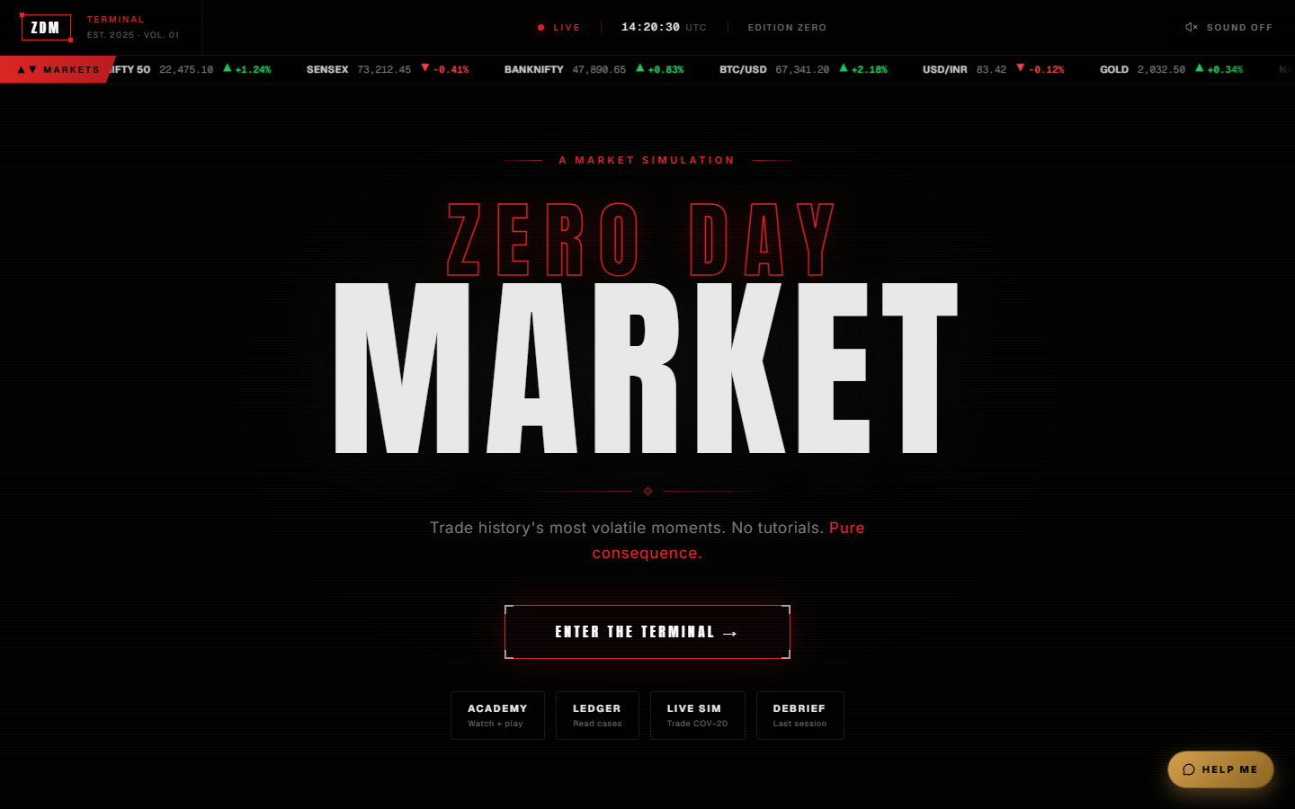
Figure 2.1 Landing Screen
The landing page is the first thing a visitor sees. It shows the Zero Day Market title over a market-terminal background with a scrolling ticker, and an "Enter the Terminal" button. Shortcuts underneath lead to the Academy, the Ledger, the live simulation and the last debrief.
User Registration / Account Creation
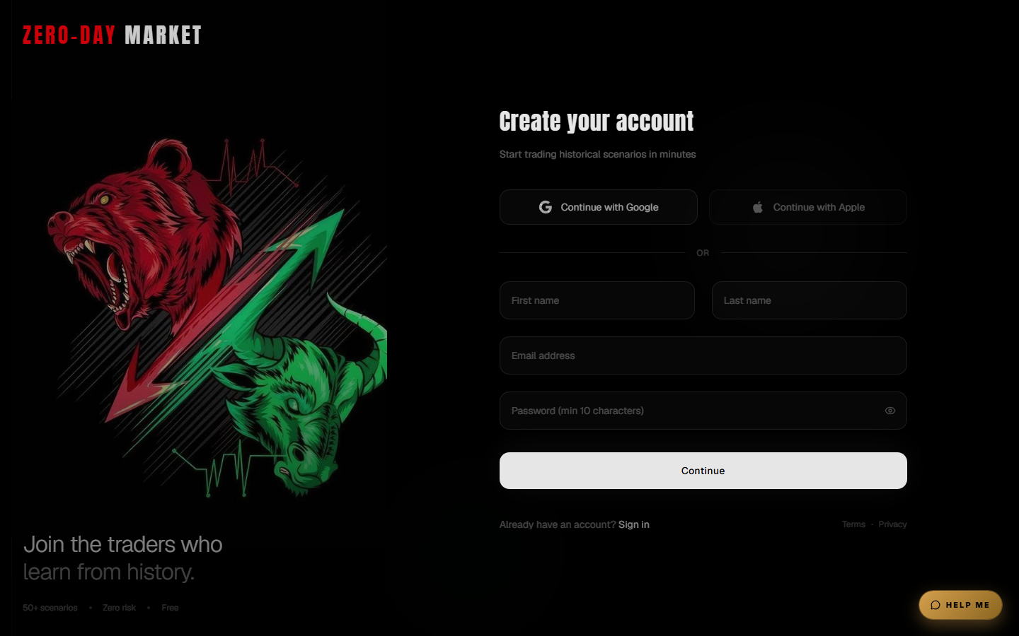
Figure 2.2 Account Creation Screen
New users create an account with their name, email address and a password of at least ten characters, or continue with Google. Every session, flagged decision and scorecard is saved against this account.
Onboarding Screen
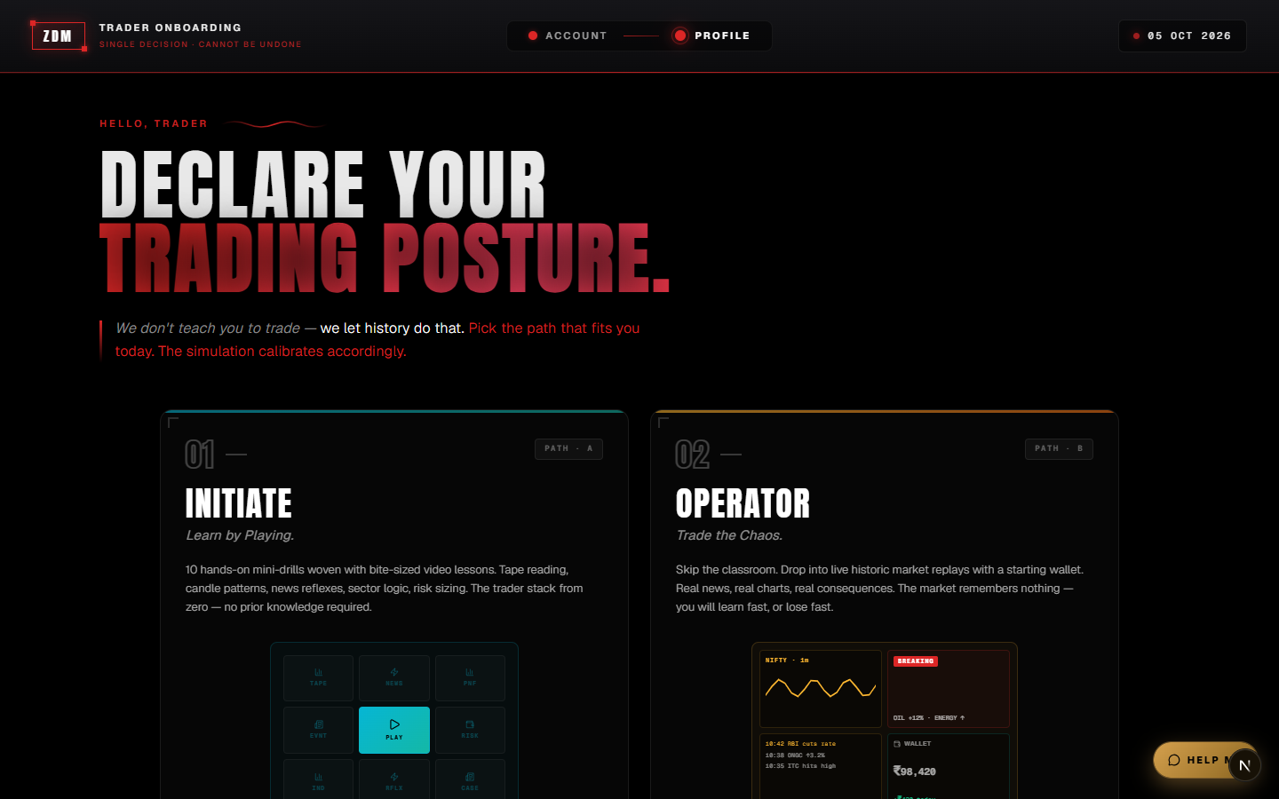
Figure 2.3 Onboarding Screen
After signing up, the user chooses a starting path. Initiate leads into bite-sized lessons and drills first; Operator drops the user straight into a market replay.
Scenario Selection Screen
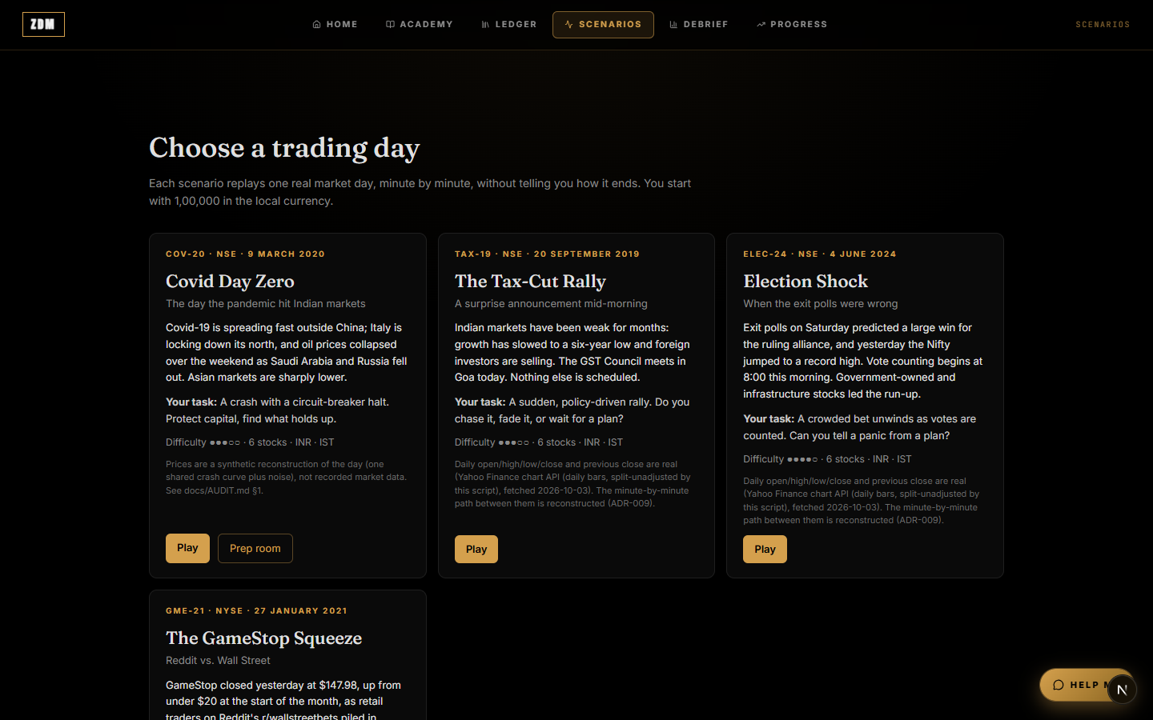
Figure 2.4 Scenario Selection Screen
Each trading day appears as a card with its date, exchange, briefing, task, difficulty and data note. The user starts a scenario with Play, and COV-20 also offers a Prep room.
Learning Hub (Academy)
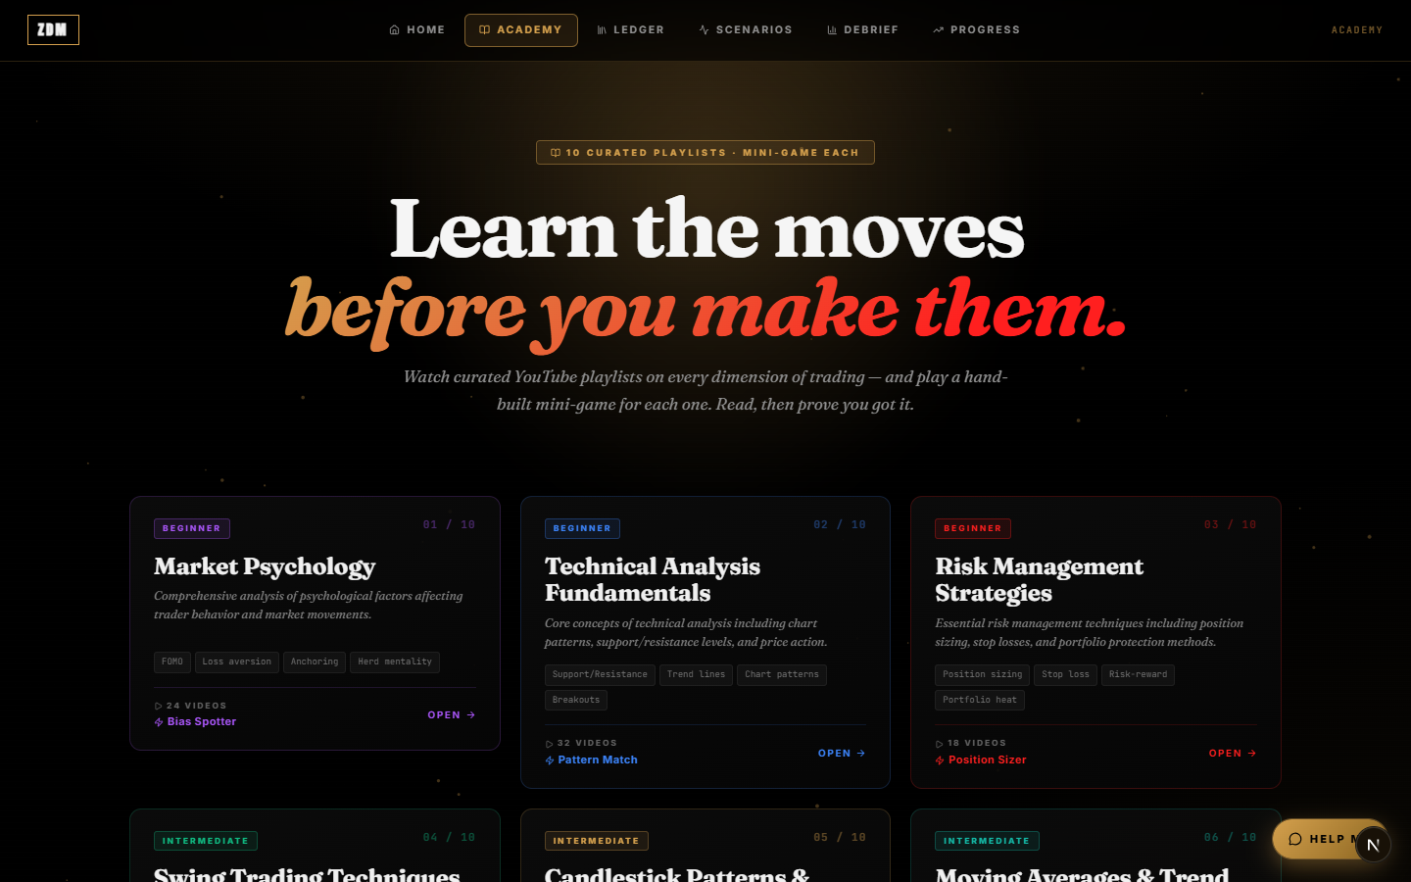
Figure 2.5 Academy Screen
The Academy groups curated YouTube playlists by topic, such as market psychology, technical analysis and risk management. Each playlist ends with a mini-game that tests what was covered.

2.5 User Classes and Characteristics
Beginner Users
People with little or no trading experience. They use the platform to learn the basics and get coached through their first market days, and most of the coach's explanations are pitched at them.
Intermediate Users
People who know some trading and analysis. They mostly use the scorecard and the comparison strategies to see whether their decisions beat simple approaches.
Advanced Users
Experienced traders. They try the harder scenarios, such as GME-21, and use the behaviour figures to check their own discipline.
Study Participants
Users who take part in the evaluation study. Each one is placed in the coached or the control group and plays several sessions on different days.
Researchers and Instructors
They review sessions through the decision timeline and analyse the recorded data in the database. There is no administrator screen inside the app; new scenarios are added by developers in code.

2.6 Design and Implementation Constraints
Hardware Constraints
Any laptop or desktop with a modern browser and an internet connection can run the platform. Nothing needs to be installed.
Software Constraints
- Frontend and server: Next.js 16 with React 19 and TypeScript. Server code runs as Next.js route handlers on Vercel's serverless functions, and each request has to finish within 30 seconds.
- Database and login: Supabase, which provides PostgreSQL with row-level security and handles authentication.
- AI models: served through the Groq API. Research uses qwen3.8-27b; the Coach and ORUS use gpt-oss-20b; the post-session debrief uses gpt-oss-120b.

External API Constraints
- On its free tier, Groq allows roughly 8,000 tokens a minute per model and 1,000 requests a day, and qwen3.8-27b is further limited to 7,000 input tokens a minute. The pipeline is built to live within these limits, using retries with back-off, the fallback steps described earlier and per-user quotas.
- Yahoo Finance is only used offline, when scenario data is prepared, so changes on their side cannot break the running system.

Design Constraints
- No looking ahead: an agent can never see data from later in the day than the current minute. The tools enforce this and it is covered by tests.
- No reading of chart images: the FinVQA-Chart study found that multimodal models often misread numbers from financial charts, so no agent is shown a chart. Every value reaches them as text.
- Grounding: any number an agent writes must come from a tool result or from the facts of the event.
- Determinism: the engine and the Monitor always give the same result for the same input, which is what lets the server replay a session and reach the same state as the browser.
- Serverless hosting: separate server instances share no memory, so usage limits are tracked in the database.

Security Constraints
Passwords and logins are handled by Supabase Auth. API keys and the database service key stay on the server and are never sent to the browser.
Network Constraints
An internet connection is needed to log in, save actions and receive coaching.

2.7 Design Diagrams

2.7.1 Use Case Diagram
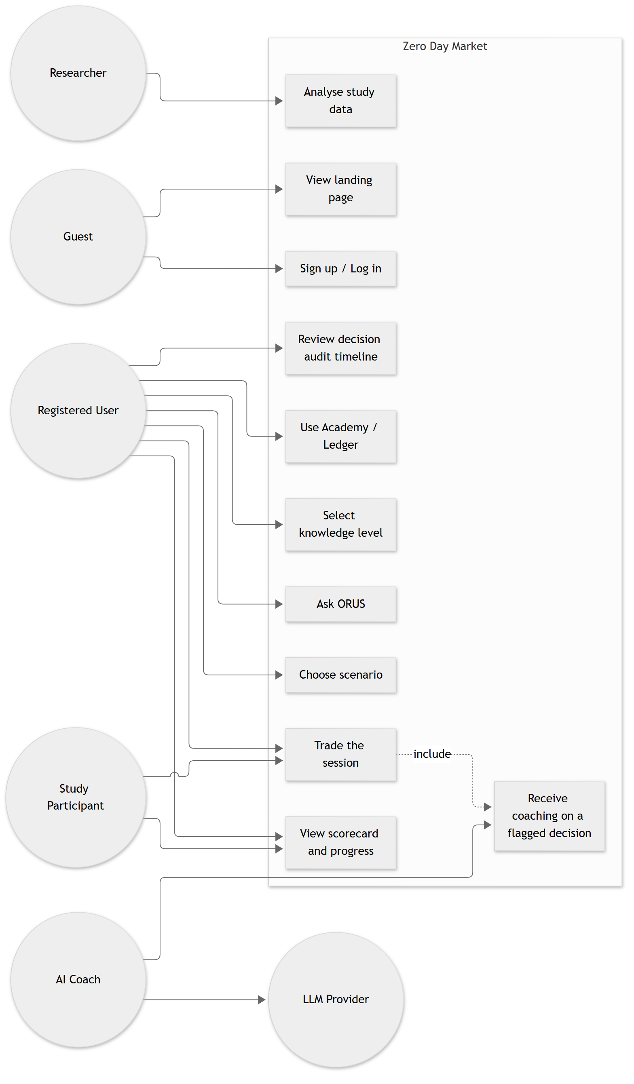
The diagram shows six actors: the Guest, the Registered User, the Study Participant, the AI Coach (made up of the Monitor, Research and Coach agents), the AI model provider (Groq) and the Researcher. A guest can view the landing page and sign up. A registered user picks a scenario, trades, gets coached, and reviews their scorecard, progress and decision timeline. Study participants do the same, except that the control group trades without coaching.

2.7.2 Class Diagram
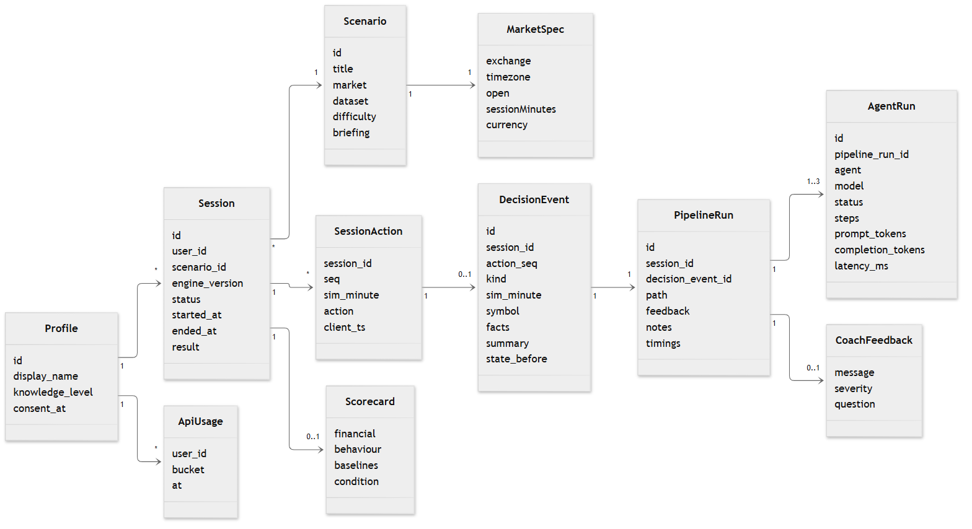
The class diagram shows how the main records relate. A session belongs to one user and one scenario and holds an ordered log of actions. An action can produce at most one decision event, each decision event has one pipeline run, and each pipeline run contains up to three agent runs. The diagram also shows the scenario's market settings, the scorecard and the coach's feedback.

2.7.3 Activity Diagram
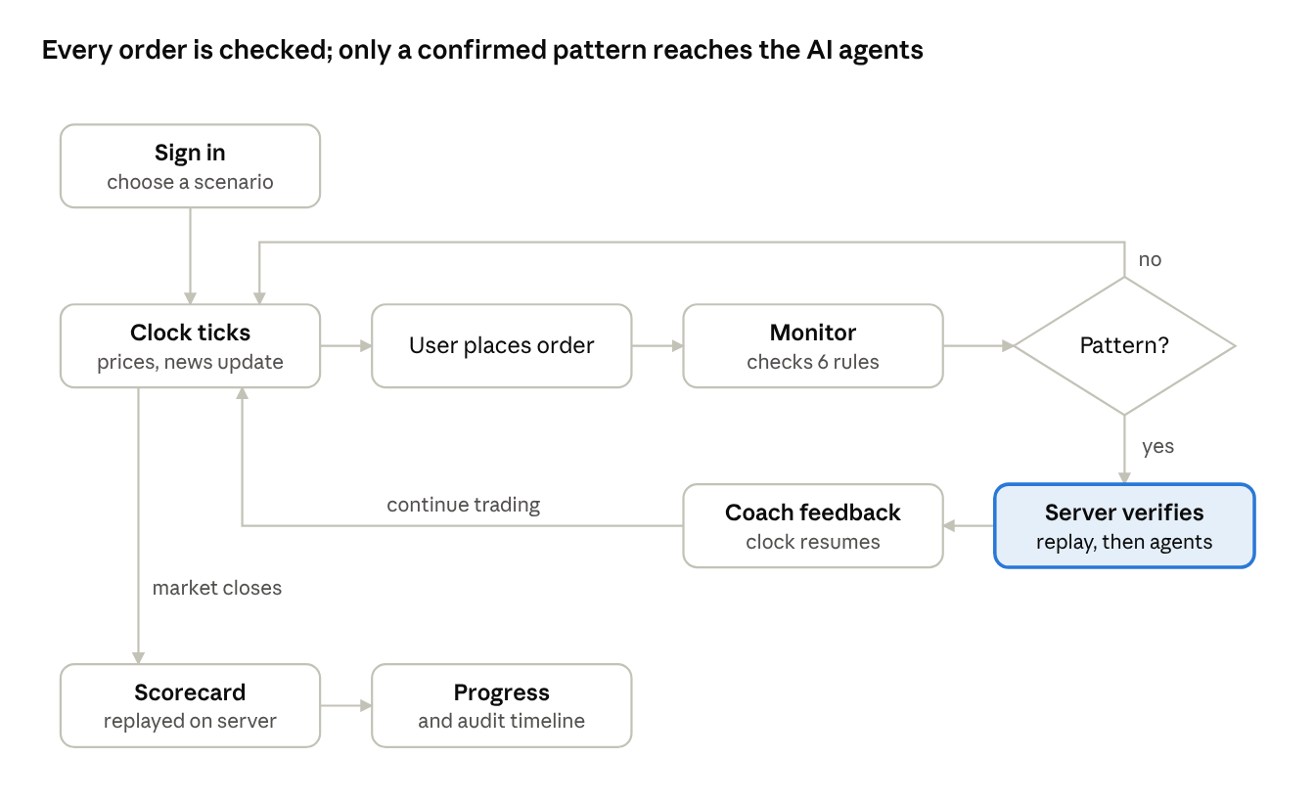
The user logs in, picks a scenario and trades while the clock runs. Every order goes past the Monitor. When a pattern is found, the clock pauses, the server checks the decision and runs the agents, the feedback appears, and trading continues. When the market closes, the scorecard is worked out.
A pattern that the server cannot confirm on replay is rejected before any AI call. Otherwise, trading goes straight back to the clock.

2.7.4 Sequence Diagram
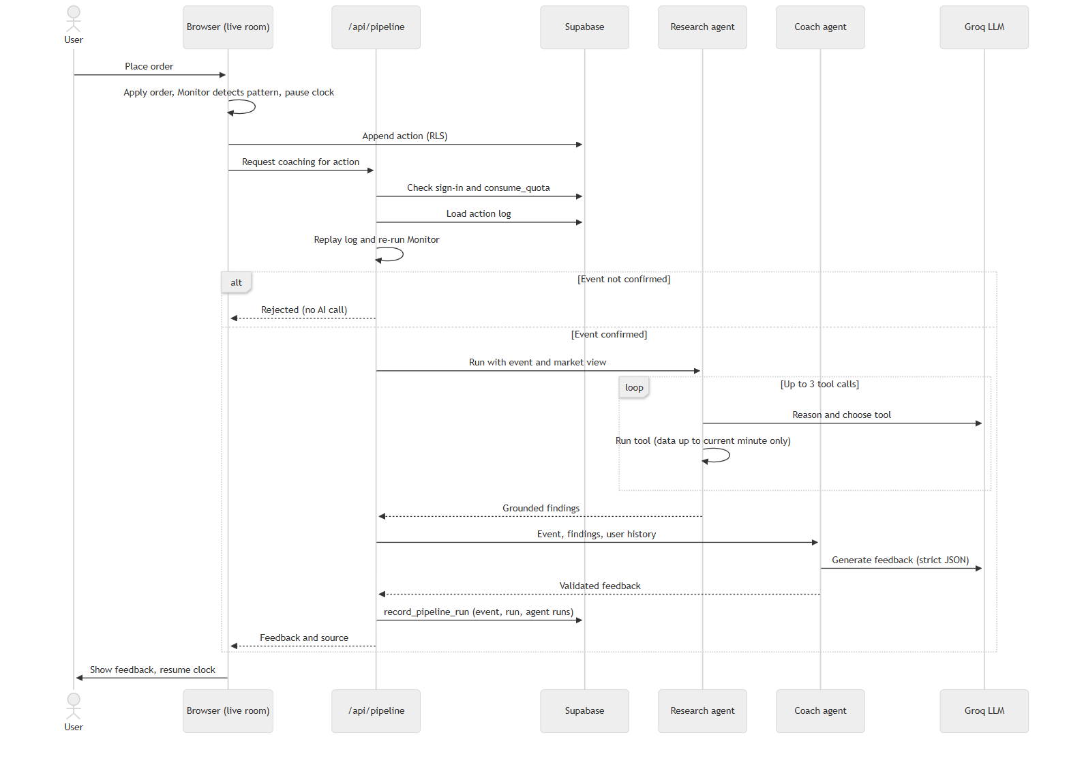
When the browser flags a decision, it asks the pipeline endpoint for coaching. The server checks the login and the user's quota, replays the action log and runs the Monitor again. Only if the mistake is confirmed does it call the Research agent and its tools and then the Coach. It saves the whole run in a single database transaction and sends the feedback back to the browser.

2.7.5 Data Flow Diagram (DFD)
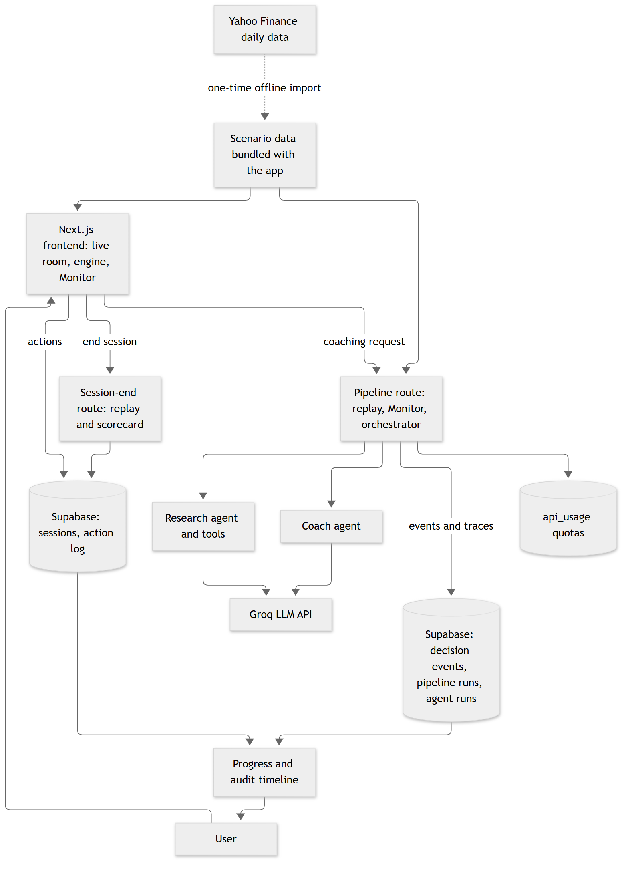
The browser runs the trading engine and the Monitor and writes each action to Supabase. Server routes replay sessions, run the agents (which call Groq), work out scorecards and keep track of quotas. Scenario data comes from a one-time offline import rather than a live data feed.

2.7.6 State Diagram
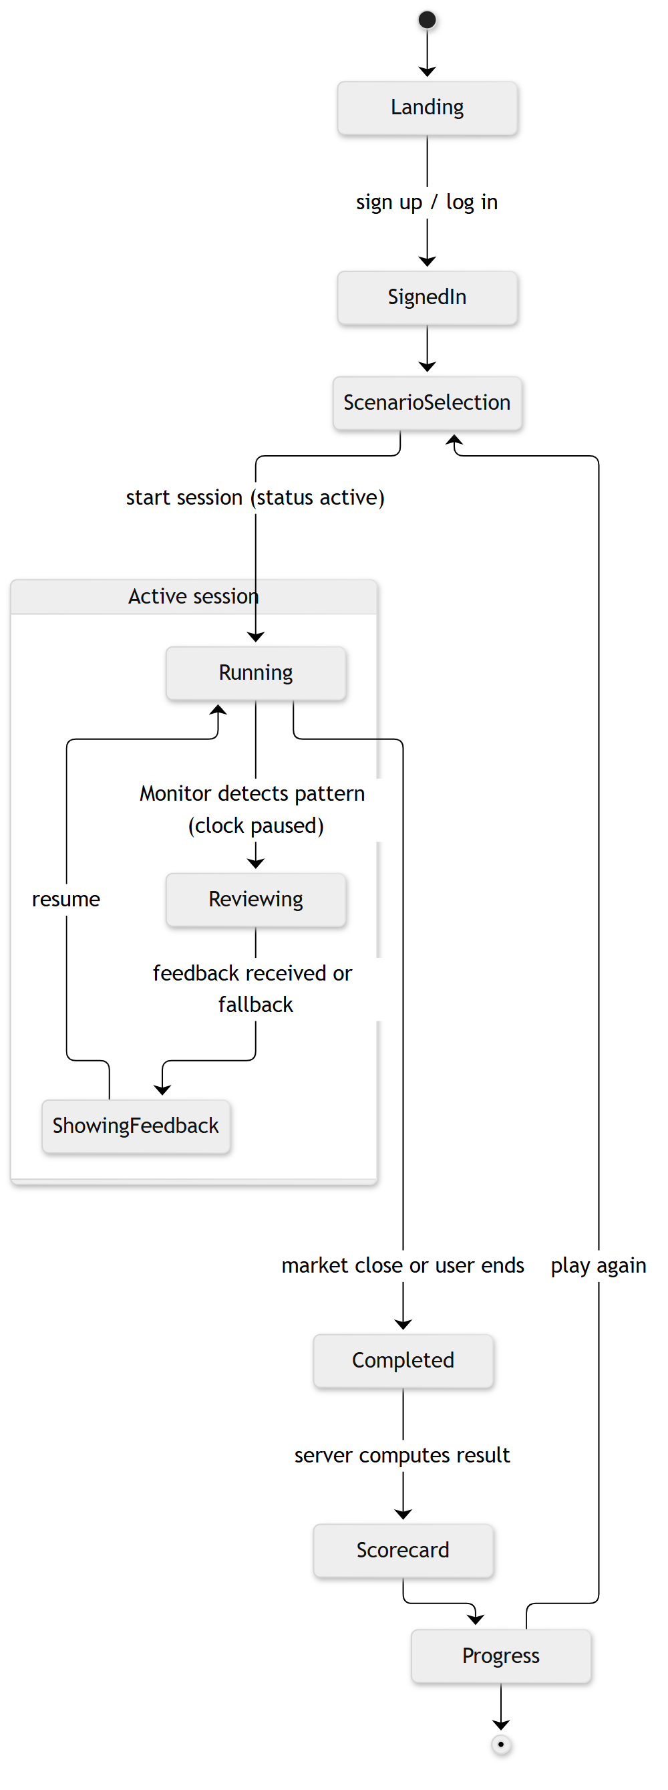
A session stays active until the market closes or the user ends it, and then it is marked completed. While it is active, the trading room moves between three states: running, reviewing (the clock is paused while the coach works) and showing feedback.

2.8 Assumptions and Dependencies
Assumptions
- Users can work a modern browser and have a steady internet connection.
- The platform is used for learning, not as a source of investment advice.
- Daily price data from public sources is accurate once it has passed our checks.
- A rebuilt minute-by-minute path that matches the real open, high, low and close is close enough to reality for practising decisions.
- The thresholds in the behavioural rules are a fair working definition of each mistake.

Dependencies
- Supabase for login, the database and access control.
- Groq for the AI models used by Research, the Coach and ORUS. If Groq is down or a limit is reached, users get prepared feedback instead.
- Vercel for hosting and serverless functions, and GitHub for source control and automated testing.
- Google for sign-in with a Google account.
- Yahoo Finance, only when new scenario data is being prepared.

3 SYSTEM REQUIREMENTS

3.1 User Interface
The interface uses a dark, trading-terminal style. It takes the user from picking a day, through trading with live coaching, to reviewing how they did.
Live Trading Interface
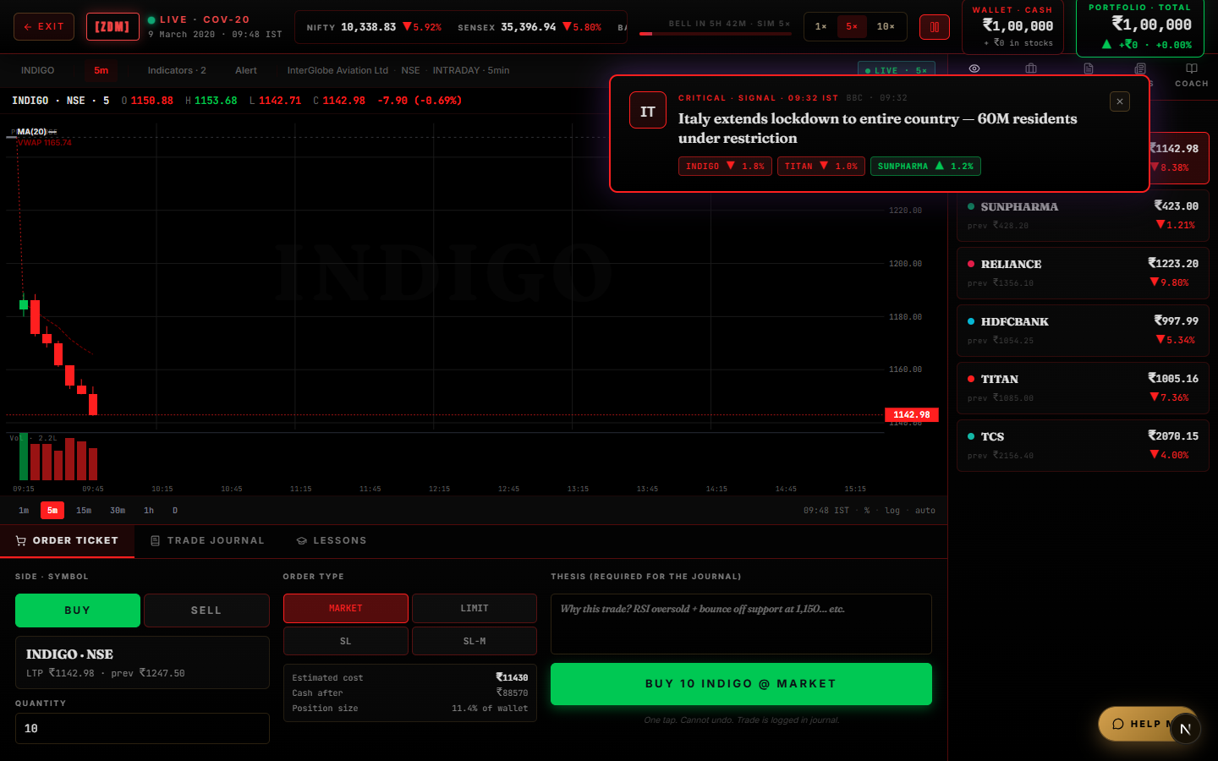
Figure 3.1 Live Trading Screen
The trading room is where the user spends most of their time. Its main parts are:
- the market clock with exchange and time zone, and a bar showing how far through the day the session is;
- a price chart for the selected stock;
- the stocks and indices, each with its price and change for the day;
- a news feed where headlines appear as they break;
- an order ticket for buying and selling, and the user's positions with average cost and profit or loss;
- cash and total portfolio value.

AI Coach Panel
[Insert screenshot of a coach message]
Figure 3.2 AI Coach Panel
The panel appears when a decision is flagged. It first shows that the clock is paused while the coach reviews, then the feedback itself, and finally a line saying where the feedback came from.
Progress Interface
[Insert screenshot of /progress after a completed session]
Figure 3.3 Progress Screen
Each finished session gets a card with its profit or loss, Sharpe ratio, largest drop, win rate, holding time, behaviour figures and discipline score, set against buy-and-hold, the stop-loss rule and cash. A trend line across sessions sits underneath.
Decision Audit Timeline Interface
[Insert screenshot of a session timeline]
Figure 3.4 Decision Audit Timeline Screen
This screen lists every logged action in order. For each flagged decision, it shows the state beforehand, the feedback given, the path taken and each agent's steps, including tool calls, model, tokens and time taken.
Debrief Interface
[Insert screenshot of a debrief after a session]
Figure 3.5 Debrief Screen
The debrief reviews the session's behaviour and recommends learning material for the mistakes that came up.

3.2 Software Interface
The system follows a client–server design, built as a single Next.js application. The browser runs the interface, the trading engine and the Monitor. Anything that has to be trusted, including the AI agents, runs on the server.
Frontend Interface
The frontend is built with Next.js 16 (App Router), React 19 and TypeScript and styled with Tailwind CSS. Charts are drawn with lightweight-charts and animations use framer-motion. The trading engine is a deterministic state machine that applies each action to the session state, and the same code runs on the server when a session is replayed.
Backend Interface
The backend is a set of Next.js route handlers that run as Vercel serverless functions:
Endpoint | Method | Purpose
/api/pipeline | POST | Confirms a flagged decision by replay, then runs Monitor, Research and Coach
/api/sessions/end | POST | Closes a session, replays it and saves the scorecard
/api/chat | POST | The ORUS help assistant
/api/debrief | POST | Writes the post-session review
/api/tutor, /api/copilot, /api/feedback, /api/portfolio-feedback, /api/sentiment | POST | Other learning and assistance features

Every AI endpoint needs a logged-in user and counts towards the hourly limits. Starting a session and saving actions happen straight from the browser through the Supabase client, protected by row-level security.
External API Integration
- Groq API: chat completions with tool calling and JSON-schema output, called only from the server.
- Supabase: database and authentication.
- Google OAuth 2.0: sign-in with Google, through Supabase Auth.
- Yahoo Finance: used only by an offline script that prepares scenario data.

AI Agent Interface
All agents share one interface that defines their name, model, limits, prompt and output format.
Agent | How it works | Model | Limits
Monitor | Fixed rules, no AI model | — | Finishes in milliseconds
Research | Reason-and-act loop with tools | qwen3.8-27b | 4 steps (3 tool calls and a final answer), 9 s, 5,000 tokens per run
Coach | One call with structured output | gpt-oss-20b | 2 attempts (answer and one repair), 3 s

The Research agent's tools are all read-only, and none of them can see past the current minute:
Tool | Returns
get_price_window | Recent prices of a stock
get_indicators | RSI, moving averages, VWAP and ADX
get_news | Headlines released so far
get_market | The market index and the volatility index
get_position | The user's holding in a stock

The whole pipeline has 12 seconds to finish, and the last 3 seconds are kept free for the Coach.

3.3 Database Interface
Data is stored in PostgreSQL, hosted by Supabase. Row-level security rules make sure each user can only read and write their own records, and every change to the schema goes through a numbered migration file.
Table | What it stores
profiles | User ID (linked to Supabase Auth), display name, knowledge level, consent time, creation time
sessions | Session ID, user, scenario, engine version, status (active, completed or abandoned), start and end times, scorecard (JSON)
session_actions | The action log: session, sequence number, simulated minute, action (JSON), browser time and server time; rows are never changed
decision_events | Each flagged decision: session, action number, pattern, simulated minute, stock, facts (JSON), summary and the state before the action
pipeline_runs | One per coaching request: the decision, the path taken (full, monitor only, template or rejected), feedback shown, notes and timings
agent_runs | One per agent in a run: which agent, model, status, error, steps (JSON), tokens used and response time
api_usage | The user, the type of request (pipeline or ORUS) and the time of each AI request, used for rate limits; users cannot read or write it directly

Database functions
- record_pipeline_run: saves a decision event, its pipeline run and its agent runs together in one transaction.
- consume_quota(bucket, max, window): records one request for the calling user and returns false once the hourly limit is reached. It locks per user and request type, so two requests at the same moment cannot both slip past the limit.
- forbid_update and check_action_order: triggers that stop the action log from being edited and make sure sequence numbers go up by one and simulated time never runs backwards.

3.4 Protocols
HTTP/HTTPS Protocol
All traffic between the browser, the server, Supabase and Groq is sent over HTTPS.
REST API Communication
The frontend talks to the server routes with JSON requests and responses. The server checks every request body and replies with standard status codes: 401 when the user is not logged in and 429 when the hourly limit has been reached.
Authentication Protocol
When a user logs in, Supabase Auth issues a signed JSON Web Token that is kept in secure cookies. The server reads it on every request, and the database uses it to apply row-level security. Google sign-in uses OAuth 2.0.
AI Model Communication
The server calls Groq's chat-completions API over HTTPS, and the API keys never leave the server. Answers that must follow a structure are requested in JSON-schema mode and checked again with Zod. If Groq returns a rate-limit or temporary error, the server waits and retries with exponential back-off, respecting the retry time Groq suggests up to a set maximum.
Data Synchronization
Every user action is written to the log as it happens, with a sequence number, and the database enforces the order. Because the server can rebuild any session from this log, neither the server's view of a session nor the scorecard depends on numbers sent by the browser.

4 NON-FUNCTIONAL REQUIREMENTS

4.1 Performance Requirements
- Prices and the clock must update smoothly. The engine and the Monitor run in the browser and take only milliseconds per action.
- Scenario data ships with the app, so opening a scenario never waits on an outside data service.
- Coaching has to arrive while the user is still happy to wait on a paused clock:
  - the server pipeline has a 12-second limit, with up to 9 seconds for Research and 3 seconds kept for the Coach;
  - the browser waits no more than 20 seconds before showing prepared feedback;
  - in our evaluation, a full pipeline run took 2.7 seconds and about 7,200 tokens on average.
- Research tools only look up data already in memory and must answer within 1 second.
- Server functions must finish inside Vercel's 30-second limit.
- Many users must be able to play at once. The real bottleneck is the shared AI quota, which is protected by per-user limits of 40 coaching runs and 60 ORUS questions an hour.

4.2 Security Requirements
User Authentication
Users have to log in before they can play a scenario or use any AI feature. Protected pages redirect to the login page, and AI endpoints answer 401 when there is no valid session.
Data Protection
Passwords are handled entirely by Supabase Auth and stored only as hashes; the application itself never sees them. The platform collects no financial or payment details.
Secure Communication
Everything is sent over HTTPS.
Access Control
- Row-level security lets each user read and write only their own profile, sessions, actions and audit records.
- Once an action is in the log, it cannot be edited.
- Audit records can only be written by a database function that runs on the server.

Server-side Verification
The server never takes the browser's word that a mistake happened. It replays the saved log and runs the Monitor again before spending any AI quota, and it works out the scorecard the same way.
Secret Management
AI keys and the database service key are kept in server-only environment variables and never reach the browser. A demo mode that skips login exists for local development only and must never be turned on in production.
Abuse Prevention
Hourly limits per user, enforced inside the database, cap how much AI a single person can use. If the limit check itself breaks, requests are allowed through so that coaching keeps working (fail open). The login check, on the other hand, always blocks when something goes wrong (fail closed).
Protection Against Common Attacks
- All database access goes through the Supabase client with parameterised queries, which prevents SQL injection.
- React escapes text before displaying it. AI replies are shown using a small, safe set of formatting, and raw HTML is never rendered, which guards against cross-site scripting.
- Request bodies and every AI output are checked against a schema.

AI Safety
- Agents can only read data up to the current simulated minute.
- Every number in the feedback must trace back to a tool result or the facts of the event.
- The feedback is educational and must not be presented as investment advice.

4.3 Software Quality Attributes
Reliability
The coach must always say something. If an agent fails, the fallback steps (Coach without Research, then a prepared message) still give the user feedback, and the panel says which one it is. In our evaluation, the fallback caught every Research failure.
Correctness and Testability
- The engine, Monitor, scoring and scenario data are deterministic and covered by 390 automated tests that run on every push.
- The scenario tests check that each stock's real open, high, low and close come out exactly, and that replaying a session gives the same result as playing it live.
- We measured the AI's quality on a fixed set of 15 test cases across four versions of the system:

System version | Patterns detected | Feedback checks passed (7 checks)
Full pipeline (Monitor, Research, Coach) | 15 / 15 | 99%
Without Research (Monitor, Coach) | 15 / 15 | 98%
One prompt, no Monitor | 13 / 15 | 89%

Auditability
Every piece of AI feedback can be traced back to the decision that caused it, the data the agents looked at, and each agent's steps.
Usability
The interface uses plain language and shows prices in the scenario's own currency and time zone. It pauses the clock during coaching so the user is not punished for reading, and it says clearly when feedback is a prepared message rather than an AI answer.
Maintainability
The engine, Monitor rules, agents, orchestrator, scoring and scenarios each live in their own module, and all agents share one interface. Major design decisions are written up as architecture decision records.
Scalability
Serverless functions scale with traffic, and per-user data is indexed for the queries the app runs. Going beyond the free AI tier needs a paid plan but no code changes.
Portability
The platform runs in any modern browser on any operating system.
Flexibility
A new scenario only needs a manifest (dates, market, stocks and headlines) and its daily price data; the engine stays the same. New Monitor rules or agents can be added through the existing interfaces.

5 OTHER REQUIREMENTS
Data Accuracy and Provenance
Historical prices must be checked before use and stored with their source. Anything rebuilt, synthetic or illustrative must be labelled as such inside the app.
Educational Support
The platform must offer learning material (Academy, Ledger and ORUS), and the coach must name the bias behind each mistake along with its classic research reference, so that feedback leads naturally into learning.
Evaluation Requirements
- Any change to an agent or prompt must be tested against the fixed evaluation cases before it is kept. If it scores worse, it is rolled back.
- The study must compare a coached group with a control group over repeated sessions, following the written study protocol.

Research Ethics
Study participants must give informed consent before they take part, and their data must be analysed without revealing who they are.
Disclaimer
Zero Day Market is an educational simulation. It does not give investment advice, and results in the simulator say nothing about how someone would do in a real market.
Scalability and Usability Requirements
The platform should be able to take on more users and scenarios without disturbing existing features, and it should stay easy to use for beginners and experienced traders alike.

Appendix A: Glossary
Term | Meaning
Agent | One component of the AI coach. The Monitor uses fixed rules; Research and the Coach use a language model.
API (Application Programming Interface) | A defined way for two pieces of software to talk to each other.
Audit trail | The saved record of each flagged decision, the data used and each agent's steps.
Baseline | A simple strategy (buy and hold, a stop-loss rule, or staying in cash) played through the same day for comparison.
Brownian bridge | A random path that is forced to start and end at given values. We use it to rebuild minute-level prices that match the real daily open, high, low and close.
Candlestick chart | A chart showing the open, high, low and close price for each time period.
Coach agent | The agent that writes the feedback the user reads.
Event sourcing | Saving every action in order and rebuilding the state by replaying them, instead of saving only the latest state.
Fallback | The simpler response used when an agent fails: the Coach without Research, then a prepared message.
Grounding | The rule that every number in an AI answer must come from data the AI was actually given.
LLM (Large Language Model) | An AI model that generates text. Used here by Research, the Coach and ORUS.
Maximum drawdown | The biggest fall in portfolio value from a peak during the session.
Monitor | The rule-based component that spots the six behavioural mistakes.
Orchestrator | The server component that runs the agents in order and handles fallbacks.
ReAct | A method where a language model alternates between reasoning and calling tools. The Research agent works this way.
Research agent | The agent that gathers market evidence about a flagged decision.
Row-level security (RLS) | A database feature that limits each user to their own rows.
Scenario | A recreated historical trading day.
Sharpe ratio | Average return divided by how much it varies; a higher value means more return for each unit of risk.
Technical indicators | Calculations on price and volume, such as RSI, moving averages, VWAP and ADX, used to read trends.
Token | A small piece of text that a language model processes. Provider limits are counted in tokens per minute.

Appendix B: Analysis Model
The system is split into four layers. The simulation layer runs in two places: in the browser so trading feels instant, and on the server so every flagged decision can be checked.
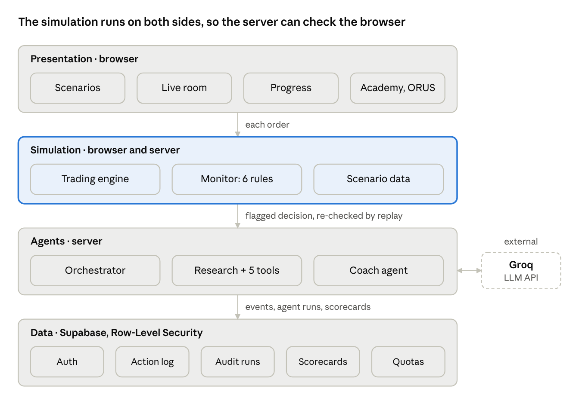
- Presentation layer (browser): the pages for scenarios, the trading room, the coach panel, progress, the decision timeline and learning content.
- Simulation layer (browser and server): the deterministic trading engine and the Monitor.
- Agent layer (server): the orchestrator, the Research agent with its tools, and the Coach, which call the Groq API with retries, time and token budgets, grounding checks and output validation.
- Data layer (Supabase): profiles, sessions, the action log, decision events, pipeline and agent runs, scorecards and usage counts, all protected by row-level security.

Appendix C: Issues List
The main open issues and limitations as of October 2026:
- The coaching study has not been run yet. The tools and the protocol are ready, but participants still need to be recruited.
- Prices are partly rebuilt: COV-20 is synthetic, and the minute-level paths of the other scenarios are rebuilt from daily data.
- Free-tier AI limits: the Research agent finishes about three times out of four, and the per-minute limit is shared by every user.
- Research has not yet proved its value: in testing, it did not improve the feedback on the checks we used.
- AI wording varies: spotting a mistake is deterministic, but how the feedback is phrased is not.
- Rule thresholds are design choices rather than measured values.
- Still to do: complete the FinVQA-Chart citation and add a consent screen before the study begins.

