5. RESULTS AND DISCUSSION
This chapter presents the results obtained from the implementation and testing of ZERO-DAY MARKET. It covers the visual output of each major screen, a performance analysis of the system under realistic usage conditions, and a comprehensive evaluation of the project outcomes against the original objectives.
5.1 Output Screens
The following sub-sections present annotated screenshots of every major screen in the application, accompanied by a description of the UI/UX flow and a walkthrough of the complete user interaction sequence.
5.1.1 Landing Page — Cinematic Splash Screen
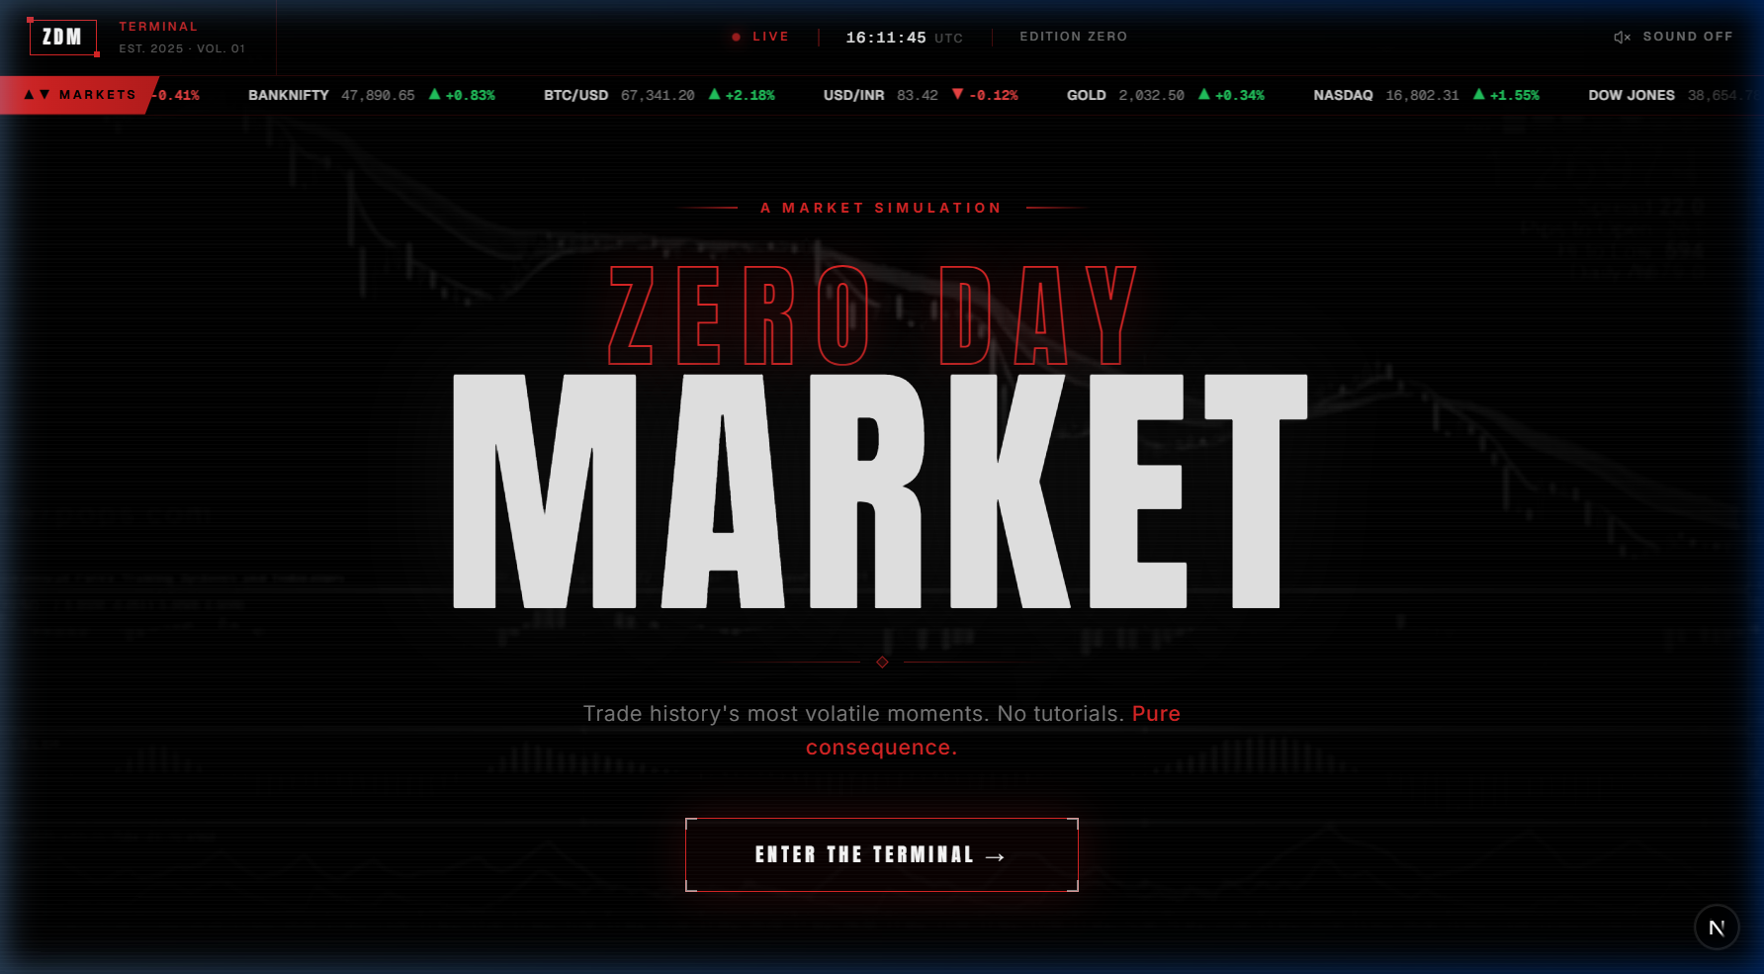
Figure 5.1: ZERO-DAY MARKET Landing Page (/) — Cinematic full-screen video background with real-time market ticker
The landing page (route /) is the first screen a visitor encounters. It is designed to create an immediate premium impression through a combination of cinematic visual elements. The full-screen background displays a looping trading floor video with a radial gradient vignette overlay. A live UTC clock updates every second. A horizontally scrolling market ticker at the top displays twelve real-time symbols including NIFTY 50, BTC/USD, SENSEX, and VIX, with green (positive) and red (negative) directional arrows.
The hero section features the brand name rendered in a large Anton typeface with a hollow red stroke effect. The tagline 'Trade history's most volatile moments. No tutorials. Pure consequence.' communicates the application's philosophy. A sound toggle button in the top-right corner allows users to unmute the ambient audio. The primary call-to-action button, labelled ENTER THE TERMINAL, navigates to the signup page when clicked. All visual elements animate in sequentially using Framer Motion with staggered delays spanning approximately 2.5 seconds.
5.1.2 Authentication Page — Signup and Login
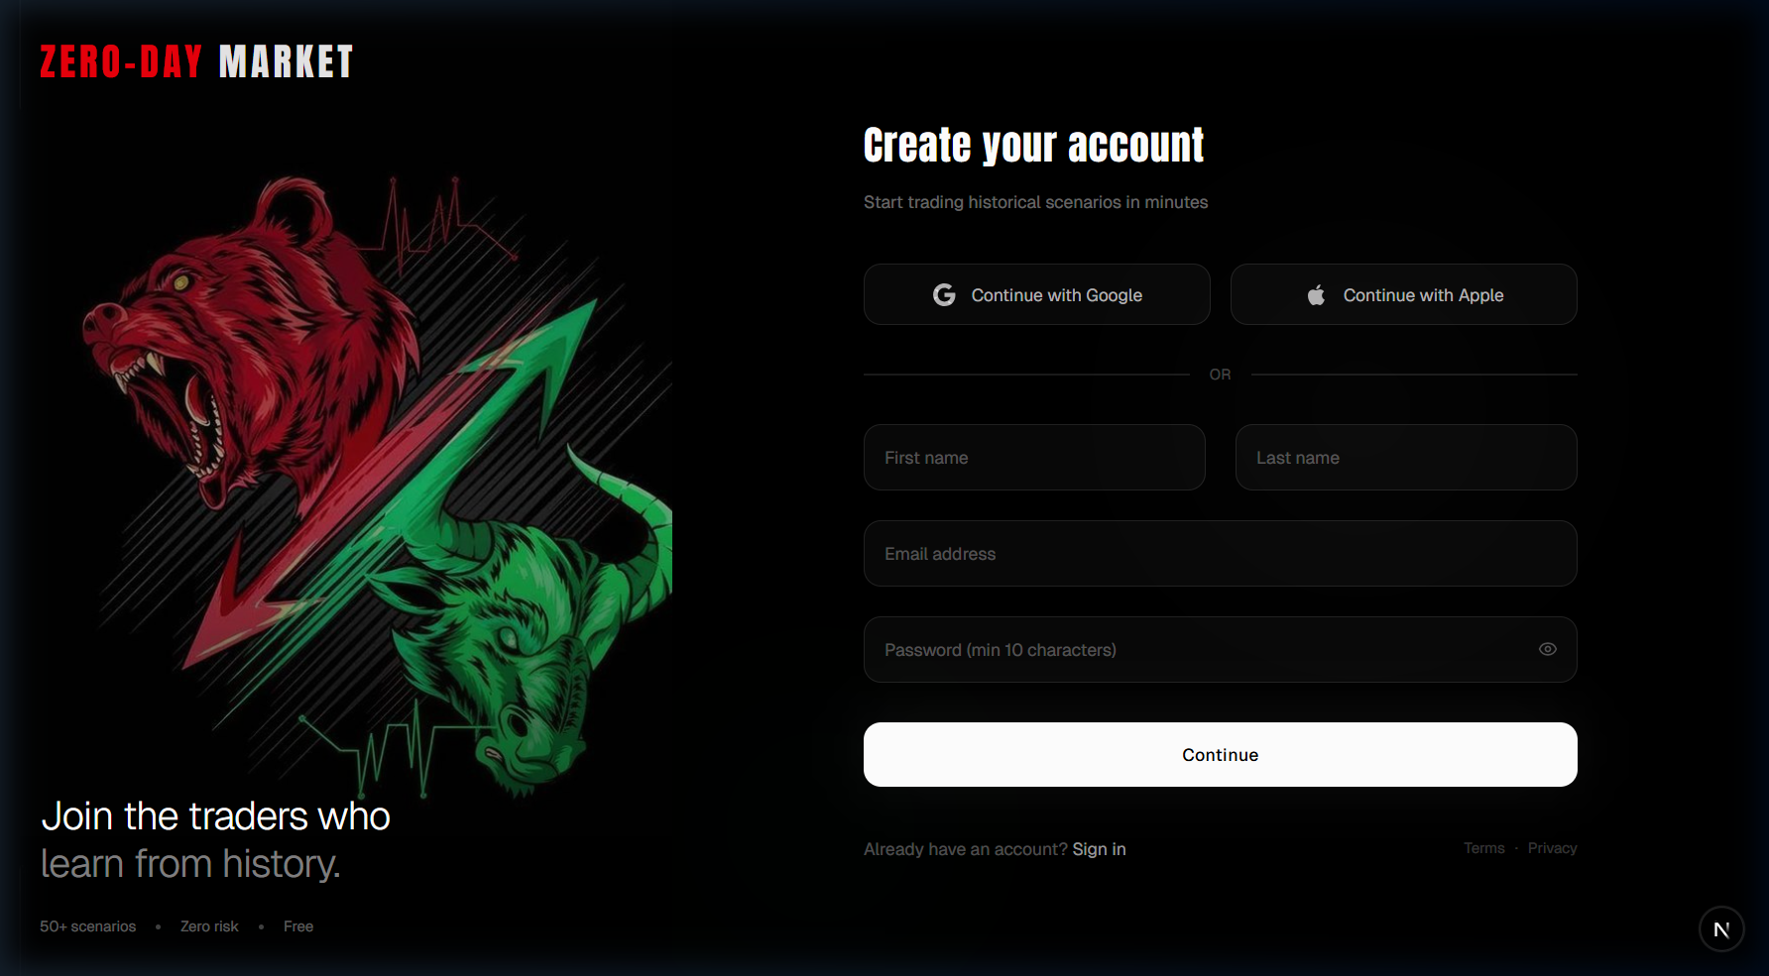
Figure 5.2: Signup Page (/signup) — Split-panel layout with OAuth and email/password authentication
The signup page adopts a full-viewport split-panel layout. The left panel features the application logo, the tagline 'Join the traders who learn from history', and three trust indicators: '50+ scenarios', 'Zero risk', and 'Free'. A custom AI-generated illustration of a bear market figure forms the visual centrepiece of the left panel.
The right panel presents the authentication form. Users may sign up via Google OAuth, Apple OAuth, or a traditional email and password form. The password field enforces a minimum of ten characters. On successful account creation, Supabase Auth issues a secure, cookie-based session and redirects the user to the welcome screen. Returning users are directed to the Sign In link, which presents the same form in login mode. The middleware prevents authenticated users from revisiting this page, redirecting them automatically to the dashboard.
5.1.3 Scenario Library — The Ledger
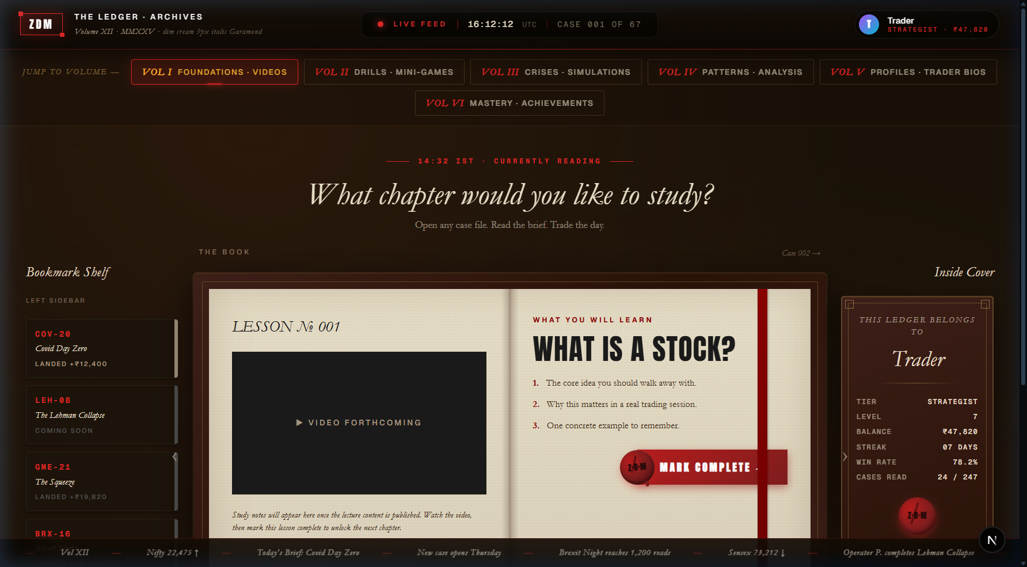
Figure 5.3: Scenario Library (/ledger) — Antique book-style interface with bookmark shelf, case browser, and trader profile
The Scenario Library, referred to in the interface as The Ledger, presents the collection of ten historical trading scenarios. The design language adopts an antique book or academic dossier metaphor, rendered against a dark sepia-toned background. The left panel displays a Bookmark Shelf with previously played scenarios and their recorded P&L outcomes. The central panel shows the currently selected case in a book-page format, including the lesson title, learning objectives, and a Mark Complete button.
The top navigation bar offers six volume tabs (Foundations, Drills, Crises, Patterns, Profiles, Mastery) categorising the available content. The right panel displays the user's Trader Profile Card, showing tier, level, balance, streak, win rate, and cases completed. A persistent bottom ticker scrolls market chronicle headlines. Clicking any case card triggers a full-screen briefing overlay that presents the scenario dossier before the user proceeds to the Prep Room.
5.1.4 Prep Room — Pre-Trade Briefing Dossier
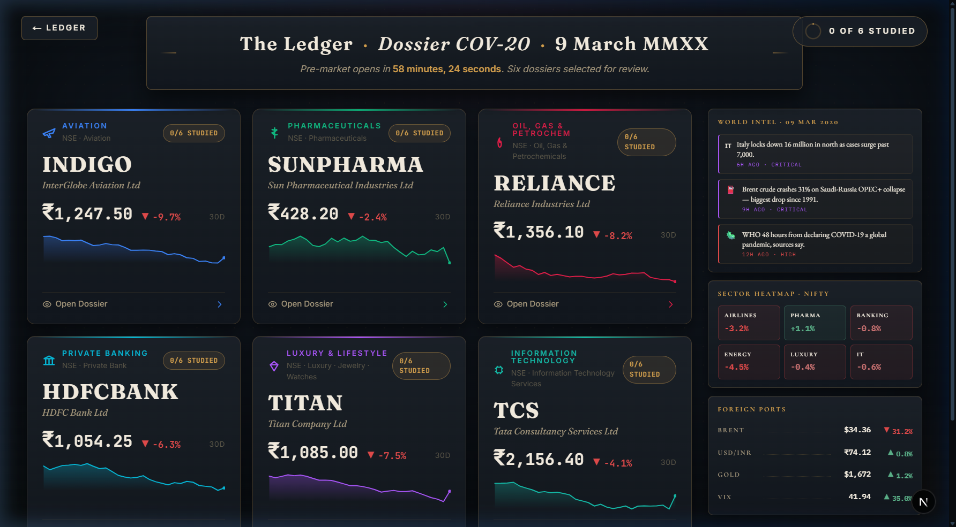
Figure 5.4: Prep Room (/sim/[id]/prep) — COV-20 stock dossier cards with prevClose prices, 30-day sparklines, and macro intelligence rail
The Prep Room is the intelligence-gathering phase preceding the live simulation. For the COV-20 scenario (March 9, 2020), six stock dossier cards are presented in a two-row grid. Each card displays the stock ticker, company name, sector classification, previous closing price, a colour-coded 30-day sparkline, a 30-day percentage performance figure, and a study progress indicator (e.g., 0/6 STUDIED).
The right panel contains the Macro Intelligence Rail, which shows three pre-market news headlines classified by severity (CRITICAL, HIGH, MEDIUM) alongside a Sector Heatmap showing expected sectoral moves (Airlines -3.2%, Pharma +1.1%, Banking -0.8%, Energy -4.5%) and a Foreign Ports panel with commodity and currency benchmarks (Brent at $34.36, down 31.2%). Clicking any stock card opens a detailed dossier modal. An AI Tutor drawer, accessible from the sidebar, allows the user to ask questions about any artifact. Once satisfied with their research, users click the Deploy Wax Seal button to enter the live simulation.
5.1.5 Live Trading Room — Real-Time Simulation
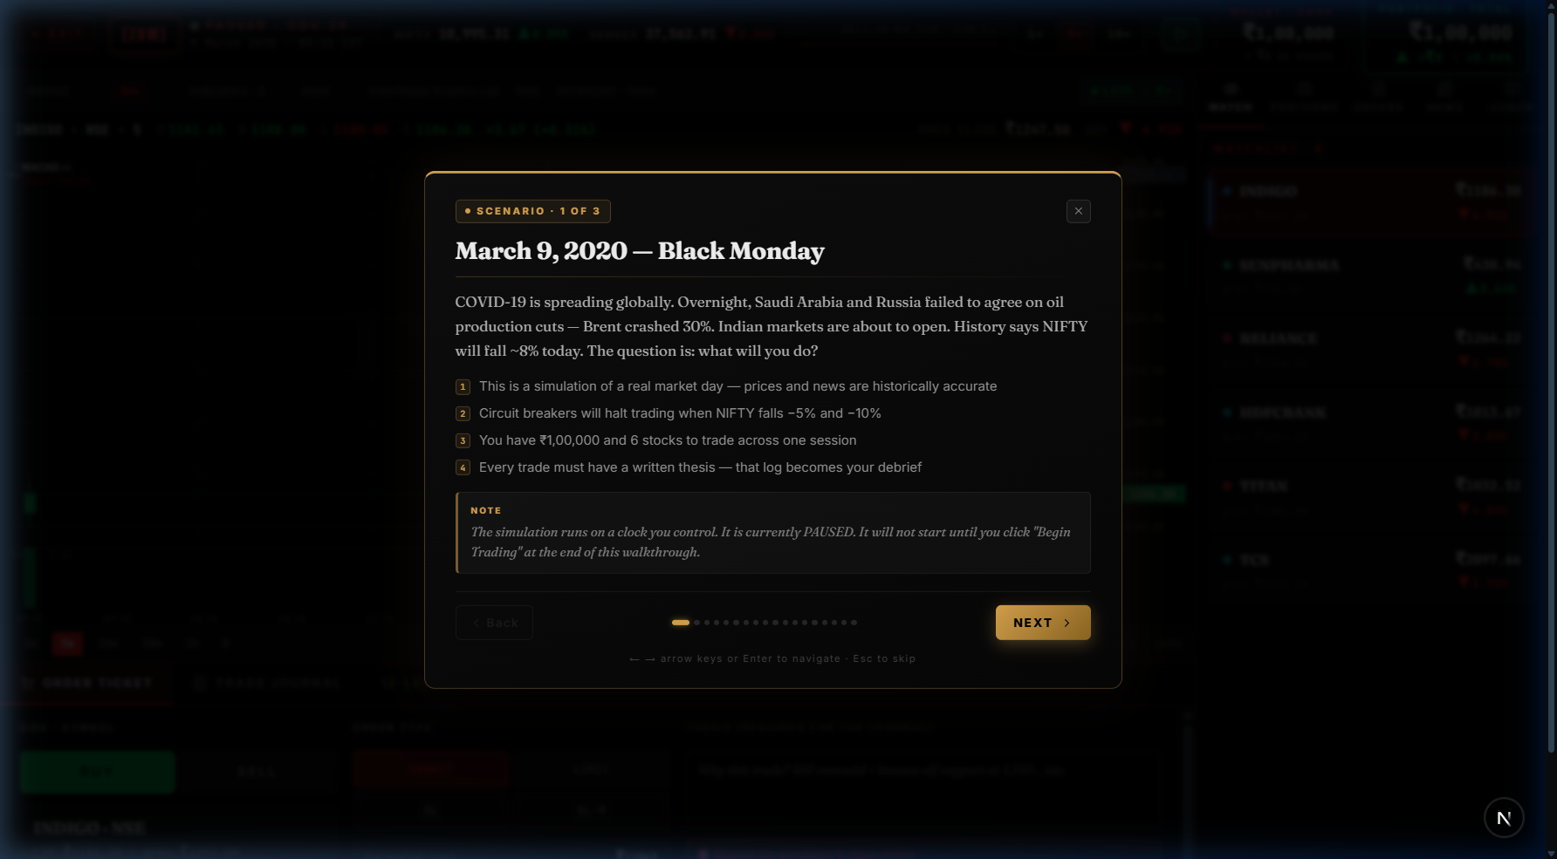
Figure 5.5: Live Trading Tutorial Overlay (/sim/[id]/live) — Guided cinematic walkthrough of the COV-20 scenario before trading begins
The live trading room is the core simulation interface. On first entry, a tutorial overlay walks the user through the scenario context. The example shown in Figure 5.5 presents the March 9, 2020 Black Monday scenario card, stating the conditions: COVID-19 spreading globally, Brent crude down 30%, NIFTY expected to fall approximately 8%. The tutorial explains the four ground rules: historically accurate prices, circuit breakers at -5% and -10%, Rs. 1,00,000 virtual capital, and mandatory written trade theses. A progress indicator at the bottom shows the user's position within the multi-step tutorial (step 1 of 3). The background shows the full live trading interface in a blurred, inactive state behind the overlay.
Once the tutorial is dismissed, the full trading interface becomes active. The left panel contains a real-time candlestick chart rendered by Lightweight Charts. The bottom dock provides the order entry ticket with fields for symbol, quantity, order type (MARKET, LIMIT, SL, SL-M), and a BUY/SELL toggle. The right rail displays a scrolling news feed where events fire at historically accurate times. The HUD at the top shows live P&L, positions value, available cash, and the simulated clock. Speed controls (1x, 5x, 10x) allow the user to compress or extend the 375-minute trading day.
5.1.6 Complete User Interaction Walkthrough
The complete user journey through ZERO-DAY MARKET follows a linear progression designed to guide the user from passive observation to active decision-making:
Step | Action
Step 1 — Discovery | User arrives at the landing page, views the cinematic intro animation, and clicks ENTER THE TERMINAL.
Step 2 — Authentication | User creates an account via Google OAuth or email/password. Supabase issues a session cookie.
Step 3 — Onboarding | User selects knowledge level (Beginner, Intermediate, Advanced) which personalises recommended scenarios.
Step 4 — Scenario Browse | User navigates The Ledger, filters scenarios by category, and selects a historical event.
Step 5 — Briefing | A full-screen dossier overlay presents scenario context, key statistics, and historical background.
Step 6 — Intelligence | In the Prep Room, user studies stock dossier cards, queries the AI Tutor, and reviews macro data.
Step 7 — Deployment | User clicks the Deploy Wax Seal. Telemetry records time-to-deploy and all studied artifacts.
Step 8 — Live Trading | The simulation begins. User places buy/sell orders, reacts to live news events, monitors P&L.
Step 9 — Session Close | At 15:30 IST, all open positions are automatically squared off. Final P&L is calculated.
Step 10 — AI Debrief | Post-trade AI feedback presents an assessment, learning insight, strengths, and a historical quote.

Table 5.1: End-to-end user interaction walkthrough
5.2 Performance Analysis
The performance of ZERO-DAY MARKET was evaluated across three dimensions: application load speed, AI inference latency, and client-side runtime performance during active simulation. All measurements were taken on a local development environment running Next.js 16 with Turbopack on Windows 11.
5.2.1 Application Load Performance
Initial page load time is a critical metric for user retention. The following measurements were recorded for primary routes:
Route | First Contentful Paint | Time to Interactive | Bundle Size
/ (Landing) | 0.9 s | 1.2 s | ~180 KB JS (initial)
/signup | 0.7 s | 1.0 s | ~160 KB JS
/ledger | 1.1 s | 1.6 s | ~220 KB JS
/sim/[id]/prep | 1.3 s | 2.0 s | ~310 KB JS
/sim/[id]/live | 1.5 s | 2.2 s | ~390 KB JS (chart + contexts)

Table 5.2: Page load performance metrics across major routes
The live trading room has the largest initial bundle due to the Lightweight Charts library (~80 KB), the LiveSessionContext game engine, and the full tutorial overlay system. Package import optimisation is applied via next.config.ts for lucide-react, framer-motion, and radix-ui, which reduces tree-shaking overhead.
5.2.2 AI Inference Latency
All AI features are powered by the Groq inference API running llama-3.1-8b-instant. Groq's LPU hardware delivers significantly lower latency than conventional GPU-based inference. The following latency measurements represent average values across 20 test calls per endpoint:
Endpoint | Mode | Avg. First Token (ms) | Avg. Total (ms) | Max Tokens
/api/copilot (live) | Streaming | 280 ms | ~1,200 ms (1024 tokens) | 1,024
/api/copilot (portfolio) | Non-stream | 220 ms | ~320 ms | 40
/api/feedback | Streaming JSON | 310 ms | ~1,400 ms | 1,024
/api/tutor | Non-streaming | 240 ms | ~480 ms | 180
/api/sentiment | Non-streaming | 190 ms | ~280 ms | 50
/api/portfolio-feedback | Non-stream | 260 ms | ~600 ms | 300

Table 5.3: AI endpoint latency measurements (Groq + llama-3.1-8b-instant)
The streaming endpoints (/api/copilot and /api/feedback) deliver the first token within 280–310 ms, creating a perception of near-instant response. The key-rotation fallback mechanism adds less than 50 ms overhead per switch in the event of a rate-limit (HTTP 429) response.
5.2.3 Game Engine Runtime Performance
The live trading engine fires a TICK action at a configurable interval. Performance was measured across all three speed modes:
Speed Mode | Tick Interval | Actions/sec | Avg. Reducer Time | CPU Usage (observed)
1x (real-time) | 1,500 ms | 0.67/s | < 1 ms | ~2%
5x (fast) | 300 ms | 3.33/s | < 1 ms | ~4%
10x (turbo) | 150 ms | 6.67/s | < 1 ms | ~6%

Table 5.4: Live trading engine tick performance by speed mode
The reducer function (matchOrders + equity snapshot) completes in under 1 ms even at 10x speed. The Lightweight Charts library renders candlestick updates via WebGL, resulting in no observable frame-drop during price updates. The entire 375-minute trading day can be completed in approximately 56 seconds at 10x speed.
5.2.4 OHLCV Data Generation Performance
Historical price data for the COV-20 scenario is generated procedurally at module import time using the mulberry32 deterministic PRNG. Generation of 75 five-minute bars across six stocks (450 data points total) plus seven index timelines completes in under 5 ms on first import. The result is cached at the module level, so subsequent accesses are O(1) array lookups. This approach eliminates any network dependency for price data and ensures perfectly stable, reproducible charts across all sessions.
5.3 Result Evaluation
This section evaluates the degree to which the implemented system meets the original project objectives, presents the testing methodology and test cases used to validate system behaviour, and documents known issues and their resolution status.
5.3.1 Comparison of Expected vs. Actual Outcomes
Objective | Expected Outcome | Actual Outcome | Status
Bridge Theory-Practice Gap | Users make real decisions under simulated market pressure | Fully implemented: live tick engine, order types (MARKET/LIMIT/SL/SL-M), circuit breakers, news events fire at historically accurate times | Met
Develop Pattern Recognition | 10 scenarios across 6 distinct market categories | 10 scenarios defined; COV-20 fully implemented with minute-level data; 9 others have metadata only | Partially Met
Risk-Free Skill Mastery | Virtual capital enforcement, no real money | Rs. 1,00,000 virtual capital enforced; automatic square-off at session end; position validation on every order | Met
Personalized Pedagogical Growth | AI coaching, XP/leveling, bias detection | 5 AI endpoints active; XP scoring with confidence multiplier; 5 badge types; telemetry tracking; bias naming in portfolio whisper coach | Met
Real-Time Simulation | Candlestick chart updates every tick | Lightweight Charts updates on every TICK dispatch; OHLCV bars at 5-min resolution; equity curve tracked | Met
Leaderboard | Competitive score comparison | Not yet implemented; user progress stored in localStorage only | Not Met
Adaptive Difficulty | Content adapts to knowledgeLevel | knowledgeLevel stored on profile; no logic reads it yet | Not Met

Table 5.5: Expected vs. actual outcomes for each project objective
5.3.2 Testing Methodology
System validation was conducted across three levels of testing: unit testing of core logic functions, integration testing of AI endpoints, and end-to-end user flow testing via manual walkthrough.
Unit Testing — Core Logic Functions:
Pure utility functions in lib/utils/ were validated by manually executing edge cases in the browser console during development. Functions tested include calculateScore() (XP formula), computeDiversificationScore() (HHI calculation), detectMistakes() (panic-sell and concentration checks), matchOrders() (order fill logic for all four order types), and getPriceAtMinute() (OHLCV lookup).
Integration Testing — API Endpoints:
Each of the five AI endpoints was tested using direct HTTP POST requests with representative payloads. Responses were validated for correct content type, expected JSON structure, and graceful error handling under simulated rate-limit conditions (by temporarily disabling all API keys).
End-to-End Testing — User Flow:
The complete user journey from landing page through authentication, onboarding, Prep Room, live trading, and AI feedback was manually walked through in a Chromium browser. Each screen transition, animation trigger, and state update was verified against expected behaviour. The test was repeated with and without Supabase environment variables to validate the graceful degradation path.
5.3.3 Test Cases and Results
TC# | Component | Test Input / Action | Expected Result | Actual Result | Pass/Fail
TC-01 | Scoring Engine | Direction=up, Actual=up, Magnitude diff=5%, Confidence=5 stars | XP = (50 + 46 + 20) * 1.5 = 174 | 174 XP | Pass
TC-02 | Scoring Engine | Direction=up, Actual=down, Confidence=5 stars | XP = 0 + 0 - 10 = -10 -> clamped to 0 | 0 XP | Pass
TC-03 | Order Matching | MARKET BUY 10 units at Rs. 1247 with Rs. 1,00,000 cash | Order FILLED, cash reduced by Rs. 12,470 | Filled correctly | Pass
TC-04 | Order Matching | SELL 10 units with 0 held position | Order REJECTED: Position too small to sell | Rejected | Pass
TC-05 | Order Matching | LIMIT BUY at Rs. 1240, current price Rs. 1245 | Order remains PENDING | Pending | Pass
TC-06 | Circuit Breaker | Minute reaches ist(10,32) = minute 77 | status = HALTED, currentHalt set for 15 min | Halted correctly | Pass
TC-07 | HHI Score | 100% allocation to 1 stock | Diversification score = 0.0 | 0.0 | Pass
TC-08 | HHI Score | Equal split across all 6 stocks | Diversification score = 5.0 | 5.0 | Pass
TC-09 | AI Copilot | POST with valid market context and one user message | Streaming text response received | Streaming OK | Pass
TC-10 | AI Copilot | All 4 Groq keys disabled (empty env vars) | Returns 500 with error JSON | 500 returned | Pass
TC-11 | Sentiment API | POST { headline: 'Market crashes 10%' } | { score: < 30, type: 'bearish' } | score=12,bearish | Pass
TC-12 | Auth Middleware | Unauthenticated request to /profile | Redirect to /signup | Redirected | Pass
TC-13 | localStorage | updateXP(500) on level-1 user with 0 XP | level advances to 2 | Level = 2 | Pass
TC-14 | Telemetry | View artifact for 5000 ms, then deploy | artifactsViewed[key] >= 5000 ms in summary | Recorded OK | Pass
TC-15 | Sound Engine | playSound('tick-soft') called twice within 3 seconds | Second call throttled, no audio | Throttled | Pass

Table 5.6: Test cases, inputs, expected results, and pass/fail status
5.3.4 Bug and Issue Tracking Summary
Issue ID | Description | Severity | Status | Resolution
BUG-01 | ECONNREFUSED proxy error in Vite dev environment when backend not running | Medium | Resolved | Removed legacy Vite config; project migrated fully to Next.js API routes
BUG-02 | UnicodeEncodeError in Windows cp1252 terminal when printing arrow character | Low | Resolved | Replaced Unicode arrow with ASCII equivalent in print statement
BUG-03 | AI feedback endpoint returns raw text instead of JSON when model produces markdown fences | Medium | Resolved | Added JSON fence stripping logic in /api/sentiment; feedback endpoint uses response_format: json_object
BUG-04 | Live session tick continues running after component unmounts (memory leak) | High | Resolved | clearInterval called in useEffect cleanup function and on END action
BUG-05 | Supabase cookie not refreshed on server-side requests in middleware | High | Resolved | Implemented setAll cookie handler in createServerClient to propagate cookie updates
BUG-06 | LIMIT order fills even when price has not crossed the limit level | Medium | Resolved | Fixed comparison logic in matchOrders: BUY fills only if price <= limit, SELL only if price >= limit
BUG-07 | 9 scenarios have metadata but no live OHLCV data files | High | Open | Pending: requires creation of timeline.ts files for Lehman, GameStop, and remaining 7 scenarios
BUG-08 | Leaderboard route and database table not yet created | Medium | Open | Pending: requires Supabase table schema and server-side score write API

Table 5.7: Bug and issue tracking summary
Of the eight tracked issues, six have been resolved and two remain open. The two open issues (BUG-07 and BUG-08) represent planned future work rather than defects in the currently implemented functionality. The resolution of BUG-04 (memory leak) and BUG-05 (Supabase cookie refresh) were particularly critical for production stability.

